Olney Memories # 80
August 1, 2010

I hope everyone is having a nice summer and that this issue will spark some additional memories.
I will send out the Contact list immediately after sending the OM # 80. Everyone can be included in on the Contact List, just notify me that you want your name to be included and I will gladly add your name to the list.
We now have 619 people on the Olney Memories mailing list. From what I hear, I’m sure there are many more readers than that by the time OM’s are passed around. As you can see there is a tremendous interest in the OM’s and it’s you folks and your memories that are making it work!
Happy Reading!
Ann Weesner King
Pianoann97@aol.com
Class of 1960
==================================================
David Schnautz
david@clarkfreight.com
This is Ann’s son. I read every OM she sends out. Every once in a while I will recognize something that Y’all are talking about. I went to Central Grade School and then to the ultra modern Middle School for 7th grade before moving to Texas. My year in the middle school was 1976 and ’77. As you can see there is a gap of 20 years more or less between my raduation and most of y’alls. That is almost an eternity when talking about an ever changing town. My highlights were going to the Town Talk on Fridays, during school, for lunch with 2 or 3 other class mates and Mrs. (Judy) Whitaker my fourth grade teacher. What a treat to walk to a restaurant instead of eating at the school cafeteria. If Becky (Jones) Miller went with us that was even better. The year would have been 1973 or so. Also the Dog and Suds was a big deal to a young boy. Trying to eat and not spill your drink. No cup holders back then if you remember. I could go on and on with my “recent” memories but they would probably be too recent for most of the group to be interested in.
I thought it interesting that Mom has 618 folks on the e mail list. Isn’t it strange that Olney’s telephone area code is………..618.
And one more thing, Little Farm Market (Whittle Ave) had sawdust floors?? You have got to be kidding. I knew they had the best candy selection in town but didn’t know about the floors.

David Schnautz
Would have been Class of ’82 if we had not moved to Texas

Dean Adams
imbumbie@comcast.net.

Here I sit on my porch with my laptop and dog looking at the devastation in my yard caused by a humungous hailstorm. My beautiful annual flowers, my gorgeous hedge of tea roses and my poor sweet corn crop are all gone. I wish Olney resident and devout gardener Eva Fay Dunaway Fessel was here to help me cry.
Now along comes OMer Jim Dale telling me that I’m an “item that needs clarification”. How depressing.
Oh Jim Dale, you are so right. Where did I get Boone or Morgan as the location of that teen center? Sheeesh. I went back to MapQuest where I got it in the first place and saw I should have said it was on the northeast corner of N. Mill or N. East Streets or vicinity. Either I wasn’t thinking or I’m not be the brightest crayon in the box.
Now let’s clarify Jim Dale’s “item that needs clarification”
This is in regard to the location of the “Rat Hole” pool hall in the basement Jim says was under Schmalhausen’s. Apparently he is confused by my entry in OM 78: On Sundays when the pool halls were closed we would go to the basement below Piper Hardware where there were a couple of pool tables. Some called it the Rat Hole I believe. Access was by a stairway in the sidewalk between Piper’s and Bonds.
Contradictory, Jim wrote in OM # 79: “The pool hall was actually under Schmalhausen’s Drug Store. It was accessed by a stairway on the east side of the drugstore, on the Fair Street side. The stairway had a protective railing around it on which the boys would sit while girl-watching and eating their ice cream cones.”
He also wrote in OM # 8: I worked in Schmalhausen's Rexall Drug Store all the 4 years I was in high school (1936-1940). At that time it was located on the corner east of its later location. There was a pool hall downstairs below it.
So as Paul Harvey used to say “here is the rest of the story”. Bette Schmalhausen wrote in OM # 9: Just wanted to comment on the location of Schmalhausen's Rexall Drug Store. It was originally on the corner of Main and Fair but moved west a couple of doors due to a fire.
Apparently neither Jim nor I remember the fire since it was before my drugstore and pool hall time and after Jim left Olney.
So now you see we have Schmalhausen’s 1 and 2 with Rat Hole # 1 under Schmalhausen’s #1, which would have been destroyed in the fire as well. My Rat Hole (#2} only had one room and two pool tables. Apparently the snooker table and domino tables Jim mentioned earlier was destroyed in the fire.
After the Schmalhausen #1 fire Burton Loveman Sr. had the store and the basement rebuilt and established Bond’s Drug Story. (Burton Loveman Jr. was in OTHS class of 1944). Apparently the outside stairway from Fair St. was filled in or closed off and an inside stairs was added in the rear of the store behind the booths. I recall dancing in the basement to a jukebox as early as 1942. Other OMers recall doing the same. However the Loveman’s apparently closed shop and left town in early 1950.
I hope everyone is clarified now. I recognized this difference in memory when I first read the OM s. That’s why I wrote in OM # 75-B: “I see where some of my memories differ from others. Some differences are probably due to time differences and some from just plain difference of viewpoint.
The following is a picture of a cute little girl. It is of our host Ann in front of Bond’s Drug Store in the 1940s. To the left of her and around the corner to the right on Fair is the sealed off stairs going down to the basement to what used the be Rat Hole number 1 and later a dance floor. To the right of her one door on Main is the stairs to Rat Hole number 2 in business about that time.

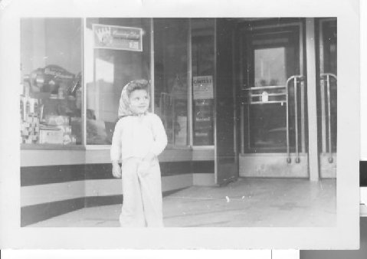

Before closing this thread I have a question for Jim. You tell of sitting on the stair rails on Fair St. watching girls and eating an ice cream cone. First, how did you keep from falling off backward to the bottom of the stairs? And where were the girls you were watching? All you could see was the blank wall of the American Brokerage Department Store across Fair. All the girls were around the corner on Main where I watched them a few years later while standing with my elbow on the stair rail in front of Piper’s Hardware.
So here I sit, an ex-gardener, trying to figure out if all this is just a dream.

Ah yes, memories, memories. Ann’s last OM brought up more. Jim Dale’s memories caused me to remember more about the pool hall on the northwest corner of Main and Walnut. I recall someone, “Mush” Porter (Lyle) or an employee, was a pool shark and kept wanting me to play for money. I was always chicken. I can’t remember the name of the pool hall either. How about you, Bud? Anyone else in our generation?

And Jim, I don’t remember the catfish picture in the Little Brick Inn. It might have been on a different wall and the Custer picture drew more attention, or they may have changed it from your time to mine. I recall the Custer picture was on the west wall and I think it was advertising a beer; Pabst Blue Ribbon possibly.
I couldn’t remember the name for hand fishing for catfish either. I thought it might be grubbing. I asked a buddy and he found it on the Internet. It is “Noodling”.
Dean Adams
class of 1943.
---------------------------------------------------------------------

.

The Class of 1942 is having a get-together with the Class of 1943 on Friday, August 27, 2010 at the Olde Tyme Steakhaus. Happy Hour and gathering at 5:30 and Dinner following. Since we have already spent all of our money we will pay for our own meal. Please reply to:

Eva Fessel 618-392-5491 Marijane Plummer 618-395-1773
318 S. Elliott St. or 4841 N. Hite Oak Rd.
Olney, Il 62450 Olney, Il 62450

Dean Adams
imbumbie@comcast.net.

This is a reprint of the biography of Jack Forest, OTHS class of 1945. This was written by OMer Theodore “Ted” Crackel crackel2@yahoo.com in OM # 53.
The reason for my resubmitting this is that I am taking credit for Jack’s success due to my teaching him how to cut brush while working for the Pure in the summer of 1944.

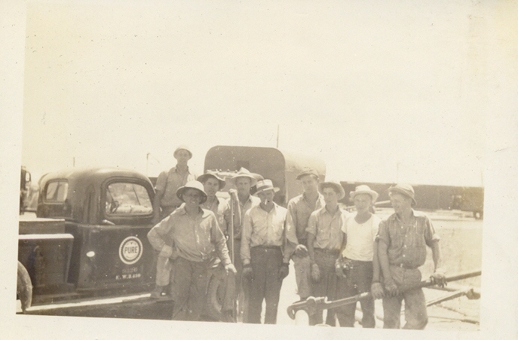

This is a picture of that motley crew that summer. As near as I can remember the members are from left, gang boss Ed Mason, Gene Wilson (’45), me, Harry Fulton (Noble), ?? Gaskins, Jack Forest (‘45), Harold Schmalhausen (‘46) whose father was proprietor of Schmalhausen’s Drug Store, George (Brownie) Brown (’46) and Gib Miller (‘45).

John Franklin Forrest entered West Point in 1945 and
graduated in 1949 as a Second Lieutenant in Infantry.
In 1950 he was sent to Korea with the 5th Cavalry.
There, he was wounded twice and received two Silver
Stars. Later he served two tours in Vietnam, the
second (1967-68, think Tet Offensive) as a Battalion
Commander in the 101st Airborne Division where he
earned his third Silver Star. In 1975, now a
Brigadier General, he served as Assistant Division
Commander of the 82nd Airborne Division. The next
year he was promoted to Major General and given
command of the 4th Infantry Division (Mechanized) at
Fort Carson, just outside Colorado Springs, CO.
In 1979, he was promoted to Lieutenant General and
given command of 1st United States Army (1979-1981) at
Fort Meade, MD – a command whose major role then was
to improve the readiness of the Army’s reserve units.
He retired from the Army in 1983 and, in 1986, joined
Ford Aerospace. He left Ford in 1991 and returned to
Colorado Springs. In 1994 Forrest became a member of
the city council. He died on March 27, 1997.

Dean Adams
OTHS class of 1943

Ann Weesner King
Pianoann97@aol.com
Three or four Olney Memory readers sent the two links below about the Olney White Squirrels. Since the White Squirrels are a fond memory of our connections with Olney I wanted to share the links with you. These are links to articles other than the one below.
http://www.chicagotribune.com/topic/wgntv-cruisin-illinois--white-squirrels-july14,0,3841830.story
http://www.chicagotribune.com/videobeta/?watchId=ee0c8c8d-a4e8-43cd-9815-31f2563a2895
Albino Squirrels

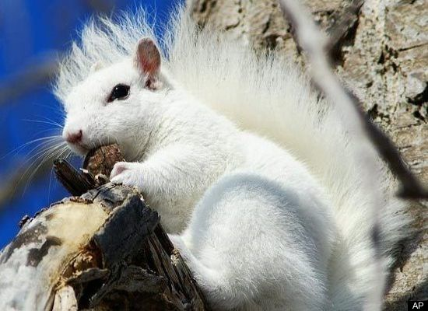
Red eyes and snow-white fur make albino squirrels look like something out of a sci-fi movie, but in Olney, Illinois, the rodents might as well be royalty. City laws give these rare white squirrels the right-of-way on every street (jay-walking permitted), and police prohibit visitors from leaving town with one of the estimated 111 colorless pets. Albino squirrels scurry down trees in towns nationwide (at least five other American towns boast similar populations), but Olney provides something of a safe haven for the animals, who don’t exactly blend in like their camouflaged counterparts. Besides street-crossing privileges, these little guys can escape winter weather in citywide squirrel houses (wooden huts that locals nail to trees) and officials even encourage visitors to feed the squirrels – only nuts, seeds, and fruit, of course. For guaranteed sightings, visit on Saturdays in October (this year’s schedule is set for October 9, 16, and 23) when a citywide squirrel census takes place (volunteers actually go around counting the number of white and gray squirrels to keep track of the population). A town hunting for squirrels seems like an even weirder sight! Otherwise, find a park bench at Olney City Park, scatter a few nuts on the ground, and wait, camera at the ready.
Ann King
Class of 1960
-----------------------------------------------------------------------------------------------------------
Sharon Burt
Trigger88@aol.com

WE NEED INFORMATION ON THESE CLASSMATES:

The class of 1960 is having its 50th Class Reunion this Fall in September and if anyone could help in locating any of the classmates listed below we would appreciate it very much. Please contact Sharon Street Burt at 618 395-6236 or trigger88@aol.com .

Jim Anderson
David Balfour Wayne Barnes
Bobbie Brown Leona Bundy
Eugene Dilly Irene Ash

Jim Hall
John Hartz Leroy Herold
June Herring Mary Jane Hughes
Sharon Lancaster Dean Mason
Karen McCoy Larry Moore
Carolyn Murphy Nancy Race
Carol Wood
Evelyn Wilson Robert Slunaker
Jim Stilwell Arlene Street Fern Tompson
Judith Tompson George VanDeList
Bonnetta Warren
Evelyn Wilson

Sharon Burt

Class of 1960

---------------------------------------------------------------------------------------
Dean Adams
imbumbie@comcast.net

Memories ( or lack of )
As I have mentioned in earlier OMs, we seem to get “flash” memories just out of the blue and “spark” memories from something we see or hear.
The memories we all seem to have the most trouble with are “request” or “demand” memories, those we want to remember and can’t. I can’t believe the detail of spark memories that I recall. You probably have noticed it in my earlier OMs.
I have been doing some research lately in my Mother’s photo album (she was my photojournalist). I find I can’t remember so many of my schoolmates, place names and odd things. The name of the pool hall mentioned above in another OM is an example. Another example is my schoolmate during the school year 1939-1940, fellow OM-er Jim Dale. We don’t remember each other, not even the names. I’m getting really aggravated with my request memory. In contacting some of my schoolmates recently it seems we all have the same problem. The exception is OM-er Mary Nell Fessel (’46),
An example of flash memory is that I remember a fellow OM-er and schoolmate in the class of 1946 but she doesn’t remember me. (Of course I’m a very forgettable person).
In 1947ish after she graduated, she went to live with relatives in Champaign. Ralph Bower, Bob Edmiston and I were attending the University of Illinois at the time as were her classmates Jean Van de Voorde and recent OM-er Pat Scherer. I believe OMer Jack Leathers (’44) was also. Jim Dale went to graduate school there from 1952-1956.
In talking to her recently on the phone I forgot to ask if she ever crossed trails with any of them. I know she did with Ralph Bower and me.
She and Ralph don’t remember my flash memory. She lived on South Neil Street in Champaign about two blocks south of where I lived. She was having a party and Ralph and I sneaked onto the service porch and pulled the main fuse cutting out the lights. It must have been Ralph that did that cause I wouldn’t have been that ornery .
This flash memory caused a valued spark memory of my crossing trails with the two ladies mentioned above, Pat and Jean. I ran into them while studying in the library at the U of I. Fortunately, I borrowed Jean’s typewriter to aid in the business letter-writing course I was taking at the time.
Aw yes, precious memories. Coincidently as I turned on my cassette player this morning as I was doing my toiletries, the first song was “Precious Memories”. I can’t remember the name of the artist but Google says there are many many country and western and several pop artists that recorded this song.

Precious Memories, how they linger. How they ever flood my soul ---

Dean Adams
Class of 1943.

===================================================================================================

