Olney Memories # 150
November 23, 2020

Here we are nearing the end of the year 2020 and wondering if it has gone as fast for everyone as it has for us? It almost seems like it went like a whirlwind that took 12 days instead of the usual 12 months. I’m sure we all can agree it has been a rather unusual year.
How many of you remember the song? “Over the River and Through the Woods, to Grandmother’s House We Go”? I used to love singing that song when I was a little girl and wishing I had a river to cross going to my Grandma’s house! Oh the funny little things kids get in their little heads…….
As Thanksgiving is approaching may we all be thankful for the blessings that we have, and although it may be a little different this year in some respects, I would like to wish everyone a Happy Thanksgiving Day.
Ann Weesner King
Class of 1960
----------------------------------------------------------------------------------------------------

Kay Dowden Byers
Kaybyers1@gmail.com

I believe that Lyle Brown's wife's name was Elizabeth - but I'm not positive. I know that Mrs. Brown was my music teacher at Cherry Street Elementary School.
Kay Byers
Class of ‘67

Dennis Brooks
brooksfoto@gmail.com
Ann- Thanks so much to all the people who responded about the hardware store. Cliff and Florence Garrett were my aunt and uncle. I had always remembered the store, playing in there while my mother ran quick errands. I somehow remembered it was on the north side of the street. Nobody in my family remembers and my parents have passed (Kenny Brooks/Nancy Kesler). I had lost track of the sisters and thought I had read Janet had passed. I was ring bearer in her wedding! Besides the store I have vivid memories of my dad and Cliff fishing/hunting all the time and his red Jeep that he drove all over town. I’ve always wished I had a photo of him with that Jeep.
We left Olney when I was 6 years old (‘57) and moved to TX then MI but always visited Olney several times a year.
Thanks!
DSB

Sandi Peer Kubbs
akubbs@icloud.com
Subject: Mrs Brown
Lyle and Elizabeth. He played piano at our church and she played organ. She taught music in the schools and gave me piano lessons. Very kind soul.
Sandi Peer Kubbs
Class of ‘65

Bud Shipley
bud.shipley@gmail.com

The photograph below is Neil Hahn and he had his barber shop there at 113 S Boone St where Betty Slover currently has her beauty shop. Neil was a good man and wonderful friend. That building now has Stivers Barber Shop in front, dad’s office was in that building on Boone St and we lived upstairs in 1971 my senior year at ERHS. We sold the building sometime after 2012. (After mom passed away)
There were some Drew sisters that also had a beauty shop in the building back in the 70’s.

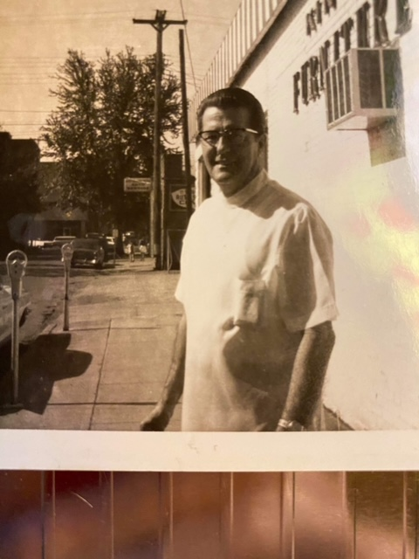

Bud Shipley
Class of '71

----------------------------------------------------------------------------------------------------------

Kathryn Robinett
klrobinett@gmail.comate:
Hi Ann,
Thanks for the Olney Memories - what a wonderful way to stimulate our gray matter! There were a couple mentions of Lyle Brown and not remembering his wife's first name. Connett is correct for Mrs. Brown's maiden name. Her given name was Mary Elizabeth, and she was commonly known as Elizabeth. They were a jovial, kind, and talented couple; and, they were PK's (preacher's kids)!
Kathryn Haenggi Robinett,
Class of '61

Marvin Doolin
marvin.doolin.jr@gmail.com

Loving #149. Isn't it wonderful when things come together!
Thanks, again, Ann, for all your work. I feel sure everyone appreciates it as much as I do.

Marvin Doolin '62
------------------------------------------------------------------------------------------------

Sue Rice
Is_rice@mindspring.com

HI ,
It seems like these memories have been coming so much faster of recent. It seems like only yesterday you were working on # 100.

(This is Ann )….It’s amazing how they Keep progressing isn’t it@ I believe people really are enjoying thinking back on these things. It gives me pleasure to do this….only this time it’s been quite a while since another issue came out. With a broken computer, finally replaced by a new one, and we made a house move too, I just couldn’t get everything done! Hopefully I’m back in the swing of things again.
Sue Rice
--------------------------------------------------------------------------------------------------

Curtis Stoltz
iam777iam@gmail.com
﻿Thanks for all the Olney Memories and the enlightening stories they bring to all of us who enjoy the amazing world,
I wanted to share that the recent chatter about center of population story and scouting...
I recall a license plate medallion that David Blain had that described the center of population, must have been a amazing parade and fun event to celebrate
Scouting brought so much to the children of the area, meeting interesting leadership of the area and discovering skills and trades from many businesses and companies by many of the corporate organizations of our area and the amazing events that surround the boy/girl scouts organizations
Camp Amwaco was one of many first scout camps endorsed by the first scout leaders currently still in existence as Crest Haven family center due north of Crest Haven cemetery on Crest Haven road and Hershey lane near old Cowford Bridge that once connected Rafetown bridge and Yager Bridges on the original Dundas trail road from Westport, IL to Louisville, IL
My great grandparents who leased their property to the newly worldwide scouting organization of Baden Scott Powell of Edinburgh, Scotland was a highly noble and professional group of men who served others by brotherly love and Masonic ties...
I traveled throughout my hometown area neighborhoods and recall many great experiences growing up there...
I recall how much fun to watch the soapbox derby races and those pinewood derby races, bicycle safety and getting a license plate for my bicycle then a sticker to z

What a marvelous world  we live in and many of us seen writing notes in class to text messages and don't call us before breakfast and after 9pm
Ha ha ha. God bless Ann Weesner for your noble efforts to keep OM for so many years.
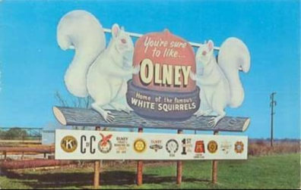

Curtis sent this picture above, wonder what happened to the “real McCoy”? Does anyone know? (Ann)

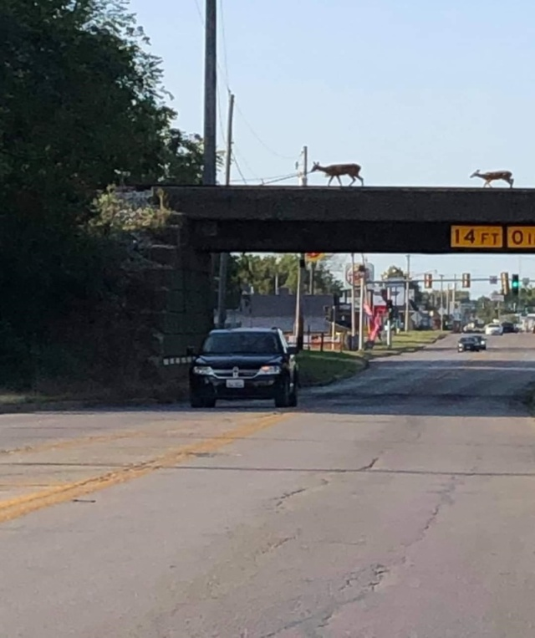
Curtis Stoltz
These are deer walking on the overhead B&O tracks where the trains used to run over Rt. 130 in Olney!




