Olney Memories # 143
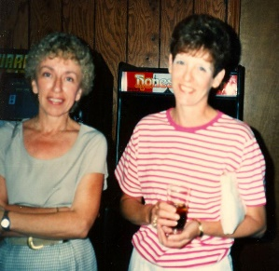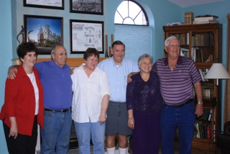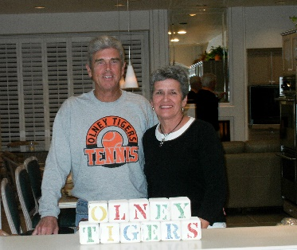
March 27, 2019
Hello Schoolmates and friends,
Here we are welcoming the days of spring. Maybe everyone isn’t actually experiencing blissful spring weather yet but if you’re not it won’t’ be long. There are some good memories below for you to read and think about and hopefully they will spur some memories of your own to send in for the next Memories. Just send them to me via e-mail and I will post them in the next issue of OM’s. Again, please let me know if any of you have a change of e-mail address.

Happy Spring!
Ann King
Class of 1960
Pianoann97@aol.com

Hello Ann’s O.M. Subscriber!

I want to invite you to participate in our 2019 RCSH scholarship drive for graduating seniors -- conducted by the Tiger Pride Alumni Association (TPAA) and the Tiger Alumni Center (TAC).

All donations are welcomed! We’re near the end of the drive and short of our goal of $20K by around $8K. Click on the link below to visit the 2019 instructions page on TAC.

http://www.erhsalumni.net/Scholarships-2019.htm
To Donate:
Please Mail Checks to
Janet Everette, Treasurer, TPAA
906 East Cherry Street
Olney, IL. 62450
Please make your check out to Tiger Pride Alumni Association
Remember: the Tiger Pride Alumni Association, Ltd., is a charitable, tax-exempt, 501(c) (3) organization.
Janet will mail you a (legal, for your taxes) statement acknowledging your donation. To do that she needs your help. Please be sure she knows the donor's name(s), the return mail address, and any special requests.
Some donors request anonymity. Some wish their gift, when posted on TAC, include an honor of someone special. Some request that a challenge to classmates to donate be included.

THE SELECTION CRITERIA
The Tiger Pride Alumni Association - TAC Scholarship recipients are selected by the Richland County High School Senior Awards Committee. Scholarships are awarded to deserving graduating seniors at Richland County High School based on the following criteria.
1) Students in good academic standing and at least a 'B' average.
2) Students that have demonstrated the Core Expectations of RCHS Students of Respect, Responsibility and Work Ethic.
3) Financial need of the student is considered in the selection, but it is not the sole criterion.
Note about the above process: None of those who will be a recipient knows of being selected until hearing her or his name announced during the ceremony on Senior Awards night. As to the TAC - TPAA directors, we have no part of the selection; afterwards key directors are informed of the number and names in order to prepare for the ceremony.
We’re in our eighth year and have funded 91 scholarships of one thousand dollars each. Hopefully we’ll fund another 20 this year!

Thanks!

Richard Williams
Founder, TPAA and TAC
--------------------------------------------------------------------------------------------------------

Jim Dillman
jdillman@lastwrites.com
Hello to you and Olney Memories Ann, and a Happy New Year to all,

It’s been a long time since I’ve written anything for OM but after reading your latest my memory bank sort of overflowed. I can still recall oh so many things about Olney from reading what others have written.

I grew up in Olney from 1932 to 1949, attending Silver Street, Central and 3 years of High-School. I moved away just before my Senior year but I guess Olney will always be considered as my ‘home”. My family lived on Ludlow Street, just across from the main park entrance. Dad was a salesman (for a lot of different enterprises) and Mom had a Beauty Shop on the front of our house. Dad, who for some reason was called Ted (although his name was Virgil), joined the Navy during WW 2, and Mom soldiered on with my brother (also “Ted”) and I, for about 3 years. When Dad got home he went into the car business which ultimately led to his acquiring a dealership in Canton, IL, which is why we moved.

I guess my earliest memory of Olney actually centers around the community swimming pool, then located in the park. During the summer months, brother Ted and I would be there when it opened in the AM and when it closed in the evening. (My earliest memory is being about 4 years old and learning to swim under the supervision of big-brother - shallow end of the pool near the kiddie pool fence and slide.) Being the younger, I followed (or was led) by my brother into a lot of adventures – some of them good- some of them not so much. Of course we were at the front door of a lot of activities which took place in the park such as county fairs, horse races and other sporting events. Baseball, softball, and football all had venues on the infield of the racetrack. I can even remember when Ralph Beale’s skating rink was housed in a tent-like structure towards the west side of the park. (I also recall that it was a time when to be accepted into the “gang”, you had to go swimming in the res on May 1st following the parade – heat, rain, snow or ice. Doesn’t say much for our intelligence, but it was a real “man-thing” at the time.)

I seem to remember just about every locale your readers mention such as gas stations, grocery stores, car dealerships, hotels, theaters, RR’s, etc., and I can usually weave them into some form of memory of one or more of my adventures or activities. It was a great place to grow up. My “playground” was limited only by the city limit signs, how far I could walk, or how long I could peddle a bicycle. Some of my personal history is probably beginning to fade but my memories of Olney and what a great start to life it afforded will never be forgotten.

Jim Dillman
Class of “50” (almost)
----------------------------------------------------------------------------------------------------
Dick Meadows
meadows1934@gmail.com
Hi Ann,
I just got a copy of a book of poems by Major Regain who I was told lived in Olney now.
Do you know anything about it?
I would like to know when and where Major lived and went to school?
He mentioned a Pat Totten in one of his poems? I think Major was born in 1940.
Fresh Oil Loose Gravel, is the title of the book.

Dick Meadows
Class of ‘51
------------------------------------------------------------------------------------------------------------

Richard Williams
Rrw41@earthlink.net

Raised by Two Railroad Men
I always enjoy reading the contributions of Ann Weesner King’s “Olney Memories.” I was not disappointed with issue “142”: I liked reading it all, but Roy Ed Doolin’s memory about the trains running through Olney hit HOME with me. You see, both my Grandfather Williams and father were railroad men. I grew up with both of them, and so I knew the railroad business. My home-away-from home was up in the Baltimore and Ohio Railroad (B&O RR) tower, located west of the waiting station at the B&O RR tracks on Whittle Ave (Torn Down Years Ago). The picture below has to be over forty years old. The tower is located in the middle of the picture below.
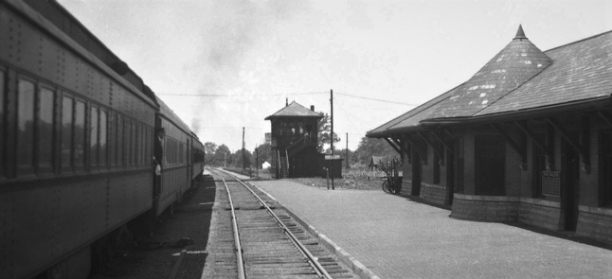
Let me set the scene. My parents lived in an apartment building (Now named Wyatt) on West Elm Street, two blocks west of the post office. My Grandfather Williams, with Grandmother Williams, lived a few hundred feet away, diagonally across the street, on Camp Street. He and dad worked at the B&O RR tower just south two streets, at the intersection of Illinois Central RR. (which coursed north and south on Kitchell Street - tracks remove years ago) and the B&O RR tracks. Between us and the tower was my school, Central School (torn down a few years ago). The school campus occupied the complete block (an "empty," mostly abandoned field now) defined by four streets: Elm on the north; Camp on the west; Kitchell on the east, and Cherry on the south.
It was a small world, my childhood neighborhood. It also included the Elk's movie theatre on Kitchell where I enjoyed many Saturday afternoon matinees (it backed up to the apartment building). And I have to include two businesses on Whittle Ave.: a soda shop / candy store on my side of the street from the post office and Jone's Bicycle Shop, a block south of the candy store. My trips to those places will wait for another writing session. The tower was much more important to my childhood.

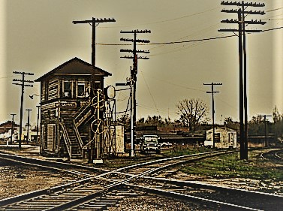
Baltimore and Ohio Railroad Tower, Olney, IL
The tower was just another block south of the school. I usually rode my bike to it. As a kid I was always welcome there, whether my grandfather or my father was on duty. Inside, I could sit on the counter next to the man on duty and listen to the chatter of the telegraph clicker -- the communication machine for RR men. I could watch his (Grampa’s or Dad’s) hands flipping the handle making his "dots" and "dashes" in a reply.
They were receiving or sending messages about the train traffic. For all I knew, when listening during my early years, they were sharing a secret recipe for potato soup or the guest list of the birthday party of Elmer Fudd. They tried hard to include me, however they could, up in that high tower (I expect they called my mom when they saw me coming so that she would not worry). My grandfather loved to play Checkers and so he and I played very often (I usually lost -- unless he took handicaps). My father, to my surprise, loved to read and had a collection of paperback novels on one shelf. He would push one of them to me to read.
Both men took time to give me lessons in telegraphy. At first my "dots" were too long and my "dashes" were too short. Over time I got the hang of it (Somewhat). I got good enough that my dad let me send a few very short and simple messages to a few other agents (He’s got their approval in advance). I even met one of them a few years later at the B&O RR ticket booth in the Cincinnati Union Terminal when I was a high school student traveling solo by train one summer to visit a cousin. Anyway, I never seemed a bother to either of them. Indeed, I at times wondered why they were said to be "at work." They rarely seemed to be working.

Above when I write about meeting a Railroad (RR) man at the Cincinnati Union Terminal, I could also have said that he reported that he gladly agreed to meet me when my father ask him to do so. You see, my father wanted to make sure I got on the correct train as he already knew that I had to switch trains at the terminal and it was a huge and busy place -- overwhelming.

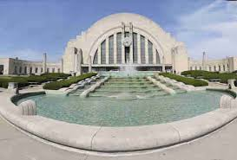
Cincinnati Grand Terminal Museum
And, Oh Yes! Yes, I was overwhelmed but greatly relieved by the help. My host didn’t just take me to the correct train gate and dump me. As we had several hours to wait for my train to Tennessee, he led me to one of the terminal’s restaurants where he paid for our lunch and gave me a brief history on the historic significance of the Cincinnati Union Terminal. He reported that it was a key junction in the Westward Movement of the people of the United States -- and that RR men were key players in our great history. That the RR industry of that century has no equal in today's economy, except maybe the internet. Being an employee of any RR was an honor. He also told me I had sent him a message years ago. He was nice about that and gave me too much praise. I guess I had totally forgotten.
Afterwards, he escorted me to the train gate. I still can, in my mind, see bits of scenes of waiting passengers. I can see a mother nursing a child with several other children clustered around her so close that each child seemed part of her. I also see lots of young adults in military uniforms -- some sleeping on their travel bags and others playing cards. I see a group of oddly-dressed families, I'm thinking foreigners, squatting in a tight circle, using their fingers to eat food out of containers, like jars, obviously not from the restaurants. The huge hall of the terminal was so packed with people that my vision was overloaded, resulting in my not seeing well -- ”Glazing Over" I guess.
After a walk that seemed very long, we reached the gate area. There, my escort introduced me to another waiting RR man, the conductor. He greeted me as "Master Williams" and personally walked me beside the train passing car after car to mine and, inside, invited me to take any window seat. He placed a reserved sign on the adjoining seat, and then excused himself saying he had some tasks to do before the train left. I later learned that his reserving the other seat made it possible for me to have space to lie down for a nap. I don't remember lying down -- I remember my head against the cool window glass as I watched the country slide pass me.
Until the gate opened and ticket holders were allowed to find their car and a seat, I was alone, maybe the solo passenger on the train at that moment. That was some experience! I, being the son of an employee, had a free pass to use the B&O RR. trains, as I had for years. I had used it, joined by my family, on many fun trips to St Louis. But, always before, I was with my family and the cars were crowded with paying passengers. I remember sitting in that silent car, leaning against a window thinking of my father. I don’t, of course, remember my exact thoughts, but I do remember being impressed. My father, a silent man, rarely talked about himself. I was admittedly surprised that he had RR company friends who would volunteer to help him by helping me.
I matured a little bit on that ‘solo’ trip. My father was a man of connections.
I want to add a point about the smell of the tower but can't figure out where to add it and so will do so here. When I think of those days in the tower, I, of course, think of father and grandfather; but I also remember the smell. I can't place it well enough to describe it (something of a mixture of old wood, dust and oil). I just know that my memory connected with the smell. I wonder if other memories have associated odors? And the answer (I just checked) is yes. Click here. (You will leave TAC)
You see, Ann’s “Olney Memories” (OM) of memories still work! Try it; read any issue. Use the navigation list to find her page here on TAC. Or click on the link below. You’ll see a page listing issues. Click on one.


Richard Williams
Class of 1960
------------------------------------------------------------------------------------------------------------
Darrell Navolt
darrellnavol3815@aol.com
Thank you Richard, for this collection of your memories. How literally close to home your story hit. What memories! Those truly were the proverbial "good times."
I grew up at 626 West Elm, along with my brothers and sisters. Like you, our Dad and Grandpa were both Railroad Men. They each had more than 40 years of service on the B&O Railroad! We, too, enjoyed those free "excursions" to the St. Louis Zoo!
My older brother was in the class of '58, while I was in the class of '62. Surely we spent some years at Central School, at the same time! Some good times, some not so good! Miss Spellman let us stand at the windows to watch the Illinois Central train go by. Good times! Then there was Mr. Boley! You might remember, he was in charge of the "dreaded paddle." Need I say more?
Jones Bicycle Shop, Oh! My! How many hours, my brother Dallas and I spent there wishing! Wishing was about all we ever got done, though. As you know, money was hard to come by.
You mentioned the candy store across Whittle Ave. from the Post Office. Whitaker's, a news stand, a record shop, a soda fountain, but especially a candy store! A penny could actually buy a piece of candy!
The Elk's Theater immediately brought to mind a large brown paper bag of buttered popcorn my Mom fixed for us kids to take to the movies. We passed that bag from oldest to youngest then back again until all the popcorn was gone. The bag was always emptied long before the movie was over!
When I think of the apartment building you spoke about, two things come to mind. There was a "hedge row" all the way across the front of the building next to the sidewalk. In my mind, it was there, like a fence, to keep us kids out of their yard. Then, I can't forget the large Buckeye trees. How many times did I carry home buckeyes in my pockets?
Thank you for the memories.
Darrell Navolt.
Class of '62

Janet Jones
jkwjones@gmail.com
Subject: ice company
Hi Ann,

This is my first contribution. I just read your OM 142, and saw the picture of the Ebner Ice & Cold Storage Co.I just remember it as the "ice plant." On Saturday afternoons in the summer, my Mom would load us up in the car to take us to town from our dairy farm out north of Claremont. You see, Saturdays were often homemade ice cream nights, so we needed ice to freeze the ice cream. Mom would take a gunny sack, and buy a big block of ice. At home, she or Dad would crush the ice still in the sack with a sledge hammer, until it was small enough to fit around the canister in the wooden bucket. Mom had filled the canister with her recipe made with our rich Jersey milk. Then my brothers and sister and I would take turns hand cranking the freezer until it got too hard for us. Then after Dad was finished milking, he would usually finish cranking it until the ice cream was good and frozen. There's nothing like homemade ice cream, whether it is vanilla or chocolate, or filled with fruits in season like peaches or strawberries. I'm sure there are many others who made, and still make homemade ice cream, but how many remember getting ice from the ice plant?

Janet Jones
Olney
ERHS Class of 1970

Vance Welker
vance.m.welker@att.net

Below is the obituary of my mother, Julia Rooney. Many of you may remember her as Julia Welker, and before that as Julia Maas. She grew up in Olney in a house on Camp Avenue that was built by my grandfather, Omar Maas (remember Maas Market?). She married Jim Welker (my dad) in 1950. After the family moved back to Olney about 1964, she worked as a secretary in the pharmacy at the clinic (Weber?) to supplement Dad’s teaching salary, and was active in our church and the PTA. The family moved to Tuscaloosa, AL in 1969, when Dad accepted a position at the University of Alabama.

Julia Ann Maas Welker Rooney, of Tuscaloosa, passed away February 18, 2019 at Forest Manor Rehab in Northport, AL. She was 88 years old.

Mrs. Rooney was born March 15, 1930 in Decatur, IL to Omar and Kathryn Maas, and grew up in Olney, IL. She earned her degree in Social Work from the University of Alabama and was a retired social worker.

She was preceded in death by her husband, Fred Rooney, her parents, and her brother, James Maas. She is survived by her children, Dr. Weston Welker (Marci) of Huntsville, Vance Welker (Trina) of Shelbyville, KY, and Kathleen Welker of Tuscaloosa; her grandchildren, Joshua Welker, Matthew Welker (Zena), Molly Hall (Ash), Jeff Tucker and Daniel Welker (Wu Ya); and four great-grandchildren.

Mrs. Rooney made the decision to donate her body to further medical education at the UAB Medical School. She requested that no formal services take place. A private family gathering in her honor is planned for a later date.

Vance Welker
Class of ‘71
-------------------------------------------------------------------------------------------------------------

Ann King
Pianoann97@aol.com
I ran across this the other day and thought this would be fitting to put in the OM’s, for it relates to most of us reading this, especially us old-timers and our memories as we were growing up in and around Olney!
++++++++
A poem to which we can relate

I remember the corned beef of my Childhood,
And the bread that we cut with a knife,
When the Children helped with the housework,
And the men went to work not the wife.

The cheese never needed a fridge,
And the bread was so crusty and hot,
The Children were seldom unhappy,
And the Wife was content with her lot.

I remember the milk from the bottle,
With the yummy cream on the top,
Our dinner came hot from the oven,
And not from a freezer; or shop.

The kids were a lot more contented,
They didn't need money for kicks,
Just a game with their friends in the road,
And sometimes the Saturday flicks.

I remember the shop on the corner,
Where biscuits for pennies were sold
Do you think I'm a bit too nostalgic?
Or is it....I'm just getting Old?

Bathing was done in a wash tub,
With plenty of rich foamy suds
But the ironing seemed never ending
As Mum pressed everyone's 'duds'.

I remember the slap on my backside,
And the taste of soap if I swore
Anorexia and diets weren't heard of
And we hadn't much choice what we wore.

Do you think that bruised our ego?
Or our initiative was destroyed?
We ate what was put on the table
And I think life was better enjoyed.

Author, Unknown ...

Ann King
Class of ‘1960
==========================================================================================================================

