Olney Memories # 142
January 16, 2019

HI Everybody, I would like to wish everyone a Happy New Year as we enter 2019! We have some new people that are added to the OM’s mailing list and we want to give them a “Welcome” to our group! Please don’t forget to give me your e-address changes. If you know of others that are interested in being on the mailing list, please let them know so they can send me their e-mail addresses. Let’s all rack our brains and get some memories going for our next issue! It always amazes me the memories that are brought up by everyone….and there are always more………
Ann Weesner King
Pianoann97@aol.com
Class of 1960
----------------------------------------------------------------

Hello Ann’s “Olney Memories” readers.
Soon, first of February, the Tiger Pride Alumni Association (TPAA) and the Tiger Alumni Center (TAC) will begin the eighth annual scholarship drive for graduating seniors of Richland County High School. You may know that we started the scholarship program in 2012.
Tiger Alumni Center members, along with businesses and others (Maybe you too), have been very generous these past seven years -- raising in total, over the years, of $91,000 for 91 scholarships! What does that mean to you? To us? More youth of our county have a chance to start college or a trade school. More future citizens have a chance for a good life – somewhere, maybe in their hometown. Click Here: Current Totals: To see the current list of current contributors.

THE SELECTION CRITERIA
The TPAA - TAC Scholarship recipients are selected by the Richland County High School Senior Awards Committee. Scholarships are awarded to deserving graduating seniors based on the following criteria.
1) Students in good academic standing and at least a 'B' average.
2) Students that have demonstrated the Core Expectations of RCHS Students of Respect, Responsibility and Work Ethic.
3) Financial need of the student is considered in the selection, but it is not the sole criterion.
Note about the above process: None of those who will be a recipient knows of being selected until hearing her or his name announced during the ceremony on Senior Awards night. Nor do the TAC - TPAA directors. It's a secret. We have no part of the selection.

WHAT TO DO
What to do? Check out our future announcements, during February and March, both here, in the “OM’s” and at the TAC website – erhsalumni.net. You can enjoy watching the donation total grow, meaning more money for more graduates. Perhaps you may want to donate too.
Thank you! Richard Williams, Founder, TPAA and TAC
---------------------------------------------------------------------------------------------------------------

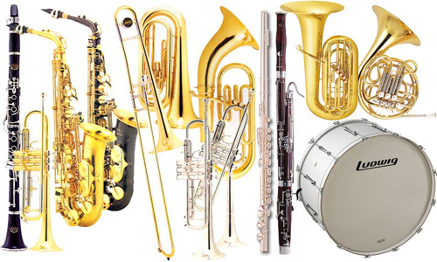
Special Invitation to Band Alumni!

Calling all RCHS, WRHS, & ERHS band alumni! The Richland County High School basketball bands would like to invite you to join us Friday, February 8th for the RCHS vs. Newton Boys Varsity Basketball Game. We provide the music. We may even be able to provide an instrument for you to use on game day!
Please contact Mr. Jones at cjones@rccu1.net, or at (618) 393-2191 ext. 3137 for more details. Please feel free to share this information with your fellow alumni!
Note: I am sending this notice out gladly for Mr. Jones, the Band Director.

​
Happy Days Are Here Again! 

-------------------------------------------------------------------------------------------------------------

Roy Ed Doolin
roydoolin@hotmail.com,

Ann, I have enjoyed reading Olney Memories and contributing. Thank you for making this all possible.

My family moved to Olney in 1953 from a small town in southwestern Illinois. Many things were different from what I was used to. For one thing, in Olney, we had a train track about 2 blocks from our house. As I recall, the passenger trains were diesel and the freight trains were steam. The steam trains were my favorite. We could hear the trains coming from a long way out of town and my brother, Marv, and I would grab our bikes and race to the tracks. I enjoyed waving to the engineer and pretending to pull the whistle chain. Usually the engineer would wave back and often blew the whistle. I was always impressed by the sight of those huge steam engines with the smoke puffing out of the stack and the steam puffing out the sides. The sounds that they made were wonderful too. The flatcars always had neat cargo on them. Often it was military, tanks jeeps, trucks big guns, and things we could not identify. I always wondered why they hauled them east and hauled them west. It looked like they were just taking the stuff for a ride. We speculated about what was in the boxcars. We could usually figure out what was in the stock cars (mostly cows and pigs). The little red caboose always came last and there were usually guys outside to wave at.
I liked the diesel trains too, just not as much. There were lots of people to wave at from the engine to the caboose. They often waved back at the kids sitting on the grassy bank. We speculated about where they were all going.

Sometime in the late 50's or early 60's they had a festival at Newton. There was a special train that ran from Olney to Newton for the 2 or 3 days of the festival with tickets for about $2.00 for the round trip. I remember riding the train up there and there were lots of Olney kids up there. I don't remember what they were celebrating. The engine was probably a diesel.

In 61 0r 62, the Olney High School mixed chorus was chosen to sing at the National Education Association convention in Chicago during Christmas break. I was fortunate to be in the choir. My brother Marv was a soloist. We rode a train (probably a diesel) up there and back and stayed in a fancy hotel. As I recall, the concert went over without a hitch.

I have ridden on two tourist attraction trains and some light rail in the city but mostly I have just watched and listened to trains over the years. We have a crossing near my home where the freight trains tie up highway traffic for about an hour at a time. I have not enjoyed watching them. Trains come through the town where I live. Passing less than a mile away. When the wind is right, they sound like they are in our yard. When they come through while I am sleeping, I don't even hear them. Overall, I still like trains but I haven't ridden a bicycle in quite a while.

Roy Doolin
Class of 1964
-------------------------------------------------------------------------------------------------------------

Dick Landenberger
Landenberger@gmail.com

I remember the Center of Population festivities very well. Most impressive to me was the sheepdog trials held out at the Snider farm. Amazing dogs. My dad and neighbor Roger Turner took Pat Turner and me to the event.

Dick Landenberger
Class of '57
-------------------------------------------------------------------------------------------------------------------------------------------

Ann King
Pianoann97@Aol.com,

Since Gary Totten is an active member of the Olney Memories, I would like to make a brief remark about the book he has written, entitled The Life of a Dog. Probably some of you have already read it or if not, like myself, had not previously heard about it. My daughter Debbie gave me the book as a surprise, and I liked it so much that I wanted to let the OM Readers know about it. I have now read and enjoyed the book, which is based on specific locations around Olney and the people of the area. I thought others from Richland County and Olney would enjoy reading it if they knew its connection to Olney.

You can reach Gary below:

totten@frontier.com
Gary Totten
Class of ’65

Ann King
Class of 1960
-------------------------------------------------------------------------------------------------------------

Ann King
Pianoann97@aol.com

Among my mom and dad’s possessions were some old newspaper ads from the Olney Daily Mails of long ago. I took pictures of the business places and put them on file. I do wish I had put the date they were published in the newspaper but failed to do that, for I was overwhelmed at that time sorting and going through things. Below are the first three I am posting for you to see.
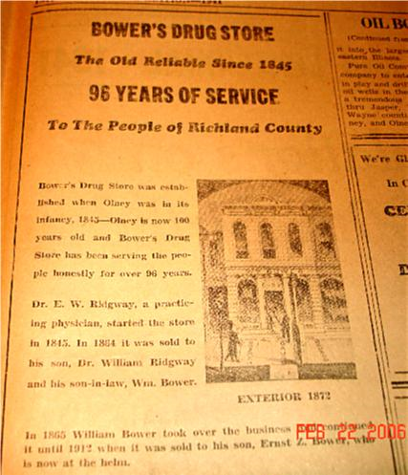
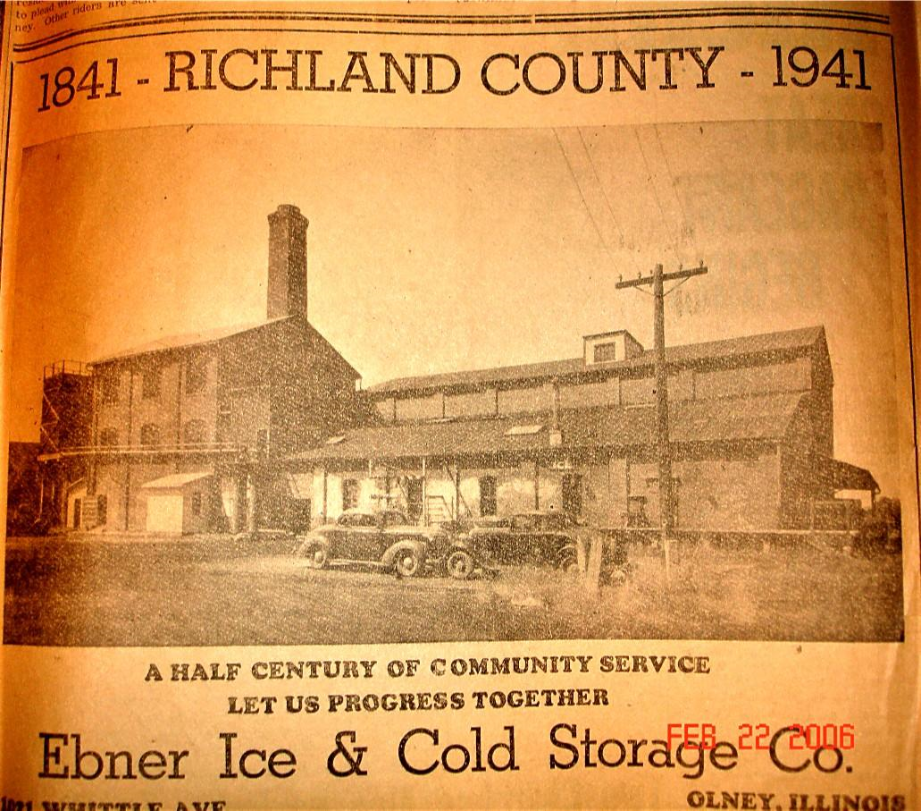
This was located on the West side of South Whittle just a tad south of
Monroe Street.
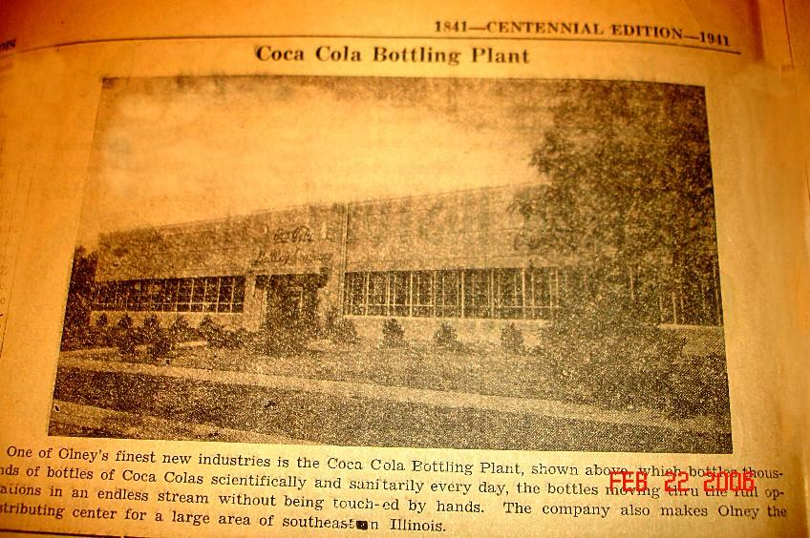

Was located at the intersection of what is now 250 and 130 on the NW corner.

Ann Weesner King
Class of 1960
======================================================================================================================================

