Olney Memories # 141
September 1, 2018
Hi to everyone this first day of September, which reminds us we are moving right along into last part of the year already! More good memories have been sent in for you to read, so kick back, enjoy and remember the good ol’ days of our hometown!
Don’t forget to send me your e-mail changes so I can keep the address list current. Thanks.
Ann King
Pianoann97@aol.com
----------------------------------------------------------------------------------------------------

Roy L Miller
roylm1703@gmail.com
Subject: 1952 Class get-together

Class of 1952 has been trying an informal meeting in Olney every two years on even numbered years. (2017 was our 65th and special). This year we will meet Sept 21 and 22. On Fri evening we will gather at 5:30 in a reserved room at the Holiday. Then on Sat at 8;30 AM, we will meet for breakfast in the salad bar area. Pretty much the same as past years. Anyone needing more info can call Phyllis at 618-395-2460 , who works hard to keep us going this way.
Roy Miller , Joplin, MO
Class of ‘52
-------------------------------------------------------------------------------------------------------

Ron Scherer
rscherer@htc.net

Regarding earlier comments and questions by ODM readers on the Center of Population…
OUR DECADE ON THE NATIONAL STAGE
Richland County can’t claim to be the center of the universe, but for one shining decade, we were the population center of the United States. There was much cause for celebration in 1951, when the 1950 census placed the U.S. Center of Population a bit west and north of Dundas, on the farm of Carl D. Snider.
According to articles in the Oct. 17 and 18, 1951, issues of the St. Louis Globe Democrat, “The town (Olney) of 7,541 and all of Richland County are agog – even more excited than when oil was discovered in the vicinity – and they’re celebrating with dignitaries, parades, speeches and a pilgrimage to the exact spot on the farm of Carl D. Snider that has brought fame.”
The area was eagerly anticipating a large parade and program on Oct. 18, which would attract such dignitaries as Illinois Gov. Adlai Stevenson, U.S. Secretary of Commerce Charles Sawyer, U.S. Census Bureau Director Roy V. Peel, U.S. Senator Paul Douglas (from Illinois), and Indiana Gov. Harry F. Schricher. Even President Truman was invited to this Republican section of Illinois, but he sent word that he couldn’t make it.
The celebration kicked off at 12 noon with a dinner at the Litz Hotel for all the dignitaries. After being hospitably fed, the dignitaries became part of a whopper of a parade headed by 10 high school bands and 25 floats, all witnessed by more than 25,000 excited fans lining the streets. Miss Olney, Angela Kocher, rode on the Olney float, waving to the throngs of people.
“The town of Dundas, Ill., only about 200 in population, and only about a quarter of a mile from the center of things, was at first miffed because Olney held the celebration,” according to a St. Louis Globe-Democrat article. “But they later agreed they couldn’t handle the crowds. They were in good humor today and had a float in the parade. On that float rode farmer Snider, his wife, and their two children, John Robert, 2, and Don Roger, 5.”
And, although President Truman was not present, that did not faze the parade organizers. According to the St. Louis Globe-Democrat, “Olney dug up a substitute that attracted much attention. He is Fred R. Levering, a former resident, who lives in Wallace, Idaho. Levering looks just like the President. He rode in the parade wearing a high silk hat and looking for all the world like a President. There was one essential difference between Levering and Truman, however. Levering is a Republican.”
The parade wound up at the Olney City Park, where Gov. Stevenson served as master of ceremonies. Indiana Gov. Schricher spoke, presumably to shed some oratorical tears of farewell to the center of population after being in Indiana since 1890.
The main speaker was Secretary Sawyer, whose Commerce Department includes the Census Bureau. “The center of population has moved across Indiana and now is in Illinois,” said the secretary. “Then he made a prophecy: The center of population of the United States will always stay in Illinois.”
Richland County could claim that distinction through the decade of the 1950s, but the good Secretary failed to anticipate some upcoming changes. As Alaska and Hawaii became states and the population began to move westward, so did the center of population. The 1960 census declared Clinton County, Ill., at a spot 6½ miles northwest of Centralia, as the nation’s new center of population, and by 1980, it had moved through Illinois and into DeSoto, Missouri, in Jefferson County.
Following the speeches and other formalities, a caravan made its way to the site of the Census Marker, which was erected along the west side of Illinois Route 130, near the southwest intersection with the Dundas/Wendelin Road. Although this wasn’t the “exact” spot of the country’s new center, it was placed in a nearby spot that would offer maximum visibility for tourists and others traveling by on Route 130. Following those ceremonies, people who wanted to be able to say they’ve stood on the center of population could make a pilgrimage up the road to Snider’s cornfield.
So, just how is the center of population determined? The Bureau of the Census has developed a complicated system in which the United States is regarded as a flat plane and everybody in it is supposed to weigh the same. At the point where the plane would balance is the center of things.
The Globe-Democrat declared the hoopla to be the biggest event in the history of Olney. And, during the celebration, “Proud Olneans pointed out that their city is the first in business per capita in the United States, that it is the center of the Illinois oil industry and it represents a large trading center. It is also the center of the red top hay industry and 86 percent of its farms are debt free. The area also leads Illinois in the purchase of War Bonds.”
Being the Center of Population for 10 years provided a great opportunity for Olney and Richland County to show off its colors.

Ron Scherer
Class of ‘62

Peter Weber
peetmd@hotmail.com
Subject: Info about Olney Sanitarium School of Nursing
Hi Ann,
I was able to locate some information for Joyce Vietz about the Olney Sanitarium School of Nursing at the Richland County Historical Society Carnege Museum. She asked for the information in the Olney Memories #140.
Joyce stated that she was in the class of 1949. That was in fact the last class to graduate; the school was closed in the Fall of 1949. The first and second year students were transferred to area nursing schools, most transferred to Decatur. Some of those in the school at the time Joyce was there are: Class of 1947: Dorothy Beadle, Halcyon Fisk, Elfreida Geiger, Betty Knowles, Blanche Milliman, Elizabeth Morrison, Marjorie Preston, Betty Stevenson, Joan Stevenson and Betty Taylor; Class of 1948: Erma Angle, Patricia Brown, Claribel Clodfelter, Dorothea Davis, Mary Diel, Katherine Harding, Betty Kaplinger, Valeta Morrison, Margaret Phillips, Shirley Ragan, Joyce Rayhill, Esther Reiber and Mariam Skinner. Those in the first class to graduate (1907-1910) were Alpha Berry, Mae Copeland, Lottie West, Philomena (Minnie) Weber, Gertrude Reel, Emma Seiler, and Ada Zerkle. I would imagine that Joyce remembers her classmates but if she wants more information on her class, I'd be happy to recheck the documents at the Carnegie Library. I hope this brings some very good memories for Joyce. Many of the women who graduated from that school were true standard bearers, serving in both world wars and in medical missions around the world.
Pete Weber
Class of 63
------------------------------------------------------------------------------------------------------------------------------------------
Ron Scherer
rscherer@htc.net

In Olney Memories #140, I submitted a paragraph that answered some of the questions that your readers have asked about the origin of the May Day activities in Olney. According to research we did while my cousin, Yvonne and I were writing our book, “Before the Big Yellow Bus: Remembering the one-room schools of Richland County, Illinois,” the first May Day activity can be traced back to 1872, when a thoughtful teacher took her pupils on a picnic. From this picnic bloomed the annual May Day Parade.
At the time I submitted that answer, I promised to share information on another “reward” we uncovered that was told years ago by William Bower, the second child born in the city of Olney, He wrote of the following experience at one of the early schools, which apparently happened before the Civil War.
“It was the custom in those days for the pupils to come early on the last day and take possession of the schoolhouse, and refuse admission to the teacher until he had provided refreshments.” (This custom apparently was not limited to Richland County; while living in Monroe County, Illinois, I learned this was also a common practice in that area.)
“On this occasion,” Mr. Bower wrote, “Prof. Smalley, the teacher at this term, promised that he would furnish the refreshments the next day, provided the pupils were on their good behavior.
“Accordingly, the next day Prof. Smalley made his appearance with a couple of baskets filled with apples, ginger bread, maple sugar, brown sugar and a jug of whiskey. The water bucket was filled with a mixture of water, brown sugar and whiskey, and all – big and little – were invited to take the gourd used as a drinking cup, and help themselves. My recollection is that none took enough to show unfavorable effect. It seems impossible,” he wrote in 1896, “that that so short a time back, such a thing could be possible.”
We don’t know if Prof. Smalley suffered any repercussions for offering such a reward, but it is certainly not a practice that would not be condoned today!
Ron Scherer,
Class of ‘62
-------------------------------------------------------------------------------------------------------------
Ann Weesner King
Pianoann97@aol.com

I believe one of the business places in Olney that that has not been mentioned used to be is the Christian Supply. Probably one of the reasons it was missed is because it was not located on Main Street. It was on North Mill Street. Mr. & Mrs. Mason owned and operated the store and it was chucked full of books, records, Bibles, Sunday School Literature, little prizes, and about anything else one could think of as I remember related to things a teacher or people might use related to church work at home or at church. They had children and one of them is Roy, which is in my class of 1960. Wish I could name the others for hate to leave them out. It was a busy place of operation for many years. Below you can see a receipt from where someone made a purchase back in 1966.

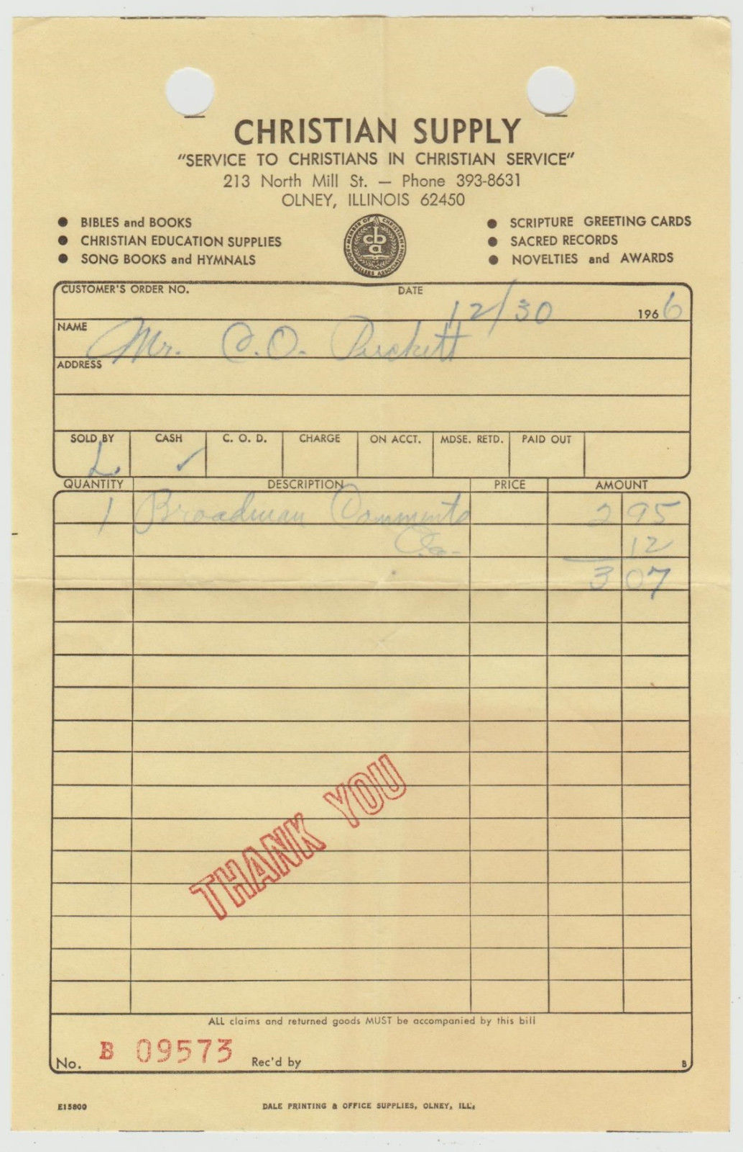
Ann W. King
Class of 1960

Pete Weber, MD
peetmd@hotmail.com
The last issue brought back memories, some of which are a bit fuzzy.
The center of population for the U.S. was just west of Dundas in 1950. Shortly thereafter, the National Plowing matches were held in an area west of Dundas. My folks brought us out there one of the days--summer of 51 or 52. They had a stage out in the middle of nowhere and I vaguely remember this funny lady telling jokes and being downright silly-she was wearing a hat with a big price tag still attached. I do believe Minnie Pearl actually visited Dundas in those days.
David Mitchell, my neighbor on Elliott St remembers playing in the Cummins band in high school. I was lucky enough to be able to play after my Junior and Senior years, but no solos for me. However, I have been playing for the past 25-30 years...somebody has to play the 3rd cornet parts. This summer we had a very talented high school senior, Caleb Thomas, who plays a pretty mean alto sax like David did, and he did a great solo in HARLEM NOCTURNE. The Cummins band has been around since 1870 and is actually supported by a local tax--------those guys don't play for free, but they do all play for the fun of it.I remember some of the players when I was much younger were people like Loren Kent,the barber, who reportedly played in one of Sousa's bands. Merl Newcome, from Fairfield, was first cornet for many years and because of necessity also played baritone. Fred Noerenberg played clarinet for many years--he also started out many of the later players in Jr High. Jim Taylor,ERHS alum and Gus Sliva protege played trumpet and baritone also before leaving the Jasper Co school district, but not before giving Newton a very outstanding music program. Cousin Anne Weber Taylor and Weesie Weber Borah, 2 of Dr Bernard's kids played flute and bassoon respectively--and respected. I also remember the car horns honking after the pieces were done and occasionally before they were done. In the old days, because the concerts began at 8 PM, we often went in PJs ready for bed . Even some of the audience members were memorable. Everyone knew whether cousin Gertrude Gassman approved of the piece in that her stage whisper was a true fff.
For those of you who obviously spent as much time as possible window shopping and building models from Jones' Cycle Shop, as I, should be happy to know that Mr Jones ( Charlie) is doing well.
For Joyce Vietz, the School of Nursing records are preserved and available to examine at the Carnegie Heritage Museum open on Sunday afternoons. You can actually see why Miss Minnie or Miss Katherine gave you an A or a B in bedpan or surgical assisting or dietary.
And the Mayday parades! In those days, Moon Michels had a soft spot for brother Tom, so he provided a float on which Tom could ride in the parade. So that Tom would not be singled out, the rest of my family, no grownups allowed, were recruited to participate on the float which had a circus theme. Tom was a weight lifter, bench pressing prodigiously labeled barbells (500# as I recall), I was a sword swallower with a trick sword whose blade disappeared into the handle and brother Frank was a lion tamer. The "lion" was our English Bulldog Algernon wearing a fuzzy yellow collar. So much for my circus career.
Speaking of parades, the Halloween parade is still going strong. I can remember after the parade, the car dealerships would stay open to show off their new offerings for the next year. One that I especially remember was Landis Chevrolet introducing the new Corvette which came in white with a fiberglass body. My buddies and I thought that a little car with a "plastic" body had a dim future in a jungle filled with huge beasts with 400 cu, inches up front. Just goes to show what we knew in the early 50's.
I will have fun on the 4th..... playing in the Cummins Band. What fun to be able to play with a bunch of real pros like Eric Combs (middle school band), Chris Jones (RCHS band) Gene Hill, Greg Downes, Andy Flynn, Keegan Tucker, and Dean Mounts----too many to mention. Not many folks stay in their cars these days. The bandshell had a restoration last year, and there are sidewalks leading to the benches which are also new. This accommodates the geriatric crowd with their walkers and wheel chairs and younger folks with disabilities. It is a rare and wonderful small town tradition. Memories are still being made in abundance.

Great memories.

Pete Weber, MD
Class of ‘ 63
======================================================================================================================================

