Olney Memories # 120
Feb 26, 2016

Hi Everyone and welcome to
Olney Memories.
Thank you for your help on the email addresses of names that were sent out for help in finding the correct addresses. Not all were identified but some were. Every little bit helps in keeping the list up to date and not getting returned mail when sending out the OM’s.
Ann Weesner King
Class of 1960
-----------------------------------------------------

Harvey Zimmerle
Harveyzimm@aol.com

Walter H. Zimmerle, aka, “Little Walt”
Born: December 20, 1906 Died: February 15, 1989

He was an Illinois High School State competitor in multiple track events. He was known for his electric fast starts in the 50 yard dash and his rapid finish in the 880 yard run. He also participated in the mile run, the 440yd and 880yd relay events

After his freshman year in High School he was Captain of the track team. He was never defeated in the 880 yard run except at the State level where he finished second twice and the National level where he finished second once and third once. It was noted that at the Nationals he beat the runners who had beaten him at the State level.

He won 31 medals in Conference, District, State and National Track Meets.
In 1926 he set a school record running the 880 run in 2:02. The record stood for over 40 years until Paul Weber ran the 880 in 1:59. April 11, 1967

A favorite story was when Walt qualified for the Nationals the second time the competitor who had beaten him at State was not able to participate at the Nationals. When the race was over Walt gave the medal he had won to the runner who was not able to compete that day. That is the kind of person he always portrayed. He was well liked and admired by those who knew him.

In 1942 at the age of 36 he was chosen to escort 26 potential military men to East St Louis for mental and physical exams. He had a stiff neck problem that had bothered for many years. However he was inducted and was placed in the Camp David Military Exchange in North Carolina. He eventually was awarded with a Citation for Meritorious Service by the State of Illinois for having Served Patriotically and Faithfully in the Armed Forces of the USA during WWII. His service was # 36 - 06 -5939

In 1947 he went to University of Illinois and learned the skills needed to join the Soil Conversation Program. The Soil Conservation Service for Richland County was his focus for over 27 years to improving and protect the farm land, waterways and the surrounding environment He loved his work.

He was a Mason of the Olney Lodge, a member of the Modern Woodsmen, the Olney Lodge 140 AF and AM, the Henry Godeke Chapter #38, The W. R. Lashbrook Council #55, and the Gorin Commandery # 14*.

Walter came from a family that lived in the southwest part of town. The environment was equal to any middle class family, but there were obstacles to overcome. He was afflicted with a stiff neck that plagued him all his life. In his later years Walter and his Mary, sang I the Methodist Church Choir until illness forced them to retire. Walter had achieved his goal and made his marks.

*While Mr. Gorin was Grand Master of the Masons, the Commandery organized at Olney, Ill., was named Gorin Commandery in his honor

Walter H. Zimmerle and Aaron Zimmerly were members of the Olney Masons at the same time. It appears that they did not know if they were related.

He tried to help us in WW II

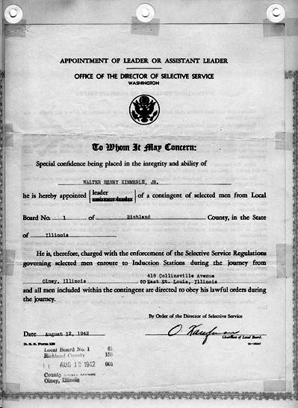
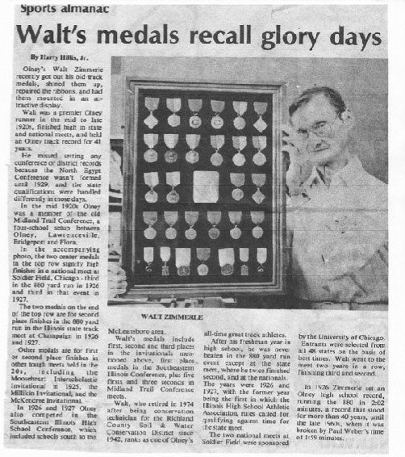
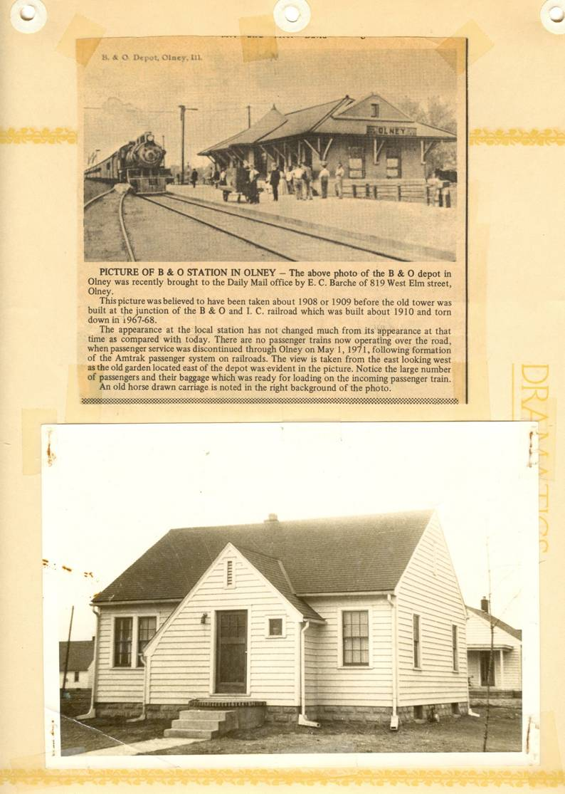
Walt Zimmerlie’s House in Olney
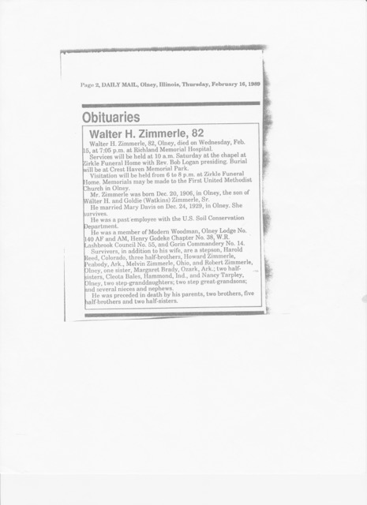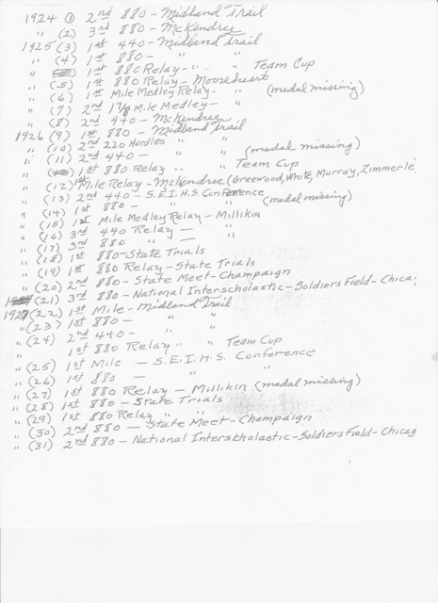

Harvey Zimmerle
Class of ‘58
-------------------------------------------------------------------------------------------------------------

Sandi Kubbs
sandikubbs5847@gmail.com
Ann, the first pizza place in Olney was Luigi's on Main St East of Penny's. I remember eating pizza from there in 1963 or 1964. Pretty good as I recall.
Sandi Kubbs
Class of ‘65

Gary Totten
totten@frontier.com
I asked my Uncle Bob Totten about that house once a few years before he passed away. I think the house was still there in the mid 60’s but I’m not sure. It must have been torn down at some point. I don’t think there is any rubble there and the lot is full of trees and brush. It no doubt became unsafe to enter. My grandparents lived in the last house on West Cherry where he and my Dad grew up. They were born in 1919 and 1924. Uncle Bob said that a well-to-do man and his wife lived there when he was a kid. He said they owned a business or factory in Olney and that they moved out of town at some point during the depression and just left the house. Sounds like a couple of generations had fun exploring it. I recall the neat marble fireplaces in it and the staircase going up stairs. Everyone in the neighborhood called it the haunted house.

I grew up by Taylor's store on Wilson Street and would ride my bike out to the railroad tracks south of the old house to rabbit hunt. Sometimes I would scare up a rabbit in the brush growing up around the house when I headed south to the tracks. The man who owned Taylor’s Grocery was named Ray and his wife’s name was Dorothy. The main cashier was Beulah. She was a tall lady who wore glasses and had a big lump on her index finger. Do any of you remember her or the Taylors?

Gary Totten
Class of ‘65
----------------------------------------------------------------------------------------------------

Marvin Doolin
marvin.doolin.jr@gmail.com
I've been wanting to respond to your call for scholarship stories and finding it difficult to know just where to start. There seems to me to be a much deeper issue here than just scholarships. I don't want to believe there'll never again be a time when more or less average people like me can "work their way" to a college degree, but at the present time it would be impossible to do what I did.

I received two scholarships as a senior at ERHS. One came from the Illinois State Scholarship Commission based on my PSAT scores, I believe, but it was honorary only. The Sputnik inspired National Defense Education Act (NDEA) was in full sway in the early sixties, though, and it paid for tuition which came to $315 for 1962-63, my freshman year at Southern Illinois University, Edwardsville. My not particularly impressive high school grades were high enough for me to qualify, and I signed up. My parents did what they could, but they were in no position to fund my education.

An uncle and his family lived within walking distance of the SIUE campus during that first quarter, and they provided room and board. They had to move around New Years and I found a room with "cooking privileges" for seven dollars a week. I worked for an A&P store at union wages for eight hours a week, netting me about $14 per week, and I pretty much lived on that for the rest of the school year.

I transferred as a sophomore to Illinois State Normal University (a year later it became Illinois State University at Normal) and found another seven dollar a week room (actually a basement with seven other guys) and a twenty-hour-a-week job at another grocery store.

Perhaps the main reason I transferred to ISNU was that Joanne King would be a freshman there during the 1963-64 school year. We were married during the summer of 1964 and learned that our marriage was cause for canceling one of her scholarships. She found a job, and I increased my hours. By the following summer it was clear our first child was on her way, and I went to full time employment at the same grocery store, but they allowed me to schedule my hours around my classes. I received my BA in English in August of 1967, a year and a summer late. Joanne received her BS a few years later at Western Illinois University, and I earned an MA in English there as well.

-- Obviously no one wishes for a return to the Cold War, but I think most of us hope young people who are willing to work can earn college degrees without having to go deeply into debt. I appreciate the opportunity that I had, and I'm very glad I took advantage of it. I wish I could be sure I could do the same if I were graduating from high school this year rather than in 1962. --

Marvin Doolin
Class of 1962

Wanda Rice
ricew118@gmail.com>
About Pizza memories....
I believe Pizza Villa was the first true "pizza" Italian-style restaurant in Olney. I worked there under Mr./Mrs. Whitaker. I had great respect for them; they had wonderful food recipes; I have never tasted better pizza, before or since. I can make them close to taste but not exact. We were making "Kentucky Fried" fried chicken with secret spices...guess the Colonel never knew... even we employees could not know the exact amounts....we did however learn that we needed to keep fresh cut chicken on ice & bread/batter it just prior to the frying. Their sauces ( Pizza & Spaghetti) were just perfection. I miss that! OK enough, I am now hungry...for veggie pizza! Can anyone send some Morel mushrooms out here for my pizzas?? I have to use baby bellas, they just don't have the flavor! We used to go hunt for the Morels in the woods outside of town; they just don't grow in the wild out here.
Wanda (Lomas) Rice
Class of '74

Richard Ray Williams
rrw41@earthlink.net
Both my father and Grandfather Williams, were agents for the B&O Rail Road. Seeing the above picture of my father standing against the depot, or station as travelers knew it, I remember it as one of three or four places in Olney that were important to me as a youth. When I was a grade-schooler and attended Central, we lived within blocks of it and the tower that was also on the location and was the place where both men worked. Then, I’d often walk there to visit with my grandfather or father. I, for example, would take hot rolls fresh from Grandmother Williams to one or the other. Later, when a teen, I would go there to borrow Dad’s car which was parked there. I even have my own experience with the station when I had a part-time job of getting the Olney mail off of trains for the post office.
My father worked all his life for the B&O, really. He dropped out of school in the seventh grade which made grandfather very unhappy. Grandfather, who had a 7 to 3 shift, made my dad get up in the morning, every day, (My Father’s memory) for the next five years and go to work with him – until Dad was old enough to be hired himself. By that time as result of his following Grandfather’s orders, Dad knew every task. He had to have been one of the best prepared B&O employees in history.
As a youth I did not appreciate his skills which included being an excellent telegrapher. I did not know of the history or value of the Morse code. The ability of the local depot operators to keep track of the actual time of train movements was particularly important in the era before the establishment of time zones, when local "sun time" might be different at each station; a miscalculation of the "meet time" of two trains running on a single track could result in disaster. Thus railroad telegraphers played a role in the operation of the railroads that was not unlike the role of air traffic controllers in the modern airline industry; they enabled the trains to run safely and on time.
I did not know that grandfather and father had the same job that young Thomas Edison once had (who also invented an improvement).
I began to appreciate his skills when I had to learn the Morse code as a Boy Scout. I bet he was smiling at my early pathetic keying, attempts to ‘read’ the ‘clicks’ of incoming messages or to send them -- or maybe it reminded him of his youth. The first time I saw him in a leadership position occurred at that time when he gave lessons to us Boy Scouts at troop meetings.
Dad always had that first job for the B&O RR. Decade after decade, until he retired in his 70s, he was, what he called, “A Railroad Man.” When I was in high school, I just saw him on his days off as he working the 3 to 11 shift and would be gone when I got home from school.
One of his “railroad” behaviors that didn’t always amuse me, after we got daylight savings time, was his habit, when asked the time, to use “railroad time” whatever the Olney time. Got so one had to check a nearby clock to be sure of the local time.
When I am in Olney and cross the ‘old B&O’ tracks, I still think of the station on the west side and instantly the empty lot sparks childhood memories.
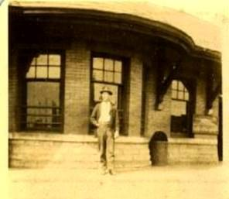
Richard Williams
Class of 196
+++++++++++++++++++++++++++++++++++++++++++++++++++++++++

