Olney Memories # 116
March 16, 2015

HI Olney Memory Readers. What a winter we have been having nearly everywhere. Think most of us will be glad to see warm sunshine, no snow, and we Texans will see some Bluebonnets soon. But I do know, too, there are some who delight in the snow and cold, so I’m glad we have four seasons.
A reminder if you want to be included on the e-mail contact list just let me know and I will add your name to the list.
Remember to keep me informed of e-mail address changes.
Thanks
Ann King Pianoann97@aol.com Class of 1960

Jan Crites jancrites@yahoo.com

The ERHS Class of 1960 Reunion Committee has been meeting monthly, since Oct. 16, 2014, making plans for our 55th class reunion on September 25-26, 2015.

Committee members Lynda (Brown) Wall, John Godfrey, Janice (Teel) Crites, Sharon (Street) Burt, Clarence Smith, & Terry Walker, braved the weather and were present at the February 24th meeting. Several members were unable to attend.

All members are working together to achieve a great reunion, and are hoping for a very good attendance. Class reunions are for sharing old memories, and making new memories!!!

The ERHS Class of 1960 Reunion Committee has been meeting monthly, since Oct. 16, 2014, making plans for our 55th class reunion on September 25-26, 2015.

Committee members Lynda (Brown) Wall, John Godfrey, Janice (Teel) Crites, Sharon (Street) Burt, Clarence Smith, & Terry Walker, braved the weather and were present at the February 24th meeting. Several members were unable to attend.

All members are working together to achieve a great reunion, and are hoping for a very good attendance. Class reunions are for sharing old memories, and making new memories!!!

As of now we are missing only 1 class member from the class of 1960, Jim Rule. If anyone knows his address or e-mail or where he might be, please let me know so we can send him information on our upcoming reunion. Thank you.

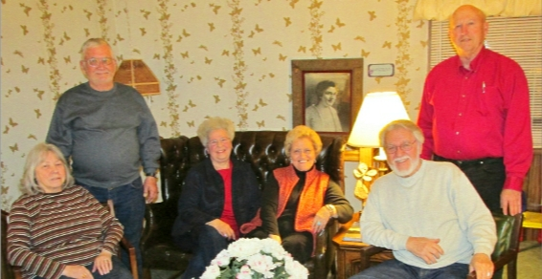
Jan Crites
Class of 1960
-----------------------------------------------------------------------------------------------------------
Ann Hill 33anthill@gmail.com

My grandmother's (Edna and Charlie Webster - he was the pharmacist at Gaffners) phone number at Seven Gables was 15F2 - was a party line and you had to crank it!!!
Ann Hill
Class of ’53
------------------------------------------------------
John Helm
mlehjerhs@gmail.com

When my dad finished his ophthalmology schooling, we moved to Olney in 1949, first living on the south side, on Jasper Street, then later on the west side on Boone Street. Our telephone number was 1076; you'd pick up the receiver, and the operator would ask, "Number please?" We had a private line because my dad was a doctor and a party line would have been inconvenient. Your picture of the old Elks building on Kitchell reminded me that I spent many a Saturday morning at the Elks Theater watching cartoons and old serial westerns. I also remember that the Elks Theater had a wooden floor, and even as a child, I worried that somehow that floor might catch fire.

John E Helm
Class of ‘58
----------------------------------------------------------------------------------------------------

Ann Weesner King
Pianoann97@aol.com

Funny how I can’t remember things of necessity today, but I can remember a phone number that we had when we got our first telephone back in the
Middle 40’s when I had to climb up on the chair to reach the phone to answer it in the hallway. Our number was 567J.

Ann Weenser King
Class of ‘60
----------------------------------------------------------------------------------------------------

David Schnautz
david@clarkfreight.com
As I was growing up in Olney it was hard to believe Olney had such a big motel. Especially compared to the other smaller ones in town. It seemed huge. Often after Church it was the gathering place for our family. Hopefully the preacher didn’t preach too long and you got to the “Holiday” in time to sit in the front room. Or better yet by the fire. The back room was nice but you missed a lot of people coming and going. The Holiday was where I was first introduced to the smorgasbord. What a killer deal for a kid to be able to go back to the “trough” as many times as you wanted. And only have to eat what you wanted as opposed to the dreadful saying “it comes with it”. One can’t forget the various kid rides Ralph had in the back. He was close to having more rides than the city park. And the rocket ship was literally out of this world. My brother and I wore the diamond plate off of the steps over the years.
One can’t forget how if you needed ANYTHING done in the oilfield simply go by the Holiday around 4. It was a who’s who of oilfield big shots. And yep…just go to the bar. That’s where the big decisions were made. I am glad to see the Holiday is trying to make a comeback.
Thanks to Ralph Beal for the memories.

David P Schnautz
Class of ’82 (if we hadn’t moved to Texas)
===========================================
============================================

