Olney Memories # 109 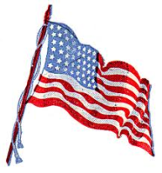 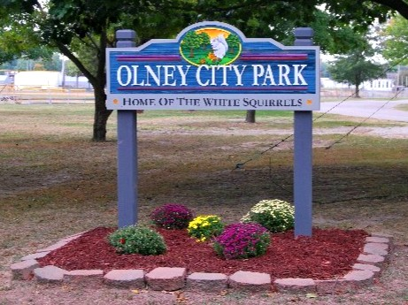 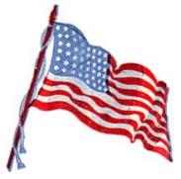
July 1, 2014

Happy 4th of July to Everyone! Keep sending your memories in for everyone to enjoy….by sending them to pianoann97@aol.com. Please also remember to send me e-mail address changes so your name and address will remain current on the mailing list.

A  Richard Williams for always doing whatever it is that he does to the photos that make it much easier for you to receive them.

Also another my husband for often helping me do certain things that help me get out of “jams” when putting these Olney Memory issues together…. ….

Ann Weesner King
Class of1960
Pianoann97@aol.com

Class of 1950
64th REUNION of ERHS CLASS of 1950
We are planning a 64th reunion for the ERHS Class of 1950 on the evening of...
Friday, September 26, 2014
This will be a reunion to meet and talk about old times. There will be no formal atmosphere and the meeting will be held at The Olde Tyme Steakhause in Olney.
You are asked to phone Olde Tyme Steakhaus (618-392-3663 or e-mail to make dinner reservations for the “Class of 1950” room.
We will order from the menu and they ask for reservations to be made 2 weeks prior to the meeting.
There will be a social at around 4:30 p.m. or so.
And we will have DOOR PRIZES for several lucky people.
We will have dinner around 6:00 p.m.
This invitation will be sent via e-mail, TAC, OLNEY MEMORIES and word of mouth. So please pass on this information to other classmates that we might not have e-mail addresses for.
Hope to see you there.
PEGGY CARSON
DON WATSON
WAYNE BATEMAN
JERRY SCHERER
BILL MAY

Marilyn Nelson Brock
marilynbrock@nwcable.net

Did I miss seeing Bowers Drug store on Main St. on here? And above it was old Doc Murray’s Office. I remember him so well as he had a big thing on his lower lip and as a young girl I wondered why on earth he didn't remove it , it looked awful . And Jupiter's clothing store on the corner east across from the First National Bank !

It was either Murray or Murphy maybe someone will remember the big what ever it was on his bottom lip ?? Also up above the Gaffners store as a kid there was a dentist office I went to,….? Does anyone remember what Dentist that was?

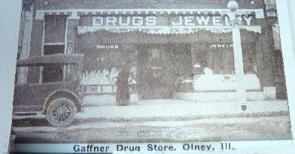

Marilyn Brock
Class of ‘56

Gloria Dean
gedean7352@yahoo.com

As usual loved it-- especially the clothesline and the stick to hold it up Remember it well.

Gloria Dean

---------------------------------------------------------------------------------------------------------------------

Peggy Long
peggylong@roadrunner.com 
Hi Ann,
I enjoyed reading the washing machine & clothes line procedures. The clothes line do’s and don’ts were ALL so true. NOW that dates me doesn’t it LOL

Peg Long
Class of (1955)
In God We Trust

Sue Turpin Engle

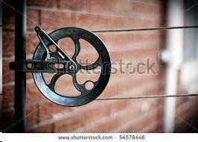

Suekissnaranch@aol.com

HI Ann,
Just read the article about the clothesline. I still use mine. Clemen fixed a pulley- line from out deck (second story) to the top of our boat barn. It is high enough to put king sized sheets on it and still drive under them without touching. Here in Utah during the summer when the temp. is 100 and the humidity 10, it takes about 15 minutes for the clothes to dry. Sure love my clothesline!!!!!

Sue Turpin Engle
Class of 1960

Gail Herrin
herringaile@gmail.com

I loved Olney Memories #10, especially the wash day memories. I had a square tub Maytag washer with wringer. 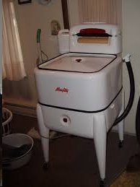 I really liked wash day from spring to fall. Not so much in winter when your hands froze hanging clothes out to dry. BUT I HATED IRONING clothes for seven people. Usually I would have a whole basket full of dampened, rolled up clothes to iron. That was a real chore for me.
You had to wear a coat with deep and warm pockets.
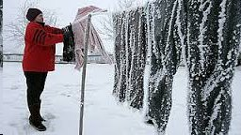
Hang one or two items in a hurry, and stick your hands in your pockets for a short time. It took a while to hang the wash believe me, if you were able to guess just right, you could take the clothes down when the worst of the water was frozen out but not totally dry yet and then you did not have to dampen them, just roll up to iron. It saved time to not have to dampen again. Yes, and in the very worst cold I did have lines up in the living room and kitchen. The kids loved it and my husband hated it. One thing I might add, the reason the kids liked the clothes hanging in the house, they would hide behind a towel, sheet, etc. and try to scare someone. I did have to tell them to quit playing in the clothes, frequently.
Gail Herrin
Class of ‘51
----------------------------------------------------------------------------------------------------------------------------------------
Ron Scherer
rscherer@htc.net
Hi Ann,
This message is not to submit my memories to OM, but to possibly seek your assistance in asking for specific memories from OM readers.
For nearly two years, We have been researching and writing a new book on the early schools of Richland County – specifically, the one-room schools in our history. My cousin, Yvonne Scherer Meckfessel, is assisting me with the writing and research, and ERHS alumnus Don Wilson, is assisting with the collection and scanning of photographs. We are approaching the downhill stretch, but we are making one last request for anyone whose family members may have attended or taught in the early schools to submit any written text or photographs they might have of those early days. We would sure hate to leave anything out of the book that might be available to us through a simple request. We still have a couple of schools for which information is sketchy.

If OM readers have anything they would like to submit, they can reach me at rscherer@htc.net, Yvonne at pagewriter405@yahoo.com, or Don at donwil90@sbcglobal.net.
If you think this fits within the mission of Olney Memories, we would appreciate any assistance you can give us.
Thank you.
Ron Scherer
Class of 1962

Ann King
Pianoann97@aol.com
Some of us have reminisced about our art classes in junior high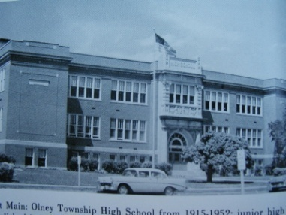 that were taught by Mrs. Mary Lou Brown of whom we thought so much, both then and now. I want to share a picture of some cuff links which I still have that I made in her class under her skills and guidance when I was in the 7th or 8th grade. I wore them in both junior high and high school whenever we were required to wear our band uniforms. Thank you, Mrs. Brown, for being such a wonderful and loving teacher to all of us….

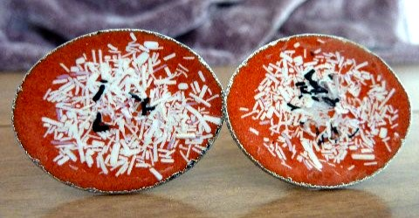
Ann Weesner King
Class of 1960
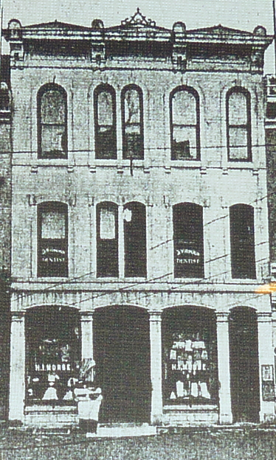 Morse Dry Goods Store
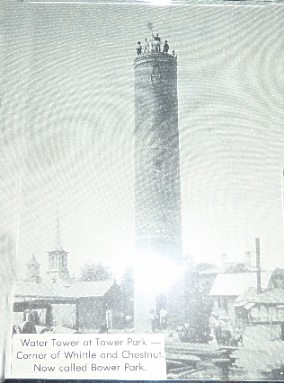

Water Tower at Tower Park-----Corner of Whittle and Chestnut
(Now called Bower Park).

;

Olney Main Street of Yesterday….. 
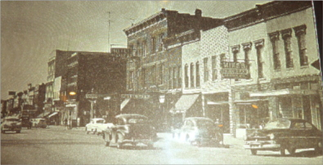
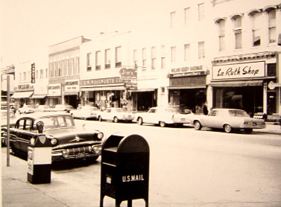
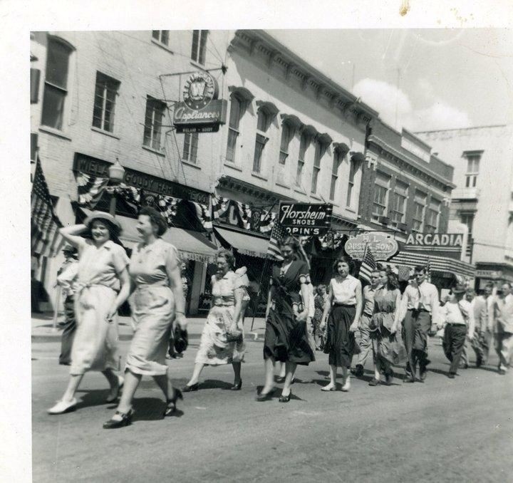

City Directory of 1948 ….Frances Richey & Eva Fessel
- - - - - - - - - - - - - - - - - - - - - - - - - - - - - - - - - - -

100 W. Main Kroger Co.

104 W. Main Wayne Restaurant

104 ½ Main Oil Well Supply

108 W. Main Harrell Plumbing & Htg

109 W. Main Court House

110 W. Main Jimmie’s Tavern

202-204 W. Main Godeke Auto Supply

203 W. Main Mark Hanna’s Service Station

205-207 W. Main Day Produce Company

208 W. Main Newton Barber Shop

217 W. Main Prairie Farms Creamery

221-23 W. Main Borah, Halman Motor Sales

228 W. Main Mike’s Ice Cream Parlor

230 W. Main Richland Co. Farm Bureau

100 E. Main Ethele Shoppe

101 E. Main First National Bank

102 E. Main Oases Tavern

201-03 E. Main Murray Hardware Store

105 E. Main Max Bloomburg Shoe Shop

202 ½ E. Main Sherman’s Dept Store

204 E. Main Propis Agai Store

205 E. Main Robb’s Coffee House

205 E. Main Nina Wagner Ins. Agency

206-210 E. Main Tressler’s 5 & 10 Store

211 E. Main Schnell’s Jewelry Store

211 E. Main Veteran’s Café

212 ½ E.Main Null’s Studio

212 E. Main Janet Shop

213 E. Main Wilson’s Radio Service

215 E. Main Tiny Tot Shop

216 E. Main Musgroves Men’s Ware

217 E. Main Maas Market

218-220 E. Main Woolsworth (5 & 10)

219 E. Main Loren Kent Barber Shop

221 E. Main Abegglin Bros. Furniture Store

222 E. Main Goodman & Harris Men’s Bugs Clothing Store

221 E. Main Willand & Goudy Hardware Co.

225 E. Main A & P Grocery Store

227 E. Main Rexall Drug Store

228 E. Main Hovey’s Ice Cream Parlor

229 E. Main Peper’s Hardware Store

230 E. Main Arcadia Theater

230 E. Main La Ruth Shop

232 E. Main Fulgum Bros Appliance

233 E. Main Bond Drug Store

307 E. Main Anneda Baby Shop

302 E. Main J C Penny

304 E. Main Kennys Café

301 E. Main Star Grocery Store

305 E. Main Polly Prim Hat Shop

306 E. Main Olney Bakery

310 E. Main Blue Ribbon Tavern

311 E. Main Montgomery Ward

317 E. Main King’s Furniture Store

====================================================================================================================================

