Olney Memories # 104
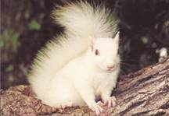
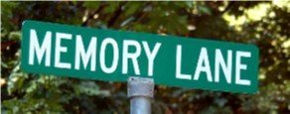

September 12, 2013

Welcome to issue # 104! Hope everyone has had a nice summer and is anticipating a nice fall season. There are quite a few class reunions coming up the end of this month….be looking for some pictures and comments from these reunions in the next issue!
Ann King
Pianoann97@aol.com
Class of ‘60
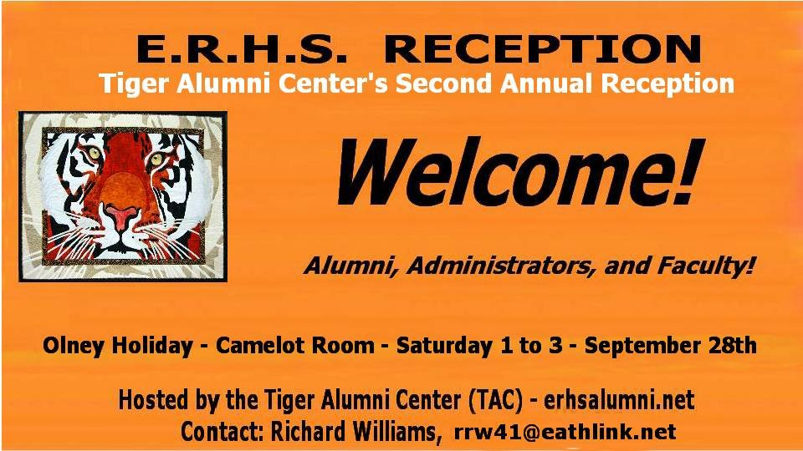

Second Annual Reception
The Tiger Alumni Center, an alumni organization for ERHS, welcomes all alumni and teachers to its second annual reception, at the Olney Holiday Motel, in the Camelot Room from 1:00 p.m. to 3:00, Saturday, September, 28, 2013.
The purpose of the reception is to give all alumni, teachers, and administrators an opportunity to enjoy a convenient and free “meet and greet” event. A special feature this year will be our presentation of “Honored Guests.” These very special Olneans are receiving our “Tiger Alumni Center’s Lifetime Achievement Award.”
Our presentation is a “Bridge Across Generations” which is intended to present people who are an inspiration and who have served OTHS and ERHS faculty and students for a lifetime.
We will be announcing their names soon in our TAC website – erhsalumni.net.
We TAC administrators do realize that many of you live far away and cannot make our reception. Perhaps you can share this news with ones who can. Thank you!
The Tiger Alumni Center is a three-year-old alumni organization with 1,400 members serving the alumni of the East Richland High School. It is our goal to connect faculty and alumni of OTHS and ERHS, both classmates and teachers from across the generations.
Richard Williams, Founder
-------------------------------------------------------------------------------------------------------------
Bud Varner
covarner@hotmail.com
Roy Miller from the Class of 52 responded that Roger Taylor was the name of the manager at Prairie Farms that my Dad would talk to. I can picture him, because when I was 9 or 10, I sold Grit Papers on a route and he would buy one from me at the creamery each week he was there.

Bud Varner
Class of ‘66
Judy Winn Brown
jdyrb1943@gmail.com 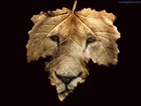

Hi Ann,
I'm always so glad to read about the goings on of years past. They are so interesting. I just lived in Olney my senior year in H. S. I have many good memories.

Thanks,

Judy Winn Brown
Class of ‘62

PS. (from Ann) Judy’s dad was Pastor at the United Methodist Church on Elm St. when Judy was a senior in High School.
-------------------------------------------------------------------------------------------------------------------------------------------
Ann King
Pianoann97@aol.com

I’m curious as to how many people know what this is and the location of this landmark? If you think you do please take a moment to let me know. I’ll give the answer and how many people knew in the next issue of Olney Memories.
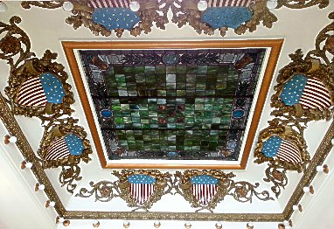
Picture taken this summer by my daughter---Debbie Schnautz

Ann Weesner King
Class of 1960
Linda Schaub-Nace
nacelinda4@gmail.com

I've read on your "Memories" site, stories about my grandparents that I had NEVER heard before!!!

My mother was Suzanne Gassmann...daughter of Louis H. "Tubby" Gassmann and George Ann. They owned the "Town Talk" ice cream parlor on Whittle Ave.

My father, Robert H. Schaub, was the son of Orville and Florence Schaub, both of whom owned the "Schaub Funeral Home " on Chestnut St.

In your latest email, you mentioned my "Papaw's" carmel corn. Unfortunately, all of his recipes were left to my aunt, Caroline Gassmann. She died at a relatively young age and I "lost touch" with her two sons. However, I have found a "close substitute": "Poppycock". Mom and Dad used to buy it when we were kids, but I had forgotten about it until about 5 years ago. I have found it in stores around the holidays, but I see that you can also order it online. The original company was bought out by "Orville Redenbacher". The "Original Recipe" is the one to get...It tastes SO much like what we remember, but with the addition of pecans and almonds. (no complaints there)

Amazing, that you Ann knew Mom, Dad and "Gramps" through the funeral home...you were very lucky to have played the organ there..."we kids" were severely "chastised" each time we turned it on and began to play...On holidays, the adults let us go downstairs, into the chapel, where "all hell broke loose". We pushed one another, at high speeds, on the rolling "bier" (I think it's called)...
it's the rolling "base" that the casket is placed on for funerals. However, there were no brakes on that "vehicle"...it was like a bobsled. Needless to say, we "crashed" into every piece of furniture, including the organ! We really did try to avoid hitting it; we KNEW that the organ was a highly restricted zone. Maybe THAT'S exactly why we were drawn to it!!

We 10 "Schaub cousins" turned that huge chapel into an Olympic stadium...Another event was the "high hurdles". We arranged the empty "flower stands" in a line and attempted to jump them.
I really doubt if there were many winners...those stands must have been 3 feet tall !!

I still think I remember the "start-up" sound of that organ, (when we dared to play it)...Wasn't it a loud (and scary) vacuum sound?? The adults, who were upstairs, (laughing and talking) didn't always hear our "music" right away...Our repertoire included "Heart and Soul" duets and, of course, "Chopsticks". Within minutes of our opening number, Dad would come running down to the balcony SCREAMING, "get off of that organ !!!"...I really don't think that we ever understood what was so "precious" about that organ. So, that's why I say that you were VERY lucky to have "free-reign".

Please accept my gratitude for creating a "place" where we can refresh the memories which are the dearest and the deepest. You are a historian...one who cares about what "once was".

-------
P.S. I love your postings of Olney Memories...we were all SO lucky to have grown up there.
I've considered moving back there for my retirement...though, it could never be the same...of course, and unless EVERYONE moves back there....We could re-create it, based upon our collective memories...wouldn't that be perfect?
Sincerely, Linda Schaub-Nace
Class of ‘65
----------------------------------------------------------------------------------------------------

From Ed Iaun - living near Mexico City
ediaun@gmail.com

Probably most of you know all this didn’t know about the State Fair Did know about Lincoln Douglas talks and DR Rip Anderson Great Grandfather wanted to duel Abe in Lawrenceville and Abe said we will use Calvary swords in 6 ft of water everybody laughed cause he was only about 5ft 6 Rip was my boss at Good Sam Hospital his Dad and Grandfather were also Doctors His cousin Dr Bill Anderson Rip and myself were going to see a patient and we went by a new Ice machine and Bill said look Rip that ice cube is round and has a hole in it that new Rip said hell I been Married 30 years to one of those !!!! Ha he was a Corker and great Surgeon and Boss Gramps Ed s Dad was in the Union Army during the Civil War some of Olney were put with Pana part of the to Calavary that went South they made a movie about it called the Horse Soldiers with John Wayne and Dee Brown wrote a book about it Graingers Raiders ???
----------
History of Olney below

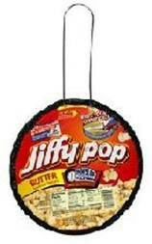
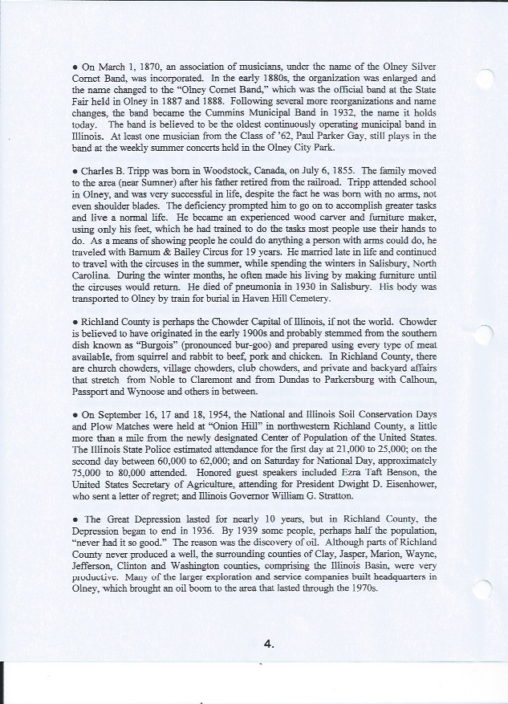
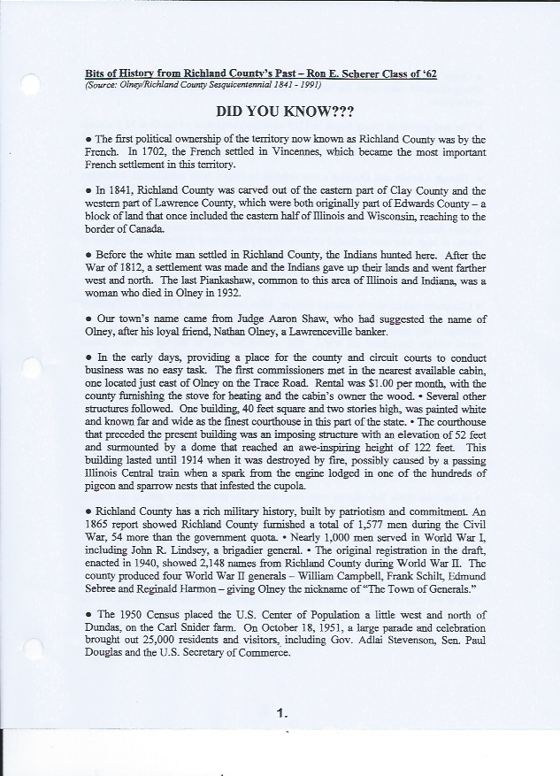
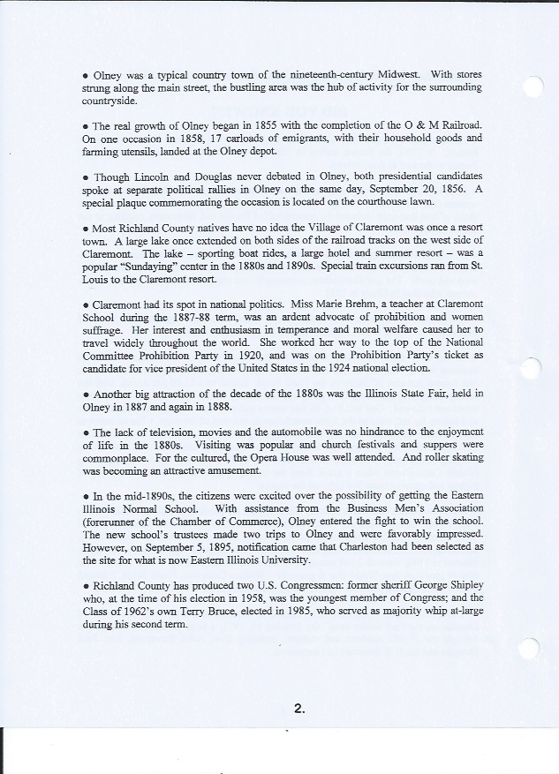
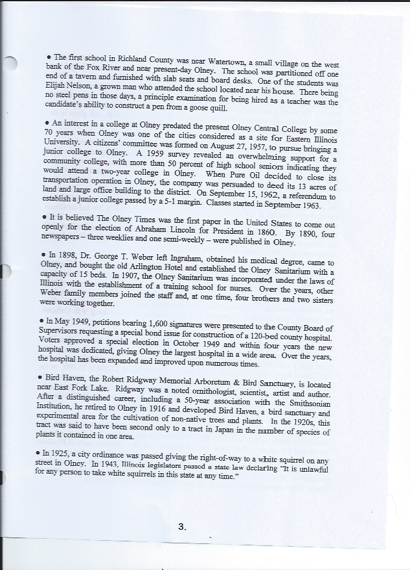
Submitted by: Ed Iaun
Class of ‘57
----------------------------------------------------------------------------------------------

David Schnautz
david@clarkfreight.com
Hello all,
The scratch pad shown below from the Olney Trust Bank is self-explanatory. I don’t have much info on that subject. I remember them being around but that’s about it.

The little black book is from J and H communications. I do know something about this subject. J and H stood for Joyce and Harold Michels. Joyce was a school teacher at Central school. I can’t remember which grade but I am going to guess 3rd. I wasn’t in her class. Harold was the Son of Mike Sr. who owned and operated West Mikes, the “other” famous hamburger joint in Olney.
Rumor has it that Harold Jr. hated the restaurant business and vowed to get out of it when his Dad was unable to operate it any more. That day came and Harold opened up a CB (citizen’s band) radio shop in the old restaurant. As I remember he was one of 2 CB shops in Olney that sold them, other than places like Radio Shack.
J and H would work on the radio and other components for maximum reception and transmission. All of this happened at the time of the big CB craze about 1973. Harold’s CB business was in a good spot, being just across the street from Prairie Farms where the trucks would unload, a quick and easy walk across the street. Harold gave out little books like the one shown below to make notes in and keep track of other people you communicated with—just another little “giveaway” piece of the past.

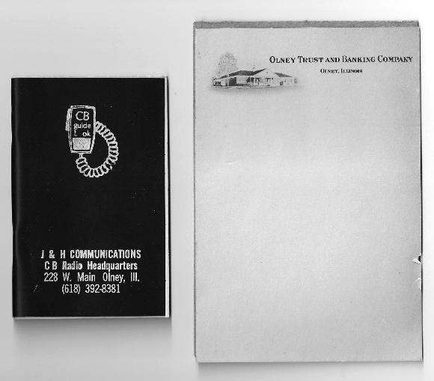

David Schnautz
Would have been Class of 1982
(if we had not moved to Texas)
----------------------------------------------------------------------------------------------------

George Roth
Groth2@nwcable.net 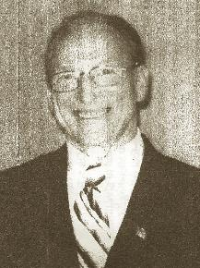

This is a condensed version from a paper I (Ann King) was given in reference to George Roth who is the third of five generations to be members of the Knights of Columbus. George has helped with many things in and around Olney for a great number of years….so I’m writing a few memos from the sheet about his contributions to the town of Olney.

George joined the Knights of Columbus in Olney on 12-1-1954 at 19 years of age. On 7-1-55 he was elected Deputy Grand Knight. On 3-1-56, he joined the fourth Degree. On 5-4-56, he was chosen Outstanding Knight of the year. On 7-1-56, at 20 years old, he was elected Grand Knight by 577 members. The council was in suspension, the club and bar were in debt. George had many money raising event s and in just two months the council was back in good standing. In six months, all the bills were paid. George started a teen center in the K of C Hall in Olney. In a short time, they had over 200 teen members which was a great asset to the teens at this time.
George made a commitment to serve his community. He worked to improve the quality of life in the area and fostered patriotism. His perseverance and strong work ethic was instilled in him by his parents as he grew up on the family farm, the youngest of 5 children. He graduated from St.Joseph’s Catholic Grade School and East Richland High School in Olney. He was employed in many areas….one being the well- known Mikes Ice Cream Parlor. He volunteered two times each month for over 3 years as activity director at Richland Memorial Hospital. He delivered meals on wheels over 2 years and distributed food and clothing to the needy. George is a member of the Disabled American Veterans, American Legion and likes to visit veterans in the hospitals.

He considers it a great honor to be nominated to the Springfield Diocesan Chapter Hall of Fame.

George Roth
----------------------------------------------------------------------------------------------------
Sam Keiffer
skeiffer@q.com

In reviewing the 1908 high school annual, I noticed several names the perked my interest. Board member D. Z. Vernor was married to my Great Aunt Caroline (Carrie as she was known to everyone), was my Great Grandmother Anna McLean's sister. I meant her several times when visiting GG (as Anna was known to us kids) before we moved from St. Louis. The other names were the Vernor ladies, Margaret, a Senior and Kathryn, a Sophomore. Margaret married Dr. O. C. Borah and they lived in the big house across the street from St. Joe's school. Cousin Margaret opened her home 48 yrs ago to my then "wife to be" and 2 of my sisters to spend the night before our wedding and to prepare for the wedding the next day and that way they only had to walk across the street to St. Joe's. One note of humor on this was Cousin Margaret had to admonish the 3 young ladies late that evening (10PM??) to be quite and go to sleep. I guess that happened several times.

Sam Keiffer
Class of 1960
============================================================================================

