Olney Memories # 144
June 4, 2019 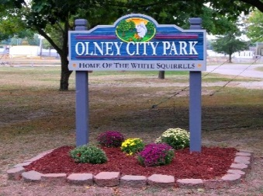

HI Everyone from Olney, those who now live out of town, and all of you who are interested in the memories of Olney. That takes in a huge portion of the OM’s e-mailing list. I was mentioning to someone the other day that I wonder how many of you know that the Olney Public Library on West Main St. has all the copies from # 1 to the current issues in their Library? Isn’t that great! A huge thank you goes to them for doing this! Also the last time I checked the Olney Museum, which is in the Old Carnegie Library on Main Street, they also had all the copies in their museum. I hope someone is keeping up with all the current issues there. Does anyone know if they are?
Here we are entering the summer months again with memories from “School is out for the summer”, and all the antics we got into on our free summer days and swimming in the pool at the Olney City Park. Seems many or most of us spent lots of time in that ol’ swimming pool that is now sadly covered in with dirt and green grass layered on top instead of the blue chlorinated water. Doesn’t seem quite right does it? So many memories that only remain in our minds now, the high dive, the unique wading pool which was sometimes called the baby pool, a place where we could meet our friends all summer long. I have no recollection of this but I have been told on the rooftop of the brick pool house dances were held in the summer months! What fun that must have been back in the 40’s. Maybe someone reading this can tell us more about that? Another place that is no longer in service now is the Arcadia Theatre! Wow, who would have thought that would have not always been open. Also what about those warm summer evenings at the Drive-In Theatre on the West side of town. Happy times at all these places in the summer months that no longer exist and the youngsters of today don’t even knew they existed and have memories of these places like we

do. Memories…..memories…………..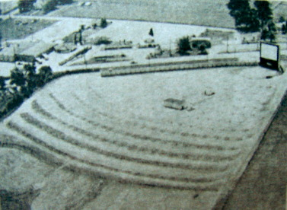
Olney Drive-In Theatre (probably in the 50’s)

Please remember to keep me updated if you have email address changes so I can keep your addresses current. Let’s read about some of your summer memories of the past!!

Happy summer to everyone.

Ann Weesner King
Pianoann97@aol.com
Class of 1960

----------------------------------------------------------------------------------------------------------------
Dale Summers
dale33870@aol.com
Dear Ann,
Your OM Memories brought many memories to mind for me. My Father, A. F. Summers, also worked as a telegrapher at the tower described in OM 143. He held down the 3-11 PM shift. I spent many hours activating the track-switching levers in the tower. Of course Dad always made sure that the switches were in the proper configuration so as not to sideline the wrong train or to possibly even derail a train if it were going too fast. When the position of passenger/freight agent opened up, Dad bid on the position and was accepted. (Seniority got him the position.) He moved into the depot shown in the photo.
It might also be noted that the telegrapher was also the Western Union operator when the WU office was closed. If you wanted to send a telegram after 5 PM, you gave the message to the B&O telegrapher.
Another task he performed (and I enjoyed watching) was when he passed orders onto the conductors of freights. The message was attached to a circular string which was then strung onto an extended "vee", making it look like a three-foot high "Y". Dad would stand by the track on which the train was traveling and extend the contraption upward so that the conductor could loop his arm through the "vee", thereby retrieving the order. How 'bout that
Again, Ann, I do so enjoy the OMs and thank you for bringing them to us!
Dale Summers
Class of ‘47
----------------------------------------------------------------------------------------------------------------

Roy Ed Doolin
roydoolin@hotmail.com

When I was about six, I took a wheel off my wagon, planning to attach the wheels to a board to make a “car.” When I pulled the first wheel off, I learned about roller bearings. The bearings fell in the dirt but I found them all. When my dad got home, he cleaned the bearings up and put the wheel back on while I watched.
In 1955, when I was nine, I heard about the Olney soap box derby race that was being planned. I decided to enter. My carpenter/mechanic skills were pretty limited. I just had the general idea of attaching wheels to a board. I hadn't learned much between six and nine.
My dad decided to help me. Dad taught me how to use a square and handsaw to make a straight cut, how to drive a nail without bending it and how to use his huge ½ inch electric drill. The race car frame was a wooden 2x12 with 2x4's supporting the steel axle shafts. The back 2x4 was nailed to the 2x12 and the front one was attached at the center with a bolt so it could turn. The car was steered by ropes attached to the ends of the steering 2x4, one rope in each hand like the reins on a horse.
We went to Nix Brothers Ace Hardware and bought some ball bearing wheels so it rolled very well. Then we got fancy. We built a seat with a back out of plywood and built a brake out of a board that rubbed on one back tire. A neighbor sold me a 1940 Ford car steering wheel with a steering shaft attached for 25 cents. I drilled holes in some 2x4s and attached the steering wheel to the car. I ran the ropes through pulleys and attached the ropes to the steering shaft. When I turned the steering wheel, the rope wrapped around the shaft and steered the wheels. The problem was that I had to turn the steering wheel about 6 turns to steer the wheels. My dad's solution was to attach a gallon paint can to the steering shaft and attach the ropes to the can so the ropes wrapped around the can. That made it steer more like a car.
It didn't look much like a car. It needed something in front. My dad got a 10 gallon barrel and fashioned it into a grille and hood. I painted The car red and silver, thinking the silver paint looked like chrome.
My brothers and I pusher the soapbox derby car to the South East Street overpass, the bridge over the B&O railroad. My dad walked along with us. There were quite a few homemade race cars there. Each one was different but all were colorful. The Olney Junior Chamber of Commerce had built a huge wooden ramp at the top of the overpass. It had a board that held two cars in place. The board was hinged so a man could move a lever to release both cars at the same time. When it was my turn, my car was pushed up the ramp along with another car and the board was raised to hold the cars in place. I climbed on to my car. Boy that was high up there. I rode it to the finish line. It felt like it was really fast. Every car made several runs. I won some and lost some and was finally eliminated. I did not win any trophies but I really had fun. All of the cars were fairly crude like mine that first year. I raced again the second year and was eliminated very quickly. Many of the cars, the second year, were made from very expensive parts. One even looked like the ones I saw in Popular Mechanics Magazine, that the National Soap Box Derby Racers competed with. I didn't go back to race the third year. I just went to watch. The official Soap Box Derby racer was back. One kid raced a go cart without a motor.
My brothers and I pushed each other all over the neighborhood in that car for several years. It broke and we fixed it and pushed it some more. I thought about putting a lawn mower motor on it but never did. We finally all outgrew it and gave it to a neighbor kid. All in all this was a great learning experience. Olney was a great place to grow up.

Roy Doolin
Class of ‘64
---------------------------------------------------------------------------------------------

Rich Wilson
rdw30296@yahoo.com

HI OM Readers,

Fresh Oil Loose Gravel: Collected Poems

 | Fresh Oil Loose Gravel: Collected Poems  Major Ragain- simultaneous man & poet, husband, father, teacher of poetry and heart to students at Kente State. ...

Actually, there are several published titles by Maj Ragain -
https://www.amazon.com/s?k=maj+ragain&i=stripbooks&ref=nb_sb_noss

From Maj Ragain's April 19, 2018, Cleveland Plain Dealer published obituary:

Kent poet Maj Ragain died in his home on April 19. He was a loving son, husband, father, and grandfather. He was loved as a teacher, friend and an inspiration to thousands of students, writers, and veterans throughout Northeast Ohio over the last 40 years.

Major Dan Ragain was born in southeast Illinois farm country in Olney, Illinois, September 15, 1940. He grew up along Olney's Vernor Lake, to which he returned yearly throughout his life.

He received his BA at Eastern Illinois University ('62), an MA at the University of Illinois ('63), and earned his PhD in Literature at Kent State University ('90).

He is the author of seven chapbooks of poetry and five book-length collections, including Clouds Pile Up in the North: New & Selected Poems, published by Press 53 last fall. Maj began teaching at Kent State University in 1969 and taught continuously since the early 1980s, leading his last writing class in the fall of 2016.

Maj served for thirty-five years as host to open poetry readings in Kent, hosting his last reading less than a week before his death. He also hosted the annual Jawbone Open Reading (which will go on, this May 4, 5, and 6 in Kent).

And as part of the Wick Poetry Center Outreach, Maj weekly gathered a group of veterans who wrote to and for each other, an encouragement in the healing art of language.

Maj's poems and his full-hearted work in the Kent community expressed his own deep connection and compassion for others.

Maj was preceded in death by his mother Beatrice Lucile Summers, father Daniel Wayne and brother Michael Wayne. He is survived by his wife LuAnn Csernotta, son Sean Kelly, daughter Megan Ryan, and grandchildren Liam Michael, Riley Danielle, and Abby Aileen.

Maj will be memorialized in Kent on the first weekend in June: On Friday, June 1, the Downtown Gallery will open an exhibit of poetry by Maj and paintings by Jessica Damen, titled, "Home to the Sargasso Sea."

On Saturday, June 2, a memorial service will be held at the Kent United Church of Christ at 1 pm, followed by a reception at the church.

And on Sunday, June 3, at the Kent Stage at 2 pm, all can gather to celebrate Maj's life with open readings of his poetry, along with music by The Numbers Band.

Major Ragain - simultaneous man & poet, husband, father, teacher of poetry and heart to students at Kent State. Born down soul in the farmlands of east central Illinois, he's covered the mountain of this world as a shepherd with many the trail and many the tongue of a story passed to the ear and many a poem drawn from the well of Pan...

Bottom Dog Press, Inc. - Remembrance of Maj Ragain

Bottom Dog Press, Inc. - Remembrance of Maj Ragain
﻿One of the most beloved members of the Northeast Ohio poetry community passed on April 19, 2018 at the age of 7...

Rich Wilson
Class of ‘68

Sue Rice
Is_rice@mindspring.com

Hi Ann,

I loved the last poem in OM # 143, and I am in so much agreement with it, even if I graduated in ‘74 it is still the way I remember growing up when I was just a kid :-)
It definitely brought back some memories :-) And, all good ones, too.

L. Sue Rice
Class of ‘74
-----------------------------------------------------------------------------------------

Roy Doolin
roydoolin@hotmail.com
Does anybody remember Bill Gaither working at WVLN radio? Probably in the 50's.

Roy Ed Doolin
Class of ‘ 64
-----------------------------------------------------------------------------------------------------------------

Curtis Stoltz
iam777iam@gmail.com
Hi Ann,
Thanks for your diligence on keeping Olney Memories story rolling along, a hats off and grand honors from my patriot encampment along the Mid Hudson river valley where speeding passenger trains echo every half hour from the Chelsea Hamlet of Wappingers Falls,NY, ocean ships troll up and down, much of the first families of Dutchess county of the American Revolution still stir among us ...it brings memories alive to hear where we grew up is no different from our forefathers defended our first freedoms along the great corridors patriotism
Curtis Stoltz
Class of 1973
-----------------------------------------------------------------------------------------------------------
Ann King
Pianoann97@aol.com
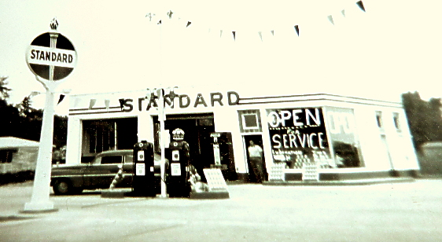
I believe this was on East Main close to the Old Library and East Side Hovey’s, but if someone knows that this isn’t correct, perhaps they could give me the correct location.
Ann King
Class of ‘60
========================================================================================================

