Olney Memories # 94
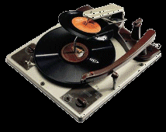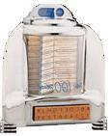

June 11, 2012
Hi Everyone,
We welcome our new Olney Memory members that have joined us!
Please remember to let me know when your e-mail address changes
so I can keep your address updated. Keep sending your own memories……..:☺

Ann Weesner King
Pianoann97@aol.com
Class of ‘60
------------------------------------------------------

George Ann (Doan) Waxler
Gwaxler48@dishmail.net

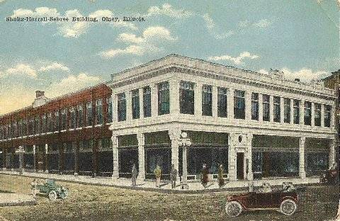

This is the old Bond drugstore corner. Do you have the Pictorial History Book of Richland County that was published in 2006? On page 139 is a picture of Main Street in 1941 and you can see that is the same picture. I remember the Star Grocery which is in the picture was across the street east of Bonds Drugstore.

George Ann Doan Waxler
Class of ‘48
--------------------------------------------------------------------------------------------
Barbara Dodson
buddodson1@comcast.net
Dear Ann,
Dear Ann, I truly enjoyed Harvey Zimmerle’s article on General Schilt. I have one memory of Gen Schilt that in looking back I thought was very amusing. During my Junior year at OTHS I dated “Marty” Ann Shilt, his daughter and following my desire to serve in the military I enlisted in the US Army in May 46 when I was 16. Following infantry basic at Ft McClellan, AL I went to Olney on leave and called “Marty” for a date, wearing my GI issue uniform I walked into the Schilt home and there sat the General. To those of you not familiar with Military Protocol I had never been that close to any General or command officer in my life. I was as nervous as a “Cat on a Hot Tin Roof.” He was very relaxed and certainly gave me a memorable experience!

Buddy Dodson
Class of ‘47.
----------------------------------------------------------------------------------------------------

Donna Sterchi Goss
dgdg55@frontier.com

Thanks so much Ann for all the work and time you spend keeping "Olney Memories" so interesting and available to so many. I noticed in the issue I just received that Anita Anderson Hildebrecht would like the recipe for the Maas Market ham salad. I, too, would love to have that recipe and also their banana cake, chocolate cake and the icing they used on both cakes. When I was young, living on a farm, we always came to town on Sat. and always went to Maas Market to buy their ham salad and usually one of their cakes. I have tried many different deli ham salads and have never had any that compare to theirs.
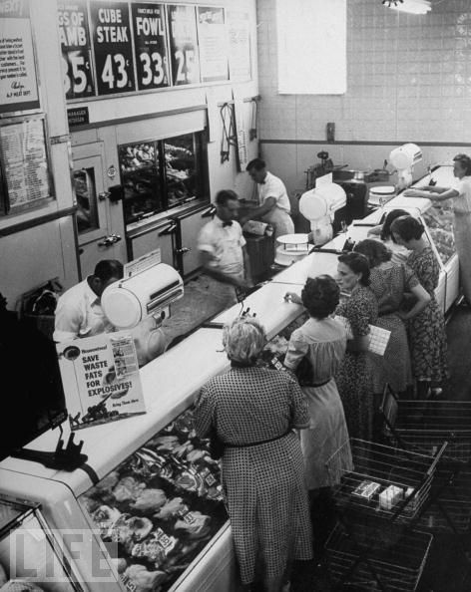 (no, this isn’t Maas’s Meat Market,
but reminds me of of it)
Donna Sterchi Goss
Class of ‘56
--------------------------------------------------------------------------------------------

Harvey Zimmerle
HARVEYZimm@aol.com

Latest on the 55th reunion for the class of 1957

Hi, we will have to go to the K of C on Friday night. Carilyn moved into town.

Yes, there will be many reunions that weekend due to the fall festival.

Sat. night we are at the Holiday.

Please share - the dates are 28 and 29 September 2012 in Olney

Harvey Zimmerle
Class of ‘57
--------------------------------------------------------------------------------------------

Gary Street
drstreet@wabash.net

We have had a wonderful response in finding people on the list I sent previously. However, when I got into work this morning we had a few returned cards.

I am now looking for addresses on:

Sally Marks
Cheryl Horrall Billick
Phyllis Taylor Lemons

Thanks a bunch.....from work!

Sharon Street Burt
Working for the class of ’62 ☺
====================================================

Ann Weesner King
Pianoann97@aol.com

How many of you remember the “foot x-ray machine” that was in Musgrove’s Shoe Store on Main Street? I remember thinking how neat it was to see my foot bones inside my shoe when I placed my foot inside this amazing machine! That was back in the 40’s and I was still pretty small. My father took these pictures and I’ve kept them all these years. (My husband told me to say that.)
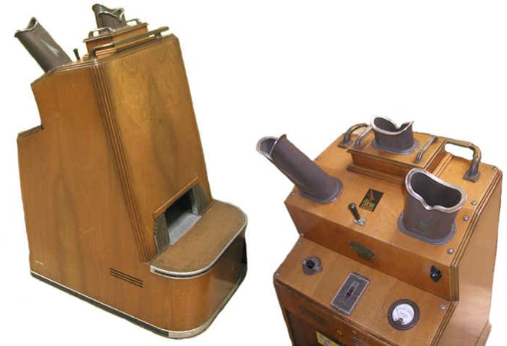

Ann Weesner King
Class of ‘60
----------------------------------------------------------------------------------
Wayne Kimmel
Wak@nwcable.net

After reading some of the Memories, I can reflect on some of the things and businesses that were in Olney. When I was at ERHS I worked at Jim's Clothing Store part time. I continued working there when I was OCC. Jack Fye, who worked at Dick Fessel’s, is a close friend and we would get together and socialize after work. People thought it was strange that we could be friends and still work for competitors.
I also saw reference to Whitakers Record Shop in one of the Memories Issues. My aunt and uncle were the owners, James and Clarabel Whitaker. My mother worked for them on a regular basis. Before it was a record shop, it was a soda fountain. It had the soda fountain bar with the white porcelain stools and the chrome tables with the black tops. I also remember a big candy selection. Everyday that Central School would dismiss, all the kids would flock the the soda fountain to buy penny candy.
I could go on and on about all the memories and the people. That is why I enjoy your writings so much.
Thanks
Wayne Kimmel
Class of ‘63
--------------------------------------------------------------------------------------------
Ann Weesner King
Pianoann97@aol.com

I saw this picture below and it brought back memories of our PE uniform that we had to wear when we went to ERHS. I remember how hard they were to iron too, although I remember my sweet mother ironed them much more often than I did. Who could forget that color green that we wore the 4 years?

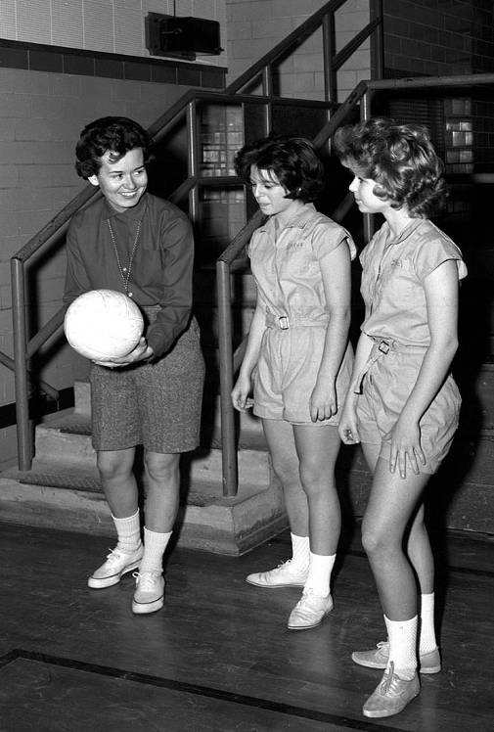

Ann Weesner King
Class of 1960
--------------------------------------------------------------------------------------------

Ann Weesner King
Pianoann97@aol.com

Continuing with some pictures of old ads from the Old Olney Cookbook published in 1905.

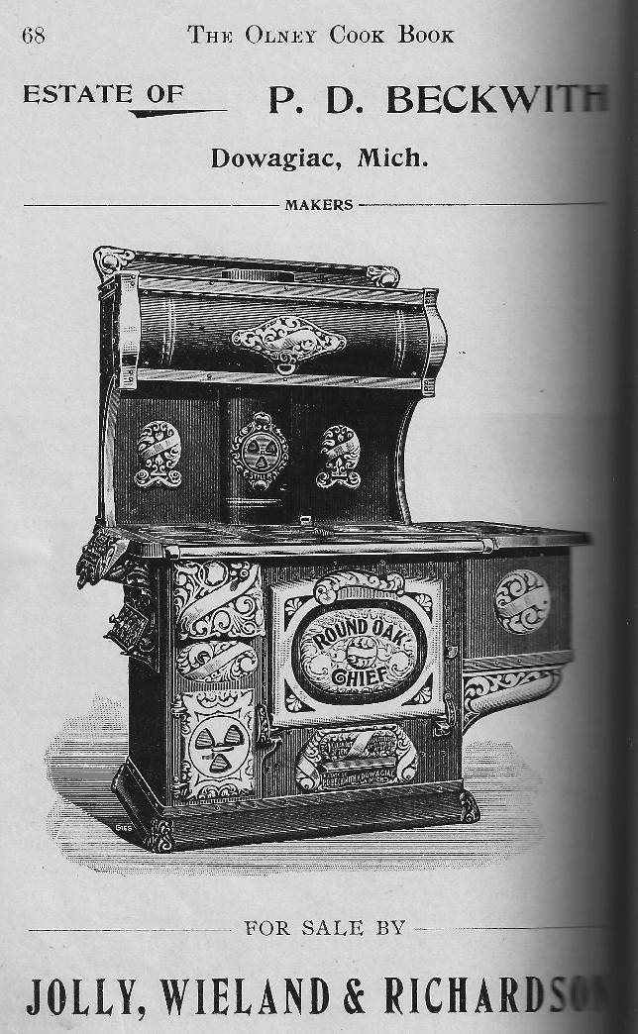

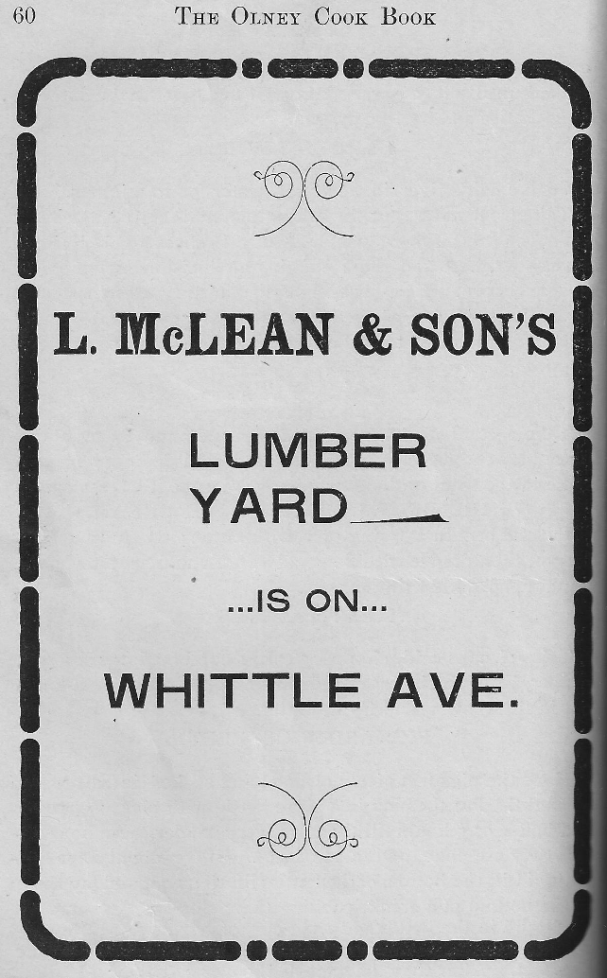

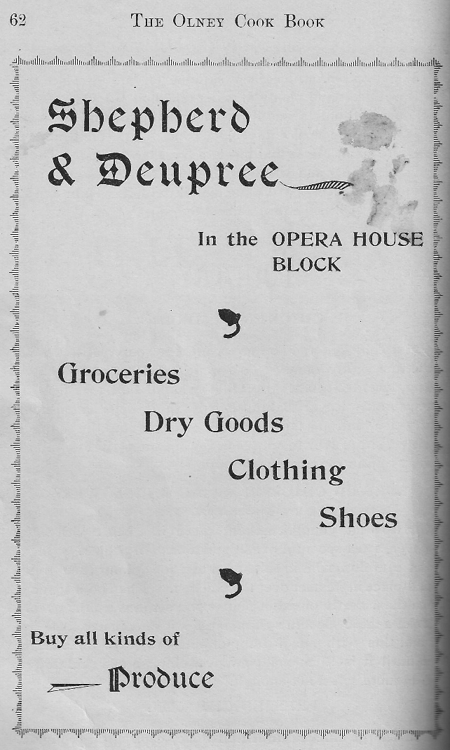

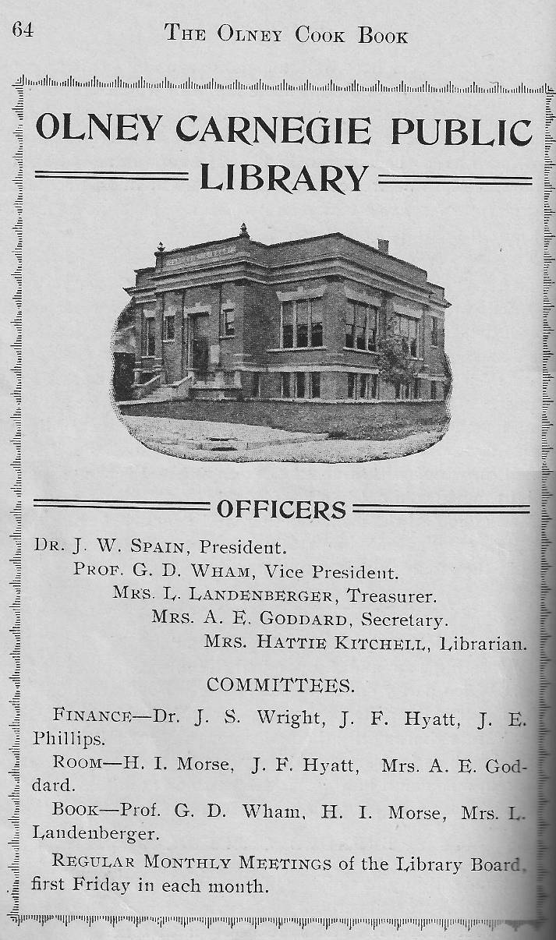

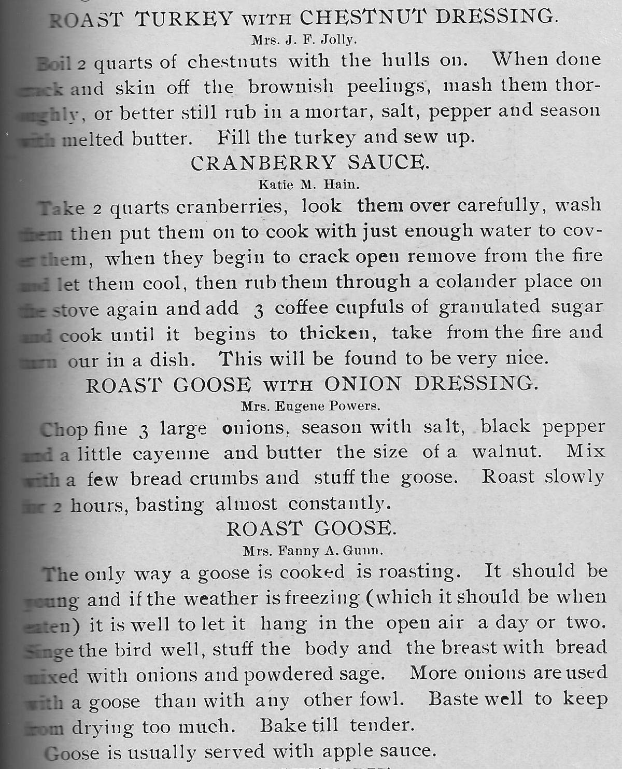

Ann Weesner King
Class of 1960
--------------------------------------------------------------------------------------------
======================================================
======================================================

