Olney Memories # 93
May 3, 2012

Remember to let me know if your e-mail address changes, and…keep sending your memories! ☺
Ann Weesner King
Pianoann97@aol.com
Class of 1960

------------------------------------------------------
Richard Williams
rrw41@earthlink.net
Reunion Season 2012

Hello Ann and ‘Fellow’ Olneans!
Richard Williams here to share reunion info with all.
The reunion season for most alumni from classes with years ending in ‘2’ or ‘7’ begins this year, rather soon for some and up and into the autumn for others.
So if you are a class member of 42, 47, 52, 57, 62, 67, 72, 77, 82, 87, 92, 97, or 2002, and if the reunion committee has not contacted you, try to contact one of them for reunion event information. Or contact me at the Tiger Alumni Center (TAC), at erhsalumni.net. If you are a member of the TAC, you can go to the site and then find the profile of each of the leaders giving the following reports. Then you can send a message to get more information.
Class of 1952 -- 60th Reunion
Phyllis Martin Slunaker (Class of 1952) has reported that the Class of 52 will hold their reunion week-end of Friday September 28, 2012.
Class of 1957 -- 55th Reunion
Judy Murray McKinney reports that the class of 1957 will have their reunion on the 4th weekend in Sept. 2012. Jean Blackburn Chandler is our committee chairman. Currently other members include with Carilyn Michels Grinstaff and Roberts Madden Beehn, and Judy Murray McKinney
Class of 1962 -- 50th Reunion
Gary Street reports that the Class of 62 will enjoy their 50th the week-end of September 28th and 29th at the Holiday Inn. Their next committee meeting is scheduled for May 8th, 7pm, at Gary’s home.
Gary wrote “This should be our largest class reunion. There will be those attending we have not seen for 50 years and some attending we will never see again. Please plan on being with us in September.”
Missing Classmates: Need to find for the Class Reunion....
Judi McClain (kraiza)
Sharon Felton Neunlist
Connie Thomas Dressback
Charlotte Jean Wiess
Janet Wiles
Bill Larkin
Joe Campbell
Margaret Harden (Brown)
Orville Mowrer
Lucille Fern Osborn Eakelberry

Class of 1967 -- 45th Reunion
Carolyn Galbreath (Marrs) reports, “We are making plans for our 45th reunion September 28 and 29th of 2012. We are in the process of searching for classmates. We have a group on facebook called ERHS class of 1967.
Class of 1972 -- 40th Reunion
The Class of 1972 is holding its reunion Sept 29 at the Richland County Country Club. I believe the following people are currently two of the reunion committee members: Mary Speake Brooks and Mark Roth. As neither are Tiger Alumni Center members I have no contact information of them.
Class of 1977 -- 35th Reunion
Janet Everette reports, “Our 35th reunion will be held during Labor Day weekend, 2012. Activities will include: ERHS football game on Fri, Aug 31, ERHS tours and reception at the Holiday on Sat, Sep 1 and brunch at the Holiday on Sun, Sep 2.”
Class of 1982 -- 30th Reunion
Julie Heindselman reports that the ERHS Class of 1982 will be having their 30 year reunion the weekend of July 7th, 2012. Julie Heindselman and Ruth Sutherlin Bruner are Co-Chairing this event.
They are actively searching for any classmates that wish to attend including those that were not part of the "Graduating Class" but were still classmates at some point in time.
Happy Days!
The above information was shared by the members of the Tiger Alumni Center. If you believe your class is having a reunion this year, try to contact a classmate. If you have information about one of the reunions not listed here, please share that with me so that I can post it in the future! We want all classmates to enjoy their reunions!
Richard Williams
Tiger Alumni Center
Erhsalumni.net
-------------------------------------------------------------------------------------------

-------------------------------------------------------------------------------------------
Gary Street
Drstreet@wabash.net
This is a list of names we need to find for the Class of ‘62 for our 50th reunion.
Judi McClain (kraiza)
Sharon Felton Neunlist
Connie Thomas Dressback
Charlotte Jean Wiess
Janet Wiles
Bill Larkin
Joe Campbell
Margaret Harden (Brown)
Orville Mowrer
Lucille Fern Osborn Eakelberry

If you know where any of these people are, please let us know. Thank you for the help.

Gary Street
Class of ‘62
--------------------------------------------------------------------------------------------

Anita Anderson Hildebrecht
AnitaSells@aol.com

I have been introduced to your site, Olney Memories by Anne Kribbs and Sandy VanCleve. They are visiting for the week-end so a lot of the conversation is about Olney and high school. We are exhausted from talking so much.

I would love the recipe for the ham salad made at Maas' Market. I hope someone knows.

Thanks for the memories,

Anita Anderson Hildebrecht
Class of 1961
--------------------------------------------------------------------------------------------
Kathleen Vaughn
vaughn304@yahoo.com

Hi Ann.

Stumbled across a copy of your firemen picture... "taken in the 1950's" Front row: George Nordyke, Stanley Shimkos, B.C. McKinney and Kenny Hayes. Second row: Jesse Gaddy, P.J. Brummitt, T.A. Street, Asher Eyer, Frank Garner, L. Hopson, Max Hocking and Carl Weston. Top row: Leo Arnold, E. Tatum, Buddy Sturgeon and Henry Gassmann.
What a great picture of Quayles's IGA. Where did you find it? We always got our baseball cards and ice cold bottles of Coke there. I believe "Air Cooled" was painted on the glass door. During the summer we would make frequent visits throughout each day, pretending to look for something to buy but were actually enjoying a reprieve from the humidity and heat. It was the coolest place in town that allowed bare foot kids.
Kathleen Vaughn
Class of '67

--------------------------------------------------------------------------------

Barbara Whart Berger
bberger4@frontier.com
In regards to the picture of the firemen in the last issue of OM # 92 I am sure the guy in the second row, second from the right, wearing a white open collar shirt is my husband, Kenny Berger. The picture was probably taken in the late 50's as that is when he was on the volunteer fire department. The man in the front row kneeling with the suit on is Stanly Shimkos. He was on the city coucil at that time. Some of the others Ken identified areLeo Arnold, Ernie Tatum, Slim Brummit, Carl Weston, Frank Garner Sr., and Curly Gaddy.
Keep up the good work, Ann. We enjoy the Olney memories.
Barbara Wharf Berger,
O.T.H.S. '45

---------------------------------------------------------------------------------------

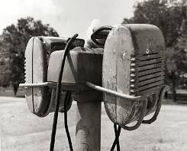
Does this picture above bring back memories of what??

------------------------------------------------------------------------------------------------------------

Harvey Zimmerle

HARVEYZimm@aol.com

Christian F. Schilt
From Wikipedia, the free encyclopedia
Jump to: navigation, search
Christian Frank Schilt
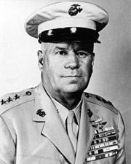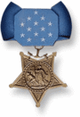
General Christian F. Schilt, Medal of Honor recipient
Born | March 19, 1895  Richland County, Illinois
Died | January 8, 1987 (aged 91)  Norfolk, Virginia
Place of burial | Arlington National Cemetery
Allegiance | United States of America
Service/branch | United States Marine Corps
Years of service | 1917-1957
Rank | General
Commands held | MCAS Cherry Point  1st Marine Aircraft Wing  Assistant Commandant of the Marine Corps, Aviation
Battles/wars | World War I  World War II  Korean War
Awards | Medal of Honor  Distinguished Service Medal  Legion of Merit  Distinguished Flying Cross (2)  Bronze Star
Christian Frank Schilt (March 19, 1895-January 8, 1987) was one of the first Marine Corps aviators and a recipient of the United States highest military decoration, the Medal of Honor. He received the Medal for using his biplane to evacuate wounded Marines under fire in Nicaragua.
In addition to his actions in Nicaragua he saw action in World War I, World War II, the Haitian and Nicaraguan campaigns and the Korean War. He retired after nearly 40 years of active service and was promoted to the rank of four-star general at retirement.

Contents
[hide]
- 1 Early life and education
- 2 Military career
  - 2.1 Military awards and decortions
  - 2.2 Medal of Honor citation
  - 2.3 Air Force Distinguished Service Medal citation
- 3 See also
- 4 Notes
- 5 References
- 6 External links

[edit] Early life and education
Christian Frank Schilt was born March 19, 1895, in Richland County, Illinois, and after attending Rose Polytechnic Institute in Terre Haute, Indiana, he enlisted in the Marine Corps June 23, 1917.

[edit] Military career
As an enlisted man he served at Ponta Delgada, in the Azores, with the 1st Marine Aeronautical Company, a seaplane squadron assigned to anti-submarine patrol. This was the first organized American air unit of any service to go overseas during World War I.
Returning to the United States as a corporal, he entered flight training at the Marine Flying Field, Miami, Florida. He was designated an aviator June 5, 1919, and commissioned a second lieutenant five days later. That October, he began his first tour of expeditionary duty as a member of Squadron "D," Marine Air Forces, 2nd Provisional Brigade, in Santo Domingo. He returned to the United States in February 1920, to enter the Marine Officers Training School, Marine Corps Base Quantico, Virginia.
Completing the course in August 1920, he went overseas again the following month, joining squadron "E" of Marine Aviation Forces, 1st Provisional Brigade, at Port-au-Prince, Haiti. He was transferred to the 2d Brigade the following March to make an aerial survey and mosaic map of the coast line of the Dominican Republic. After completing that assignment he returned to Quantico in October 1922.
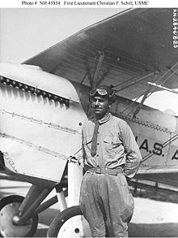
1stLt Schilt standing beside a Curtiss F6C fighter aircraft at Naval Air Station, Anacostia, Washington, D.C. in August 1925.
U.S. Naval Historical Center photograph NH #45845.
Except for service at Naval Air Station, Pensacola, Florida, from January to July 1923, and completion of a three-month photographic course at the Air Service Technical School, Chanute Field, Illinois, in 1925, Schilt remained at Quantico for the next five years. While attached to that post, he won second place in the Schneider International Seaplane Race at Norfolk, in November 1926, flying a special Curtiss racer at a speed of 231.3 mph (372.2 km/h) over seven laps of a triangular 50 km course.
In November 1927, Schilt was ordered to Managua, Nicaragua, where he joined Observation Squadron 7-M. He was awarded the Medal of Honor for heroism from 6 to January 8, 1928, at Quilali, Nicaragua, where two Marine patrols were ambushed and cut off by bandit forces. Then a lieutenant, he voluntarily risked his life to make ten flights into the besieged town, evacuating 18 casualties and carrying in a replacement commander and badly needed medical supplies. To make a landing strip on the village's rough, rolling, main street, the Marines on the ground had to burn and level part of the town, and since his O2U Corsair biplane had no brakes they had to stop it by dragging from its wings as soon as it touched down.
Hostile fire on landings and take-offs, plus low-hanging clouds, mountains and tricky air currents, added to the difficulty of the flights, which the citation describes as feats of "almost superhuman skill combined with personal courage of the highest order."
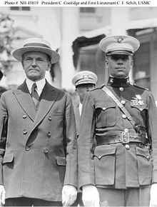
1stLt Schilt and President Coolidge at the White House for the Medal of Honor presentation, c 1928.
He returned to the United States in August 1929, and after commanding Fighter Squadron 5-N at Quantico, was named Chief Test Pilot and Flight and Aerological Officer at the Naval Aircraft Factory, Philadelphia. He served in that capacity for two years before returning to Quantico in June 1932, to enter the Company Officers' Course at the Marine Corps Schools. He completed that course in July 1933, and a month later entered the Air Corps Tactical School at Montgomery, Alabama.
Graduating from the tactical school in June 1934, Schilt began another four years at Quantico, where he was Air Officer on the Staff of the Commanding General, Fleet Marine Force, and later a squadron commander with Aircraft One, Fleet Marine Force. He then served from May 1938 to June 1940, as Executive Officer of the Marine Corps Air Station St. Thomas (MCAS St. Thomas), Virgin Islands. After that he returned to Quantico to complete the Senior Course in the Marine Corps Schools and serve with Base Air Detachment 1, Fleet Marine Force.
He left Quantico in May 1941, when he was assigned to the American Embassy in London, United Kingdom, as an Assistant Naval Attache for Air. In that capacity he traveled through England and Scotland and served as a naval observer in North Africa and the Middle East. He returned to the United States in August 1941, and was assigned to Quantico as Engineer and Supply Officer of the 1st Marine Aircraft Wing.
In September 1942, he arrived on Guadalcanal as Assistant Chief of Staff, 1st Marine Air Wing. After that he was commander of Marine Aircraft Group 11, Chief of Staff of the 1st Wing and Commanding Officer of the Strike and Search Patrol Commands, Solomon Islands. He returned to the United States in September 1943, and commanded Marine Corps Air Station Cherry Point, North Carolina, until March of the following year.
From April to June 1944, Schilt headed the 9th Marine Aircraft Wing during the organization of that unit. He then served for six months as Chief of Staff of the wing and for another month as its commander before returning to the Pacific theater in February 1945. This time he was Island Commander, Peleliu, from March to August 1945, and Commanding General, Air Defense Command, 2d Marine Aircraft Wing, on Okinawa until October 1945, when he took command of the 2d Wing.
Returning from Okinawa in March 1946, the general reported to the Naval Air Station Glenview, Illinois, the following month. There he headed the Marine Air Reserve Training Command until July 1949, when he was ordered to Naval Station Norfolk as Chief of Staff, Fleet Marine Force, Atlantic. He served in that capacity until he took command of the 1st Marine Aircraft Wing in Korea in July 1951.
In April 1952, Schilt returned from Korea to serve in Hawaii as Deputy Commander, Fleet Marine Force, Pacific, until February 1953 when he became Commanding General, Aircraft, Fleet Marine Force, Pacific, at the Marine Corps Air Station El Toro, California. He left El Toro in July 1955, and assumed his duties at Headquarters Marine Corps as Director of Aviation on August 1, 1955, as a lieutenant general. He served in this capacity until retirement from the Marine Corps on April 1, 1957, when he was promoted to full general.
General Schilt died on January 8, 1987, at age 91, in Norfolk, Virginia, and was buried with full military honors in Arlington National Cemetery.^{[1]} His grave can be found in section 2E, lot 151-2.^{[1]}

[edit] Military awards and decortions
During his career he received the following military decorations:
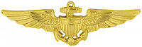

Naval Aviator Badge
1st Row | Medal of Honor |  | Navy Distinguished Service Medal |  | Legion of Merit w/ valor device
2nd Row | Distinguished Flying Cross | Bronze Star w/ valor device |  | Air Medal w/ 4 award stars |  | Navy Presidential Unit Citation w/ 1 service star
3rd Row | Marine Corps Good Conduct Medal | Marine Corps Expeditionary Medal w/ 1 service star |  | World War I Victory Medal w/ Overseas clasp |  | Nicaraguan Campaign Medal (1933)
4th Row | American Defense Service Medal w/ Base clasp | American Campaign Medal |  | Asiatic-Pacific Campaign Medal w/ 2 service stars |  | World War II Victory Medal
5th Row | Navy Occupation Service Medal w/ Asia clasp | National Defense Service Medal |  | Korean Service Medal w/ 5 service stars |  | Nicaraguan Medal of Merit w/ silver star
6th Row | Nicaraguan Cross of Valor | Order of Military Merit, Taeguk Cordon Medal |  | Korean Presidential Unit Citation |  | United Nations Korea Medal

[edit] Medal of Honor citation
Rank and organization: First Lieutenant, U.S. Marine Corps. Place and date: Quilali, Nicaragua, 6, 7 and January 8, 1928. Entered service at: Illinois. Born: March 1, 1895, Richland County, Ill.
Citation:
During the progress of an insurrection at Quilali, Nicaragua, 6, 7, and 8 January 1928, 1st Lt. Schilt, then a member of a marine expedition which had suffered severe losses in killed and wounded, volunteered under almost impossible conditions to evacuate the wounded by air and transport a relief commanding officer to assume charge of a very serious situation. 1st Lt Schilt bravely undertook this dangerous and important task and, by taking off a total of 10 times in the rough, rolling street of a partially burning village, under hostile infantry fire on each occasion, succeeded in accomplishing his mission, thereby actually saving 3 lives and bringing supplies and aid to others in desperate need.^{[2]}

[edit] Air Force Distinguished Service Medal citation
Citation:
The President of the United States of America, authorized by Act of Congress, July 9, 1918, takes pleasure in presenting the Distinguished Service Medal (Air Force) to Major General Christian Franklin Schilt, United States Marine Corps, for exceptionally meritorious service to the United States while in a position of great responsibility from 27 July 1951 to 5 April 1952. As Commanding General of the FIRST Marine Air Wing, United States Marine Corps, General Schilt provided United Nations Forces engaged in action against the enemy in Korea with outstanding tactical air support for ground operations. Operating from three separate sites, including an aircraft carrier, General Schilt skillfully integrated his unit into Far East Air Forces interdiction program by implementing highly efficient fighter bomber, night intruder and night interdiction operations against enemy support missions. Concurrently, the Wing performed productive photo reconnaissance missions, helicopter airlift, and air rescue operations. The Wing contributed to the destruction of ammunition stockpiles, fuel lubrications and other combat material, and proved an efficient deterrent to the build-up of the enemy's war machine. Achieving success in all its operations, the Wing materially aided the overall Far East Air Forces operations. The outstanding combat efficiency of the First Marine Air Wing in sustained operations against the enemy in Korea was achieved through the able and mature guidance of General Schilt. His vast experience in aerial combat was not only a valuable source of aid to operations of the United Nations Forces, but also evoked the full and unceasing effort of his command toward the United Nations' objective in Korea. General Schilt's significant achievements in combat, and his resourceful leadership sustained the highest traditions of the military service and reflected great credit upon himself, the United States Marine Corps, and the United Nations forces.
Harvey Zimmerle

Class of ‘57
--------------------------------------------------------------------------------------------
RoseAnn Schwartz
roseannschwartz@webtv.net
Click the link below for some Great pictures of the late 50’s and 60’s! Brings back lots of good memories. ☺



Memories of Yesteryear (click link)

RoseAnn Schwartz
---------------------------------------------------------------------------------

George Ann (Doan) Waxler
Gwaxler48@dishmail.net
This same picture is in the "Olney Richland County Sesquicentennial 1841---1991" book. It gives the names as follows:
Olney Fire Department, 1950's.
Front row: George Nordyke, Stanley Shimkos, B. C. McKinney and Kenny Hayes.
Second row: Jesse Gaddy, P. J. Brummitt, T. A. Street, Asher Eyer, Frank Garner, L. Hopson, Max Hocking and Carl Weston.
Top row:Leo Arnold, E. Tatum, Buddy Sturgeon and Henry Gassman
^{George Ann Waxler}
^{Class of ‘48}
----------------------------------------------------------------------------------------------------------------

^{Kenna Hayes King}
^{miracle7kk@hotmail.com}

Hi There,
On the photo of the Olney Fire Department, on the 1st row to the Right is my "Dad", Kenneth Hayes. :)
Ohhhh, the top left cornor is the Fire Chief, Leo Arnold.
Thanks,
Kenna
Class of ‘61
--------------------------------------------------------------------------------------

^{Kathleen Vaughn}
^{vaughn304@yahoo.com}
Newspaper clippings submitted by Kathleen Vaughn:
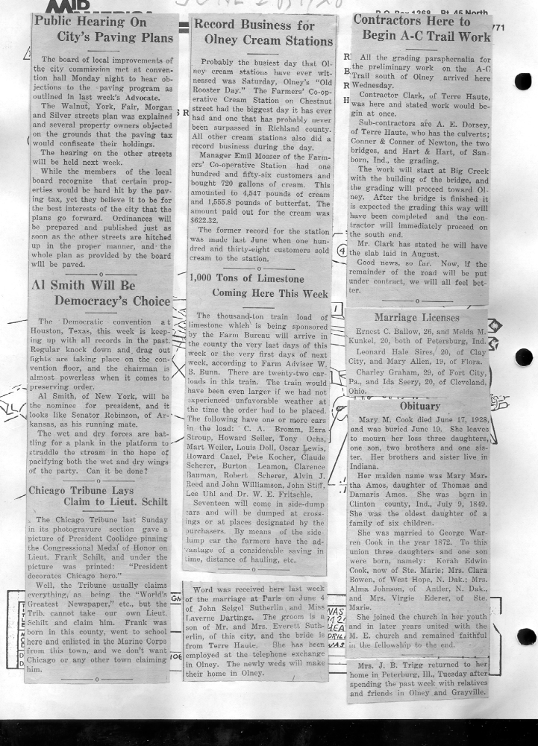
^{Kathleen Valghn}
^{Class of ‘67}
------------------------------------------------------------------------------------------------------------------------------------------------------
^{Harvey Zimmerle}
HARVEYZimm@aol.com

From Private to General, USMC

Christian Franklin Schilt, Olney, Illinios

Medal of Honor Citation:
Rank and organization:

First Lieutenant, U.S. Marine Corps. Place and date: Quilali, Nicaragua, 6, 7 and 8 January 1928. Entered service at: Illinois. Born: 1 March 1895, Richland County, Olney, IL. Other Navy awards: Distinguished Service Medal, Legion of Merit, Distinguished Flying Cross with 1 gold star.
Citation: During the progress of an insurrection at Quilali, Nicaragua, 6, 7, and 8 January 1928, 1st Lt. Schilt, then a member of a marine expedition which had suffered severe losses in killed and wounded, volunteered under almost impossible conditions to evacuate the wounded by air and transport a relief commanding officer to assume charge of a very serious situation. 1st Lt. Schilt bravely undertook this dangerous and important task and, by taking off a total of 10 times in the rough, rolling street of a partially burning village, under hostile infantry fire on each occasion, succeeded in accomplishing his mission, thereby actually saving 3 lives and bringing supplies and aid to others in desperate need.
The last Marine aviators withdrew from Nicaragua in 1932.
Click this link below for interesting information & photos:
Christian Franklin Schilt, General, United States Marine Corps
three of the articles I had, also appeared in "Foot Prints." I thought you should give credit to the Richland Co. Genealogical Society Fall 2011 issue of "FOOT PRINTS Past and Present;"

Loy Zimmerle

Class of ‘57

I understand that these articles above pertaining to General Christian Franklin Schilt also appeared in "Foot Prints." I was asked to mention that credit should be given to the Richland Co. Genealogical Society Fall 2011 issue of "FOOT PRINTS Past and Present;" they did a page on Schilt that included the "Olney Hero Welcomed Home," "Chicago Tribune Lays Claim to Lieut. Schilt," and the June 11 Washington, D.C. article on Schilt receiving MOH from President Coolidge. Thanks.
Ann King
========================================================================================================

