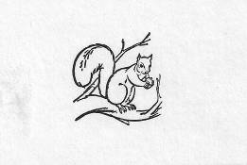
Olney Memories # 90
Jan 28, 2012

Below is the list of names for which I still don’t have e-mail addresses. The list includes some names which weren’t on the previous list. If you know the e-mail address for anyone on the list please let me know. I’d like to thank everyone who have provided e-mail addresses that I did not have.

Ann Weesner King
Pianoann97@aol.com
Class of 1960

-------------------------------------------------------------------------------------------

Carole Eastserday Bassett
Chritina Burton Biggers
Cindy Combs
Dean Dietrich
Polly Roe Dougherty
Steve & Carolyn Gallbreth
LaDonna Cook Golf
Cheryl McShane Greene
Linda Hall
Patric Hall
Lora Lee Moir Hensel
Bill Keen
Pat Landis
Vicki Slunaker Merritt
Ed Mosser
Amy Packer
Flo Potter
Harold Quick
Major Dan Ragain
Ruth Reckling
Patricia Reynolds
Joyce Jones Robinson
Michael Stiff
Kay Sumpter
Kay Totten
Brooks (Calvert) Walker
Ralph Webber
Paula Duncan
Galen & Sonnie Brinkley Coldfelter
Lawrence Eagleson
Jeannie Milford Faris
Bertha Coan Bradham
Mike Chaplin
Steve & Barb and Findley
Charles Stangle
Bill Guinty
Robin Bellinger Long

------------------------------------------------------------------------------------------

Lynn (Miller) Neathery
lynn.neathery@gmail.com

Joann Jones Patterson, (Jonsey) as she was known to all...passed away Dec 16th in New Braunfels, TX. She is survived by her Daughter, Jill and Son John Dickerson...and husband Dean Patterson.

She as voted most popular in her class and music was her love....she played the piano musical accompaniments for most of Gus and Mary Sliva's musical productions at ERHS ..."Freedom land" being one of many.

She graduated from the U of I , Champaign and began her teaching career in Germany. She taught until the past few years in Texas which had been her home since the 1970's.

Her family can be contacted at 1680 Huffman Lane, New Brunfels, TX 78132 % Dean Patterson.

Lynn Neatherly
Class of ‘51

-------------------------------------------------------------------------------------------

Harvey Zimmerley
Harveyzimm@aol.com

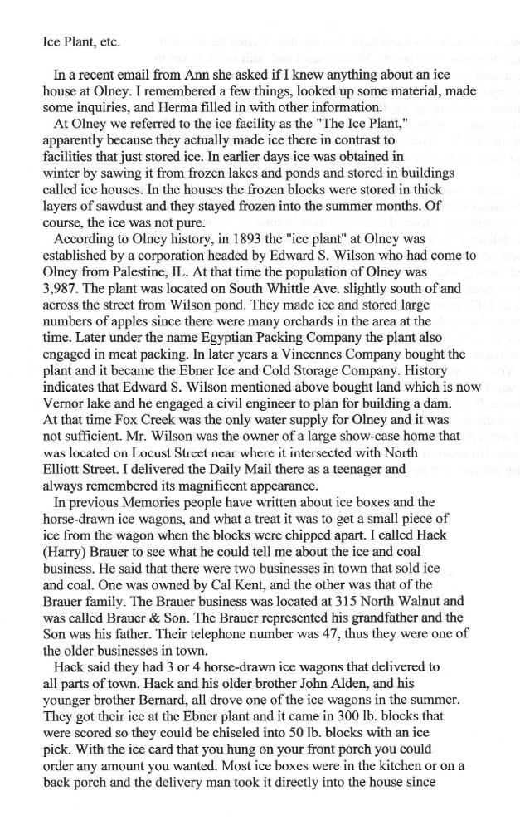

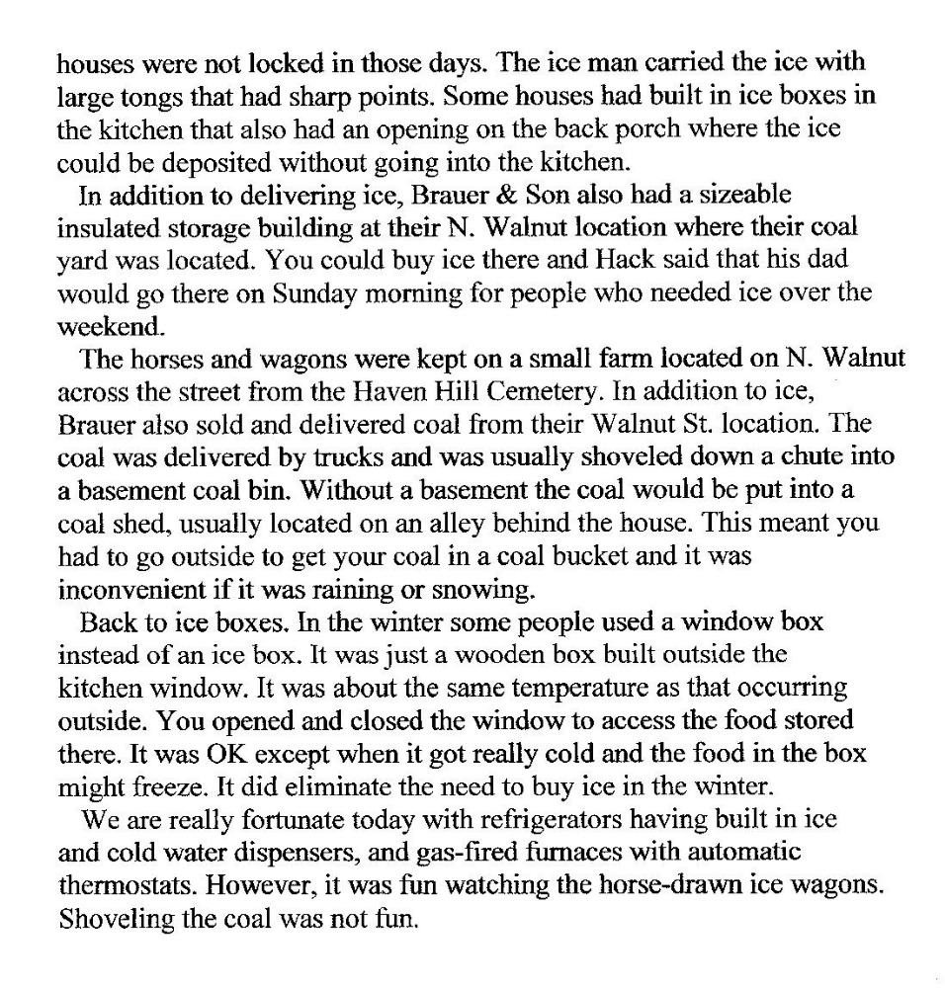
Harvey Zimmerley
Class of ‘57
------------------------------------------------------------------------

Alice Magee
am1315@verizon.net

I too miss Jim Dale. He was such an interesting man, and we became good friend through e-mail. He had close connections with my family and we shared good stories over the years. He told me about the time when he was a boy and was awed when Frank Schilt would come to town in his single engine bi-wing plane and perform aeronautic maneuvers over his mother's house on Chestnunt Street. I used that information recently in remarks I made in Cherry Point, N.C. when the new headquarters building was dedicated to my father, Christian Franklin Schilt. The generation is fast disappearing which would remember such startling, exciting events (or would even consider them exciting), What a treasure trove he was for remembering our every day history. Yes, he will be missed!
I had (have) so many cousins, aunts and uncles living there, and I lived there too briefly when my dad was over seas. How I treasure that time. What fun it was!!! Does anyone remember the name of the ice cream wagon's horse? Thanks for sending me notice #89.

Alice Magee

------------------------------------------------------------------------------------------------

Harvey Zimmerley
Harveyzimm@aol.com

I found these stories below at the Olney CC while I was researching my family tree. They were salvaged by some one and placed in the binders on the South wall of the library. The information went back many years, covered many situations and shed the light on the challenges that our ancestors faced.

The stories covered the daily lives of People and the growth of Olney. The people in those days had to handle the same type of challenges that we all have to face. The challenges were predicated on the existing situations of the time. Such as people had problems with horses and we have problems with our means of transportation.

Olney grew and enjoyed the opportunity of having been at the right place at the right time. I would have loved to attended the Opera, see Buffalo Bill or to have gone to the State fair in Olney.

The ice houses, glass makers and the brick yards would have been a magnet for me, and the list goes on.

History is to be shared. I hope the articles bring back memories of what our ancestors faced and accomplished. Perhaps these articles will open many doors of the past and you, the readers of Olney Memories, will remember many more stories to share with the OM

Loy Zimmerle
Class of ‘57
-----------

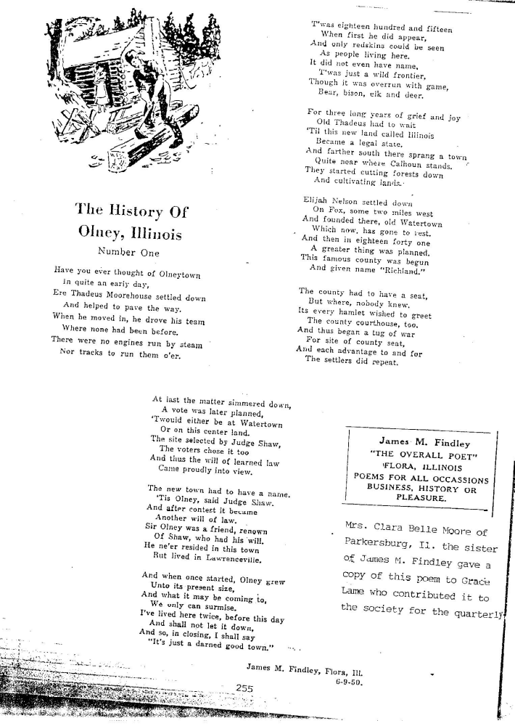
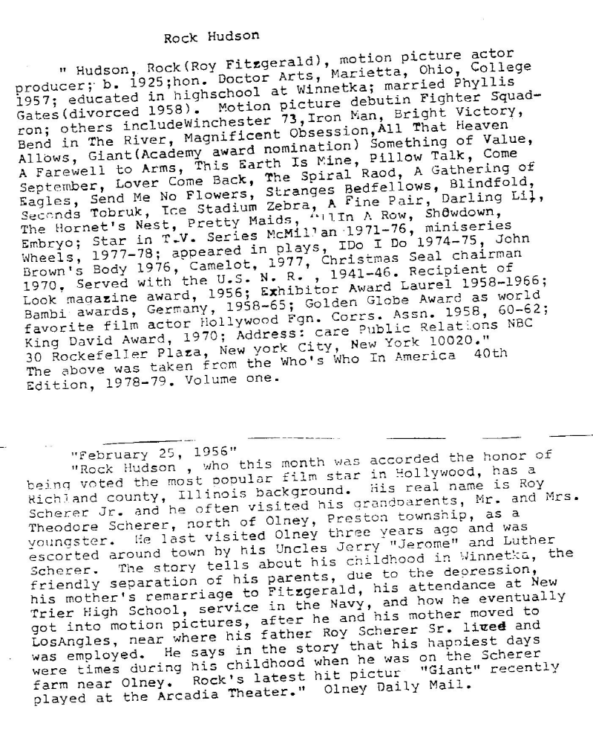

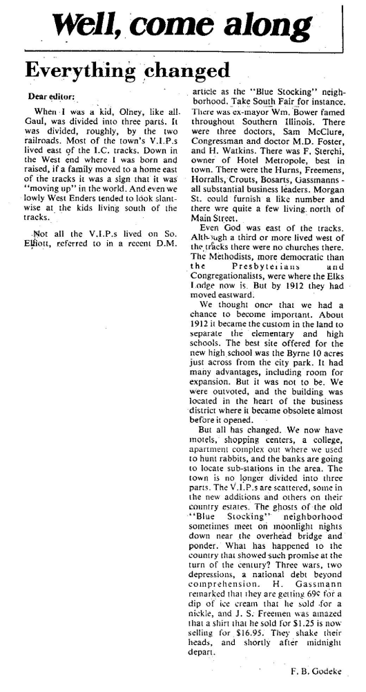
Loy Zimmerle
Class of 1957

---------------------------------------------------------------------------------

Ann Weesner King
Pianoann97@aol.com

A couple of people suggested it might be interesting to print a few recipes now and then out of the old cook book that I printed ads from recently. Here are three that might be unusual for our time. I copied the recipes word for word.

Mince Pie Mrs. Barbara Mills

Boil 2 pounds good meat tender, chop fine when cold, ½ pound suet, 1 table-spoon cloves, 1 nutmeg, 1 Table-spoon cinnamon and ginger, 2 cups sugar, 2 pounds seeded raisins, 1 lb. currants, ½ pound citron, chopped fine. 1 pounds tart apples, chopped fine, 1 tea-spoon each of salt, mace and all-spice; mix well, put in jars and cover. Will keep all winter.
-------------

Pork Cake Mrs. Chambers

One pound salt pork, chopped fine, 1 pound raisins, seeded, 3 cups brown sugar, 1 pint boiling water, 1 teaspoon soda, 1 teaspoon each of cinnamon, cloves and nutmeg, enough flour to thicken, pour in boiling water over the pork.
--------

Fried Cakes Mrs. W.B. Lile

Two coffee cups, not to thick, sour cream, or 2 cups sour milk and 2 Table-spoons butter, 4 eggs, a little nutmeg, salt, 2 tea-cups sugar, 1 small tea-spoon soda dissolved, flour enough to roll, fry in hot lard.

Ann Weesner King
Class of 1960
---------------------------------------------------------------------------------==============================================================================================

