Olney Memories # 85
May 30, 2011

Hope everyone is having a nice and safe Memorial Day Weekend.

Thank you for sending me your e-mail address updates. The list of Olney Memories subscribers now has a total of 637 members!

Ann King
Pianoann97@aol.com
Class of 1960

-------------------------------------------------------------------------------------------------------
--------------------------------------------------------------------------------------------------------

Sam Totten
smtotten@sbcglobal.net

I enjoy the OMs very much although many of them are long after I left Olney to go to College. However I was wondering if anyone remembered the "Junior Police". I think it was formed when I was in the 8th grade at Central. We were taught many things about police work (rather simple in those days) and city government. At some point someone suggested that we have an election and take over the city for a day. I was elected Mayor (sorry I do not remember the rest of the officers). We got very excited as the day approached and finally arrived when we took office. As I recall, we didn't make many momentous decisions that day, but we learned a lot about how our city operated. We visited the water plant on the Fox River, the sewer plant south of the city (downstream--good thinking), City hall, the police department, public works, the fire department and the jail. It was a fun day for me and "the City Council". Perhaps someone can fill in some of the blanks in my memory about the Junior Police.

Sam Totten
Class of '50

-----------------------------------------------------------------------------------------------------

Mitzi Tracy
rmtracy97@frontier.com
I work for TrustBank (formerly Olney Trust Bank). Next year (2012) the bank will be celebrating 100 years of business. Our marketing committee is in the process of gathering information and looking for any memorabilia of the bank. Could you post in your next issue of OM’s that if anyone has any stories (memories) or any memorabilia of Olney Trust & Banking Company or Olney Trust Bank they would like to share, please send information to marketingofficer@trustbank.net .

Thanks,
Mitzi Tracy
--------------------------------------------------------------------------------------------

Nellie Peters
Nlpeters@aol.com
Always glad to receive the Olney Memories and wanted to mention that the Class of 1946 is having their 65th high school reunion. I was sure when I received the notice someone had made a "typo" - I couldn't possibly have been out of high school 65 YEARS! Maybe it was just sent to the wrong classmate!! But, sure enough, October 15 & 16 - I can hardly wait to see all those "OLD FOLKS" - if I remember to wear my glasses!!

Regards to all,
Nellie Elliott Peters
Class of ‘46
--------------------------------------------------------------------------------------------------------------------

Marcella Cummins Zorn
marcellazorn@gmail.com

I just finished reading the paragraph you sent me about “how Olney Memories came into being”……What a lovely way to begin something extraordinary!

When my children wondered what it was like growing up in Olney (they only know Olney as it is now), I would try to paint them the picture of what Olney was like in my childhood. It was very idyllic in my memories. Catching fireflies, going to the pool, roller-skating, playing all day with my neighborhood pals in the endless summer days, going to the baseball field near my home, eating ice cream and drinking marshmallow Cokes at Mikes, watching movies at the Arcadia every Saturday, riding my bike all over town, saving my pennies to buy paper dolls at Woolworth's or Tressler's, and on and on. So I know I will enjoy reading the memories of others.

Thanks!
Marcella Cummins Zorn
Class of ‘56

---------------------------------------------------------------------------------------------------------------------------------

Ann Weesner
Pianoann97@aol.com

My son David has been going through some boxes and showed me some memorabilia items from Olney. He thought they might be interesting to you if I could scan them and share them with you for the Olney Memories.

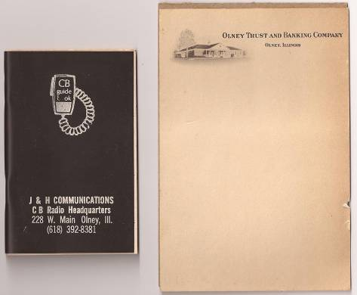

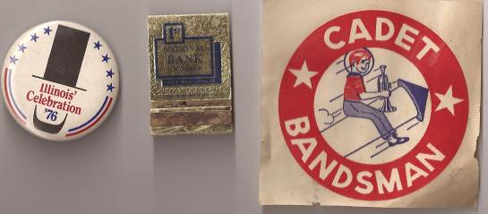

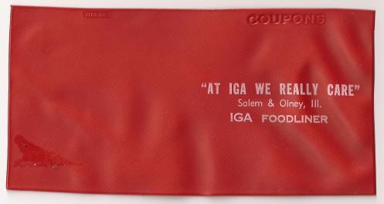

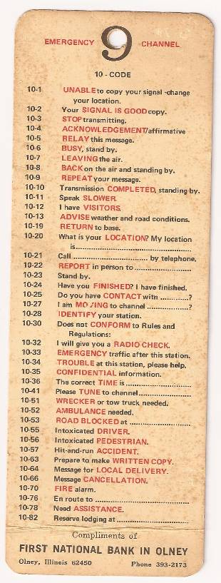

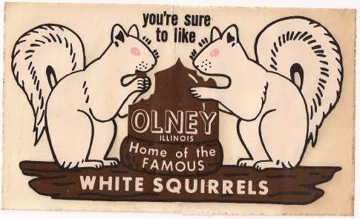

Ann Weesner King & David Schnautz
Class of ’60 Would have been ‘84
---------------------------------------------------------------------------------
====================================================
====================================================

