Olney Memories # 83

March, 5, 2011

Here is the first issue of Olney Memories for 2011. I want to thank all of you who have updated me with your new e-mail address.

I will send the updated E-mail Contact List following OM # 83.

Ann Weesner King
Pianoann97@aol.com
Class of 1960

Charlie Fregeau
n5hsr@sprynet.com
Some of the old phone #’s.
Weesner C W RFD 3 EX 5-1945
Weesner Eugene RFD 3 EX 3-4588
Weesner Guy RFD 5 EX 3-7143
Weesner Minnie 413 E North Av EX 3-4890
Weesner Wm RFD 5 EX 3-6147
I know that Olney was still manual (i.e. operator assisted calls) in 1954 and while your number was 567, it was still manual. When did Olney get dial phones? My guess is right around 1960, because they put in the EX 5 exchange in 1961 or so, judging by the pattern of the numbers issued. EX 5 is what the phone company calls a TPS exchange. It would have not been placed into service while Olney had manual phones. The manual phone numbers were assigned numbers on a TPL basis when they went to dial phones, that’s the way GTE did things in those days. Terminal per station meant that you couldn’t tell who the other party on your line was. Terminal per Line meant that all the parties on the same line had the same 2-xxx or 3-xxx digits and only the last digit differed.
In 1964 when Claremont got dial phones and in 1965 when Noble got dial phones, it’s interesting to see they were immediately given TPS exchanges. One of the exercises I did for school on my first computer was put in all the numbers of Noble from the 1963 phone book and then find them in the 1965 phone book to find the new number. There was no real correlation between the old line and the last 4 digits of the new number. But by the mid 60’s equipment to provide TPS service had become cheaper and easier to implement.
I remember the summer of 67, when GTE went around replacing the lines in the rural areas with 4-party lines on the 395 prefix. Many of these rural lines had up to 10 parties on them and more prior to dial. I was able to find all the parties on Granddad’s line in the 63 phone book and confirmed it with my Aunt Barbara. They were all EX 3-800x and were probably issued numbers from 1 to 0 in order of their old ringing codes. The old line number was Rural 7. Granddad was EX 3-8008 and had been 7F22, since that’s the number Dad had to call from Chicago when he needed to talk to someone down there about wedding arrangements and such. In the summer of 67, Granddad became 395-2828. In December of 1968 when we moved to Olney, we became 395-3629.
Charles Fregeau
Would have been class of ‘75.
----------------------------------------------------------------------------------------------------

Bill Sager
bill.sager1@gmail.com

Thanks Ann:

Got OM #82, (finally got the other 81 read), enjoyed reading them, it brought back a lot of memories. Enjoyed watching Tim Jones two movies of the Anglin’ Road. (OM 82). I guess his next one will be about ‘The Ghost Horse’. While watching them, I thought of a tale about ‘The Headless Horseman’. Anyone remember anything about that tale, and was that tied in with Anglin’ Road’???? All I remember, a headless man dressed in black wearing a black cape, riding a black horse across a bridge, looking for his head on the other side?? That came from behind the ‘Cobwebs’ of my brain somewhere.

I will say these Olney Memories has cleared-out a bunch of ‘Cobwebs’. (o:

I’m living in Guthrie, OK now. (About 30 miles north of Oklahoma City). Doing a web site for the church. www.zlcguthrieok.org When I came to Guthrie, the Pastor and the church people wanted a web site, and was asked if I could start one. So with a lot of help from a ‘computer geek’ in Warrenton, Mo that I knew, got one started. You might want to see what I’m doing in my ‘Retirement’. Keeping busy in my ‘Old Age’. Plus, my kids got me a ‘Wii’ (Nintendo) for Christmas, been Golfing an Bowling so for. That my friend, is making sore muscles places I had forgotten I had. (This will keep my ‘Out’ of a ‘Wheel Chair’ or put me in one) (o:

Bill Sager
Class of 48

--------------------------------------------------------------------------------------------------------------------

Charlie Fregeau
n5hsr@sprynet.com
Fred Speith lived across 130 from my Granddad Leaf out in Preston Twp. About 1450 N.
Mom and all the Leaf kids went to the McsBurg School that is now permanently located on the County Fairgrounds.
Mom got skipped from 4 to 6 and 6 to 8. The last grade she attended at McsBurg was 8th grade. Then, when they ‘consolidated’ in the late 1940’s, they sent her to Central to do 7th grade and almost had her repeat 8th. (Central had grades K through 8 until ERHS became ERJH.) She then went 4 years at OTHS/ERHS. (It was ERHS when she graduated.) I think most of the Leaf kids went to ERHS, which I didn’t know they could do. Until 1947 or so, it was Olney Township high school, and Granddad lived out in Preston Twp.
Zimmerly’s (yes, a relation, Grandpa Taylor’s wife was Laura Zimmerly) funeral home became Summers-Zimmerly, then by 1963 it was Summers-Rainey, last I saw for Chuck’s funeral it was Summers-Marshall.
Charley Fregeau

Kenna Hayes King
miracle7kk@hotmail.com
Yep, I can remember 1957 very well as I was getting ready to be a Freshman in High School! :) We had a Woolworth's in our town too. Below is a 1957 Sandwich Menu from Woolworths.... If anyone doubts what we paid for a coke and a sandwich at Woolworths in the 1950s, here's proof of the era we lived in.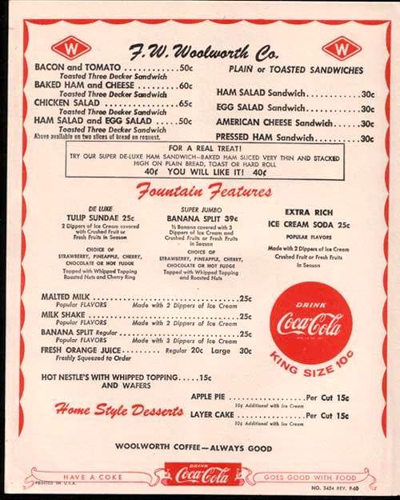

Kenna Hayes King
Class of ‘61
-----------------------------------------------------------------------------------------------------------------------------------------

Charlie Fregeau
n5hsr@sprynet.com

I see several names in the Olney Memories I recognize from Mom’s ERHS yearbook in 1951. I’m sure if she were still with us she’d also have a few comments.
If you think Olney has changed since you guys were in high school (Yes it did, I’ve got the 1963 phone book to prove it!) you ought to see how much my Dad’s neighborhood in Chicago changed. It used to be a nice neighborhood, too. There’s a whole group on FB for it, but the old neighborhood was about the size of Terre Haute!
I wish I could find Barbara. I’m sure she would enjoy these, too.
I recognize, for instance, Bette Schmallhausen.
Oh my, I didn’t know Monte got flunked! No wonder he was such a sour gym teacher. He ended up being in Mom’s class (1951) and I ended up having him for gym 3 years in a row. 7th, 8th and then he got transferred to ERHS so I had him for 9th, too. He must have got skipped a grade somewhere because he was with Mom in 7th grade and ended up graduating with her, too.
I see in #11, someone mentions the Dundas General Store. My grandpa and the aunts used to drive up there on Saturday morning when I was visiting down from Chicago in the early 60’s driving up there in his 56 DeSoto.
You mention Pure Oil in #12. Mom worked for Pure Oil from 1951 to 1954. She worked for Oscar Morgan. Oscar knew Granddad from somewhere. You also mention May Day parades. Somewhere my sister has a tiny picture from May Day 1949 of a little 13-year-old freshman at the high school twirling her baton. In color, no less. That would have been my Mom. She still had the baton when us kids were growing up.
Hmm, Musbach Chevrolet. I remember being sort of friends with Susan Musbach. Too bad I wasn’t allowed to date when we were living in Olney.
That the Olney 1963 phone book was the last in larger print? The last to not have Claremont but only Olney and Noble? The last to have EXpress 2, 3, and 5 for prefixes? Probably the first to have Your Area Code is 618 on the cover? The last not to have Direct Distance Dialing for Olney?
Starting with the fall 1964 phone book, Olney had DDD and the listings were changed from EX 2-, 3- and 5- to 392- 393- and 395- At the same time, Claremont got 869- and was brought into the General System. Noble got 723- a year later. The listings got smaller with the 1964 book, too.
Dad took a bit of getting used to calling Mom at 7F22. In Chicago they had dial telephones. Dad’s number was PUllman 5-8862. Dad was used to dialing at least in Chicago. They even dialed 211 for a Long Distance Operator. What year did they cut over to dial telephones in Olney? Haven’t seen anybody mention that so far, but I’m only up to number 14. I know they didn’t have dial telephones in 1951, because I can see it in Mom’s yearbook. I know they didn’t have at least rural dial telephones in 1954. I know they did have dial telephones by 1962. (Otherwise there would have been some mention of changing the numbers on the cover of the 1963 phone book.) I would have thought someone would remember it. It must have been a big thing, going over to dial telephones and SC 1543 telephones, and later AE 80’s.
Fred Speith took Mom and Dad’s wedding photograph that is shown below. Supposedly it won a prize at the 1954 Illinois State Fair.
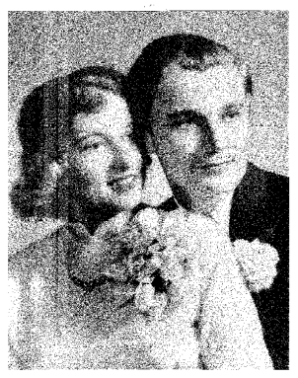

This is my mom and dad’s wedding picture. Donald Charles Fregeau (of Chicago) and Mary Joan Leaf of Preston Township. This is from February 6, 1954. Don is a buyer from the Chicago Pure Oil office and Mary is a secretary who works with Oscar Morgan at the local Pure Oil office here in Olney. Picture by Fred Speith of Speith Studios, who happens to live just right across highway 130 from the bride and her parents. Groom was class president of his high school class in 1946, and the bride is a 1951 graduate of ERHS. They were married in Olney at the Methodist Parsonage. Witnesses were William S Fregeau, the groom’s brother, and Grace Leaf, the bride’s sister-in-law. The reception was held at the bride’s family home in Preston Township. Official photographs were taken by Fred Speith of Speith Studios. Photographs at the reception were taken by George W. Leaf, the bride’s brother. The couple plan to live in Chicago after the honeymoon.
That evening, they were in a hotel in Newton, if I remember right. What I do remember is that they were given a good old fashioned shivaree. (sic).
What no one could see is that a mere 14 years later, the bride and groom would be back in Olney with two noisy boys in tow. Don would have a different occupation, radio announcer. Pure Oil would no longer have an office in Olney, having donated that to found the OCC campus. And the Pure Oil headquarters in Chicago would have moved to 200 E Golf Road in Palatine. (That address is now somewhere near the Woodfield Mall in Schaumburg. The place hasn’t moved, just the boundaries of things!)
Did you know Mom was supposedly the last girl in her class to get married?
Charley
Ann Weesner King
Pianoann97@aol.com
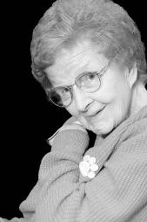

I’m sure many of you remember Mrs. Arrah Jean Shumaker who taught history in the ERHS School District for over 40 years.

Since I have many fond memories of her, as I’m sure many of you also have, I was sad to read the other day in the Olney Daily Mail that she had passed away at the Brandel Care Center in Northbrook, Illinois on Feb 14 at the age of 87.

Ann Weesner King
Class of 1960
----------------------------------------------------------------------------------------------------

Charlie Fregeau
n5hsr@sprynet.com

Well, we only lived in Olney from 1968 to 1972, but we have lots of relatives and ‘visited’ a lot.
I remember, for instance, the 1966 125th anniversary of Olney. Men couldn’t come into town without having grown a beard. Somewhere I still have one of the 50 cent tokens from that celebration.
I went to VBS at the Nazarene Church in 1965, if I remember right. My aunts Minnie and Barbara Leaf were among the teachers. I was down to my grandparents visiting. My parents were gone for two weeks on a ‘second honeymoon’. I spent two weeks every summer through 1966 at my grandparents in Preston Township right on highway 130. Fred Speith lived across the highway. I remember going down to the mailbox to get the mail every day in the summer and Granddad getting his day-late copy of the St Louis Post Dispatch with the 4 color comics on the back page. Granddad used to get up early in the morning and go round to certain oil wells and measure how much oil was in them, for which he got paid a bit. Some of the wells he also supposedly got a royalty check for the oil they pumped out. We used to get up early in the morning and Grandma would make those BIG pancakes and simple syrup for Granddad, and of course, being the curious kid, I had to go, too.
Also went with him to pick up Aunt Barbara from the Shoe Factory. We’d go down and park just before noon on Saturday and wait in Granddad’s DeSoto. And I remember on Saturday, going up to the Dundas General Store and picking up groceries.
When we moved to Olney, our first house was rented in Orchard Heights. The address was then 104 Mimosa Drive, but I understand that it has been annexed to the city and the address is now 2505 Mimosa Drive. Twas there on a Monday night in March 1969 that I began to ask my parents a lot of things about being a Christian. Mom was just going to the phone to call Rev Kaufield to see when he could come over, when who should knock on the door but John Kaufield. I ‘went forward’ the next Sunday, which, if I remember correctly, was Easter Sunday 1969. I remember being baptized on August 3d, 1969 along with Becky Scherer.
I think it was May of 1969 that we moved to 303 W St John, on the corner against Hurn’s Lumber. (Now there is an entrance there, but then there was not.) The house we lived in was old, supposedly built around the time of the Civil War, or so the story goes, and added onto in the 1930’s. Apparently someone had a TV at that house before Olney had cable, because there was still a tall TV antenna mast next to the house. I remember Dad buying plastic gold colored numbers for the front of the house and a new mail box. The last time I passed the house in 1997, the numbers and the mailbox were still there. One day that first summer, Uncle Russell O’Brien drove up with his farm truck. He gave us one of his old worn out tractor tires and in the back of the farm truck was enough sand to fill it, so we had our own sandbox to play in. Somewhere that summer, Granddad brought us an old tire, and we got some rope from the hardware store and made a tire swing out of it.
Then there was Christmas Eve 1969. A truck drove up to our carport from Jones Cycle Shop. I had been riding a little red Schwinn that by age 12 had become too small for me, obviously. Well, the gentleman opened up his truck and pulled out the prettiest blue adult-sized Schwinn Racer I had ever seen. Mom said it was the first time she’d ever seen me speechless. We still have that bike, some 42 years later. Supposedly my Aunt Barbara Leaf bought it for my Christmas present that year and Dennis Seesengood helped her pick out the color. (Blue was my favorite color in those days.) I would go on to ride that bike to ERHS a couple years later.
Does anyone remember Sherry Findlay? (sic)
With this bitterly cold weather we had I had a memory I’m not sure you want to publish in Olney Memories.
The winter I was in 8th grade going to ERJH (the old OTHS building on Main St) from St John St, I remember one day it was like -16 or -20. I was bundled up in like double pants, long underwear, two scarves, etc. etc. I saw this girl. She was wearing a car coat, but it’s what she wasn’t wearing that got me. She was wearing a mini skirt. No leggings, no jeans, not even pantyhose down below. She was going to ERJH same as me and I didn’t see her later that day. Wonder if she turned into a human popsicle on the way to school.
If you were going to turn into a human popsicle, what flavor would you want to be?
Well when we moved to Olney, we were driving an 1963 Chevy II 300 made in Willow Run Michigan. It was a white 2 door sedan, 194 six, 3-speed manual. Since we didn’t have a garage, my job at 12 years old on cold Sunday mornings was to get ready early and go out about 5 minutes early and start the car. This was long before the days of remote starters. (We had remote starters, they were called kids. . . .) The reason I got to start the car early was twofold. First, the car didn’t stay running nicely until it warmed up a bit in winter. Secondly, if it was warmed up, one could used the defrosters to keep the windows clear, and the passenger compartment was warmer than frostbite. I remember Dad teaching me to make sure that the Three-on-the-tree was in neutral, and the handbrake engaged, then to push down on the clutch and the brake when starting, then hold the throttle just a little bit open after starting until it warmed up.
In summer 1970, my dad’s brother Bill had a chance to purchase a 1966 Toranado for his wife to replace the 1962 Corvair he’d bought her many years before. The car was in very good shape, whereas our Chevy II was starting to develop the dreaded front fender rot so common to GM products in those days. He lived over in Florissant, Missouri in those days. Bill brought the car over on July 1st, 1970. We got Aunt Pudd (known as Sarah Helen Taylor, Notary Public to most of the rest of you) to fill in the transfer of plates from the Chevy II to the Corvair. (I still have that paper here.) That was the year George Shipley used his influence with Paul Powell to get GS on Olney’s plates. We had GS 3851. (I still have the plates.) We sold the Chevy II to some family that lived out in the country and owned a 66 Ford Galaxie. I didn’t catch the name. We later heard that during that bitter winter (remember, it got 16 below one weekday) that it started for them when their newer Ford wouldn’t.
Well, now that we had a Corvair, we needed someone that knew how to work on it. Does anybody else remember Mr. Wagy? He was a block and a half down toward Main on Camp from our house on St John. Just behind the FS station next door to Mike’s Ice Cream. I remember riding my Blue Schwinn past there to the FS station, which is the nearest place with compressed air for tires.
And I still had the job of warming up the car. The Corvair was much fancier than the Chevy II. It had 2 speed wipers and windshield washers and an automatic transmission (no Park gear, however.) So again Dad had me check to see that the selector on the dash was in N, and the handbrake engaged before I started it and warmed it up. It took a little longer to warm up in the cold winter Sundays because the engine was in the BACK and the defrosters were in the FRONT and the engine being air cooled took a little longer to get heat up to the defrosters. But when I rode in the car when Dad was driving, I always rode in the back. Still have the burn marks on the back of my ankles from the heater vents, even though they were tightly closed so Dad could have all the heat for the defrosters.
And I got a new job. Because of the placement of the license plates on the Corvair was a bit easier to work on than the Chevy II, I got the job of changing the license plates every year from then on. That was fine with me, I collected (and still do collect) license plates. The first plates I got to take off the Corvair was the single July 70 Missouri plate that was on the Corvair when Uncle Bill drove it over from Florissant. In a few more years, I wouldn’t be just starting the Corvair, I’d be driving it with my learner’s permit and would take my driver’s test on the car up in Danville. But that’s another story that doesn’t have to do with Olney.
But one thing that happened as a result of the Corvair is that Mr Wagy also knew I collected license plates. One day he brought over a nice run from 1942 to at least 1963 and just gave them to me. My earliest Illinois plate at that time was the 1964 from the Corvair (that’s also another story, but doesn’t have to do with Olney) And one day Loren Grimes, one of the people that lived on the opposite corner of our block, found a 1927 Illinois plate in an oil field and gave it to me. (He also gave me his B truck plates after they expired every year.) He worked for Pure Oil and was later transferred to Springfield. Never found out what happened to his daughter Lu Ann.
One of the reasons I started collecting license plates is that in the early 60’s Illinois had very colorful license plates, usually the colors of some college. Those of you that are old enough remember the 1963 plates being chrome yellow on John Deere Green, and 1964 was white on purple which faded to a lavender usually by end of year. How many remember plates of different sizes prior to 1956? Also 1956 was the first year for Amateur Radio plates. Olney’s school colors were on the 1948 plates but not by design, that was just the colors they picked that year.
Is Tom Gallagher related to Lisa Gallagher who was ERHS class of 1975?
Is Nancy Craig related to Lorene Craig (Leaf) who married Dick Leaf?
Found out that LuAnn Goldsmith is on FB. Her dad had me lead the singing in Junior High Sunday School at Calvary Baptist in the 1970-71 era over in the house across the parking lot from the old church.
My problem with writing for Olney Memories is there are two sets. My memories of us actually living in Olney 1968-72 and Mom’s memories of growing up in Preston Twp and graduating from high school and all, plus the collective stories from all the family members including Barbara. Sometimes they merge. Mom had some good stories. Like the time she was arrested for riding her bike nude. The time she wore a 2-piece suit swimming in the Res and walked through a patch of poison ivy. Baton twirling in the May Day Parade as a 13 year old freshman. Monty Forsyth putting limburger cheese on the radiators in the basement of the OTHS building on Main. She took Drivers Ed at 14. Somewhere I have her certificate, it’s number 13, which I presume is #13 for East Richland High School. It’s dated 1948. The day she quit working at Pure and her boss Oscar Morgan came out to the farm to beg her to come back. Somehow Oscar Morgan knew Granddad.
Then there are the family stories. Grandma (Cora Margeret Taylor) supposedly graduated from OTHS, would have been class of 1915 or so. Then there’s the time they lived in Reece Kansas for a while (they show on the 1925 Kansas census.) And Grandma shot a kid in the behind for stealing kerosene. The time Graddad took our dog Pepper hunting.
Charley Class of ’75… if we’d have stayed.

Mary Noerenberg Cummins
cummings_mary@msn.comP

Hi, All! Mary Ann (Noerenberg) Cummings, here. Richard Ray Williams, class of 1960, has begun to put together a special website for ERHS alumni/former students that is absolutely fabulous! I suggested to him that we should do a special section on the music department and he was grateful for the idea. Richard asked that I head up this project in getting pictures together to put on the website in this special section. I have only scratched the surface of my own pictures and those of Ann (Weesner) King. (a few examples are below)

I am asking any or all who would be willing to share their picture memories with everyone of any musical event (marching band, concerts [both junior high and high school], musicals at the high school, etc.). If you are not able to send them to me digitally via e-mail, please feel free to send me your pictures to my home address so that I can scan them. I promise to get them back to you in a prompt manner, unharmed! My "snail mail" address is P.O. Box 237, Pesotum, IL 61863. My e-mail address is cummings_mary@msn.com. Your pictures will be properly marked as to whom they belong when posted on the website.

Looking forward to hearing from many of you! I'm attaching a picture of the Pen and Ink drawing my Dad received at the Sliva Salute in 1989 that Richard has incorporated into the www.erhsalumni.net/ website. Please feel free to become a member (it's free!!!) and keep track and get back in touch with old friends from school. At this time, we are trying to achieve a membership of over 300 by mid-March. When you become a member, tell them I sent you!!

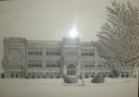
ERHS High school 1915 – 1952

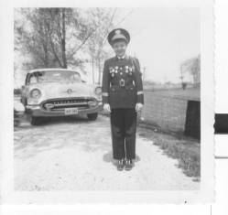

Ann Weesner - junior high 1956-lots of medals!

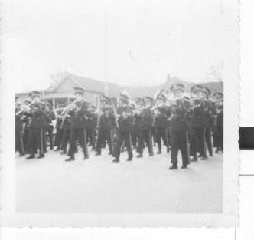
1957 HS band in May Day parade

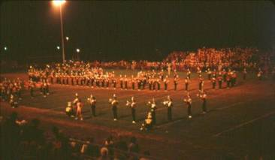
1964 ERHS band at Vincennes Marching Band Festival

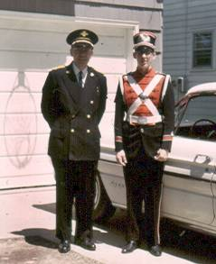
Mr. Noerenberg and son, Paul, ready for May Day parade 1965
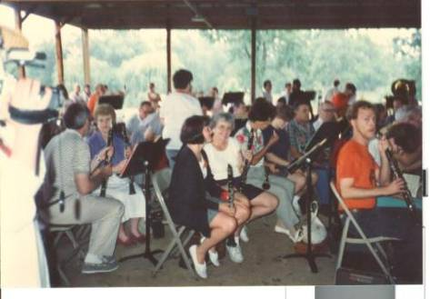
The Silva Salute Band preparations.

Mary Ann (Noerenberg) Cummings,
cummings_mary@msn.com
Class of 1970
====================================================================
====================================================================

============================================================

