OLNEY MEMORIES # 82

Many of you have sent me your new email addresses. I realize there have been numerous e-mail address changes, especially in the Olney area, and if yours has changed please remember to let me know.

Here’s wishing you and your family a Happy New Year!

Ann King
Pianoann97@aol.com
Class of 1960

-----------------------------------------------------------------------------------------------

Olney Memories # 82
December 27, 2010
--------------------------------------------------

Nancy Poland Hocking
bnhock@live.com

Just thought I would let Pat Scherer Vancleve know that when I worked at the telephone office I was paid 35 cents an hour. I worked in 1945. I thought this was really great. I tried baby sitting and would get $.50 for a whole evening which might run into early morning hours. Those were great days but I really wouldn't want to go back. Ann we do so enjoy getting the memories and thank you so much for all your efforts.

Nancy Poland Hocking
Class of 45

----------------------------------------------------------------------------------------------------------

Mike Eckel
mikecr5@wabash.net

I thought that some of the readers would be interested in hearing that Marshal Provines passed away recently. I don't know when he started at ERHS, all I really remember about him is that almost every conversation I had with him had to do with hair length or the joys of detention. I've always wondered what he would have thought about seeing the boys walking around with shaved heads or the haircut where they only had hair on the very top of their heads (a very extreme flattop). To me it seems like the bald look is much more distracting than hair that went below your collar line.

Mike Eckel
Class of '72
----------------------------------------------------------------------------------------------------

Bill Sager
bill.sager1@gmail.com

(Don't forget the (.) dot between bill and sager) I might not get your e-mail.

I want to say 'Thanks' to Julia (Maas) Rooney for submitting my name on the 'Olney Memories'. And a 'Big' Thank You Ann, for sending me the 81 OM's to read. I just finished OM #18. Boy, do I have a way to go. (o:

I'm not a native of Olney, but my folks were raised in Richland Co. They married in 1928, Moved to Borger, Texas. That's were Max & I were born. Dad worked in the Oil Fields.

A Big S.W. Wind blew us into Olney in the winter of 42. We started back to school at Central, I, in the Seventh Grade and Max in the Third or Forth? Dad went to work for Pure Oil about that time.

What I have read, has brought back some of the best years of my life. (Teens) I read about Gher's on South Whittle. It was Tucker & Gher's Grocery then. I worked three summers there, helping Mrs. Tucker clean and cut-up chickens, stocked shelves and etc. Worked at the Coca Cola Plant, Burned Rubber on Main, Hung-out at Schmalhausen's, Seen as many Westerns I could afford at the Roxie Theater. Went to the Acadia. The list goes on.

Will write more when I catch-up on all the OM's. Just wanted to say Thanks for the Memories

Bill Sager
Class of 48

Tim Jones
unclefroggie@netscape.net

http://www.youtube.com/watch?v=kBmzc3CzVeY Titled unst on You Tube is the first part of the prologue to the Ghost House of the Anglin' Road. I haven't completed the project. I hope to improve the video and get better narration. As you can tell I don't have a very good speaking voice but several people told me I should narrate. It is very hard to do without making mistakes. I narrated a little portion of the first part. first So I used the computer to create a voice with a British accent. I always admired the actor Christopher Lee who made a lot of movies, Hammer films Dracula, I tried to make the voice sound like him. I hope to find someone who will do the narration in the final edition. Also although I used a high definition camera for some of the scenes, not all from the Anglin' Road, and some of my own , the quality is very poor and doesn't seem to transfer to You Tube although some times HD is available. My intention is to just generate an atmosphere.

http://www.youtube.com/watch?v=3OC1fEM_3Dk titled Production 1 on You Tube is the second part of the Prologue and contains a little of the first part. Couldn't get the whole piece to tranfer to You Tube. So the start of the second one has the same opening as the first, but continues with the rest of the prologue.
This is a childhood memory and is not intended to be taken too seriously nor entirely accurate. Just a story. I will keep working on this project one of my many hobbies. The Ghost Horse of the Anglin Road is in the works and hopefully more stories from the Anglin' Road Chronicles. The Anglin' Road Chronicles is meant to be a series of stories sort of like the Twilight Zone.
Comments welcome but be kind, I’m a sensitive artist. This is an exclusive for Olney Memories.

Tim Jones
Class of ‘66

Ann Weesner
Pianoann97@aol.com

When we were in Olney for my 50th Class Reunion this past September we were driving along on Route 130 and I suddenly saw the Anglin’ Road that has been mentioned several times in the Olney Memories by different readers. I asked my husband, Richard, to pull over and take a picture of this memorable road so I could post it in the next OM’s. Of course, little did I know that Tim Jones (above) was going to send in a contribution for this very issue about the road. It seems the Anglin’ Road has been a big part in many of our memories of Olney.
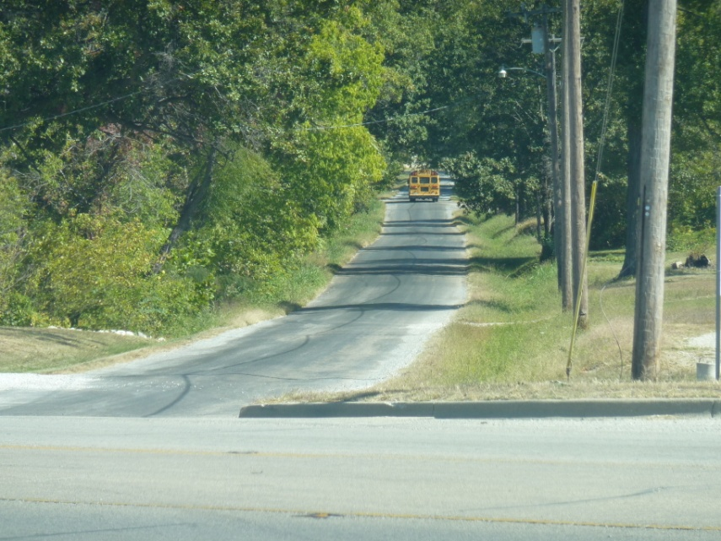

Since I had heard that the 130 overpass nearby might eventually be torn down for widening and has been there for as long as most (all?) of us can remember, I decided to take its picture for this issue.

==================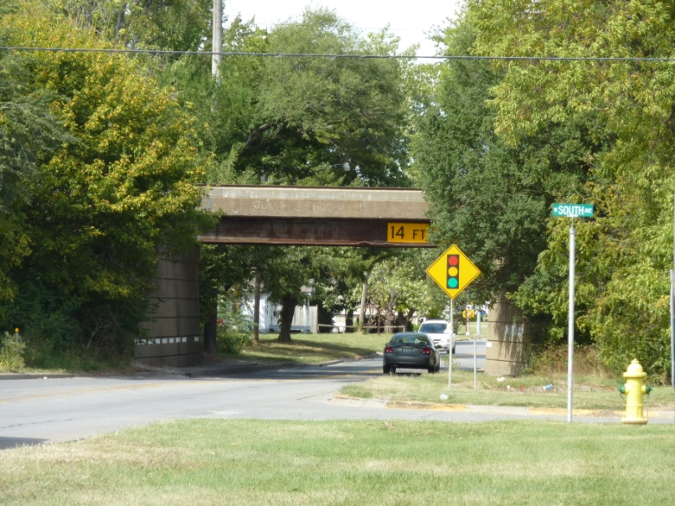

Ann Weesner King
Class of 1960

Richard Williams
rrw41@earthlink.net

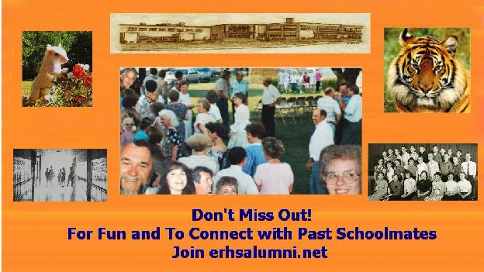

Hello Ann and all ERHS alumni! I'm writing to you to share with you our new website for all who attended ERHS. The goal of the website is to keep us connected as fellow schoolmates. Take a look. For a limited time you can look at most of the public pages by using the password of olney. First go to erhsaluni.net (That's NET). When you get a pop-down with two boxes, one for new members and guests, key in the letters olney (all lower case) in the guest box.

You are welcome to join! Indeed, I hope you do. If you find a 'page' waiting for you, you can join on your own. If not, then you'll have to follow the steps to notify me of your desire to join. No problem, just a few emails and a simple process.

I am the 'owner' of the site and truly hope to make it a communications center for all who attended school in East Richland. Thanks,

REMEMBER, THE PASSWORD IS OLNEY (For a limited time)

Richard Williams
erhsalumni.net
Class of 1960

