Olney Memories # 78

April 30, 2010

Again it’s time for Olney Memories. The updated OM’s Contact list will be sent out separately after you have received this. Remember to keep sending in your own memories!
I hope some of these recent memories trigger some thoughts before too long from some of you who haven’t contributed for a while.

Ann Weesner King
Pianoann97@aol.com
Class of 1960

---------------------------------------------------------------------------------------------------------------
-----------------------------------------------------------------------------------------------------------------
Sue Adamson Fritz
trinity400@gmail.com

Ann: Thank you so much for including me in the Olney Memories mail list. It is amazing to see how it has grown over time. I am not from Olney, but my great-grandfather and my grandfather were both natives of Olney. I am an active genealogist and would like to learn more about the family that remained there. If it is alright, I would like to ask your readership if they remember or know anything about the family that I am writing about. I would like any memory/knowledge, both good and bad!
I have visited Olney several times. I remember visiting there as a child, as we still had family there. I took my dad there for an afternoon last summer and we drove past the 2 family homes there and went to Ebenezer Cemetery to see where Moses and Lydia Bullard Adamson, our ancestors were buried.
Moses and Lydia Adamson had 12 children and after that, informally adopted our "Aunt Edna". Moses and Lydia lived at 317 Richland. Moses died in 1917, and Lydia died in 1935.
Edna married Ray Ferren and they lived at 606 E. Elm. They had a son, Castle Ferren.
The great mystery of my dad's life is to learn who Edna's parents were. She was born in 1897, and was raised by the Adamson's. She was our beloved Aunt. When her son,Castle, died there was some indication that Edna's birth name may have been "Norris" and that she was born near Norris, IL; Lydia Bullard Adamson's first cousin, Mary Bullard (daughter of General Bullard) married Oliver Norris in 1878. Mary had a daughter (Elmira "Ella") who would have been around 17 when Edna was born. (Mary Bullard Norris then married Stephen Fryman in 1886); This is, of course, speculation, but I wonder if anyone from Olney might know some information on this old mystery!
My Dad is 83 years old and still wonders about his aunt. By the way, my grandfather was Arthur L. Adamson born in 1885 in Olney. He lived there until he left for college, where he attended Westfield College, then married my grandmother (who was from Vigo County IN).
Anyone know anything of these families?
Sue Adamson Fritz

============================================================
Chapter 4

Dean Adams
imbumbie@comcast.net.

This is the conclusion of my memories of people and events during my Olney days.
During the summer of 1942 I got my drivers license and I had saved enough money to buy a car.
Our scoutmaster, Morris Byrd had been a pumper or gauger for the Pure before moving to the Pipe Line gang. He had a model A coupe equipped with mudgrip tires he used to get around to the wells and tanks in the field. His asking price was about what I had available so I bought it.
I drove it all through my senior year and into my first year at Millikin.
Here’s a bunch of us off on a safari.

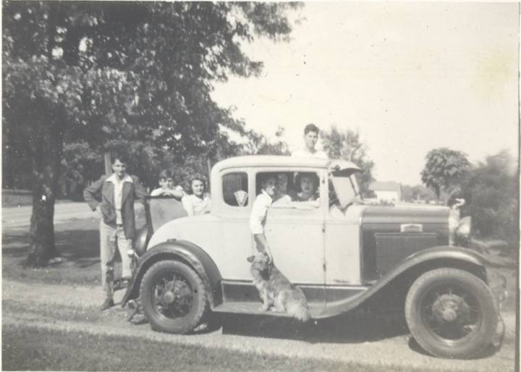

I remember driving to Newton, Flora and Lawrenceville to the ball games but I don’t remember how we got four people in the from seat.
At that time Louis Stivers was star football quarterback, Keith Sutton was equipment manager, Jackie Eaton and Jerry Hovey were junior and senior cheerleaders. Louis went to Eastern then to Carlinville as coach then principal (I think). Keith became a surgeon in Tulsa and Jerry became famous for founding Hovey’s Hamburgers. I never had the pleasure of tasting one.
During our senior year in 1942 classmates Donovan Conour and Loy Mackey drove model A sedans and Tom Massey had a model A like mine. We did some minor drag racing but his engine cylinders had been bored to a larger diameter than mine and would run faster. Keith Sutton drove ’32 Ford pickup from their farm on the Pump Station Road.
We enjoyed the Pump Station Park in those days. South along the river was a driveway to the home of a family that made and sold archery equipment, bows and arrows etc.
After our retirement, Keith and I enjoyed the hobby of metal detecting. At our 45th reunion in 1988 he mention that the west side of 130 somewhere opposite of the City Park there had been an event that caused people to gather and the area should be good detecting. I presume this is about where the Community College or Walmart distribution center is now.
While in Olney at that time I detected City Park and opposite the swimming pool to the side of the swings that were there then, I found a 1942 silver Mercury dime. I wonder if I could have lost it at that time. I also hunted Millers Grove and found a 1937 wheat ear penny.
Speaking of Walmart, I told my daughter, who works for them at their corporate office in Bentonville AR, about an OMer mentioning that Sam Walton had been interested in Olney.
Of course we dragged Main Street like all generations. Gas at the Star Station on West Main was 15 cents.
I had a spotlight on my car and Oakey Grubb wasn’t too happy about me flashing people on the downtown Main St. sidewalk. He told me to take it off but I talked him out of it later.
Don Gray (’44) and I spent a lot of time playing pool at the City Cigar Store. Bill Propes was the proprietor. He was the father of Norma Propes (’41). There was also a pool hall on the corner west across Walnut from Lucile’s.
On Sundays when the pool halls were closed we would go to the basement below Piper Hardware where there were a couple of pool tables. Some called it the Rat Hole I believe. Access was by a stairway in the sidewalk between Piper’s and Bonds.
Don worked at Musgrove’s for a few years after he got out of the Army. He said he was the best-dressed guy in Olney. He married Louise Laughton (’44). He later joined the Pure and worked at the tank farm near Noble. He was then transferred to Kansas then here in Colorado.
Both Tom Massey’s dad and mine were Masons. That year Tom and I went to DeMolay meetings and events held in the Masonic Temple across the street from the Methodist Church.
That fall or winter I got the A stuck in the mud on the west side of the skating rink in the tent behind the grandstand at the Fairgrounds. I spun the wheels until they were deep in the mud. I had to leave it overnight. The next day Reuben vonAlmen (’44) came and waded out in the mud. He grabbed the rear bumpers and lifted the rear end up and set it on dry land. I asked his brother and OM-er Bill (’45) if Reuben had back trouble in later years. Bill though maybe he did.
Reuben drove a 1920s Buick type heavy car. He had it rigged with a model T magneto so that when he parked he would gently touch bumpers with the car in front or back. When the owner grabbed the door handle he would get a terrific shock.
I was in Olney sometime in the 70s or 80s and was talking with one of my chasing around buddies Bob Wimer (’44). He said that earlier he and Reuben were partners in an oil well and pipeline equipment recycling business.
Mr. Snively was my homeroom monitor in study hall. Ralph Weber (’44) sat beside me. He could sign Mr. Snively’s name on a library pass better than Mr. Snively could.
As was the tradition, the senior class marched in the Mayday parade, see below.
Shown up front left if Bob Edmiston, myself, Ralph Bower, Donavan Conour and
Kenny Schrey in back. Willard Gray is behind Kenny out of the picture.
Bob studied journalism and worked on a paper in Shelbyville. Ralph and I studied Mechanical and Aeronautical Engineering respectively. Ralph went to work for General Electric Co and I, failing to become a rocket scientist, played trombone on street corners for nickels and dimes.
Donavan specialized in retailing and worked in Robinson and Kenny became a building contractor there in Olney.
Willard went into the army out of high school and made it a career. He retired as a Sergeant Major. His wife served in the Nurses Corp with General Patton. She is honored with a plaque and gazebo in front of the Olney Memorial Hospital. After retirement Willard became a gentleman farmer and became an acknowledged writer. He has two published books available at Amazon.com or Barns and Nobel. Type Willard D. Gray into Google for full information.
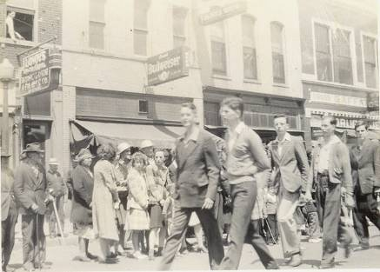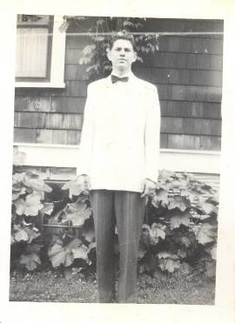
`

In June of ’43 I went to the senior prom. Jackie Eaton preformed a dance number at the prom. I believe this was the year she married a GI named Provost from George Field. For the prom I borrowed John King’s white jacket (see above). John was Richard’s older brother. (I had a white sport coat but no pink carnation-ha)
After graduation from High School during the summer of 1943 Ralph Bower, Bob Edmiston and I went to the National Youth Administration (NYA) camp near Mattoon. This was one of the depression fighting programs that President Roosevelt had in operation. Ralph and I learned machine shop and Bob learned welding. About the middle of the summer the program was cancelled. Ralph and I went to Indianapolis and Bob went to St. Louis to work in war plants.
About that time Loy Mackey went into cadets in the Air Force.

The fall of 1943 I entered James Millikin University in Decatur. Soon after I sold my model A and bought a 1938 Ford V8 from my classmate Vernon (Sleepy) Kurtz.
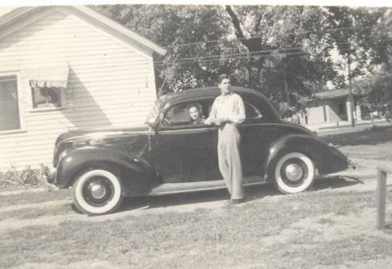

During that winter my folks moved closer to downtown, still on Main Street. They lived caddy cornered across the street from Burches.
At that time the Little Brick Inn was still there next to Burches store. Do any of you OM-ers remember the picture that was on the wall? It was a large painting of Custer’s last stand. At Burches store was a red headed lady named Joy. She was still there in the ‘70s I think; a very long time anyway.
During that winter Ralph and Bob went into the service, Ralph in the Army and Bob in the Navy.
On the way home from Millikin that spring of 1944 highway patrolman Cecil Stallard pulled me over just north west of Newton. He just wanted to visit. He was a friend of Dad’s.
That spring I went over to George Field and enlisted in the Army Air Corps Reserves. I also took my car to Hocking Auto Parts on Walnut for some minor repair and a new paint job. Max (’44) and Bob (’46) Hocking did a good job.
During the summer of 1944 I worked on a gang for the Pure based at the Noble tank farm. Our job was to cut and stack brush off the big pipeline from Noble to the refinery at Martinsville. Beside myself, the gang consisted of George (Brownie) Brown (’46), Harold Schmalhausen (’46) and Jack Forest (’45).
Harold was the son of the proprietor of Schmalhausen’s. Jack, you remember from earlier OMs. General Jack had retired during the ’80s in Colorado Springs. I called him once but his wife said he was out shopping.
During the summer Don Gray and I did a lot of chasing around. We would stop in occasionally at a new teen center at a house on the northeast corner of Main and Boone or Morgan.
We also went out in the country for chowders. We had trouble finding a parking place at a chowder at a crossroads near Stringtown. I enjoy the chowder we have here at our retirement village at one of the dining rooms. It tastes just like I remember back home. The only trouble is they only serve it every five weeks. I see on OMs by the next generation that most chowders are in town now at the park and churches. Time changes everything.
I was going home one night about 1 AM from the other side of town and I noticed a car following me. When I got home, parked and got out, there was Oakey Grubb. He wasn’t happy about my going through a stop sigh up town. He was driving a pretty ‘36 Ford sedan with a brand new Washington blue paint job.
After the war I was talking to Reuben vonAlmen and he had bought Oakey’s car.
In the ‘50s when I was in Olney I talked to Oakey while standing in front of the Court House. He was chief then. I don’t think he remembered being unhappy with me ten years earlier about the spotlight and stop sign. He was a good old boy; he never did arrest me, maybe he should have. He must have been a cop an awfully long time.
Ralph and Bob came home on furlough that summer of 1944.

Ralph Bower Me Bob Edmiston
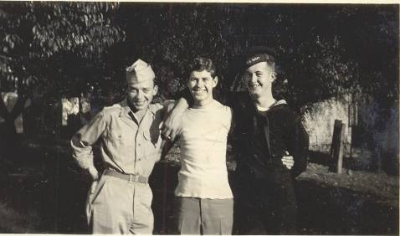

The following school year at Millikin Ralph would come over on a pass from Camp Grant and we did some more chasing around.
After finishing my sophomore year at Millikin in the spring of 1945 I was called into the Air Corps. Since the war was winding down I was sent to airplane mechanic school instead of cadets. This was about the same time Loy Mackey received his commission and was home on furlough.

Loy Mackey
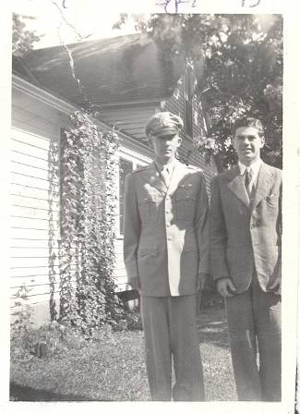

When I was home on furlough in ’45 I was driving a girl I was dating home to Noble in Dad’s ’38 Chevy. We were driving west on 50 (that was before it was 250 and you crazies were using old 50 for drag racing). Where the Olney-Noble Airport was to be later there was a repair barricade in the road. I don’t know how this could have happened. I wasn’t driving very fast, maybe 10-15 mph, maybe less. (Might even have been backing up)
Anyway I missed the barricade and learned a valuable lesson. Don’t worry about seat belts, we didn’t have any and never roll your car sideways. Always flip it end for end. The only damage to either of us was a glass cut on my shoe.
.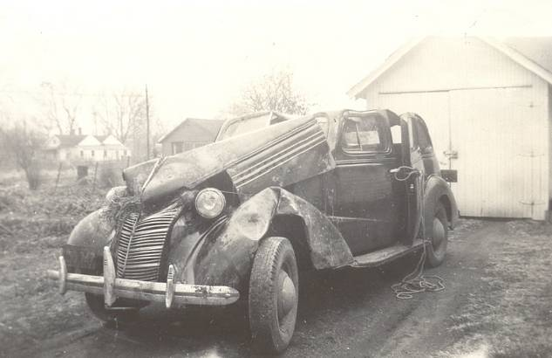

Dad had the car rebuilt good as new at Hocking’s; same place I had my car painted during the summer of ’44. That old ’38 Chevy took a lot of abuse, however it ran well until Dad traded it in 1950.
After I was discharged from the Air force, having spent my service time in the Caribbean, I started my junior year at the U of I. Ralph and Bob had been discharged earlier and were studying at the U of I already. Loy decided to stay in the Air Force for a career.
After graduation from the U of I, I took a job at McDonnell Aircraft in St. Louis. While there I ran into Jay Eaton, Jackie’s brother, who was already working there. He later became a Vice President of one of Martin Marietta’s facilities. He and Jackie came to visit us while we still lived in St. Louis. She was teaching dancing at that time. I don’t remember if she had married Leland Jared by then or not.
While living in St. Louis we were able to come back to Olney quite frequently. Olney was designated the nations center of population. A marker is located nine miles northwest of Olney and was located there on October 18, 1951.
The National Plow Matches were held northwest of Olney on Onion Hill on September 16, 17, 19, 1954 attracting many people in Richland County. Onion Hill is located on Fox Prairie, scene of Willard Gray’s first book.

My folks, who came from farming families, were interested in the proceedings. I attended one event with them. Seems like the point of the matches was to see who could plow the straightest for the longest distance.
During the ’70s I had a ranch in Arkansas and was able to return to Olney for an occasionally visit. My Dad died if 1976 and I spent a little time in Olney at that time. Mr. Snively had been a friend of Dad’s and he signed the guest book. I didn’t get to see or talk to him however.
Bill Hull ('45) and Wanda Rone ('45 ) who married Bill were operating an appliance store in a house a few doors east of Dad’s home. This was the only commercial operation at this time in this neighborhood. According to OMs by Gloria Dean and other Deans, several stores and offices were in later years where Dad’s and the Dean’s grandfather’s home was. This is caddy cornered across from Burches Store. I understand there is a Sears store there now. Louis Stiver’s uncle’s house next door to the Dean’s would also have to be removed. I also understand a Speith Studio is directly across from Burches. This could be where the Hull’s store used to be.
I have a problem with the Olney’s city fathers. They have a sickness. First they tore down good old OTHS. Then they tore down my folk’s first house then my folks second whole neighborhood. Then they tore down Gaffner’s. Now they have or are going to tear down Central and the swimming pool and I don’t know what all. Sheeesh.
During the time of Dad’s death I sold his house to Ann Bowlby Jones (post- ’46). Her husband Bob Jones had recently started Bob Jones’ Truck Line. Ann bought the house for their son and his wife.
I came to Olney in 1988 for our class 45th reunion. I paid a visit to Ann at that time. Bob Jones had recently passed away. I had left some of Dad’s antiques and tools in his garage. Ann’s son hadn’t disturbed them. He let me take the outboard motor that I mentioned in chapter 2 with me.
I have been an OM-er only a short time. Many of you have read Ann’s mailings of your OMs for quite a few years. Ann tells me there are well over 600 on her email mailing list now.
When I started reading the first OM after Ann found me on Facebook I received my first memory spark. After reading all 74 OMs that were released at that time, my head was full of memories.
As one grows older he focuses on his memories and reveries and puts them in perspective. That is what happened to me while writing my memories of Olney. I realize that I was getting “flash” memories, i.e. memories that just popped in my head. Also I was getting “spark” memories, ones that came from something I read, saw or heard.
And finally I was getting, or trying to get “request” or command memories. These are ones that try to come when someone says, “do you remember?” Also when you try to remember some detail relative to a flash or spark memory. They are the most evasive of all three memory types. The missing Sally Rand memory in chapter 2 is a good example.
Once again I’d like to thank all of those that I’ve emailed and phoned for memory help. We’re few but I’m thankful there are as many of us left as there are. I hope that these 6700 words of memories will give you additional memory “sparks” for further contributions to Ann’s Olney Memories.
In conclusion I’ll mention that after my retirement from Martin Marietta one of my hobbies was restoring model As.

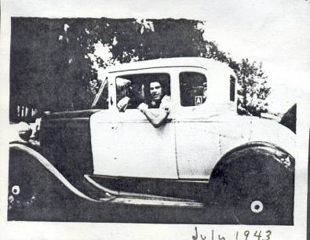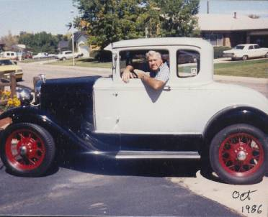

THE END (for now)
Dean Adams
Class of (’43)

