Olney Memories # 77

April 6, 2010

Here we are already at Olney Memories #77! Following this issue you will be receiving the OM’s e-mail communicating list in a separate mailing. Also thanks to everyone for letting me know when your email address changes.

Ann Weesner King
Pianoann97@aol.com
Class of 1960
================================== Chapter 3 Dean Adams (’43)
: | imbumbie@comcast.net

Continuing with my memories of people and events.
At this time I’d like to take time to thank all my fellow OM contributors, schoolmates and others for helping me keep my memories in order.
In 1939 I went to OTHS as a freshman. Along with me went Mr. Snively from Central.
This picture of OTHS brings back many memories for me. The parking space to the left of the cars is where I parked my car during my senior year.
One year, it must have been in early spring, I was walking in the front of the school when Mr. Clark, the agriculture teacher, was teaching a group of FFA boys how to trim trees. He was using the tree in front for demonstration. For some reason I became interested and stopped to listen. It came in handy in later years.

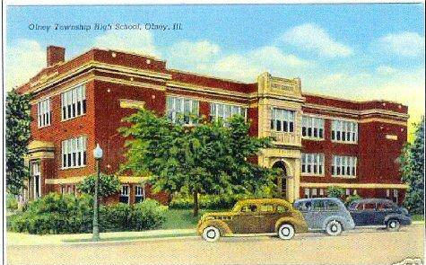

This was also Gus Sliva’s first year. He came full of ideas. He had our marching band doing all kinds of things. One was he got us batteries and flashlight bulbs for our caps. While the band was performing at half time at football games the lights would go out and we would turn on the bulbs and our formations would spell out something.

Gus Sliva
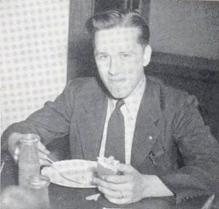

Here we are marching in the May Day parade in 1940,

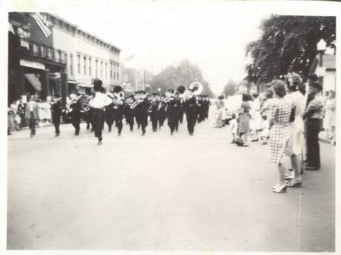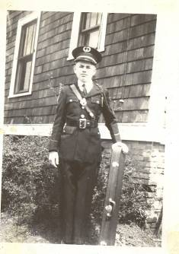

Gus took us to Slanker’s Woods several times for weenie roasts. We did a lot of marching drills. Harry Lee Fessel (’42) (later proprietor of Gaffner’s) would rat a tat tat on the drum. Harry Lee married Eva Dunaway (’42). Classmate Glen Iaggi was also in the band playing baritone. He later became Vice President of Motorola. He returned to Olney and built a million dollar home on East Lake.
I played trombone and stayed with the band from 1939 through 1942 until Gus went to the service and Mrs. Jack Germer took over the band. I didn’t play in the band my senior year.
In the early ‘70s while living on my ranch in Arkansas, I visited my Dad in Olney. I was standing at the counter in Gaffner’s getting a battery for his watch and there was a man standing next to me. I wondered why he had such a puzzled look on his face. It wasn’t until sometime later that I remembered it was Gus. I wished I had remembered him at the time. I would have said, ”There are thousands of us and only one of you so it’s no wonder you can’t remember”.
At this time I was engaged in stamp collecting. Dean Smith (‘46) and I would take old rags to the Taylor Print Shop on Chestnut and trade for stamps. OMer Marshall Dodson said he did the same thing. Dean Smith became a school teacher in Westminster, here in Colorado and later a principal.
I believe it was the summer of 1940 when Jackie Eaton (‘44) and her Mother came to live on the LeMay farm. The LeMay’s were Jackie’s grandparents. Jackie’s brother, Jay, was going to school in St. Louis at Parks Air College and her father was an agent for the FBI and was rarely home. I don’t recall for sure how Jackie acquired her dancing skills. I would rather believe she had been taking lessons since she was a child where she came from.
In my sophomore year in ’40-’41 I began a series of mathematics classes under Mr. Brown. He drove a badly faded gray 1937 Chevy sedan. Also, if my time is right, Police Chief Bill Armsey was shot and killed in the line of duty. He was the father of my classmate Francis and George Armsey (‘41).
I must have done a lot of swimming in the pool the summer of ’40 since I contacted an ear infection from the chlorine. Doctor Jackson used a heat gun, which looked like Buck Roger’s, to dry it up. Early in my sophomore year while in the library Loren (Shorty) Dellzell (‘41), Vernon Cassady (‘41) and George Armsey (‘41) were concerned about my protruding ear.
That year I fell in love with young Miss Claribel Lee. I remained in love with her during my school years. Later she married a Mr. Benson and they built a trailer park in the north part of Olney.

Claribel Lee Benson Loren Cammon 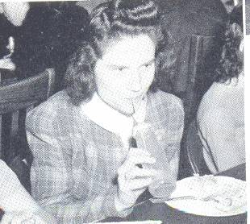 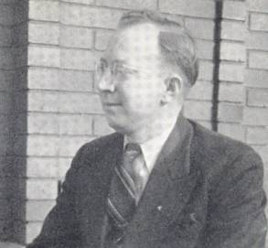

Loren Cammon was my biology teacher that year. I remember he told a lot of jokes; some were funny. He wore rose-colored glasses at the time. He took us on a field trip to Bird Haven. (How can I remember that large Morel mushroom I found when I can’t even remember what I had for breakfast?)
I heard later that Mr. Cammon had moved just outside Colorado Springs here in Colorado after he retired. I never got down to see him until he moved back to Olney.
That year they started dances in the gym and I learned to dance. Johnny Von Allmen (’41) was sort or my dancing mentor as well as Jackie Eaton. He showed me how to dress and showed me how Mr. Cammon danced with Mary Jo Bracy (’42). I danced with Jane Hampton (’44), Joy Forsyth (’44) Joann Nooner (would have been ’44) and others. Jane married Charlie Jones.
Johnny had quite a career. He was a notable trumpet player with many awards beginning in grade school at Central. During his last years at OTHS he organized a dance band with Gus Sliva playing sax and Jim Butler playing sax and clarinet. I can hear them in the gym playing Dipsy Doodle. A few years later he would come home from college with a clarinet-playing friend and they would really swing it out with Red Morris at the Triangle out on West Main.
I recall dancing a lot with Lois Olsen (’42) in the basement under Bond’s by music from a jukebox. We accessed it from inside the drugstore past the booths.
The year 1941 has an exceptionally large number of memories for me, both things I did and things that happened.
During the summer in addition to going to Camp Walton I went to Camp Kosciusko on Winona Lake in Indiana with Richard King. Later Richard and his brother John (’41) became proprietors of King’s Furniture.
It was this summer that our scoutmaster, Morris Byrd, took us to Spring Creek State Park in Indiana for a campout. Also the scouts conducted a scrap metal and paper drive for the war effort. We used Ralph Bower’s ’34 Plymouth with the back seat removed for a truck.
I had a scout patrol called the Wolf Patrol. In it was Charles Tarpley (’46) father in law to OMer Una Tarpley. Also included were Oscar Forney (’44) and Ted Cox (’46) fellow OMer. We took hikes west on the railroad tracks to the trestle and northeast to a little stream for cookouts. The latter was probably where East Fork Lake is now.
During that school year I was working on my long jumping for the Boy Scout athletes merit badge in the front yard. I’d see Jim Butler walking out to see Jackie Eaton. He must have had a terrible crush on her to walk all the way from his home near the Farm Bureau, over two miles. I believe it might have
been the city limits or almost.
George Bailey (Cotton Top) also was walking out that way to see Anna Mae Spangler (both ’47). Evelyn Gill (’46) (she married Richard King) told me they got married. This must have been the longest High School romance in our generation. .
Jim Butler married a cousin of Jean Vandevord (‘46) from Belleville. He became an announcer on Olney’s radio station WVLN. After that he was announcer on station KMOX in St. Louis. After that he went to California where he was a news anchor or something.
That year I began working and saving to buy and later maintain my first car. I opened a savings account at the First National Bank. Fred Newton worked there for an awfully long time. He graduated from Millikin in the ‘30s. I attended Millikin myself after graduation.
I ushered at the Elks for free movies, caddied at the golf course and washed windows for Jane Hampton’s mother.
I shined shoes at Iaggi’s Barber Shop. This was on the south side of East Main east of Fair. It was between the American Brokerage and Wachtel Sister’s Millinery Shop. I believe King’s Furniture was next then Montgomery Ward at that time. I may be wrong. The American Brokerage wasn’t listed in the ODM’s 1941 list of stores that Ann had in an OM. It was either an oversight or I’ve gone crazy. Either one is possible.
My classmate, and one of my chasing around buddies, Donavan Conour worked at the American Brokerage.
I believe next I worked at Kroger’s on the northwest corner of Whittle and E. Market St. across from Bower Park. That was Olney’s only Kroger store at the time. However they put in another one I believe in the vicinity of King’s Furniture during the time I worked there.
For a while I substituted for my friend and classmate Tom Massey who was a bellhop at the Litz Hotel.
In the spring of 1943 I washed cars and pumped gas at the Marathon Station on the corner of Boone and East Main. This station had a different brand either earlier or later according to some of the OMs.
Olney’s 100th year centennial and celebration was during the summer of 1941. My dad, as well as most of the men, grew beards. Refer to other OMs and Olney History for details.
Hurn Lumber Company’s entire block at the corner of Walnut and York was consumed by fire. Classmate Wid Miller helped fight it by manning a fire hose while I yelled support.
During my junior year in 1941 I took Latin under Miss Smith. I sat beside George Shipley (’45). We used to play tricks on her by holding blank pieces of paper in our hands to make her think we were cheating. She would always catch us and smile. I liked Miss Smith. I dated her younger sister Hazel Balding a few times. I took Spanish under Miss Hovey the next year. I wish I had taken Spanish both years since I spent my service years in Puerto Rico and our country is invaded by Latino’s.
George Shipley went on to be Congressman for several terms. After retiring he moved to Florida and was a lobster fisherman for 18 years. His brother, my classmate Bill Shipley, was County Sheriff for many years. After retiring he moved to the Rez.
Our Latin class was on the second floor at the west end of the hall with the windows facing west. While we were in class one day a B-25 from George Field buzzed the school a few feet above from the west. It sounded like it was coming right through the window. Miss Smith was so scared I thought she peed her pants.
About this same time in 1941 a B-25 landed for some reason at Ulrich Field, Olney’s airport at the time. This was on the south side of 50 about a mile east of Bateman's Auto Parts (we called it the junk yard because we went there often for car parts). It must have been spring because the plane got terribly stuck in the mud and couldn't take off. Heavy equipment from the Pure Oil Company had to pull it out.
I think this airfield was the second one in Olney. The first one was north on N. East Street across the road west of Miller’s Grove. At least it was there in 1938. It sounds like the location of Bower Knolls as told on someone’s OM. Behind Miller’s Grove was Bird Haven. When East Lake was built it covered Bird Haven and part of Miller’s Grove. The last airport was Olney-Nobel as far as I know.

TO BE CONTINUED

Dean Adams
Class of ‘43

Harvey Zimmerle
HARVEYZimm@aol.com

These are photos taken this year in the spring of 2010 of Bird Haven in Olney, Illinois taken by my cousin, Debbie Jones, who lives in Olney, IL.

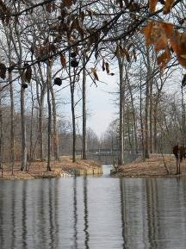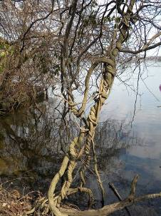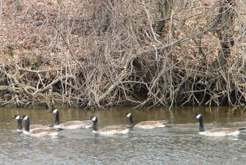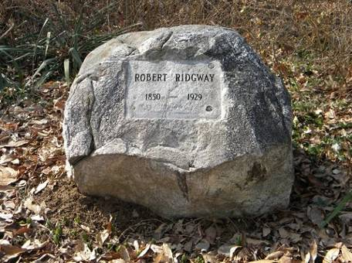

Harvey Zimmerle
Class of ‘71

