Olney Memories # 73

January 8, 2010

Welcome to Olney Memories # 73. Hope everyone had a good year and is ready to start another New Year.

Please remember to send me any e-mail changes if there are any.

Since there have been some more changes for the Communications List, I’m again sending along the updated names and addresses so everyone can keep in touch with one another.

Ann Weesner King
Pianoann97@aol.com
Class of 1960

---------------------------------------------------------------------------------------------------------
Susan McCarty Hall
sjanehall@sbcglobal.net

Dear Ann.
I remember when we were seniors and Rock Hudson came to visit his uncle who
worked in Gaffner's. Several of us were at Lynn Miller's house, and Rock's cousin,
Jerry Shearer brought him by. We took turns sitting on his lap, and he was very
handsome. When he returned to CA he sent each of up an 8 x 10 glossy picture.
I still have it.

Susan McCarty Hall
Class of 1951

Janet Tuttle
jjtuttle@flash.net
Hi Ann,
I always look forward to the Olney Memories and enjoy them so much.
Just a personal note about Elaine Shepard. I was born on April 25, 1933 in Olney, and my mother gave me my first name, Janet, after the movie star Janet Gaynor, and my dad gave me my middle name, Elaine, after Elaine Shepard. I don’t think my parents ever knew her, but Dad knew of her and thought she was pretty. I have over the years saved several pictures and articles which have been written about her, and wish I could have met her.
Janet (Garrett) Tuttle
Class of ‘51

Walter Gibbs
gibby114@hotmail.com

Hi Ann,
My brother met Rock Hudson. We had fifth grade together and I had Rheumatic fever and was put to bed for six week's. Do you remember that? A movie star name Jim Bannon that played in the Gene Autry , Roy Rodger's , Lone Ranger and other names of western movies. Jim Bannon Came to Olney and had a western show which he was the star. It was put on by the Shriner's Club. Somebody told somebody in the Shriner's club that I could not go. They got him to come to our house. He gave me a picture of himself and of his horse and signed his name to it. I still have that picture. I just had to tell you this.

Walter Gibbs
Class of 1960

Bill Bowen
w.bowen@sbcglobal.net

Just got a look at #71 grocery stores.

Must be a story about the two Bunting stores at Main and 130.

I didn’t know him, but Lawrence Bunting was my grandpa.

Just in case more stories come, I'd like to see them.

My dad used to work for Hawkins grocery at East and Main, maybe 60+ years ago.

Bill Bowen
Class of ’51 (missed '51, landed in Thompsonville)

---------------------------------------------------------------------------------------------------------------------------------

Ron Janes
mrlj@wabash.net

Bill,
I don't know the relationship, if any, between Lawrence Bunting and Ed Bunting but I know that Ed Bunting (father) and Glenn Bunting (son) had Buntings Grocery on Route 130 and Elm. Maybe someone can fill us in on any relationship.

Thanks for your reply.
Ron Janes
Class of '54

---------------------------------------------------------------------------------------------------------------------------------

Terry Willis
yenko427@hotmail.com

Hey Ann, Here's another little piece of information about the time I was at Rock Hudson’s aunt and uncles house laying carpet. When I told him that I worked at UPS, he said " That's really interesting, because when Rock first got to Hollywood, he immediately found out where a big time producer lived and went right up to his house ( remember, this was back in the 50's) but could not get passed the maid. So. he went out and bought a brown pair of pants, a brown shirt and a hat, then he wrapped up a brick bat in brown paper and went up to the door of the producer. When the maid came to the door, he told her that he was with UPS, and that the only person that could get the package was the person that it was addressed to. She then told him to wait and she would get Mr. Hudson. He told his uncle that he thought he would faint before the producer got there. When the producer arrived at the front door, Rock spilled his guts as fast as he could--- the rest is history!!!

Terry Willis
Class of ‘73

Terry Walker
theaged@yahoo.com

Ann,

Thanks for the memories! I found the one about all the grocery stores particularly interesting. I was raised next door to Wilbur's Grocery. My first job was there sorting glass pop bottles by brand. Wilbur, the man who owned the store butchered chickens behind the store.

Terry Walker
Class of ‘60

-----------------------------------------------------------------------------------------------------------------------------

Ed Doolin
roydoolin@hotmail.com

I remember another grocery store: Fox Grocery 1019 E. Chestnut St. It was built next to the Fox's house and opened in about 1955. They had two teenage sons at the time who worked on a 1932 Ford roadster hot rod in their garage. They pushed it up and down the street trying to get it started. I don't remember it ever running under its own power for more than a few feet.

Ed Doolin
Class or 64

Ann Weesner King
Pianoann97@aol.com

Does anyone remember the caramel popcorn that the Town Talk Restaurant on Whittle Ave sold in cellophane bags just inside their front door? I remembered that as we were making caramel popcorn this Christmas.

Ann Weesner King
Class of ‘60

Tom Zuber
Tom.Zuber@il.usda.gov

Folks,
Bart, my son, purchased a photo of the "Goose-Nibble Store" with the proprietor sitting on the bench in front of the store. We did not know the proprietor’s name but when George Roth saw the photo he identified the proprietor as Jack Roth.

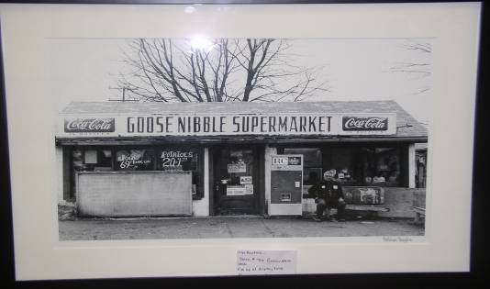

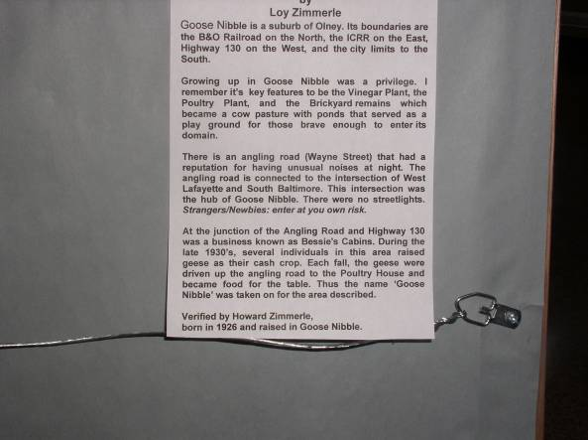

Tom Zuber
Class of ‘63

Gloria Dean
masdean33@sbcglobal.net

I re-read the Olney Memories (I think it was the 71st). One thing that I have been thinking about, after someone mentioned her in the Olney Memories. That is Elaine Shepard. They talked about her being a movie star and the movies she starred in. But the thing I remember which I'm sure was her, is that her photo was on the back of many many "Western Magazines" in an ad for some brand of cigarettes, and she was shown in a "Clock Dress" that had a very full skirt with the roman numerals of a clock face on it and it was spread out all around her. Now if it wasn't her, who was it? I'm sure I was told that she was formerly from Olney. They may have mentioned that too, and I missed it.

Gloria Dean

Class of ’50 (Flora)
---------------------------------------------------------------------------------------------------------------------------------

Harvey Zimmerle
HARVEYZimm@aol.com

My home town - Olney, Illinois

Thought you might get a kick out of this. Be sure to listen to the
song!
http://www.youtube.com/watch?v=E2AWvMHKcIs

Recognition belongs to Tim D. Dunahee of Olney for the DVD he made on the Olney

White Squirrels and the fact that the City of Olney Passed a Proclamation in the spring of 2008

which made the theme song of the DVD the official song of Olney, Illinois.

The name of the Song is "Olney, Take me There".

The song was written and sung by Peter Martz.

Harvey Zimmerle
Class of ‘57

