       Olney Memories # 139

                       May 8, 2018

Hello Olney Memory Readers,

Welcome to OMs # 139 for the month of May.  I’m sure most of us have fond memories of May in our school years and the May Day Parades that were held and the highlights of those exciting times, themes for each room in the parade and planning and decorating days and weeks in advance.  Remember the pride of marching in the exciting parade with the band blaring their harmonious marching tunes as we walked along hoping to see our moms and dads and waving to them and feeling so proud and happy!  And then the final leg of the parade always ended in the park with treats for everyone that was in the parade.  I myself don’t really remember what all the food was, but the one thing I do remember in my days of marching was ice cream in the little paper cups that we ate with the flat wooden spoon.  How good that tasted.  I always think of these memories when May 1 rolls around on the calendar.  In my way of thinking it’s too bad that this ritual, so to speak, is no longer still going on.   I think it was a highlight for students as well for the parents and citizens of Olney!  Any comments on this?

Everyone is busy. I know I am, but let me encourage you to take a few moments and send me some memories that you have. You don’t want to just see things from my file like I’m afraid this issue has turned out to be.

Ann King

Class of ‘60

[Pianoann97@aol.com](mailto:Pianoann97@aol.com)

---------------------------------------------------------------------------------------------------------

I came across this check in a box this past winter containing some of my parent’s things.  It’s an old check from the First National Bank and I have no idea how old it is but it’s not new.  I do know that.  In the upper left-hand corner in red notice it says “Center of Population of the United States”.  That sorta shows it’s age!  Thought this might be a bit of interest to some.

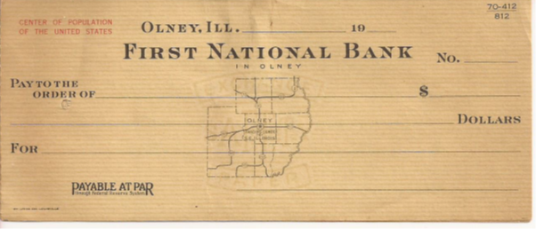

With summer approaching maybe these two pictures below will bring back memories to us older readers of the old swimming pool in the Olney City Park!  Here are two pretty old pictures taken including the West Deck and the island in the middle.  I’m not sure of the year myself.  Maybe you readers can give some help on this!

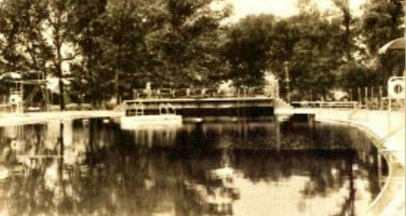

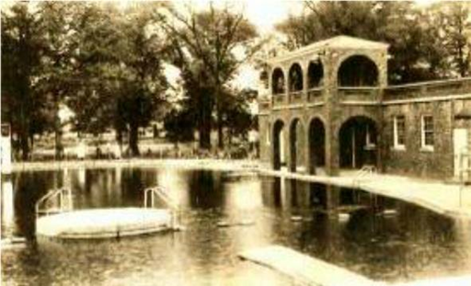

-------------------------------------------------------------

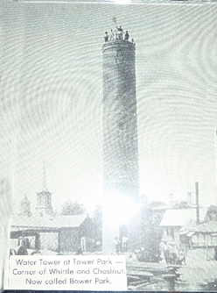

Once upon a time there was a Water Tower in Bower Park on the corner of Whittle Ave and Chestnut.  Again…the year I do not know.   Anyone know?

What would summer be in Olney without the Cummins Municipal Band playing their concerts for the public in a summer setting in the Park on summer evenings?  This pictures looks like this could be one of the early pictures of the Cummins Band….again I have no year to put with this picture……or does anyone know any members of the band?

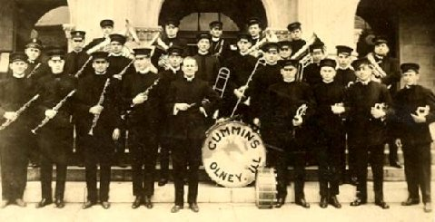

After any evening activity I imagine it’s pretty safe to say families stopped in at West Side Mikes for a bowl of homemade ice cream, either eating it in Mikes or taking it home in the carton shown below!  Albert and Myrtle Michels were the owners of the West Side Mikes and really good friends of mine, but I’m sure many of you can say the same!  Those… were… the ..days….as the song goes!!



