Olney Memories # 137
DECEMBER 14, 2017

Hello and Merry Christmas to one and all! May you all have a wonderful Christmas and a Happy New Year! This completes another year of Olney Memories and looking forward to another year filled with Memories of Olney that we can recall and share with everyone! Send your memories to me and we will fill up a new and first issue for 2018.
Ann Weesner King

Ann Weesner King
Pianoann97@aol.com

I was going through some of my mother’s music not long ago and came across the small music book shown below which was put out by the First National Bank. I’m pretty sure they gave it out to their customers around Christmas time. It’s a right nice little booklet filled with Christmas Carols, a sample of 2 pages shown below along with the front cover and the back. The book is labeled “copyright 1953”. It’s a nice keepsake and wonder if anyone else has found this in their parent’s belongings?
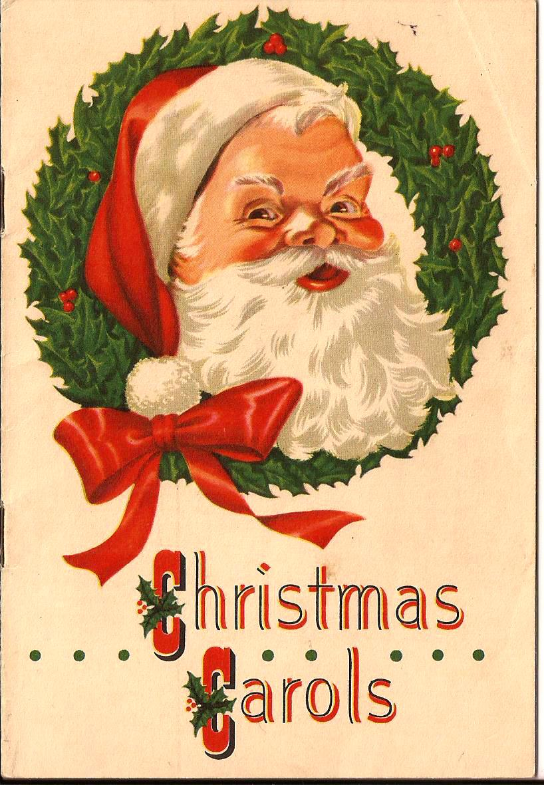

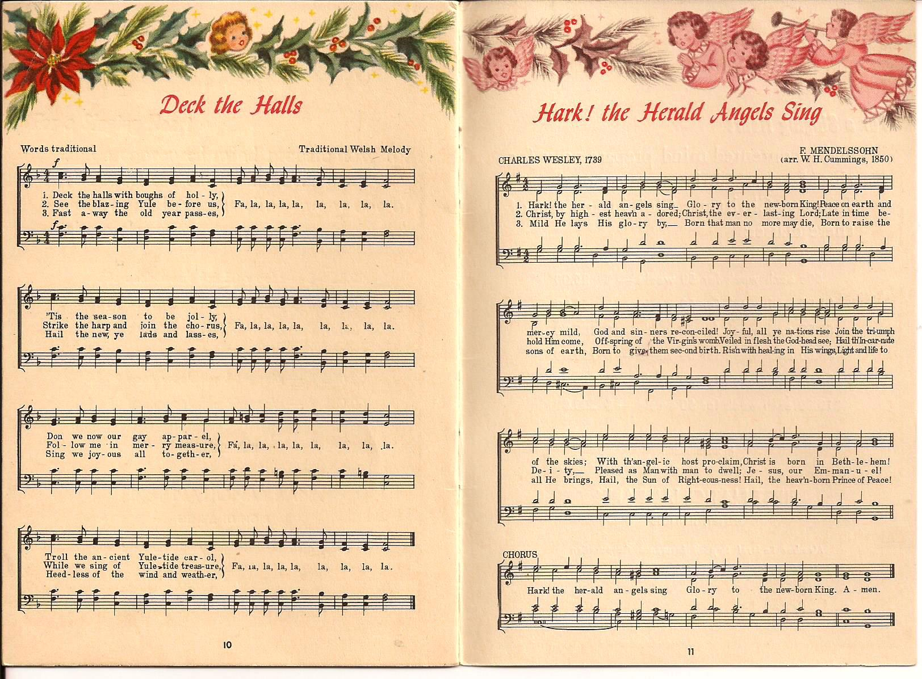

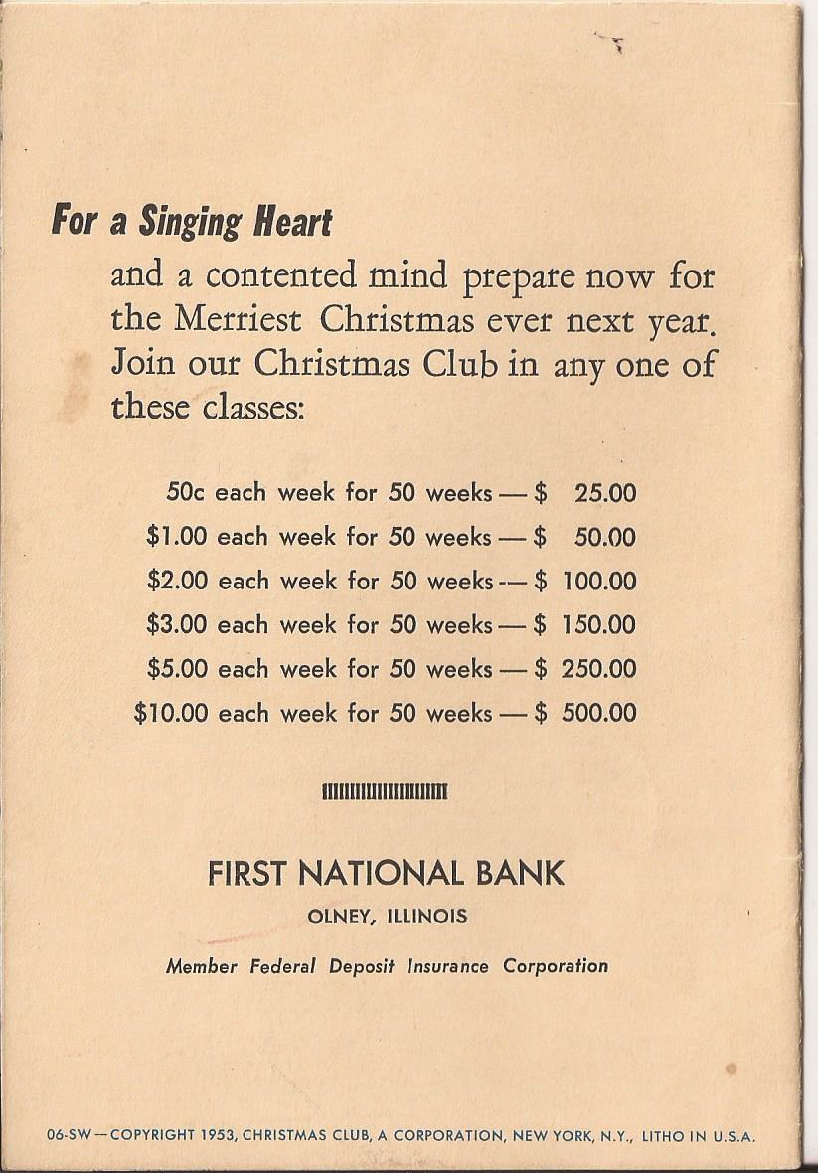

Ann King
Class of 1960
-------------------------------------------------------------------------------------------------------------

Pete Weber
peetmd@hotmail.com

I have some excellent memories from the old Elks building. First, when I was very young, perhaps 6 or 7, Community Concert Association brought world class performers to the Elks theatre. I believe George Bolet, pianist, played there and Teddy Wilson's band also played
in Olney, possibly later. The Elks dining room was also very nice, sometimes having Fred Noerenberg or Frank Martin at the organ. As I recall, the dance floor was open during and after dinner.
Dancing at the Elks also happened during my high school years but with a younger clientele at the Teen Center. If a slow dance didn't get the juices flowing, there were games of skill on the mezzanine for the more active and unlucky in love.
Wonderful memories of growing up in Olney.

PS. I played a lot of bumper pool and ping pong as I recall.

Pete Weber,
Class of '63
-------------------------------------------------------------------------------------------------------------------

Barbara Wharf Berger
Bergeerbarb66@gmail.com
The list of gas stations did not include my husband’s family station; an independent which was more than a gas station. The downtown store located was located on the NW corner of Kitchell and Main Street. We
sold hunting, fishing supplies as well as petroleum products and auto parts. Sometime in the 60's they moved to the location at the corner of Route 130 & W. Butler St. where a new station and hardware building
was built. Our two sons, Chris & John joined their dad, Kenny in the business there.

Barbara Wharf Berger
O.T.H.S. Class of 1945

-----------
P.S. (this is Ann). I well remember going with my dad as a child to the Berger’s original station at the corner of Kitchell and Main Street on many Saturday mornings as I tagged along with my dad on his errands. I loved going into Berger’s for there were so many things to look at while he took care of his business.
----------------------------------------------------------------------------------------------------

Mary Jane Hughes
hughes.micki@gmail

I remember the kids' matinees at the old Elks theater. My brother Larry and I were Western aficionados and they showed lots of them. Fun days.
Micki Hughes
Class of ‘60

Sam & Marilyn Totten
smtotten@charter.net
Ann, This sure brought back memories. We took our Honey-moon trip with Star Stamps. We routed our trip past the Star Stations & came home with $10.00 to purchase our wedding pictures from the Drug Store.
Sam and Marilyn Totten
Class of ‘50
-----------------------------------------------------------------------------------

Larry Judge
lj5313@frontier.com
Greetings Ann and all of the “Memories” readers out there…...
My last post regarding the largest number of “Service Stations” in Olney piqued my curiosity as to how many grocery stores citizens of Olney had access to in the past and what I found in the Genealogical library at OCC was truly astounding. As of this writing, there were exactly 10 times as many grocery stores in 1941 as there are currently. If you include the “Meat Markets” listed that weren’t redundant with the afore listed “Grocery Stores” in the 1941 City Directory, that makes 41 locations to purchase grocery’s.
Everyone remembers the “neighborhood store” closest to them growing up and I hope the listing below stirs some memories and comments of your subscribers own experiences.
>> A & P Tea Co 225 E. Main
>> B & B Food Store 222 S. West
>> Barche Grocery 414 1/2 W. Butler
>> Bowen Grocery 410 W. St. John
>> Brinkley Grocery 622 N. Fair
>> Brown Clifford M. S. West and limits
>> Bunting Grocery 101 N. West
>> Burchs Grocery 524 W. Main
>> City Market 313 S. Whittle ave
>> Corner Grocery 635 W. North ave
>> Ferndell Food Store 412 E. Main
>> Forney Sam O. 330 S. West
>> Fulks Cash Grocery 309 S. Saratoga
>> Hamptons Market 423 S. Whittle ave
>> Hawkins H. O. & Sons r 1008 E. Main (the “r” indicates this was also a residence)
>> J & J Market 329 S. Whittle ave
>> James Grocery 109 S. Saratoga
>> Keens Grocery and Service Station 317 S. West
>> Kroger Grocery and Baking Co 100 E. Main
>> Kroger Grocery and Baking Co 321 E. Main
>> Kroger Grocery and Baking Co 215 S. Whittle ave
>> Lawless Harve Grocery 416 W. Cherry
>> Lynch Ed 532 S. Whittle ave
>> Lynch Ed 1705 E. Main
>> Maas Market 217 E. Main
>> Meadows Market 204 N. Walnut
>> Paramount Market 309 E. Main
>> Powell Grocery 429 E. South ave
>> Reads Grocery 300 S. Grant
>> Schaeffer Grocery 419 S. Mill
>> Schneiter Grocery 410 E. Scott
>> Schneiter Fred & Son 307 S. Whittle ave
>> Schneiters (John) Sons 205 N. Walnut
>> Star Grocery 301 E. Main
>> T & G Market 704 S. Whittle ave
>> Taylor Grocery 727 W. Elm
>> Van Matre & Pauley 412 E. Main
>> Wallis Grocery 323 S. Baltimore
>> Wilburns Grocery 703 E. North
>> Wilkerson Grocery 327 N. East
>>
>> Kirks Meat Market 225 E. Main
>>
>> The greatest number of grocery stores in Olney seems to have peaked around this time as the 1938 Directory lists 36 stores and the 1948 Directory shows 38.
>>
Submitted by Larry Judge
Class of ‘71
========================================================================================================================================

