Olney Memories # 135
Sept 25, 2017
Hello to everyone. I want to thank so many of you who took the time and trouble in helping me locate the “lost” readers and their new e-addresses and gave me leads to finding their new e-mail addresses. Many were found by your help; sometimes it was by one knowing where someone was and their address and sometimes it was a chain reaction. It is amazing how this works! Sadly I found out a few had passed away. There are some yet who are still missing but I still have hopes of locating them. Thank you again for help in this matter. Please remember when you DO have email changes to let me know of them so I can update your email address and you won’t get on the “list”!
Wishing you a good fall season and see you next issue!

Ann Weesner King
Pianoann97@aol.com
Class of 1960
========================================

Richard Williams
rrw41@earthlink.net
Hello “OM” Subscribers!
Below is an announcement that was published in the Olney Daily Mail. I am pleased to share it with you “OM” fans! Even if most of you can’t possible attend, you may enjoy knowing whom we are honoring. And, if you have a good story to share about our 2017 recipients, please email me immediately! Richard rrw41@earthlink.net

TAC’s Lifetime Achievement Program
On Saturday, September 30th, from 1:00 to 3:00 in The Holiday’s Camelot Room, the Tiger Alumni Center (TAC) will celebrate the lifetime achievements of three distinguished school district employees and one alumni. The school employees, alumni, family and friends are welcome to attend the awards.
The 2017 outstanding recipients, nominated by the TAC members, are the following:
- Frank Bernard Godeke (1901 - 1997) graduated from Olney Township High School around 1918 (Teacher, Olney Township High School, 1925-39 and principal and teacher, ERHS, 1951-1966);
- Harry Hillis, Jr. (Olney Township High School, 1946), a local volunteer activist, served as local publisher and an East Richland school board member for 40 years;
- Sam Kieffer III (ERHS Class of 1960) has been a lifetime volunteer activist whose most far reaching community achievement was the organizing of the Pueblo Sports & Soccer Association in 1979, which within 2 years had over 2500 kids playing soccer; and
- Dr. Gerald M. Mastio (1932 - 2012) was a retired physician and surgeon at Weber Medical Clinic for over 30 years and President of the East Richland School Board for 10 years, a leader putting students first and promoting quality education as an essential part of life.
Fifth Year of the Program
This year marks the fifth year that the directors of the Tiger Alumni Center have conducted their ceremony honoring the outstanding service of school employees and alumni.
Past recipients of the Lifetime Achievement award honored in the 2013 ceremony were District Employees Mary Lou Marsh Brown, Ted Beagle, and George Rumsey.
Those honored in the 2014 ceremony were ERHS alumni Terry Bruce (ERHS Class of 1962), Dr. Michael Murray (Class of 1955), and Dan Borah (Class of 1964). District Employees honored were Bernard Eagleton, Gail Lathrop, Larry Miller and Gus and Mary Sliva.
Honored in the 2015 ceremony were Clairbel Benson, Bernie Edwards, Amy Fletcher, Margaret Griffin, Lee Grubb, Fred Noerenberg, and Marshall Provines. Two alumni recipients were honored with the “Founder’s Award.” They were Frank Wagner (Class of 1965) and Tom Weber (Class of 1964). Richard Williams, founder to both the Tiger Alumni Center (TAC) and the Tiger Pride Alumni Center (TPAA), created this division of the Lifetime Achievement awards program after last year’s ceremony.
Honored in the 2016 ceremony were Janet McKinney Everette (ERHS Class of 1977), Ann Weesner King (ERHS Class of 1960), Superintendent Leslie Purdy, Teacher Arrah Jean Shumaker, Teacher Edmund Snively (OTHS Class of 1924), and Dr. Peter Weber (ERHS Class of 1963). Mrs. King received the 2017 Founder’s Award.
Saturday, September 30th
The program will be administered by Clarence Smith, (Class of 1960), Tiger Alumni Center Director and Tiger Pride Alumni Association Director. He will be assisted in the program by Nancy Rumsey (Class of 1966), and Richard Williams (Class of 1960).
TAC – TPAA
The Tiger Alumni Center (TAC) is a web-based alumni organization serving the current and past employees of the Richland school district and the alumni of Richland High School. Richard Williams started TAC in September, 2010. He is also founder of Tiger Pride Alumni Association (TPAA), a 501(c)3 charity organization, started in 2014.
To know more about TPA and TPAA, visit our websites. For the TAC, visit/click: erhsalumni.net. For Tiger Pride Alumni Association, the link is tigerpridealumni.wix.com/tigerpride
A special section of the TAC site is that of Ann Weesner King’s “Olney Memories.” Link:http://www.erhsalumni.net/class_gallery.cfm?gallery_link_id=11859 There, visitors will see a list of 135 issues filled with fond memories of Olney.
My Best!
Happy Days!
Richard
------------------------------------------------------------------------------------------------------------------------------------------
Gary Totten
totten@frontier.com,

Hi Ann,

I recently published a book that I had been working on for several years. It’s a book of 11 short stories and 156 pages long. All the stories are true and based upon things that have happened to me or others I have known well. Most are funny but some are more serious, insightful, or philosophical. They are geared toward the baby boomer generation. They are about life in rural areas and small towns, although Olney and Richland County are where most originate. On some, I have changed the names and
others I didn't. They are easy reading.

I was wondering if it would be appropriate to include a mention of it in the Olney Memories. Most people in our age category would recognize some of the names and places mentioned in the stories.

I am selling the book for $14.95 plus sales tax and postage if mailed. If mentioned in Memories, we could just say that someone could contact me at my e-mail address to get more information. Several of my class members have already purchased one, but I wouldn't want to offend anyone by thinking I was "advertising" in Memories. I didn't really write it to make money, but did it for fun and to highlight the values and life in rural southern Illinois.

Gary Totten
Class of ‘65
-------------------------------------------------------------------------------------------------------------
Wesley Weston
wminmex@gmail.com
Ann,
Wes Weston here (although I was know as “Lee Weston” back in the day. However I had a legal name change from “Carrol Lee Weston” to Wesley Adam Weston. I really got tired of telling my son that the lingerie adds sent to “Ms. Carrol Weston” were a mistake……….so I just changed my name. I graduated from Olney class of ’64. Talk about a years long bunch of fun……..I have a lot of fun memories from Olney. From the pool hall that used to be above Richeters Store (at walnut and Main street) upstairs. It was ran by a gentleman by the name of Pud McGregor. I learned how to shoot pool there when I was in the 7th grade. I used to sneak off and play pool for 30-40 minutes during lunch hour. Lots of fun and will never forget the fun times I had there. The atmosphere was always tainted with the smell of cigars. I guess that is why I really enjoy a good cigar with a glass of good tequila.
Marty (Johnson) Weston and I have been married for 52 years now and have 5 grandchildren and 2 great grandchildren. I guess that life has been good to us.

Please add my name and email address to your mailing list.. Marty and I live in Mexico full time now and make a few trips to the states on occasion. We take a few cruises and a few trips up to see the grandkids and our children.

Take care and I really enjoy the memories of Olney when we were growing up…………

Saludos…………..Wes Weston
Chapala, Jalisco, Mexico
Class of ‘64
--------------------------------------------------------------------------------

Charles Fregeau
n5hsr@sprynet.com
How Many of you remember the gas stations in Olney and Richland County
From the 1960s, I remember the Amoco? Station west of the Junior High, Kerr-McGee on West Main and the old DX station north of Granddad’s on 130. There must have been more, but I walked past the first one every day for 2 years, the second one was where we got our gas usually and the third one is where we fueled up going home to Chicago from Granddad’s when we lived in Chicago.
Charles Fregeau
Class of ‘75
PS. Sorry I missed the 60th party for Class of 75. Doc put me back in the hospital again.
-------------------------------------------------------------------------------------------------------------
Jim Dillman
jdillman@lastwrites.com
Hi Ann
Thanks for the wonderful Olney Memories updates. I grew up in Olney but I’m writing with a related question you may not get any answers to. When I was very young, pre-school even, there was a one-room school house several miles west of Dundas. The school was provided for grades 1-6 (and maybe higher), had the proverbial out-houses and pot-bellied stove, and the students sat in rows according to grade. My Uncle, Dewey Bennett, was the teacher, at least for some period of time. I only remember because he had a near-by farm and for a period of time my 3-year older brother Teddie attended that school. As I recall, my Mother was very ill at the time (she did recover) and Aunt Mary and Uncle Dewey were taking care of us. When my Aunt Mary had an obligation to go somewhere, I would actually go to that school and Uncle Dewey would baby-sit me for the day, while teaching all of the students, one row at a time. I was probably given a book and told to sit in a corner and be quiet, but I really don’t remember those details. My question, asked primarily out of curiosity, was if anyone remembers the school and/or can add any information to the few details I’ve provided?
Incidentally, I was back in Olney in 2014 and my old home at 320 N. Ludlow St., across from the park entrance, is still there and looks the same. Many of the common landmarks were familiar but in the 66 years I’d been away, a lot has changed. Your Olney Memories sure brings back a flood of nostalgia. Thanks Ann
Jim Dillman
(Almost of the class of ‘50)
----------------------------------------------------------------------------------------------------
Kathryn Haenggi Robinett
klrobinett@gmail.com
Regarding history of wages in Olney: when I began working at Richland
Memorial Hospital as a "vacation relief" nurse aide during summer of
1960, I was paid 75 cents an hour. "Regular" year 'round nurse aides
were paid $1/hr. I recall feeling disappointed at receiving 25% less
for doing the same job, but the experience was good; I worked 2
summers and weekends during my senior year. After nurses' training in
St. Louis, I returned as an R.N., earning a "living wage" (don't
recall amount).
Kathryn Haenggi Robinett
Class of 1961
----------------------------------------------------------------------------------------------------
Mary Friederich
grandmary12@laffhouse.org

My, how interesting all of these articles are and how lonnnnng your list of recipients. So enjoyed Janice Ma’s list of facts and glad I was the child and being taken care of at this time and not the one who worked for these pennies. Thank you for all of your work...delightful to read.

mary friederich

Ann King
Pianoann97@aol.com

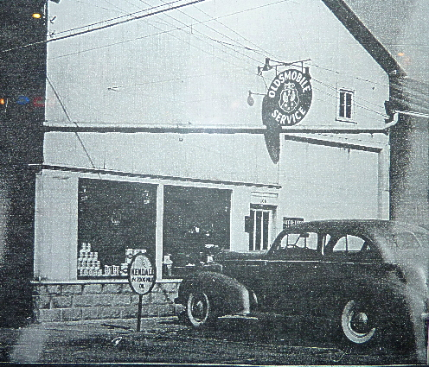

This picture is the Oldsmobile Service Department on Whittle years ago.

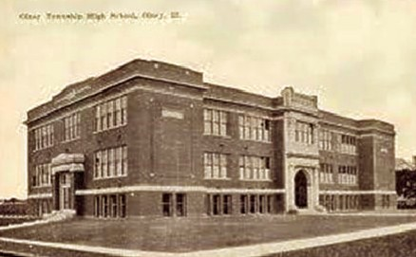

The Old Township HS and to many of us it was turned into
Our Jr.High School. Located on East Main Street

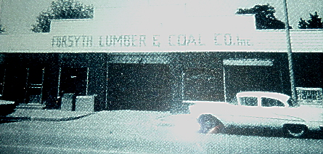

Forsyth Lumber Company located on Whittle Ave was owned
and operated by Benny Forsyth dad and mother.

Ann King
Class of 1960
===================================================================================

