Olney Memories # 134
August 26, 2017

Hello All,
I inadvertently skipped # 132 as the result of changing my office location and files. Telling you this so no one will think they missed receiving 132….it’s just void. Issue # 133 was the last issue you received. Now we are on to # 134.

I will also add that the walk down Main Street was just great, just like everyone’s memories that you all send in. I enjoy them all so much and hear so many comments about your postings. Keep it up, this is just a great thing for Olney and the community.
Also we have an overload on 134 so the next issue will be coming out real soon, with a few already submitted on the next issue. If any of you want an announcement of your upcoming class reunions for Sept be sure and get it into me so I can get them posted! Or any other “memories” for that matter.
Ann Weesner King
Pianoann97@aol.com
Class of 1960
------------------------------------------------------
Bonnie Liester French
bleefrench@yahoo.com
Wow! What a wonderful detail of all the stores in Olney. Just wanted to thank you, Bernie Morgan, for all your memories and research on the background of Olney. My husband and I really enjoyed following your tour in words and it brought many wonderful memories. I moved to Olney when I was in the second grade and have always thought of it as my hometown. I graduated in 1960 and have keep up with Ann's Olney Memories since she started posting them. She is a wonderful lady and deserves high praise for all her devotion to our memories.
Bonnie Leister French, Newton, IL
Class of ‘60
----------------------------------------------------------------------------------------------------

Hi Ann,

Could you please put this in the next Olney Memories:

The class of 1957 is planning their 60th reunion the week-end of Oct. 6th and 7th. We are in need of some addresses of classmates listed below:

Robert Bell
Ray Beechum
Audrey Thompson Bolton
Ada Murray
John Walters

If anyone has any information for these or if you know of anyone else from this class that has not received their invitation, to please contact me at

carilyn1@frontier.com

Carilyn Grinestaff
----------------------------------------------------------------------------------------------------

Curtis Stoltz
iam777iam@gmail.com
I found this in a recent copy of the Sumner Press, Mrs Omar/ Geneva Parrott was my second grade teacher...I recognize names from Richland county too, maybe someone may have some clues.

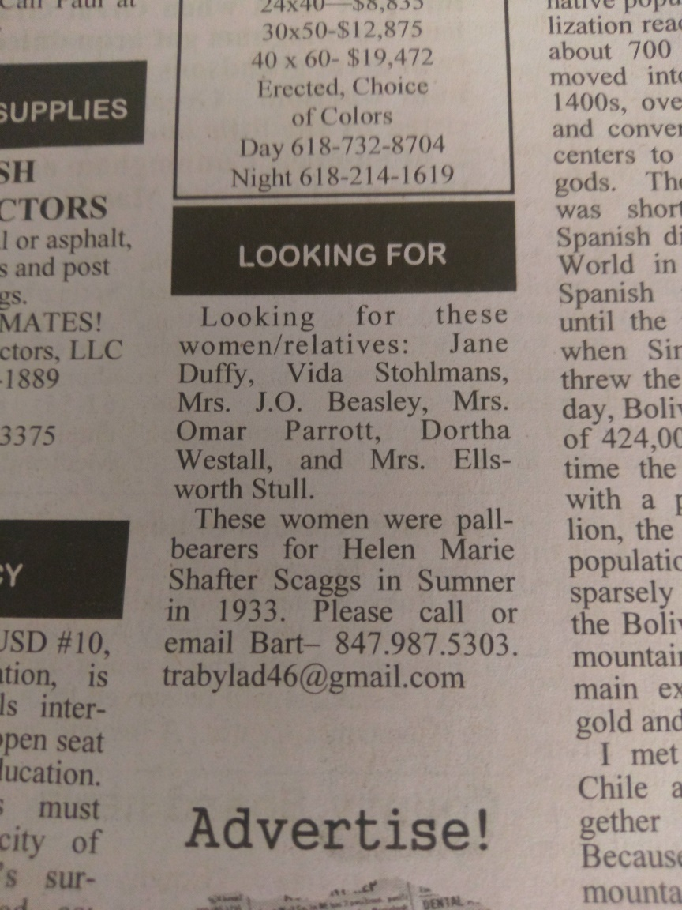

Curtis Stoltz
Bernard Morgan
bernardorgan@mchsi.com

THE GIRL WHO LIVED IN THE PUMPKIN CENTER STORE.
This year of 2017 marks the Fifty year anniversary for the ERHS graduation class of 1967. A reunion is planned for this September.
She joined our group late. We accepted her and soon it was as if she had been with us from the beginning. Her family moved into the old Pumpkin Center Store on Route 6 Olney. In the May sunshine of 1963 my Dragon classmates and I graduated from the friendly confines of that wonderful hall of education, the Dundas Grade School. Our group numbered 17, and we were the latest crop from that little town of Dundas to venture forth to the city and become Tigers the following September.
The four years passed quickly. Baccalaureate was scheduled for Sunday, May 28. Commencement would follow on Wednesday, May 31. We would receive our diplomas after a short walk across the stage. It would be a short walk into the future. We were now young adults with our lives in front of us. There were 238 names of graduating seniors on the program. Some would go onto further education, some would go to work, some would serve in the military, some would marry, and one had already answered the call of the angels.
She was only seventeen when she passed. She would have been sixty-eight this June. She died two weeks prior to graduation. Her death was a result of right ventricular heart disease. Survival rates are much higher today due to earlier diagnosis, improved medicines and procedures and our knowledge of heart disease today.
I went to visit her yesterday. Her resting place is Haven Hill Cemetery in Olney. She’s on the side where the upright stones are. West of the old railroad bed. South of the main road. East of the horseshoe drive. She’s there. Her Father, James on the left. Her baby Sister, Julia on the right. Brother Danny and his wife in the row behind and to the right. Her Mother, Doris and a Sister, Diane survive.
I’ve written and rewritten this story many times. All the while, knowing that I had a completion date to meet. None of my words portrayed her as I remembered her. As I placed the flowers at the base of her stone: I asked myself. How best for us all to remember her. Two sentences immediately came to my mind. They captured the essence of her spirit and have the power to save. I remember a girl so generous and unselfish, who always put other’s needs before her own. A girl who had so much love in her heart for those around her, that it broke. She would have been concerned for those with her same condition. This is her legacy. Know the symptoms of heart disease and stroke. Early diagnosis is so important. Risks can be lowered by following 7 simple rules. Not smoking, being physically active, maintaining a healthy body weight, eating a healthy diet, controlling blood pressure, controlling cholesterol, and controlling blood sugar.
Today, Tuesday, May the sixteenth, is the fiftieth anniversary of her entry into Heaven. That day we lost an angel and Heaven gained one. These are my memories of Linda Deck-The Girl Who Lived InThe Pumpkin Center Store. Storyteller.

Epilogue. The old store is still there. I took a drive down Mt. Gilead Lane after my visit. I’ve driven this road thousands of times going to and from work. As I turned off 130-I noticed that things had changed a bit. Just around the curve on the right is the Preston Township Town Hall and storage facility. The field in the bottoms to my left is now a forest. My friend, David Burgener used to farm it back in the day. Cross the angle bridge over Fox River. Doris and Blondie Wilson’s home is still there as is the little house next to it. After that on both sides of the road are many new homes. The setting on the north side of the road in the trees is attractive with the homes located there. The old barn that was falling down in the 60’s is still there, none the worse for wear. The old store sits at the top of the hill at the first crossroad. The folks that live there now have horses in the back yard. The Beauford Wilson home is still behind it up the road to the north. The Kuenstler place west down the road on the north is gone. My friends Wade and Gwynn Wilson live on the south side of the road. They live up the lane where an old hay barn used to sit. The home of Merritt and Evelyn Semple is still there. Paul Kermicle tells me that the twins, Shirley and Carolyn Semple at a young age used to drive to the old store ran by Mr. Jenkins. My old workplace looks about the same. The grainary where we parked the truck is gone as is the tin shed we kept the younger heifers in. The folks who live there now have chickens in our old dairy barn. So many good memories here. The old Shady Grove School across the road is long gone. West and on the south side is a new home in our old pasture. The Mt. Gilead Church still sits at the second crossroad. It was a nice drive. Lots of new with a nice touch of old still there to keep it all familiar.

Bernard Morgan

Edward Iaun
ediaun@gmail.com>
HARVE NEIL WAS A BARBER FOR MY DAD TILL DAD DIED AND HE HAD HIS SHOP. HE WAS A GREAT SOFTBALL CATCHER. HE MARRIED AN EARNST GIRL AND LIVED ACROST FROM US ON CORNER OF BUTLER AND LUDLOW THE EARNST HAD A FARM. IT MAY BE THERE. I BET MIKE AND ANGY DOLL WOULD KNOW. IT LOOKS LIKE MIKE’S MOTHER’S HOME PLACE ??? I DONT SEE WELL SO DONT KNOW BUT IT WAS BUILT BY GERMANS, JUST LIKE THE BARNS NORTH OF OLNEY.

Ed Iaun
Class of ‘

-------------------------------------------------------------------------------------------------------------------------------------------
Ann Landenberger Hill
33anthill@gmail.com

Hi -
As I remember it Elaine and my mother were friends in California. Elaine worked at Warner Bros. My mother would go there to visit with her. They would have lunch in the studio's commissary where there were
Stars galore to see. I am certain that my mother was hoping to be "discovered" as she was beautiful and could act too. A good while ago there was a notice on the bulletin board at the Senior Center in Olney asking for information about Elaine Shepard and I responded. Possibly this is the same man. ???

Stories all over the place!!!!
Ann Landenberger Hill

Gaile Herrin
herringaile@gmail.com
Started thinking of the old days. Started working first of June 66 years ago after high school graduation at an Olney car dealership, 44 hours a week, $35 a week. Worked there a year and a half and went to General Telephone of Illinois Accounting Office, 40 hours a week @ .77 cents an hour, minimum was .75 at the time, but O.T. was time and a half. When minimum raised to $1, I had just reached there, so I did not even benefit from it. Ladies, no pants or pant suits allowed even on weekend O.T., 12 and 1/2 years there then they moved to the Bloomington main office. My husband would not move. I spent the rest of my working life at Roadmaster and it's successors, 27 1/2 years all together. In the early years, no pants or pant suits allowed. Then a couple girls started wearing pant suits when they became so popular without permission, gradually all the girls were wearing them, so the rule was changed to no jeans. Then one of the president's started casual Friday's, and jeans were allowed on Fridays and I retired at that point. Personally, I thought pants were preferable to the time period the short, short skirts were in. At least you were not seeing underpants when someone bent over. A long work record helping raise 5 children to adulthood.
Gaile Herrin
Class of ‘51
----------------------------------------------------------------------------------------------------
Janice Bagwell Ma
jleahma@comcast.net
I was just trying to remember what a minimum wage was when we were teenagers. A couple of times during the summer I held part time jobs. Do you remember what the going rate was? I was looking for it online but was unable to find it. Sometimes the internet is very uncooperative! Below is something of interest I did find that I thought might be of interest to the Olney Memory readers, which shows the changes in wages and statistics that are today and we can compare to the time we were growing up in Olney…..

The year is 1910 One hundred six years ago. What a
difference a century makes!
Here are some statistics for the Year 1910 and the way Olney probably was in many ways that year:

The average life expectancy for men was 47 years.
Fuel for this car was sold in drug stores only.
Only 14 percent of the homes had a bathtub.
Only 8 percent of the homes had a telephone.
There were only 8,000 cars and only 144 miles of paved
roads.
The maximum speed limit in most cities was 10 mph.
The tallest structure in the world was the Eiffel Tower.
The average US wage in 1910 was 22 cents per hour.

The average US worker made between $200 and $400 every year.
A competent accountant could expect to earn $2000 per
year, a dentist $2,500 per year, a veterinarian between
$1,500 and $4,000 per year, and a mechanical engineer about
$5,000 per year.
More than 95 percent of all births took place at HOME.

Ninety percent of all Doctors had NO COLLEGE EDUCATION!
Instead, they attended so-called medical schools, many of which were condemned in the press AND the government as 'substandard.'
Sugar cost four cents a pound.
Eggs were fourteen cents a dozen. Coffee was fifteen cents a
pound.
Most women only washed their hair once a month, and used
Borax or egg yolks for shampoo.
Canada passed a law that prohibited poor people from
entering into their country for any reason.
The Five leading causes of death were:
- Pneumonia and influenza
- Tuberculosis
- Diarrhea
- Heart disease
- Stroke

The American flag had 45 stars.
The population of Las Vegas, Nevada, was only 30!
Crossword puzzles, canned beer, and iced tea hadn't
been invented yet.
There was no Mother's Day or Father's Day.
Two out of every 10 adults couldn't read or write
and only 6 percent of all Americans had graduated from high
school.
Back then pharmacists said, ‘Heroin clears the complexion, gives buoyancy to the mind, regulates the stomach, and bowels, and is, in fact, a perfect guardian of health’.

Marijuana, heroin, and morphine were all available over the counter at the local corner drugstores.
Eighteen percent of households had at least one full-time servant or domestic help.
There were about 230 reported murders in the entire USA !

Janice B Ma
Class of 1961
---------------------------------------------------------------------------===================================================================================

