Olney Memories # 133

JULY 21, 2017

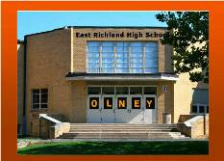

Welcome to another issue of Olney Memories. We have added some new readers on the roll since we sent out # 132. This is always a good thing, and shows that there is interest in good ol Memories of Olney! Also with this issue will be the accompanying mailing of the ”Contact List”. This is a collection of the names and e-mail addresses of the OM readers who upon request want to be placed on this list. All you have to do for you name to be on it, is to email me and tell me you want your name on the list. A lot of friends have been united by this simple way of finding people! This has been and is a good thing.
Also please remember to let me know of your e-mail changes, I have no way to keep the OM’s coming your way without you keeping me up with your current email addresses.
Keep your memories coming….
Ann Weesner King
Pianoann97@aol.com
-------------------------------------------------------------------------------------------------------------

Ann King
Pianoann97@aol.com

I was remembering the lazy, crazy, fun days of summers we had as kids back in the old swimming pool at the city park. Decided I would post these pictures for you to remember how it looked when a lot of us old-timers were youngsters and spent a lot of our summer days swimming here at this location! Bring back some good memories of good times?
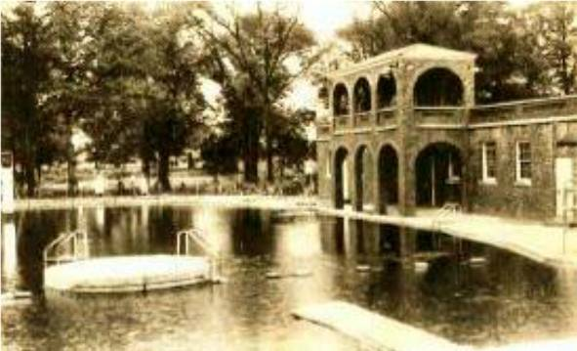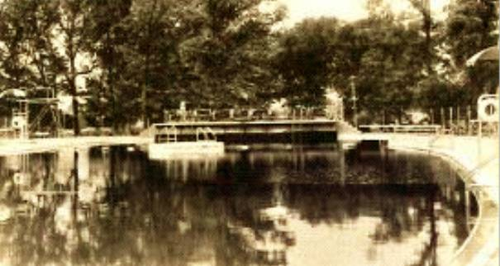
Ann Weesner King
Class of 1960
---------------------------------------------------------------------------------------------------

Dr. Gary R. Street
drgrstreet@nwcable.net

The class of 1962 is having their Class Reunion this coming September. The names listed below are people we are still searching addresses for. If you know the whereabouts of any of these, please let us know at:
drgrstreet@nwcable.net . Thank you.
Karen Stiver Stewart

Sallie Marks

Sarah Combs Pampe

Linda Ring Mullen

Sharon Felton Neunlist

LTC Pat Clark

John Cowan

Homer F. Jennings

Harry W. Sager

William J. Larkin

Donna Van Metre Clark

Ramona Miller Shipley

La Verne White

David Kallensrude

Robert “Butch” Higgins
---------------------------------------------------------------------------------------------

Bernie Morgan
bernardmorgan@mchsi.com

DOIN THE TRADIN

I treasured the time spent with my Grandparents. One of my fondest childhood Dundas memories was the weekly shopping trip to Olney with them. They called it, DOIN THE TRADIN. My paternal Grandparents, Pa (Grandpa Floyd) and Grandma Ethel were married in 1916. They met at a threshing. Pa was one of the laborers and Grandma was one of the cooks.
Threshing was done by a large steam engine and an operating grain separator. The machine would separate the edible kernels from the stems and husks. It was customary for the machine and crew to travel from farm to farm until the wheat and oat harvest was done. The host family would prepare meals for the workers, usually noon and supper meals. Neighbors assisted, men with the threshing activities, women and girls with the meals, and children helped as well. It was a social event. It was long hours and hard work for all. Women began the day early and prepared the huge meals from scratch. After each farm was completed, the machine would move down the road to the neighbors and the process would begin anew. Pa was 20 and Grandma was 18 when they met.
Mom didn't drive and Dad's oilfield shift hours didn't allow for a Saturday shopping trip. Dad worked evening tower as a roughneck in the oilfield. He slept during the day and worked at night. On Saturdays, after the heat of the day was done, we would walk to my Grandparents, who lived across the street from the Dundas School. We would all pile in Pa's 49 Ford, Pa, Grandma, and Aunt Maude in the front and Cousin Lou, Mom with little sister Debbie on her lap, and me in the back.
We would travel Route 130 to Olney. Route 130 was completed in 1931. Up to that time there were no hard roads between Olney and Newton. Travel between the two towns was by country dirt roads. The new ease of travel between the towns will come with a price. Little towns up and down the new 130 will see a change in their local commerce. Towns with two groceries and a bank will one day only have one grocery and no bank. Then there will be no grocery. In 1953 there were over thirty eight neighborhood and downtown groceries in Olney. There were seven Groceries in the One hundred through Three hundred block of East Main downtown. By 1958 that number will have fallen to slightly more than two dozen groceries. By 1965 all the downtown Groceries are gone and many of the neighborhood Groceries as well. We're seeing the end of an era. The Mom and Pop Groceries are gone and business has moved to the newer larger IGA and Kroger on outer East Main. We always parked in the Schneiter Grocery parking lot on North Walnut. The Schneiter family operated the store for over eighty five years. Ray and brother John ran it when I was young. Their parents were born in Switzerland. Pa normally remained by the car or in front of the store visiting with other oldtimers. Grandma and Aunt Maude would go their way, Lou would disappear, and Mom with little Debbie and me in tow would go ours. We were off to do the tradin.
Bartering dates back to 6000BC. Goods were traded for food, tea, spices, and weapons. Due to lack of money, bartering remained popular in the 1930's during the Great Depression. It was used to obtain food, goods, and other services. Trading goods or labor for supplies was important with money in short supply. Workers were exploited thru the Great Depression of the 30's. A large supply of unemployed for very few jobs caused the wages to drop to an all time low. Poverty was a national issue. In 1938 FDR established the Fair Labor Standards Act. Minimum wage was set at twenty five cents an hour. Pa said, that a rural worker's wage was around a dollar a day back then. This was the world of my Grandparents young married years. They came from a time when trading was the norm.
Saturday shopping in those days was a social event. Sidewalks and stores were full. Folks would reconnect on that day. People would drive to town early Saturday morning to secure a favorite parking spot, walk back home, and return later in the day. They would sit in their cars or stand beside them. It was all about seeing who came to town. For many it was more about the visiting than the shopping. For a lot of us, once a week was as often as we came to town. I remember those days of the 50's and doin the tradin. I remember the blind Olney Daily newspaper salesmen. The first one was Joe Clark. Joe was British born and quite a unique individual. Rolla Eichhorst took over the downtown route when Joe became too ill to continue. Rolla lost his sight from injuries during World War 1. I can still hear his singsong call as he walked his beat: "Ollllney Daily". Emphasis on the drawn out Olney and a quick Daily thrown in at the end.
In those times, not all of the stores were air-conditioned. The summer evening heat would lay upon you like a blanket. Especially downtown where the heat was slow to fade after the day. Some stores had screen doors and ceiling fans to help escape the heat. Doors would be propped open, and the shoppers came like bees to the hive. Some had front and rear doors. Clerks gave personal attention. It was an atmosphere of one big happy family. Stores usually stayed open until the first show at the Arcadia let out. Then the drugstores with lunch counters would be busy as well as the restaurants. It wasn't unusual for the smaller Mom and Pop stores to stay late. Downtown Groceries stayed until every shopper was taken care of.
Let me give you a tour of downtown 1958 Olney as I remember it. We'll walk Walnut from Schneiters to Main Street, cross the street, and come back down Walnut. After leaving Schneiters, we walk south, cross the street, and these are the stores on the west side of Walnut. Virginias Flowers, Harris Barber Shop, Pete's Cafe, Nina Wagner Insurance, and Rechtors on the corner of Main. In another time the Rechtors building was a Kroger. There were three Krogers in town at that time. This one, one on Whittle, and one on East Main. Across to the east side and north on Walnut are these businesses. Larkin Family Shoe on the corner, Rite-Way, Blanks Insurance, and Home Cab. A few years earlier there were two basement businesses under Larkin with entrances down steps next to the building on Walnut. Harris Barber Shop was there before he moved across the street. Brooks Shoe Store was the other. Cousin Lou, when he was a little boy, got his first pair of cowboy boots at Brooks. After the stores were gone the entrance was filled in and sidewalk covered the steps to the basement shops. Gone except for a memory.
Now in those days, no space was wasted. A thriving culture of a different kind was to be found above and below the ground floor stores. There were residents in the apartments, doctors, dentists, optometrist, attorneys, accountants, oil producers, geologists, real estate and insurance agents, auctioneers, state offices, a dance studio, and even a radio station. We would walk the whole town in those days. Unlike today where everybody wants to park by the door at WalMart.
From Rechtors to the Railroad tracks are the following: VFW, Olney Plumbing and Heating, McWilliams Plumbing and Heating, Bowery, Green Cleaning Service, and Illinois Gas. The City Cigar Store and Poolroom are above Rechtors. This is where Lou will spend his Saturday night. In a few years it will move to a street location two doors from the railroad tracks. Upstairs in the building next to the Poolhall is a Duckpin Bowling Alley. Duckpin bowling is similar to bowling as we know it today but with these differences: the ball is slightly larger than a softball and lacks finger holes, and pins are shorter, smaller, and lighter. Scoring is the same with a three ball frame instead of today's two ball frame.
We'll cross the street, head east, and visit some of my other memories. Built of stone, occupying the whole block, our beautiful old courthouse is over one hundred years old. I remember the creaky floors, and the clock striking the hour. The chime could be heard for quite a distance, especially later in the night when all was still. Public bathrooms were located in the basement. Women on the west side and men on the east. Doors on the Main Street side. Descending the steps onto a marble floor, you were brought into another world of sound. As you walked across the floor your footsteps would follow you and reverberate around the room. It had echo. Even a drop of water into the sink took on a whole new sound. Today, some sixty years into the future, I can still here the echo when I drive by or see a photo of that grand old landmark.
We'll cross South Walnut which is only a block in length, and ends behind the courthouse on West Market Street. My birth place, the Jackson Hospital, sits behind the Court House on Market. I was born there in Forty nine and cost seventy dollars. The First National Bank is opposite the Court House. It's been there since 1866.
After the bank, we'll cross Whittle and visit the businesses on that block. Whittle is not a street; it's an Avenue. There is no North Whittle only a South. Whittle dead ends between Shermans and Gaffners.
Murray Hardware, Ted's Watch Shop, Litherland Shoe Repair, Town Talk, Bowers Drug Store, Busy Bee Cafe, Merle Norman Cosmetics, Tiny Tot Shop, Maas Market, Kent Barber Shop, Abegglen Furniture, A&P Food Store, Schmalhausen Rexall, Don's Department Store, and the building on the corner at Fair Street used to be Schmalhausen in an earlier time. A fire forced them to move two doors to the west. In 1958 it houses a number of offices including, Ealey Jewelry, Alfeld Photo Studio and a US Army Recruiter. In a few years Ealey's Jewelry will be next to the Arcadia in the former La Ruth Shop location. Bowers began in 1863 and is the oldest business in town. Aunt Wilma's first job was at the A&P store. I had my first cherry coke at Schmalhausen Drug Store. In an earlier time there was a basement pool hall around the corner on Fair Street. It has had a number of owners and names. Olney Recreation Center, Jones Bozo Pool Room, and the infamous nickname, The Rat's Den. This completes the two hundred block.
After crossing Fair Street, we'll meet the stores that make up the three hundred block. On the corner is the Olney Flower Shop. It used to be the Star Grocery. Next door is Sears and Roebuck, managed by Dundas native, Hack Mitchell. He recently passed at age Ninety one. Continuing on after Sears is Hunt Jewelry, Schaeffer's Homemade Candies, Anneda Baby Shop, Singer Sewing Machine Company. Paramount Grocery used to be in the Singer building. Next is Montgomery Wards, King's Furniture Store, and Van Matre and Pauley Grocery. Van Matre and Pauley used to be across from the Library. In 51 a fire destroyed their building, forcing a move to this block. The former burned Grocery will one day become East Side Mikes and then Hoveys.
Crossing South Boone Street to the east brings us to the Carnegie Library, Dr. Fritschle, and Woody's Conoco. Now we'll cross Main to the north and head west back the other way.
Stallard's Shell Service, East Side Mike's(Hoveys), Olney Cleaners, and Hotel Litz comprise the four hundred block. Built in 1904 the Litz was formerly called the Metropole Hotel. Across North Boone and we're ready for the three hundred block. Burgener's Standard Service, B & J Furniture Mart, Al's Tavern, Richardson Electric, Olney Bakery, Western Auto, and J.C. Penny make up this block.
Across Fair and we're back in the two hundred block. On the corner is Fulgham Appliance. Over the years this little building has been a Drug store, and actually had an entrance from the lobby of the Arcadia. Also it housed Brownie's Shoe Box, Gobert's Bootery, and will end up hosting another screen for the Arcadia. The Arcadia is next. To this date I can find records dating the Movie House to 1926. I believe that it existed as a Silent Theatre prior to that date. The Orchestra Pit is still there and doors on the rear of the building have been bricked in. Those doors would have allowed a rear access for traveling troupes prior to the movie era. There were also three other Silent Movies on Main in the old days. They were the Savoy, Alcoa, and the Bijou. The La Ruth Shop and then Drew's Radio-TV are next. When Lou was younger and before our Grandparents bought their first TV, Pa and little Lou would spend the Saturday evening watching the newfangled television through the window at Drews. Mar Kay Shop, Weiland-Goudy Hardware, Jim's Men to Boys Wear follow. The Mens Wear and the Hardware Store will be destroyed by fire in 1966. F.W. Woolworth, Musgrove Men's Wear, Musgrove's Shoe Store, Janet Shop, and Tresslar's are next. Woolworth and Tresslar are what we used to call a Dime Store. They each are variety stores, both carrying a wide array of merchandise usually priced between five cents to five dollars. Tresslar was the more modern of the two. It had newer fixtures and a more efficient use of space. Woolworth had a dated older appearance and will remain that way until it closes in the sixties. PN Hirsch will occupy that location. After Tresslars is Van's Appliance and Sports Store. From my earnings mowing yards in 1958 I paid fourteen dollars for my first ball glove at Vans. Shermans Department Store, Gaffners, Crackel's Appliance and Music, The Oasis, and we're back at Larkin's Shoe Store. That is our 1958 tour as I remember it. At another time I'll take you on a tour of Whittle.
At the end of the evening we would all congregate back at Schneiters. Lou was always last. Just when everyone would begin to wonder where he was, he would magically appear and slide into his place in the back seat. Finally we're all loaded and ready to go. Pa, Grandma, Aunt Maude in the front; Cousin Lou, Mom with little sister Debbie on her lap, and me in the back. Tired and content we would make our way back home after another day of DOIN THE TRADIN. Storyteller
Writer's credit to Cousin Lou for sharing his memories of our Grandparents and DOIN THE TRADIN in 1958 Olney.

Bernie Morgan
Richard King
kingrwarren@aol.com

I bought this book a few years back when I getting out and about quite a bit more than I do now. When I bought it I had no idea that there's a little bit about Olney in it and it tells the readers that if they go through Olney to be sure to stop in at Hovey's. I thought that was interesting.

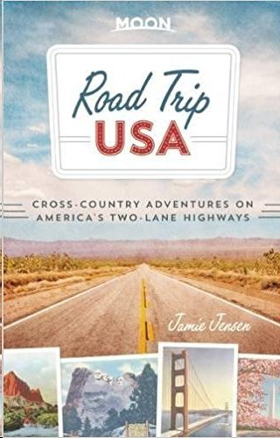

“Perhaps the best reason to detour through Olney is to sample the incredibly good, inexpensive burgers and milk shakes at HOVEY’S, on old US-50 at 410 E. Main Street—look for the Mike’s Ice Cream sign.”

Richard King
==================================================================================================================

