Olney Memories # 131
May 12, 2017
Hello OM Readers,
It’s beautiful Springtime and a fresh beginning for many things. Two things we think of are new spring flowers, possibly memories of our mothers' pretty flower gardens they took such pride in, and the smell of freshly-mowed grass from our dads' push mowers (some of us older readers that is). My first paid job was mowing a small section of our front yard with a push mower for 10 whole cents! I thought I was RICH. I suppose quite a few of us remember when power lawn mowers first came into use. My, what a great improvement! All of us have seen changes big and small through the years and that is what the Olney Memories is made of…keep on remembering, writing, and sending them to me! You all are doing GREAT! Wishing you a Happy Springtime filled with fresh new memories for all of you.
Ann Weesner King
Pianoann97@aol.com
Class of 1960
----------------------------------------------------------------------
Richard Williams
rrw41@earthlink.net

Thank you, “OM” Readers,
Thank you, “OM” Subscribers, for helping us make our 2017 RCHS scholarship drive a success! With your help, the Tiger Alumni Center’s members, combined with others who care about Richland County youth, and under the leadership of the directors of the Triger Pride Alumni Association, raised the funds to award 20 graduating seniors with a thousand-dollar scholarship.
As you who follow our scholarship drives know, we now have awarded 71 scholarships over the past five years! As you also know, I get deep satisfaction by participating in the successful scholarship drives. Every youth we can help, is one more of the many I’d love to help!
Some of you may not know that our school district has been supportive of our scholarship drives every year. Indeed, it was Chris Simpson, when he was the ERHS principal, who helped me get the scholarship drives started and has been supportive of our efforts ever since then, even though he has been busy with his responsibilities as Assistant Superintendent of Schools.

The 2017 Scholarship Certificate
Do you like the certificate each recipient receives? Can you see the two images of our current high school building (across the top) and our last one (a building once on Main St that was home to our high school students from 1915 to 1952)? Did you know that Stan Gill, member of ERHS Class of 1964, is the creator of it? Several years ago, he volunteered to design one for TAC. He’s been updating it ever since. Stan emails a master copy to Clarence, “Smitty,” Smith, ERHS Class of 1960, TAC and TPAA director. Smitty, an artist with calligraphy skills, beautifully inscribes the name of each recipient on the certificate, making each one a souvenir of the night and an art object suitable for framing.
To see the pictures of the recipients click on the following link: http://www.erhsalumni.net/Your-2017-Recipients.htm
I want to thank RCHS principal, Chad LeCrone, for sharing the pictures with us. He is also going to provide a short biography for each recipient. When I get those printed, I’ll let you know! Thanks Chad!

On another subject, I’d like to invite the reunion committee members of classes who are gathering for reunions this year to email me with their reunion plans. I’ll post that information on TAC for all to see.

Happy Days!
Richard
-------------------------------------------------------------------------------------------------------------------

Class of 1962
55th Reunion
2017
Friday and Saturday Nights
September 29th and 30th
The class of 1962 is meeting in Olney, at the Holiday, both Friday and Saturday evenings at 6:00 pm, September 29th and 30th. Each evening will begin with a cocktail hour and some introductions, announcements, and notes from classmates that cannot attend, an excellent dinner and mild entertainment.
Mr. Paul With, our county historian, has arranged for us on Saturday afternoon, around 2:00, to tour the Heritage House Museum and the one-room school house next door. From Gary: "We are aware that our 55th class reunion may not have a large attendance. And, we know that of our classmates can't make it back "home." The Class of 1962 55th Reunion Booklet will be packed with many interesting items.
We are asking all attending or not to include with your returned registration form (or mailed alone if not attending) a one-page, typed article in regards to your family, profession, interesting facts about you and what you are doing presently. Your article will be entered into the booklet.
Prices:
Friday night only: Tickets at $28.00 each.
Saturday night only: Tickets at $28.00.
Both nights: Tickets at $56.00 each.
Booklet: $10 each.
Photograph: $10 each.
Also, if booklet or photo needs to be mailed: add $2.50 for postage.
For more information, contact: 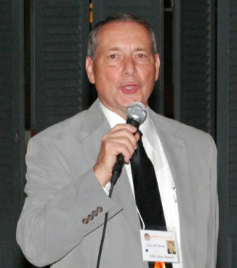
Dr. Gary R. Street
400 South West Street
Olney, IL 62450
Posted by Richard, April 24, 2017
-----------------------------------------------------------------------------------------------------------
Charles Fregeau
n5hsr@sprynet.com
Although I don’t remember ALL those details from 1965, I do remember some. I also remember turning right past the bank to go down to Brown Shoe Company to pick up my aunt Barbara in Granddad’s old DeSoto. I remember City Hall and the Post Office on the left mostly. And of course we parked on the gravel lot on the right side of Whittle down by the then B&O tracks.
Thanks for the memories.
Charles Fregeau
Class of ‘75
------------------------------------------------------------------------------------------------------------

Gaile Herrin
herringaile@gmail.com

Ann Weesner King, I read my contributions to Olney Memories # 130 and thanks for putting them in. The cruising Olney Main Street by Bernard Morgan was so detailed it was amazing. Wish my memory was that good 😊. I remembered a lot of it, but by far not all. He had to have spent a lot of time putting that together. Thanks to him and to you for the memories and for all your work putting Olney Memories together each time. I appreciate you.

Gaile Herrin
Class of ‘51
----------------------------------------------------------------------------------------------------
Roy Miller
Rlm322@frontier.com

Bernard.
My what a long history you just gave us. I am 82 and did not know most of that. Two things I want to talk about. “The OM railroad came in 1855. It became the B & O in the 1980’s “ When this RR stopped. it was the Illinois Central, one of many that went N-S in Illinois. The B& O was the E-W track next to the shoe factory. I rode it many times in the 1960’s, to fetch new cars from St Louis for Eaglesons. I graduated in the class of 1952. In my senior year, the auto mechanics class started in the new building at the first of our senior year. We guys put the car hoist in the building and lots of the other things to set it up. At Christmas vacation, the rest of the HS moved out there. The graduation ceremony for we seniors was held on the football field for the new school, This was in 1952, not 1953.
All this knowledge and about 65 cents will get you a cup of coffee at McD.

RLM
Class of ‘52
-------------------------------------------------------------------------------------------------------------
Larry Judge
lj5313@frontier.com

An abridged summary of Elaine Shepards family and life in Olney
(born April 2,1913 Olney, IL - died Sept 6,1998 Manhattan, New York)

Thomas J. Shepard married Bernice E. Shadle on June 29, 1912 at the home of an Aunt in Stonington Illinois. This would have been an Aunt to Bernice, as Thomas arrived in this area with an immigrant family as an orphan child from the state of Pennsylvania and had no relatives here.
He was 45 years old and she was barely 21 when married.
Bernice was one of five daughters born to J.D. and Lillie Shadle originally of the Ingraham community located 20 miles northwest of Olney. A 1915 telephone directory lists the Shadle family as living at 711 West Elm Street in the far western edge of Olney and J.D. employed as a “laborer”.
This was Thomas Shepards second marriage as his first wife, Eva Phillps of the Dundas area, tragically died of cancer the previous year leaving him with three children.
Thomas Shepard was a skilled monument artisan and after being a partner with Thomas M. Wharf at “Olney Marble Works” (1903 city directory) started his own business; the “T. J. Shepard Monument Company”. It was located just 2 blocks west of his residence at 228 East Chestnut Street in the center of Olney amongst some of the nicest and largest houses at that time.
(Unfortunately, none of the residence’s where the Shepard or Shadle family’s lived survive today.)

The 1920 census lists the following residing at the 228 E. Chestnut house:
Name Age
Thomas J. 55
Bernice Emma 28
Mabel B. 16
Burl P. 13
Thomas Jr. 9
Elaine E. 6
Elbert J. 3

Elaine states in her first book that at age 9 her parents were divorced which would have been 1922. The actual divorce was granted on April 21, 1926. The court did determine that Thomas “abandoned” Bernice 4 years prior, so Elaine’s memory is essentially correct.
Whether it was the stress of a combined family from a previous marriage all residing in the same house or other unknown factors, (Elaine makes no comment) Thomas essentially banished Bernice from his house.
Court records indicate that Thomas had been quoted by his associates as saying that he “would never pay one cent to that woman”. The divorce was uncontested and later proceedings involving Bernice seeking legal help in obtaining court ordered monetary support from T.J. would reveal that Bernice had strictly followed all of the requirements to avoid all contact with Thomas and was found to be “above moral reproach”.

The 1925 city directory lists the following residing at 228 E. Chestnut…
Name Age
Burl 18
Mabel 21
Thomas J.(retired) 60

By this time T.J. had sold his monument business to Ray C. Minkler, so whatever fortunes he possessed were not affected by the onset of the depression era.
After the split from Thomas, Bernice would take her children to live with her parents at the west end of town.
The same city directory lists “Mrs. Thomas Shepard” living at 711 W. Elm St along with her parents and a sister, Genelle Shadle whom in a twist of fate I found to be listed as the teacher at Central school of Elaine’s younger brother Elbert in 1924 during his 2’nd grade. The same school attendance records have Elaine in 5’th grade at 10 years of age.

Court proceedings involving enforcement of Thomas’s obligation of support continued at least through 1929 with him being summoned and even incarcerated by authorities for non-compliance. At some point, Thomas at least partially settled with Bernice by writing a $600.00 check, (a copy of which is with the divorce proceedings in the court house). This was a huge sum of money during that time.

The 1930 census lists the only Shepards residing in Olney as
Name Age
Bernice Shepard 38
(divorced, saleslady
department store)
Elaine 17
Elbert 13

Their new address is listed as 212 E. Chestnut St., which ironically would be right next to T.J. Shepard’s house, her former residence. This seems logical as she would have been familiar with all the neighbors and surroundings and, 228 E. Chestnut no longer houses Thomas Shepard.

Thomas has evidently moved his family from the first marriage
out of Olney to “parts unknown” to me at this time, quite probably in an attempt to avoid any more support of Bernice.
However harsh Thomas appears to be, I have reason to believe that Thomas did somewhat provide for Elaine and Elbert. A picture of Elaine in a Freshman class group picture (1928) at Olney Township High School, even though very poor quality, clearly shows Elaine in relatively very sharp clothing.
Elaine relates in her first book that although she saw little of her father after the divorce, he did drive her a long distance to “boarding school”. This would have been McKendree College after she graduated from High School in Lawrenceville in 1931. A conversation they had during that (at least 3 hour) trip motivated Elaine to learn more about world affairs and politics.
Elaine would go on to attain a degree of Hollywood fame but more notably as a journalist and author gaining widespread respect among Vietnam veterans for her coverage of the air campaign in southeast Asia.

Post Script:

The 1930 Lawrenceville Illinois census lists Elaine as a “boarder” with Louis and Doris Andrews living on 12’th Street working as a clerk. Lawrenceville is located 20 miles east of Olney and would have been easily travelled to by highway or railroad.
An obituary of Elaine’s mother Bernice appeared in the Lawrenceville newspaper in Dec. 1984 stating that Bernice was a former resident and died age 92 Oct. 7 1984 in New York City.
The article states that she was to be buried at Ingraham (the Shadle’s original hometown) at a later date but I could not locate the gravesite and none of the local population could recall a Bernice Shepard being buried in the area.

I have yet to determine why they moved to Lawrenceville and only know that Elaine attended her final 2 years of High School there.

If any “memories” readers have any information they could share about Elaine Shepards time in Olney or Lawrenceville, it would be very much appreciated.
(researched and written by Larry Judge)

Attached is an MGM studio portrait of her which I had digitally restored.

(researched and written by Larry Judge)

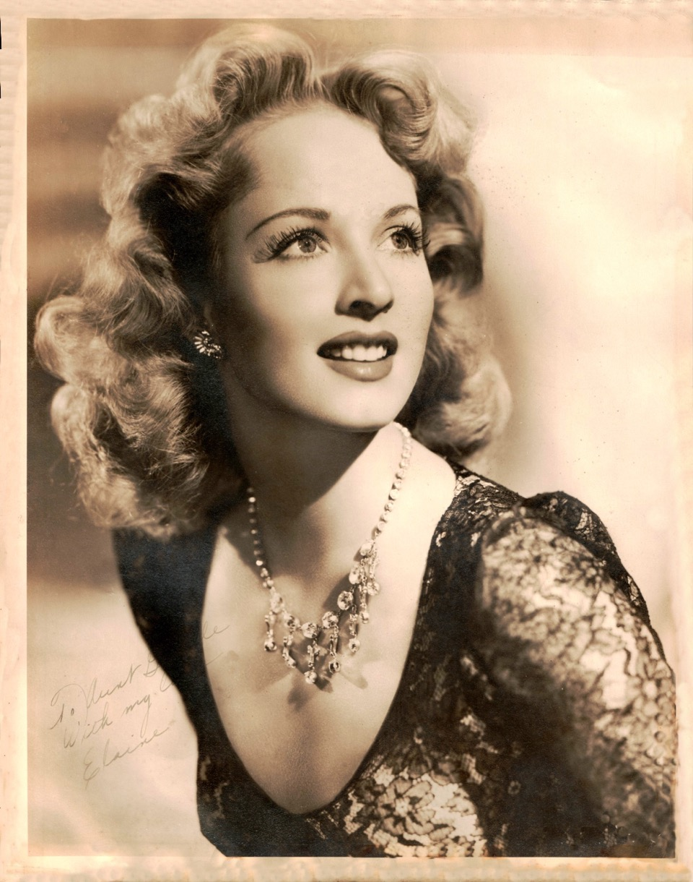

Thank you
Larry Judge
Class of ‘71

Mike Zimmerle
ztech1@nwcable.net
Olney Trivia - In 1841 the city of Olney, was laid out. It was laid off on either side of the trace road, but the town has built more toward the south. In the earlier years the town was called “the painted town” because the New Englanders, of whom there were considerable numbers, painted their houses, and this gave the town an attractive appearance. It grew slowly, having only 300 inhabitants in 1855.
The first church house in Richland was built by the Regular Baptists. It was used also for school purposes. It was known as Antioch, and stood five miles east of Olney. Wm. Martin of Kentucky was the preacher there. Union church, twelve miles southwest of Olney, and Shiloh, west of Olney, were Baptist churches.

Mike Zimmerle
Class of ‘71
Mike Zimmerle
Ztech1@nwcable.net
Does anyone in the Olney, Illinois area know where this barn was located, when this photo was taken, or anything about the group and their gatherings? My husband's grandfather, Neil Hahn, is in the front row, right side of the picture. He lived in Olney, Illinois as did his three children and their children. We have the original photo, but no date. It has a stamp in the lower left corner from Spieth - Olney, Ill. We would love to have more info and would have loved to have been there to experience it. Thank you!

- Yes, I believe it was at Silver Crescent Stables and the barn may still be standing but it does not look like it did when the music parties were going on there. Go south on 130 , look for a sign for Antioch church. Turn right (west) and not far on the right it the area where the Silver Crescent Stables were.

- Mark Jennings Yes the silver crescent stables barn is still there and is still used a barn.. I live within roughly a mile from it.. it is on Elbow road about 6 miles south of Olney.
Mike Zimmerle
Class of ‘71
==================================================================================================================

