Olney Memories # 128

October 26, 2016

 



Welcome to the October issue of the Olney Memories for the young and old, far and near. This issue brings back more memories for us to read and think about.

We have quite a number of new names/people that have been added to the e-mail list for the OM’s! This is always good to have new members for our Olney Memories group. I will be sending out the “E-mail Contact List” also this time, and for our new people this is a list of names and e-mail addresses of OM people who would like to have their names shared with other OM readers. Many lost friends have been found through this list. http://cdn-cf.aol.com/se/smi/2b00000252/02 If you would like to be a part of this, just let me know you would like to be included in this list and you will be added to the e-mail list.

Remember to send me any e-mail address changes you have so I can update your addresses! http://cdn-cf.aol.com/se/smi/2b00000252/01 I will also be waiting for your memories sent to me for the next issue!

Ann Weeesner King

[Pianoann97@aol.com](mailto:Pianoann97@aol.com)

--------------------------------------------------------------------------------------------------------------------------------------------------------------------------------------------------------

Bob Bradley

[bbrady@charter.net](mailto:bbrady@charter.net)  
  
**Subject:** **J.W. Musgrove**

Ann I read with interest the remarks concerning the Musgrove family and in particular J.W. who was their oldest son. Monte being the other son.

I was in sixth grade with J.W. at Silver Street in 1955. Mr. Williamson was the teacher / principal. Others in the class included Joe Clow, Jon Quail and Bill Pampe to name a few. J.W. participated in the class and for sure he had a disability. I admired the Musgroves for sending him to school and he did them proud.

Several years ago I was scanning the local obits and J. W. name showed up. The last many years of his life he lived in a community called Beverly Farms in Godfrey IL. This is a community of 400 challenged adults. Based on the 0bit J. W. found a home there and was involved in the activities that took place. I had wondered from time to time where he ended up. It gave me a good feeling that he had been provided for.

We have lived in the Metro East area of St. Louis for 30 years. Recently attended the 175th anniversary celebration. It is always good to come back and visit friends and renew memories.

Bob Brady,

Class of 61

-------------------------------------------------------------------------------------------------------------

Harvey Zimmerle

[HarveyZimm@aol.com](mailto:HarveyZimm@aol.com)

Thought you might like this for the next Olney Memories infohttp://cdn-cf.aol.com/se/smi/0201d20638/01.

This is when Olney lost the chance to be a large area and the railroad

plans were stopped by the production of cars changed many things in the nation.

**1910 Ford Model R**

 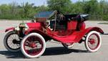

The year is 1910 One hundred six years ago. What a difference a century makes!   
   
Here are some statistics for the Year 1910:  
   
************ ********* ************  
   
The average life expectancy for men was 47 years.  
   
Fuel for this car above was sold in drug stores only.  
   
Only 14 percent of the homes had a bathtub.  
   
Only 8 percent of the homes had a telephone.  
   
There were only 8,000 cars and only 144 miles of paved roads.  
   
The maximum speed limit in most cities was 10 mph.  
   
The tallest structure in the world was the Eiffel Tower !  
   
The average US wage in 1910 was 22 cents per hour.  
   
The average US worker made between $200 and $400 per year.  
   
A competent accountant could expect to earn $2000 per year, a dentist $2,500 per year, a veterinarian between $1,500 and $4,000 per year, and a mechanical engineer about $5,000 per year.  
   
More than 95 percent of all births took place at HOME.  
   
Ninety percent of all Doctors had NO COLLEGE EDUCATION!  
   
Instead, they attended so-called medical schools, many of which were condemned in the press and by the government as 'substandard.'  
   
Sugar cost four cents a pound.  
   
Eggs were fourteen cents a dozen.

Coffee was fifteen cents a pound.  
   
Most women only washed their hair once a month, and used Borax or egg yolks for shampoo.  
   
Canada passed a law that prohibited poor people from entering into their country for any reason.  
   
The Five leading causes of death were:  
   
1. Pneumonia and influenza  
2. Tuberculosis  
3. Diarrhea  
4. Heart disease  
5. Stroke  
   
The American flag had 45 stars.  
   
The population of Las Vegas , Nevada , was only 30!  
   
Crossword puzzles, canned beer, and iced tea hadn't been invented yet.

There was no Mother's Day or Father's Day.  
   
Two out of every 10 adults couldn't read or write and only 6 percent of all Americans had graduated from high school.  
   
Marijuana, heroin, and morphine were all available over the counter at the local corner drugstores. Wonder if that Included Olney?  
   
Back then pharmacists said, 'Heroin clears the complexion, gives buoyancy to the mind, regulates the stomach and bowels, and is, in fact, a perfect guardian of health.'  
   
( Shocking? DUH! )  
   
Eighteen percent of households had at least one full-time servant or domestic help.  
   
There were about 230 reported murders in the ENTIRE U. S. A. !  
   
I am now going to forward this to someone else without typing it myself.

From there, it will be sent to others all over the WORLD - all in a matter of seconds!

Try to imagine what it may be like in another 100 years.

Harvey Zimmerle

Class of ‘57

Ann Weesner King

[Pianoann97@aol.com](mailto:Pianoann97@aol.com)

Thinking you might enjoying seeing a picture or two of past business places that have been in Olney some years ago…….

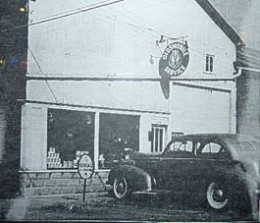

I wonder if this was called Eagleson’s yet? Anybody know?

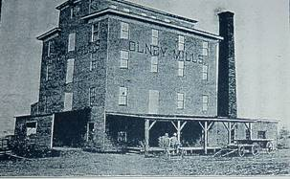

Olney Mills Does anyone know where this was located?

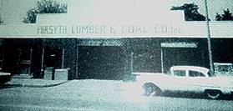

Forsyth Lumber was located on South Whittle

Benny Forsyth was in my class in school and his

Mom and dad ran the business. Benny, did you

help too?? ☺

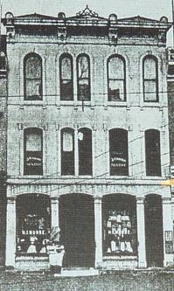

Morse Dry Goods Store

I believe this building is across from the post office on Whittle and

still standing.

Ann King

Class of 1960

----------------------------------------------------------------------------------------------------

Bill Newton

[billnnewton@yahoo.com](mailto:billnnewton@yahoo.com)

Ann, I have to share this with you in regards to your question whether or not we could remember the Olney Tiger Fight Song.  A year or so after graduating I was at a football game and the person next to me was aghast that I didn't know the lyrics!  I told him I could still finger it? (I played the trumpet and never sang the song).

Bill Newton

Class of ‘70

PS. This is Ann. Bill, I can still play the Tiger’s Song on my Clarinet too, but I need you to play along with me, two instruments sound better than one if we can’t have the band playing with us! ☺

----------------------------------------------------------------------------------------------------

Jan Kern

[Grannyjanny012001@yahoo.com](mailto:Grannyjanny012001@yahoo.com)

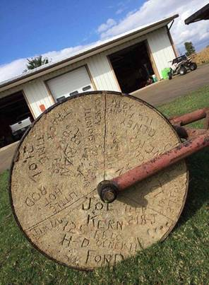

I am sending a picture of a lawn roller that might draw some interest in the Olney Memories. My son, Jason Kern, received the picture from a classmate of his, Pete Seals. Pete noticed the name of Joe Kern Class of 1952, written on the concrete portion of the roller. Along with Joe’s name were various other writings such as his old phone number back in the 50’s, things pertaining to his car, motorcycle and also another name, Walt Ryan, who was also in the Class of 1952. Joe Kern is a brother to my husband Mike, so I contacted Joe Kern. Joe does not remember any of the details of this roller or why it was made. My husband and I thought perhaps it was built in the Automotive Shop Class for use of ERHS when the school was built. We found out from Pete Seals that he had borrowed the roller from a Walter Koertge, who bought it from a Max Miller. Maybe someone knows the history of the roller. I also asked Roy Miller as I worked with Roy several years in the Credit Department of AMF and he was in the Class of 1952. He didn’t know anything either.

Jan Jones Kern

Class of ‘63

Jerry Scherer

[jerrycars@aol.com](mailto:jerrycars@aol.com)

A couple of weeks ago I was in Olney for my 66th Class reunion and while I was there I got to thinking about what stores were on the Main street in Olney years ago so I would like to go through what I remember----- Let’s take a walk down memory lane on Main street in Olney (circa late 1930’s or early 1940’s) we will Start at the Richland county Court house and then go East to the First National bank continuing West across Whittle to Ben Murry Hardware store on the corner then next to Nina Wagener’ insurance office and to Bower’s Drug store, Then a small coffee shop, Next (I believe was Memert’s Jewelry Store then an A&P grocery store, a barber shop, and of course Schmalhausen’s Drug Store where we spent many hours visiting and drinking ‘Cherry cokes’ ------then a hardware store next Bond’s Drug store and cross Fair St. to Star Market which was run by Harry Balmer, next is a business I don’t remember, then Montgomery Ward on to a grocery store on the corner. Then cross Boone St. And on East to the Carnegie Library then Dr. (Dock) Fritchley’s office (He always parked his car under a tree in the front yard) and on East to a gasoline Station(Conoco-I think) on the corner and cross the street East to another service station(Standard) and next was the Chevrolet Dealership.(diagonally across Main St was the Olney Sanitarium then to the West for the (OTHS)OLNEY TOWN SHIP HIGH SCHOOL from there go across the street West to Miller’s Shell service (The owner was Tad Miller) The next store Was Pauley’s grocery store. Then next was a Cleaners and then the New Olney Hotel then cross Boone street West to Bergner’s Standard service station then Al’s Tavern, next was a Plymouth Dealership then Penny’s on the corner. Cross Fair St.to the Arcadia Theatre and Tilton’s Drug store which you could enter from the mezzanine of the theater as well as from the sidewalk in front, Next was the La Ruth shop then a couple of stores (I think one was Weland Gowdy Hardware store). Next was Woolworth’s 5 and 10 continuing on to Musgrove’s Men’s Wear then Tressler’s 5 and 10 cent store, next Musgrove’s shoe store , next City Cigar and pool hall then Sherman’s Department store. Gaffner’s Jewelry and Drug store then a tavern (I think it was the Oasis ) My Father had a jewelry store on the north east corner of main and Walnut in 1942 and l94.

I am sure that there are other stores that I have forgotten, but this is just what I can remember.

JERRY SCHERER

CLASS OF 1950

--------------------------------------------------------------------------------------------------------========================================================================