Olney Memories # 126
August 18, 2016

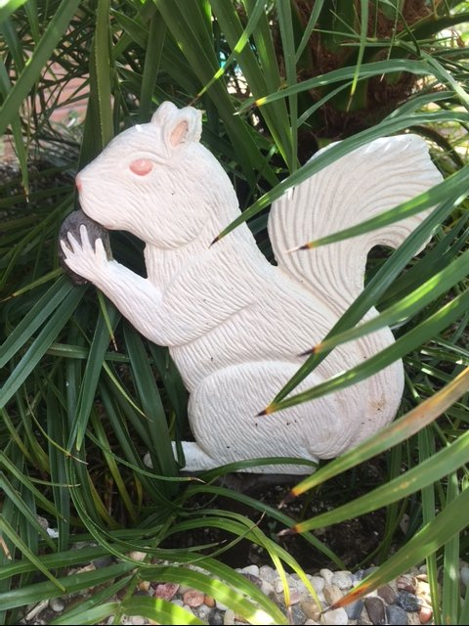
An early Labor Day greeting with this issue, and wishing you a Happy Fall Season. And….what happened to Summer? I hear most everyone say…”it went so fast!” So, more memories to think about and remember and more memories to make….

Once again remember to let me know when you have an address change. Letting me know sure does help me in getting the Olney Memories to you, otherwise in most cases I just don’t know how to find you!!

By the way, the picture of the White Squirrel is in our backyard in a big pot. The Squirrel came from the White Squirrel Shop in the Old Bowers Drug Store Building on the South side of Main Street. I’m pretty sure most of us have some fond memories from the Old Bowers Soda Fountain and going in that store with our moms and dads many years ago. It was a grand store back then with that great soda fountain and it’s a fine store now with all the White Squirrel gifts in the same Bower’s Building. Go in and look for yourself, it will bring back some good ol’ memories for you. The “original floor” is still there which you will see if you are able to go in. Here is a picture of the Bowers Drug store many years prior, I’m not sure of the year this picture was taken. But I will tell you I barely remember when the soda fountain was on the left hand side of the store as you see it here as you go in the front door.

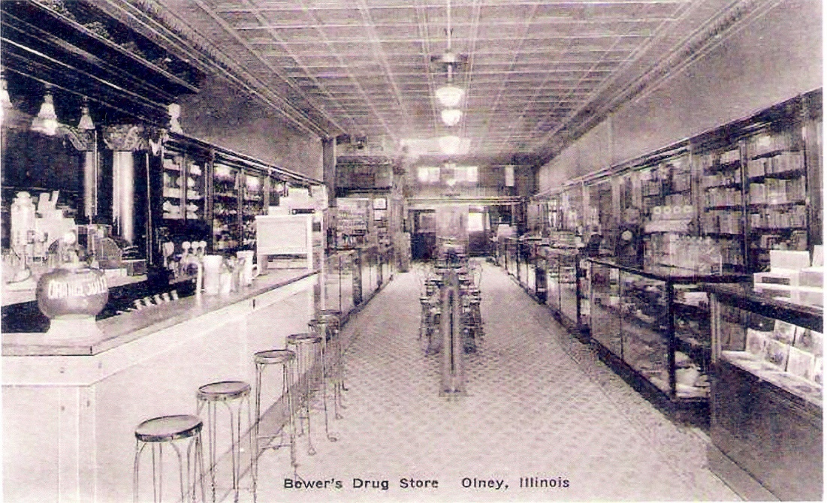

The note below is from Norm whom I sent out an SOS a few weeks ago. I asked him to write a short note to let us all know how his wife was doing since some of the donations had come from the Olney Memory readers. I didn’t want to leave you up in the air about it and thought it fitting you would want to know. Thank you.

Ann Weesner King
Pianoann97@aol.com
Class of 1960
--------------------------------------------------------------------------------------------------------------------------------------------------------------------------------------------------------

Norm Alexson
normanaxelson@comcast.net

Just a note to let you know how things are. My wife Melody has been recovering from her last surgery very well. She has been working with her Physical Therapist to get strength back in her good leg. Almost 3 years ago she had a Stroke that weakened her right side. So her good side her left is the side she had the fracture and Miniscus tear. We are so great full for those who are helping us with donations to get a special seizure Dog that would let Mel know when she is about to have a seizure. This requires payment for the dog and funds needed for 3 weeks of one on one training with the dog even before we get to take the dog home. We have received a little over one fourth of the funds needed and the time is getting shorter to let Canine Partners 4Life know we are ready for the trip. Any help is desperately needed and to read about Melody’s journey check her out at A Special dog for my beloved Melody at www.crowdrise.com/a-special-seizure-dog-for-my-beloved-loved-melody/fundraiser/normanaxelson

Thank you Everyone for all your help.

Norm Alexson
Class of ‘65

--------------------------------------------------------------------------------------------------
David & Linda Green
cdllgreen@comcast.net

Ann
The Center of Population was a few miles west of where I grew up on the Dundas road. I was 10 yrs. old at the time, and yes, it was a big deal with much celebration at the time. Even years later, people would stop and ask if we could tell them where it was located; which was basically out in a field. The Ruritan Club in Dundas has many memories for me; as a child it was a grocery store and deli; we would buy lunch meat and cheese at the deli. The Ruritan Club is used for many different functions like meetings, chowders, receptions, etc. I don't know if they still have the chowder, but it was always one of the best.
Linda Green
Class of 1958
--------------------------------------------------------------------------------------------------------------------------------------------

Kathryn Robinett
klrobinett@gmail.com
Ann, thanks once again for the great job of jogging and connecting our memories! I remember what John Helm reports of Richard Nixon coming to Olney on the train (the track down the middle of Kitchell Ave.) passing by Central School, which was actually in session that day. I would have been 9. I recall that our teachers led us all out to the edge of the school yard to wave at Mr. Nixon as he stood on the back or front of the slowly moving train car, waving back to us. I was too young to appreciate what his mission was, but we younger students were aware that it was something important. Thanks to John for recalling that event.

Kathryn Haenggi Robinett
Class of '61
-------------------------------------------------------------------------------------------------

Cindi L. Rettmann Dodson
clrettmann@aol.com>
My father, 'Bud' Dodson, (class of 47'), grew up in Olney & I just wanted to let you all know how wonderful I think the 'Memories' are. My Dad has always shared so many stories with me about his youth & you help bring them to life. My most clear memories are of visiting my Grandmother & going to the park to see, & at that time, play with the white squirrels. It was/is a very special place & I love reading the things everyone writes about it. Very surreal to me. Growing up in the Denver area I realize I'll never have a special place like this to go as I age to do a lot of remembering. Thank you to all of you!!

Cindi L. Rettmann/Dodson
------------------------------------------------------------------------------------------------------------------------------------------

Bette Schmalhausen
bette12041@gmail.com>
In response to John Helms item about Richard Nixon's visit in 1952, not only did the schools close but many stores, banks, etc. closed for the visit. That a big event for Olney.
Bette
Class of ‘51
----------------------------------------------------------------------------------------------------
Clarence Smith
smithcj2@nwcable.net
Subject: Center of Population marker
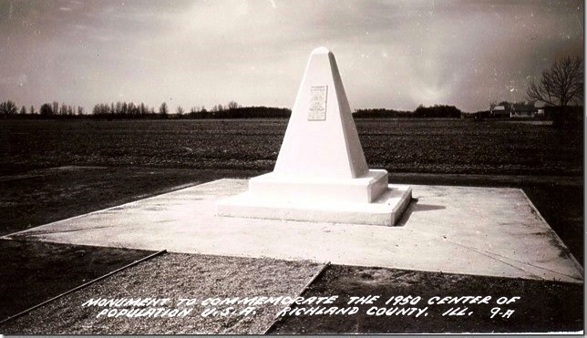

Ann,

This is the original marker located on the west side of Rte. 130 just south of the Dundas intersection.
No one seems to know what happened to it. It is not the one you pictured in Olney Memories, that one is located in front of the Ruritan building in Dundas and is probably just a replica.
Clarence (Smitty) Smith
Class of ‘60
--------------------------------------------------------------------------------------------------------------------------------------
Roy Doolin
roydoolin@hotmail.com
I have enjoyed reading OM for several years, thank you for keeping it up, Ann. I lived in Olney from 1953 to 1963. My family moved after my Junior Year and I graduated from another high school. I have lived in Pennsylvania and Louisiana before moving to Texas 21 years ago. I live 60 miles north east of Houston now. I have fond memories of Olney Mayday Parades. As I recall, we started by the Shoe Factory on Whittle and turned right on Main, ending at the High School. We didn't have a picnic, just a track meet. I think I threw a shot put for Cherry Street School in one or more track meet. I thought I was good but a boy from Central school was much better.
Olney had a taxi service in the 50's and 60's. You could ride anywhere in town for 25 cents. We lived on the east side of town and there was a grocery store on the west side of town where you could call in a grocery order and the taxi would deliver the order. Somebody can probably remember more details.
Thanks.
Roy Ed Doolin
Class of 64
----------------------------------------------------------------------------------------------------

Susan McCarty Hall
sjanehall@sbcglobal.net
Subject: The Arcadia theatre.
Dear Ann,
I remember when the Arcadia had a movie called "Mom & Dad". It caused quite a stir. There was a nurse on duty in the lobby and a cot in case anyone was overcome by the film. I didn't see the
movie.
Next door to the theatre was Tilton's drugstore where we had ice cream after the movie. They we're nice people.
I also remember going to see "Gone With the Wind” when I was 6 or 7.
Susan McCarty Hall
Class of '51
--------------------------------------------------------------------------------------------------
Martha Noerenberg Hertendy
mjhertendy@hotmail.com

Hi Ann. I am very disappointed to hear the Arcadia theatre has closed.......there is, however, one other closer place to see movies. The drive in outside of Newton is still operating!!
Martha Noerenberg Hertendy
Class of ‘72
----------------------------------------------------------------------------------------------------

Ernest Marshall
emarshall1946@gmail.com
Subject: 125th Anniversary
I remember the 125th as I was just barely able to grow a "little" goatee. We were "BROTHERS OF THE BRUSH" at that celebration. I remember how the older men had Full beards down to their belts and actually supported me in my effort to grow something. Of course some had a good laugh but it will always be something I will remember. I still have my Brothers of the Brush button after all these years. We met out at Miller's Grove. Just thought I would share this. God Bless.
Ernest Marshall
Class of ‘64
----------------------------------------------------------------------------------------------------
Mary Jane Hughes & Ann Weesner King
hughes.micki@gmail.com
Yes, remember Musgrove's shoe store. Also remember Musgrove's Men's wear (I think) not sure of that. They had a retarded son, JW Musgrove I think was his name. He hung around the store a little now and then. I think his mother and dad had their hands full with him. No special schools for little boys and girls like him in Olney I don't think, and they chose to take care of him themselves which I give them great credit for instead of ship him off somewhere. They were sweet people. I remember the x-ray machines and how wonderful it was to see our feet and little toes inside those machines and yes how people cringed at the thought of those machines later on.

(As short as this is it took us both to get the above together….)

(This is from Mary Jane entirely)…… I would like it if you would add the part about my mother and JW and their shared addiction to baseball trivia. They had such a great time together, and it’s a fond memory. I always thought that was one of the most interesting things about JW, the fact that he could reel off all of that baseball data without having to think about it. As an adult, I wonder what other surprises he may have been hiding. MJ

Mary Jane Hughes & Ann Weesner King
Class of 1960
---------------------------------------------------------------------------------------------------==================================================================================================================

