Olney Memories # 125
July 9, 2016

------------------------------------------------------------------------------
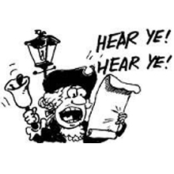
Have you heard that Olney is turning 175 years old? This will be the Olney/Richland Co. Dodransbicentennial Celebration! There are lots going on towards the end of July with concerts (including country music band Diamond Rio) drawings for a beautiful white squirrel quilt, antique car-trucks-tractors-farm implements show, many children’s activities, food, and historical displays all weekend long. I was just a baby when Olney turned 100 years old and then I remember for the 125th celebration, my Mom and Dad (Chris and Venus Weesner) hooked up their buggy to my horse Flicka and rode in the parade. My what a time we all had!

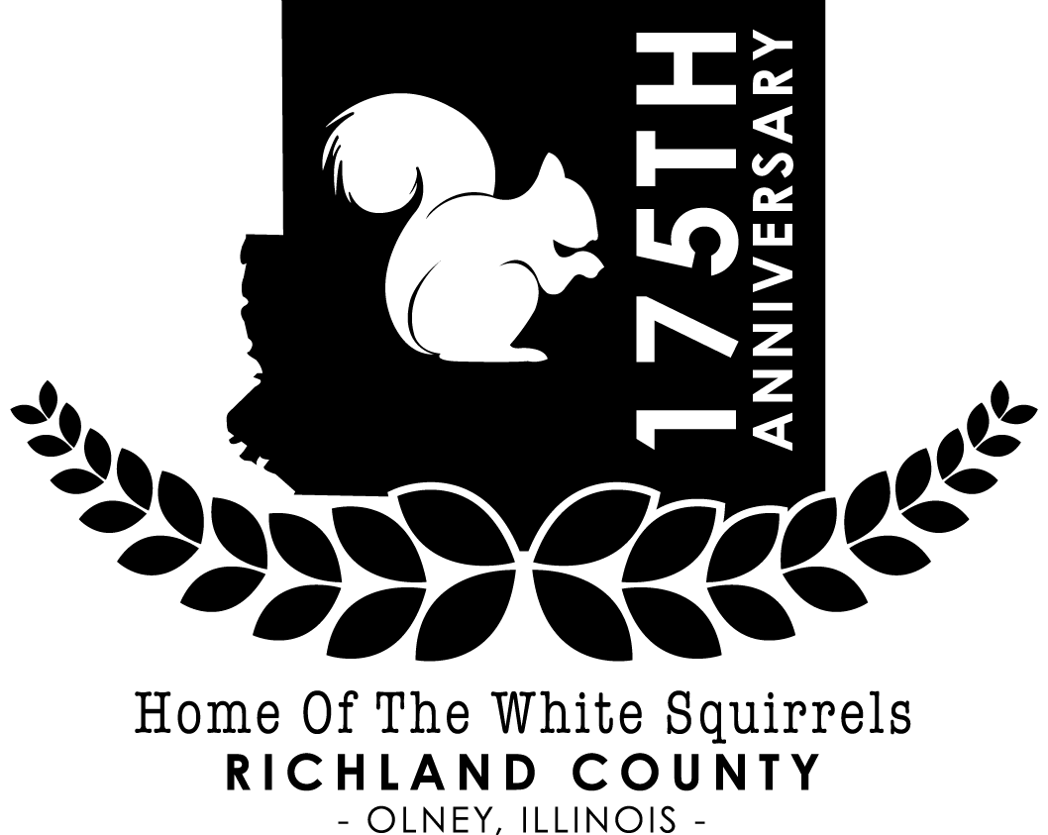

Please click for more information for this exciting weekend in Olney and also see the yellow flyer below… looks like a really fun time for every one of all ages!

http://www.olney175.com/
https://www.facebook.com/OlneyRichland-Co-Dodransbicentennial-685538694895865/
http://www.ci.olney.il.us/
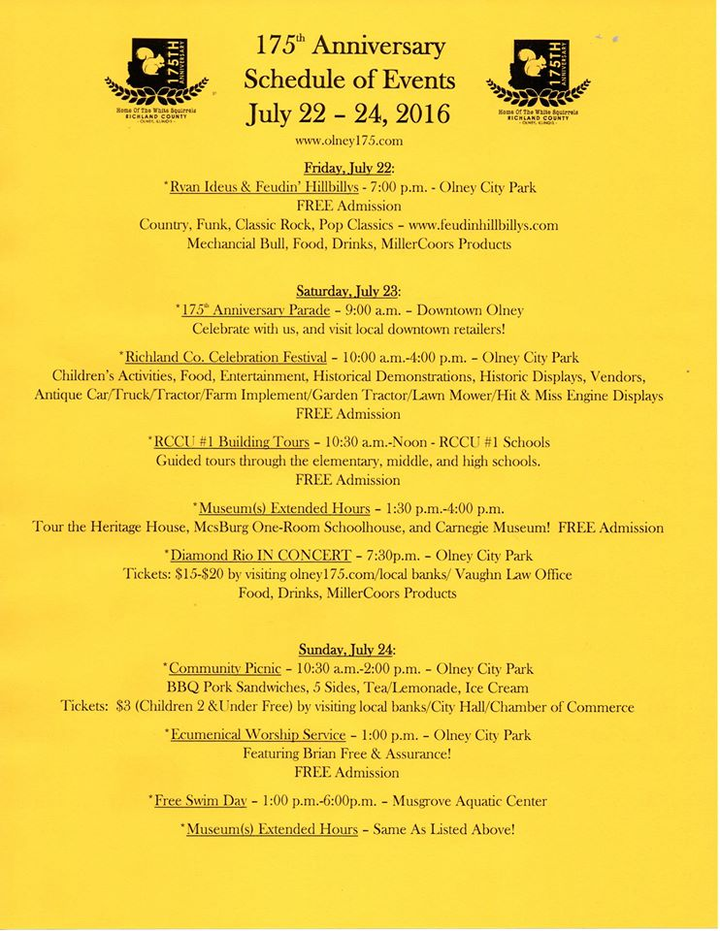
Ann Weesner King
Pianoann97@aol.com
Class of ‘60
---------------------------------------------------------------------------------------------------

John Helm
mlehjerhs@gmail.com

According to what you found, the marker is actually located IN Dundas. I was ten years old when all that took place. You'll be able to transfer the picture of the monument to your column, I would think. I've been talking with someone on the Trains Magazine website; he's originally from Dundas, now living in Indiana, and says he still has a small farm near Dundas. I don't know his actual name, as we have nicknames on that site. I knew if I got you started on this project, you'd come up with more information than I had, and you didn't disappoint me.

JEH
Class of “58
-------------------------------------------------------
Ann Weesner King

So I guess that would have made me about 8 years old when this Center of Population monument was dedicated. How well I remember (for my age that is). My Mom and Dad, Chris & Venus Weesner, and my Uncle Guy and Aunt Maude Weesner went to the all-day event which took place on Onion Hill which was West of Dundas on the Dundas Road. Correct me, someone, if I am wrong about the location of Onion Hill. I remember there were refreshments, and I think tractor pulling events (maybe) and other things that I’m not sure I remember well enough to write about. But it was an exciting day for sure! The population at that time according to the map was over 150 million. How exciting to have the center of population monument so close to Olney!

1950 Census Population Center
Inscription. This monument was erected to commemorate the determination of 1950 center of population of the United States of America in Richland County, Ill. and was dedicated October 18, 1951 at the ceremony attended by Adlai E. Stevenson Gov. State of Ill., Henry R. Schricker Gov. State of Ind., Charles Sawyer Secretary of Commerce, U.S.A.
The 1950 census of population conducted by the Bureau of the Census, U.S. Department of Commerce determined the center of population of the United States to be at latitude 38 degrees 50 minutes 21 seconds north and longitude 88 degrees 9 minutes 33 seconds west. This marker is located near the center of population.
Erected 1951.
Location. 38° 50.063′ N, 88° 5.074′ W. Marker is in Dundas, Illinois, in Richland County. Marker is at the intersection of County Route 1800 N and North Easy Avenue, on the left when traveling east on County Route 1800 N. Click for map. Marker is located in front of the Dundas Ruritan Club building. Marker is at or near this postal address: 4616 East Dundas Lane, Dundas IL 62425, United States of America.
Also see . . . U.S. Census Bureau History: 1950 Overview. This link identifies some of the new manners in which the census was taken in 1950, the first decennial census after WWII. Citizens outside the U.S. (especially military) were counted for the first time; UNIVAC1, one of the earliest non-military computers was used to tabulate census data; and for the first time, select populations were recounted. (Submitted on May 6, 2010, by John Desaulniers, Jr. of Mingo, Iowa.)
By John Desaulniers, Jr., March 17, 2010

2. 1950 Census Population Center Marker
Detail of marker

John Helm
Class of ‘58

Ann Weesner King
Class of ‘60
-------------------------------------------------------------------------------------

John Helm
mlehjerhs@gmail.com

Julie Seiler writes that the Arcadia Theater has closed; closest movie now Vincennes or Effingham. Guess that means no movies in Lawrenceville any more either. This isn't the first time the Arcadia has been closed. Another piece of Olney history down the tube; many years since the Elks Theater and the Olney Drive In closed.
I used to have some quality hand holding time in the Arcadia!

John Helm
Class of ‘58

George Roth
gsroth2@nwcable.net
My mother was a school teacher. She was born and raised in Olney. She started teaching school as soon as she graduated from high school.
She taught in schools like this school around Olney, Claremont and other towns. She later went to college and was hired as office manager by large company in Evansville.
The shoe factory in Olney was the biggest company and had the most employees of any company for many miles in any direction at that time.
They hired her as office manager and she moved back to Olney.

They had students past the age that is normal now. My grandfather Roth taught at Stringtown School for part of three years.
They had school when the children were not needed in the fields or at home. Usually fall and winter.
He was also the Blacksmith for Stringtown and the surrounding area.
He had telephone communalized lines installed for the area.
He started an insurance company that is still in operation. My brother Bob or Jim was still selling insurance for them till last year. Another company took it over last year.
When people had animals they would contact him. Most of the time he had the answers. My father acquired much of that information. He helped many neighbors and friends with their animals.

His mother and father came from Germany. They both died and he was later raised by an aunt in St Marie. We lost record of him till he appeared on a census, working on a farm around Olney.
How or where he acquired all this knowledge we have no information.

I thought you might be interested. If you heard of the Joe Brassie Sr., while you were living in Olney. His daughter was my mother, Florence Brassie Roth.

Since you were from Olney and knew most of the information about the people from that area I thought you might be interested.

George Roth
-----------------------------------------------------------------------------------------------------------------------------

Gloria Dean
gedean7352@yahoo.com
I couldn’t seem to get the reply to work on the last one, but you mentioned about kids riding their bikes to school.
I went to a country school until I was in the 7th grade and I either walked or rode my bike. Walked usually with someone else. Carolyn went a year or so to Calhoun HS before we moved to town and she walked most of the time. She may had ridden her bike some, but not often. We didn't have a car, only the farm truck and it was needed on the farm so we didn't use it often. I think we rode bikes some to Central too, of course didn't have buses then. WOW you missed a lot didn't you. HA HA
Gloria Dean
-----------
(Ann)---Yes Gloria, honestly I felt like I did miss a LOT because I didn’t like riding the school bus. I always wanted to ride my bike with the other kids or walk with them to and from school. I felt like I missed out on a lot by riding the school bus! Any thoughts on this from other bus riders?
----------------------------------------------------------------------------------------------------

Mary Jane Hughes
hughes.micki@gmail.com
When I went to first grade at St. Joe's, the nuns decided I had to be switched from being left-handed. They used hours of the Palmer method to teach me to write and also to control my right hand. I didn't think much of it until someone watched me write and said I wasn't writing, I was actually drawing the letters.
There was a whiny kid around the corner whose mother used to tell her to quit crying or she'd give her something to cry about. I remember we all thought it was funny because we got tired of listening to her too. The best was a neighbor kid named Bernie whose mother kept him from touching the hot stove by saying, "Burny-burny, Bernie." We used to roll on the floor over that. Children Services could come running at things people considered normal parenting back then.

Mary Jane Hughes
Class of ‘60
----------------------------------------------------------------------------------------------------==================================================================

