Olney Memories # 117
June 16, 2015

Welcome to Olney Memories # 117. Wishing everyone a great summer full of fun and activities and also sitting back and relaxing in the lazy days of summer!
As in almost every issue we have new members on our mailing list to welcome! Keep the memories coming in and also reminding you to send me your e-address changes.

Ann King
Pianoann97@aol.com
Class of 1960
----------------------------------------------------------------------------------------------------
----------------------------------------------------------------------------------------------------
Kathryn Haenggi Robinett
klrobinett@gmail.com
Hi Ann,
More telephone trivia from the past. We lived in rural Olney, and our wall crank phone # on the party line was two shorts and a long. For long distance connection, a switchboard operator in Calhoun plugged a connection. The ringing from the crank phone was heard by all who were on the same line, so if my dad went to town and for some reason needed to phone home to Mom, he spoke in German for privacy. When dial phones were installed, gossip was that those wishing to continue eavesdropping could merely set their new dial phones in a dishpan in order to hear the dialing "vibrations." Where there's a will....
.
Kathryn Haenggi Robinett
-------------------------------------------------------------------------------------------------------------
Mary Jane Hughes hughes.micki@gmail.com

We shared our party line with a family who had several unruly older boys who swore at us if we were on 'their' telephone line when they wanted to use it. Dad finally got fed up after many unresolved complaints to the phone company and got a private line.
Mary Jane Hughes
Class of 1960

Gloria Dean gedean7352@yahoo.com
I just read the latest OM and I have to tell you about my experience with the phone. I don’t remember our #’s but we lived in the country and had the wall phone that we had to crank. In fact we had 2, one for Olney and one for Calhoun.

Then we moved in town and phone lines were scare I guess due to WW2 still going on. We had one as my dad was a volunteer fireman.

The story I love to tell is this. When I was in Jr High at Central School, Mr. Jacques the History teacher said that someday our phones would answer and tell people where we were and when we would be home. I just knew he was CRAZY. But later we moved to Flora where I graduated from High School in 1950 and was just 17 in April when I graduated, but went to work soon as a telephone operator. That was just before the Flora office changed to dial. But a family moved to Flora from Chicago, (which had to be a huge cultural shock, moving from the BIG CITY to a small country town, with probably 7000 residents or less). Anyway I don't think they liked us very well, but one day the lady placed a long distance call to a # in Chicago, station to station call. When the # answered it was an answering machine and I had to charge her as she had not asked for a particular person. She was MAD to say the least and called me back and told me OFF in a few words. She called me a "HICK TOWN OPERATOR". Of course that reference upset me, and even though I was still a very timid quiet person, I told her in no uncertain terms that I might be a "HICK TOWN OPERATOR" but I did know what an answering machine was and that we even had some in OUR LITTLE TOWN.

One of the other operators, working by me had no idea what the lady had said, but she (the operator) thought it was hilarious and later told the supervisor how funny it was coming from me such a timid quiet person.

Gloria Dean

Ann Weesner King pianoann97@aol.com
Along the way in OM’s they are been numerous mentions about Gaffner’s Drug Store. Pictured below is an original bottle of Camphor Spirit that came from the Robt. Gaffner Drug Store. Notice the phone number on the label is 2-3811. This bottle has been around quite a while now. I found this is my mother’s medicine cabinet a few years back when we were breaking up their housekeeping.
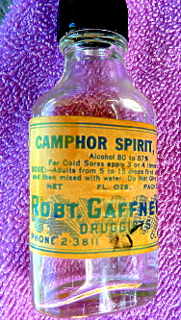
Ann Weesner King Class of ‘60
-------------------------------------------------------------------------------------------------------------
Elaine (Stivers) Shaw ve.shaw1940@yahoo.com
It is really enjoyable looking back in Olney's history while looking forward as we keep in contact with each other.

As we get older holding on to relationships become more and more important. I graduated in 1958. A few years ago a bunch of us women who graduated in 58 started getting together for a weekend sleepover once a year and meeting for lunch every other month. We meet in different restaurants. The group has tried out about all the restaurants in Olney, have traveled to Mt. Carmel to eat at the Red Cafe at Wabash Valley College, have gone to Red Hill to the Trace Inn. We have also hit some little towns like Noble and Sumner.

We meet at 1:pm and usually break up about 3:pm. I look forward to going every other month and usually only bad weather keeps me away. It is a whole different type of relationship compared to what we had in high school. But I really believe that the foundation that we built with our classmates in school makes our get togethers today even more important to us. As we get older holding on to relationships become more and more important.
For the yearly sleepover we rent a log cabin out in the woods for a Friday night and Saturday day. We have been having it in April but sometimes it is cold so maybe May will become a consideration. The every other month lunch get together occurs in Feb., April, June, August, Oct. and Dec. There is probably the same 8-10 of us there every other month and then different people will come as they come back to Olney to visit families or vacation. I believe that we have had as few as 8 when I have been there and as many as 14. We may have had more attend but I wasn't there at those meetings. Lou Ernest is the person who has more or less held it together and gotten people notified. Jolene Lathrop is the one who contacts me every other month as a reminder that it is time to get together. Jolene has been a very good friend since the 7th grade. I have a lot of wonderful memories of our growing up together in Olney.I am very grateful to Lou, Jolene and whoever else coordinates these every other month get togethers. They have become very precious and dear to me and I look forward to them. And just as an afterthought I think that we all turned out really good. Our luncheons have become a time of sharing, of laughter and much wonderful conversation. It is really a neat and super time of remembering the past while we look ahead to the future. I hope that we are all still getting together like this when we are 90.
Elaine Stivers Shaw Class of ‘58
----------------------------------------------------------------------------------------------------

Richard R Williams
rrw41@earthlink.net

Hello OM Contributors!
I am trying to find pictures taken at the tenth reunion in 1970 of my class, the Class of 1960.

I am presenting a slide program as part of the entertainment for my Class of 1960’s 55th reunion. The program features pictures of classmates attending past reunions. I have pictures for all years but the reunion held in 1970. I realize that many of you OM readers are from other classes and wouldn’t normally have any pictures of my reunions. However, as each class often has members who have married those from other classes and as many of you are second and third-generation family members, some of you could have pictures we’d love to have. Please contact me, at rrw41@earthlink.net if you can help. Thanks!

I might recommend to committee members for reunions for other classes that you might want to begin such a collection for your class, if you have not already done so.
Thanks Again!

Richard Williams
Class of 1960

Cindy Totten
yorkieart@yahoo.com
Tucked away in the middle of downtown Olney is Wildwoods Gallery, home of Olney’s finest gift shop, and once, home of Bower’s Drug Store. Perhaps you remember sipping a soda at the fountain. The marks remain where the old barstools once stood on the beautiful mosaic tile floor. The building which holds over 150 years of memories of downtown Olney now is home to a full line gift shop and is also home to the White Squirrel Shop. Here you will find handbags and accessories, a baby boutique, unique home décor, handmade soaps, kitchen gadgets and a wine accessories department. The White Squirrel Shop offers tees, caps, socks, Christmas ornaments, dishware, statuary, and many other unique white squirrel items.
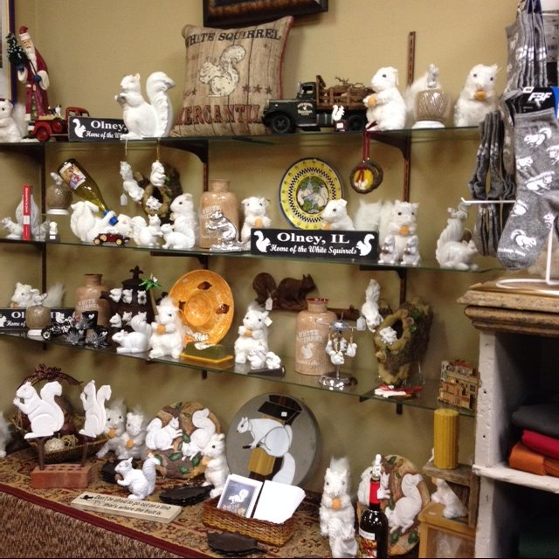
We happily ship to white squirrel lovers everywhere. Please call (618) 393-7263 for more information. The photos below show the outside and inside of Bower’s Drug Store many years ago.

How many of you remember when Bower’s looked like any of these pictures below?

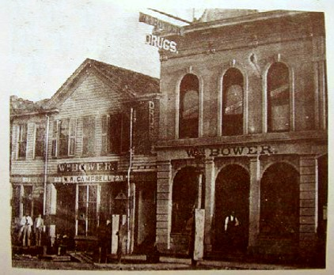
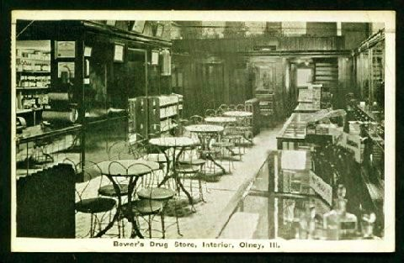
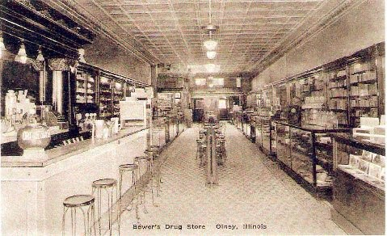

Cindy Totten
================================================================================================================================================================

