Olney Memories
February 11, 2015

Happy Valentine’s Day!
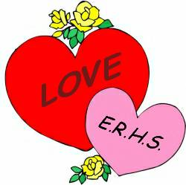
Happy Valentine’s Day to everyone and enjoy OM’s # 115. Keep thinking of good ol’ memories to send our way to share with all of us. Remember to send me your e-mail changes. If you want to be on the e-mail Contact List, just send me your name and e-mail and tell me you want your name to be on the list, that’s all there is to it and I will add your name to the list. Thank you.
Ann Weesner King Pianoann97@aol.com

Hello Fellow “OM” Readers,

Many of you have heard of the Tiger Alumni Center and some of you are members. You may remember that for several years now we conduct a scholarship drive for ERHS seniors. Our drive for this year is now open and all are welcome to participate.

All you have to do is mail a check to our high school, care of Mr. Simpson, Principal!
The Address:
East Richland High School
c/o: Chris Simpson, Principal
1200 East Laurel Street
Olney, IL 62450

Your Check:
Make your check out to “ERHS” and in the note space, write “TAC Scholarship.”

The Record:
You will receive a letter from the school accountant for your tax record.

Our 2015 Goal:
Our goal this year for the 2014 scholarship is $6,000.
For more detail, visit us at http://www.erhsalumni.net/Scholarships-2015.htm

Thanks!
Richard Williams, Founder
Tiger Alumni Center
------------------------------------------------------------------------------------------------------------------------------------------------------------------------------------------------------------------------------------------------------------------------------------

John Helm
mlehjerhs@gmail.com

Enjoyed the new #114 - it brought back a lot of memories for me, as I, also was employed by WVLN AM and FM, "The friendly twin voices of Southeastern Illinois". I was a part-time staff announcer there starting in 1956, working mostly after school and on some Saturday afternoons and Sunday mornings. I volunteered for the draft in 1959, and got out of the active Army duty in February '62. I went to radio school in Chicago, and got an 8-hour shift Monday thru Friday at WGEZ in Beloit, Wisconsin. I enjoyed it there, but my best girl was in Olney. I got a call from WVLN saying they were interested in having me come back to work there. So I came home, and in addition to announcing, worked in the Continuity Department, writing copy. I separated from WVLN and went to work for Sadler Motors Volkswagen in Vincennes in 1963 as a part of their sales force. Helen and I married in September of '63, and we lived in Vincennes, where our older daughter Laurie was born.

John Helm
Class of ‘58

Ann Weesner King
Pianoann97@aol.com

The Elks building has been talked about numerous times in the OM’s so here are a couple pictures from the past I thought you might like to see.

This is a photo of the Elks Building from the south end on Kitchell Ave.
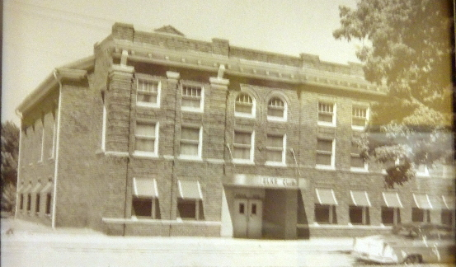

This photo shows the inside of the Elks building years back in time.

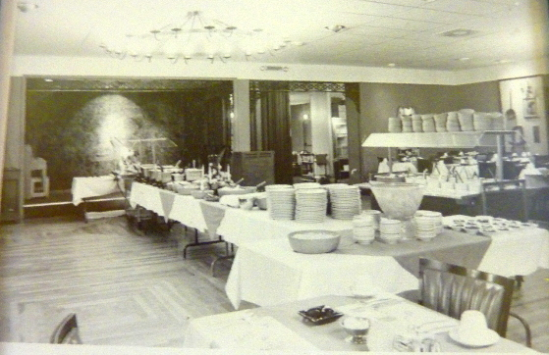

Ann Weesner King
Class of ‘60
----------------------------------------------------------------------------------------------------

Charles Fregeau
n5hsr@sprynet.com
Hmmm, didn’t Mrs. Brown teach music at Cherry later? And Mrs. Hatch, is that the same one that was later over at ERJH?
Charles Fregeau Class of ‘75
------------------------------------------------------------------------------------------------------------------------------------------

David Schnautz David.Schnautz@clarkfreight.com
Hello all-- this is Ann’s son David. I read Ginny’s note about Central School. That is where I spent 6 years of my life. I would have graduated ERHS in 1982 had we not moved away. Looking back they were pretty good years. A lot of freedom with just the right amount of discipline. You knew what was expected and you were expected to act that way. Like leaving the “campus” to go eat with Mrs. Whitaker at the Town Talk over lunch. She would drive her maroon Thunderbird and her entourage of 3 or 4 students would walk and meet her up there. Quite the relaxed atmosphere and responsibility for a grade school guy. I could go on and on but I won’t. What prompted this was the picture of Mrs. Hatch. She taught me in the first and second grade. 1971 and 2. She also taught my Mom when she went to Central. Does anyone know how many years she taught? Had to have been a bunch of them. She touched so many lives and generations. I admit I didn’t like either of those years at first. She wouldn’t let you get by with much. But looking back…..i am so glad I was in her classes. I was mad at Mom and Grandma, Venus Weesner, for “pulling strings” and making sure I was in her class. I have since got over that also.
Long live the memories because that is the only thing they can’t take away.
David P. Schnautz
Class of ’82 (if we hadn’t moved to Texas)

Roy Miller
rlm322@frontier.com
Ann,
The issue spoke of Bill Gaither. Back in my days at AMF/Roadmaster. Joe Wilkerson also worked there as a V/P. He showed me a post card reply that he had received from Bill Gaither answering his question to Bill asking if he had worked at the Olney radio station. Bill replied that indeed he had done so in the summer of 1954. Also another older couple named Gaither also went to the same church that I did in Olney who were kinda distant relatives of Bill. I went to most of his concerts in the 70’s, mainly in Evansville.

Roy Miller
Class of ‘52

Ed Doolin
roydoolin@hotmail.com

I also wish to thank you, Ann, for keeping this site going. I enjoy reading each new entry.
My wife and I attended the 1964 class reunion. Wow, 50 years! It was well organized and well executed with casual and formal activities. My thanks to all who put it together. I wish I could have had more time to find and see more of my old classmates.
WVLN AM and FM brings back lots of memories, Marv, my brother, and I sang on a childrens’ Saturday morning program. Marv played his ukulele as we sang gospel songs. Lee Hayward was a WVLN personality. His real name was Lee Eggley and he had a large family with a son named Fred who was about my age, we both were car nuts, and built model cars together. He delivered Olney Daily Mail papers at the same time that I did, I think he had a brother who was also a paper boy, Fred had a couple of go carts. I watched him race at least once, I think it was at Claremont, and I drove his cart around the Dog and Suds parking lot in the winter.
My family lived in Olney for 10 years and I had a great time.

Ed Doolin
Class of ‘64

Ann Weesner King
Pianoann97@aol.com

There have been many comments about West Side Mikes and East Side Mikes in the Olney Memories from time to time. What would Olney be with that topic! A lot of you will recognize this actual box below. This was one they used when packing half gallons of Mikes Ice Cream to take home! Good Ol’ Mikes Ice Cream Parlor!

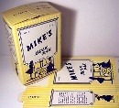

Ann Weesner King
----------------------------------------------------------------------------------------------------

Charles Fregeau
n5hsr@sprynet.com

OK, I want to discuss phone numbers with the guy that said Olney had dial phones by 1953. They may have had them in town, but not out in the country. My dad called my mom a few times while they were dating in the fall of 1953. His number was Pullman 5-8862 (now that would be 773-785-8862) but her number was 7 F 22. Dad still remembered it some 40 years later. Her number became 3-8008 somewhat later, and of course EX 3-8008 and in 1964 618-393-8008. Her dad could be reached at that number through 1967, when GTE changed the party arrangements and gave them a new number. Locally we didn’t have to dial the EX (or later 39) until the late 70’s due to the nature of the telephone dialing equipment in the central office. The odd thing is that my dad could dial 618 EX3-8008 and dial Granddad directly without an operator even before Olney got direct distance dialing in 1964. The purpose of the Express prefix on the phone number was to bring it into conformity with what is now called the North American Numbering Plan so that it COULD be dialed directly. Starting in 1947, Bell Long Distance worked with the local phone companies to give every phone number in the US an area code, a prefix, and a 4 digit station number, that is (618) EX 3-8008.
This took nearly 30 years to complete. But you need to understand there were TWO big conversions going on. First, every phone in the United States and Canada had to be cut over to dial, a process which started with places like New York and Chicago in the 1920’s and was completed only in 1982. Chicago alone wasn’t complete until 1948. Second, to renumber phone numbers so that they fit in the 3 digit prefix-4 digit station format. Only 4 places in the US at the time had 7 digit local numbers, New York, Chicago, Boston and Philadelphia, thus all they needed was an area code. (Chicago was 312 originally). And the third piece of the puzzle is a machine that could route calls based on the area code.

There were several tiers of local numbers that had to be ‘converted’. The most common second tier was like St Louis, which had 2-4 numbering (Chestnut 1000), as did Los Angeles and Kansas City, and Atlanta. Bell Long Distance would coordinate with the local phone companies to assign new prefixes that conformed to the NANP. Chestnut 1000 became CH 1-1000, for instance. But in some case, such as Atlanta, wholly new prefixes were assigned. Sometimes, like in Atlanta, some of the old prefixes were converted then others later. Other times, like St Louis, they were all converted at once.
The third group was Memphis/Little Rock and towns like them who had grown from 4 digits to a mix of 5 and 6 digit numbers. 27xxxx in Memphis became 727-xxxx, for instance. There did not seem to be a rhyme or reason to what they chose to replace the existing prefixes with.
Fourth group was 5 digit numbers (like Olney) and 4 digit numbers (like a lot of the small towns around them). Again, prefixes were chosen to integrate them into the NANP. Terre Haute was a special case, since they had words instead of numbers for the prefix. But for purposes of conversion the first letter was treated like a number and a prefix was placed in front of it. In Olney, they put 39 in front of 2-xxxx and 3-xxxx (5-xxxx didn’t come until after the conversion to Express and Express 4 was already in use in the area of East St Louis.) In Terre Haute, they put 23 in front of the Crawford (232-) Harrison (234-) and Lincoln (235-), but apparently 233 was already used or planned for in that area code so Drexel became 533-. In the case of 4 digit numbers, a 3 digit prefix was picked that was available out of the NANP. Less than 4 digit numbers were either filled out to 4 digits, or combined with a nearby exchange.
Why Olney needed 3 prefixes? You see, Chicago could get away with 7 digit phone numbers because they had a unique selection point for each ‘station’, this is called Terminal Per Station (TPS) and it’s the way phone companies have been operating since the 1970’s when the new electronic switching equipment made it much cheaper than its alternative. Olney, on the other hand had Terminal Per Line. Each line had a unique code and the last digit rang the party on the line. So not all the 20,000 possible numbers were useful. A private line, for instance, always ended in 1, as did the first party on a two party line and the numbers ending in 2-0 for that line number were not used. If 2-4581 was a private line (and it was and still is today), then 2-4582 through 2-4589 and 2-4580 were not used. Also TPL did not originally use 1 or 0 as the first digit after the prefix, so that’s another 2000 numbers lost there. Beginning with the EX 5 prefix approximately 1960, the new equipment installed for that was Terminal Per Station. From my 1963 phone book, EX 5 looks like it started with 1001 and was numbered straight up. That is the next new phone number was EX 5-1002, whether or not it was on the same line. At this time, they seem to have put EX2 – 0xxx on the same equipment. My grandfather was on a 10 party line in the country, and they all started with 3-800x for instance. Had Olney been cut over to dial and TPS at the same time, there might have been only one prefix. 618-393 is still a very lightly used prefix to this day. When Noble (1965) and Claremont (1964) were cut over to dial, they were cut over Terminal Per Station. I have a 1963 Olney Noble phone book and a 1965 Olney phone book and did a comparison of the Noble phone numbers and the line number on the system from 1963 has no relationship to the number assigned on the new 723 prefix in 1965.
Kankakee, a town with 70,000 people, cut over to dial in 1953 and had only 3 prefixes because they were set up TPS. Danville, 40,000 got 2 prefixes in 1957.
Incidentally the county seats got 2- as one of their prefixes where possible. Olney 392-, Lawrenceville 932-, Quincy got 222, Danville got 442, Joliet got 722, Springfield got 782, Vincennes 882.
The reason for TPL equipment, especially in the country, was that copper wire cost money! In the early days, each separate phone number had to have a pair of wires running out to it from the central office, and had to have a separate pair of wires run into the dialing equipment. TPL meant only one pair of wires per LINE running into the central office. The last digit signaled to the local dial equipment which ring to use. Different rings were used on party lines and the equipment generated them, but they weren’t ‘two longs, two shorts’. There were various schemes used to ring just one phone on the line. By the 1970’s, you could put many many telephones on one pair of wires, and keep them separate, and by the 1970’s electronic switching made all the old mechanical dial arrangements obsolete and expensive to maintain. I had such a hybrid arrangement in 1980 in Freeport, where the house had only one phone line coming in, but needed a second phone number, so they put a ‘splitter’ in .
Sigh. Now that I’ve told you more than you ever wanted to know about phone numbers, dialing equipment, the two great conversions, and so forth, I need to eat breakfast.
Charles Fregeau Class of ‘75
-------------------------------------------------------------------------------------------------------------

======================================================================================================================================

