Olney Memories # 110
September 4, 2014

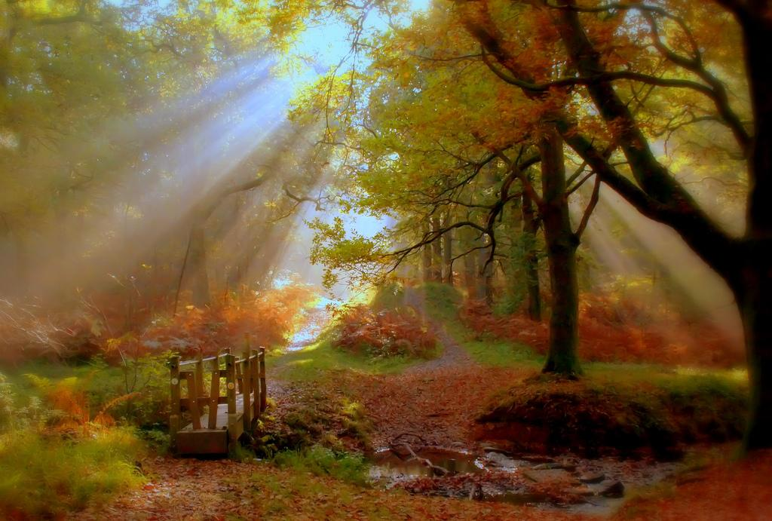
Hello and a big welcome to all of you from the end of the summer issue. We have been having LOTS of technical problems with our computers (Trying to solve them with a new Apple iMac hasn’t even done the job yet.) and if any of you have sent in any contributions that are not in this issue would you please resend them to me. I will be sure they get into the next issue of OM’s. Also if you have written me about anything at all or asked to be added to the mailing list and I have not responded, that means I did not get your e-mails so please write again, and I will address these issues.
Please continue to send in your memories. Also please remember to keep me up to date on your e-mail addresses, this helps to keep things running smoothly.
Ann Weesner King
Pianoann97@aol.com
Class of 1960

------------------------------------------------------------------------------------------------
THIS IS JUST A REMINDER TO GET YOUR RESERVATIONS IN
64th REUNION of ERHS CLASS of 1950

We are planning a 64th reunion for the ERHS Class of 1950 on the evening of Friday, September 26, 2014.
This will be a reunion to meet and talk about old times. There will be no formal atmosphere and the meeting will be held at
The Olde Tyme Steakhause in Olney.
You are asked to phone Olde Tyme Steakhause (618-392-3663 or e-mail www.oldetimesteakhause.com) to make dinner reservations for the “class of 1950” room. We will order from the menu and they ask for reservations to be made 2 weeks prior to the meeting. There will be a social at around 4:30 p.m. or so.And we will have DOOR PRIZES for several lucky people. We will have dinner around 6:00 p.m. This invitation will be sent via e-mail, TAC, OLNEY MEMORIES and word of mouth. So please pass on this information to other classmates that we
might not have e-mail addresses for.
Hope to see you there.

PEGGY CARSON
DON WATSON
WAYNE BATEMAN
JERRY SCHERER
BILL MAY
--------------------------------------------------------
Richard Williams
rrw41@earthlink.net
Hello OM readers!
Richard Williams here with great news! That’s the creation of the new Tiger Pride Alumni Association. LTD! Sunday afternoon, August 24th, volunteers met for the first time to organize an alumni organization. By the end of their meeting, they had created the Tiger Pride Alumni Association, LTD (TPAA).

Board Members. The following volunteers were elected as Directors:
Kellie Bussard Cook, Class of 1964
Mary Ann Noerenberger Cummings, Class of 1970
Janet McKinney Everette, Class of 1977
Lisa Hough Hemrich, Class of 1990
Nancy Huchel Rumsey, Class of 1966
Clarence "Smitty" Smith, Class of 1960
Judy Dale Hill Walker, Class of 1964
Richard Ray Williams, Class of 1960

The founding officers are:

President, Kellie Cook
Vice President, Lisa Hemrich
Treasurer, Janet Everette
Secretary, Mary Cummings

The new Directors know that without the legal assistance of Tom Weber, Class of 1964, and Frank Wagner, Class of 1965, TPAA would still be a dream of mine (Richard Williams).

For more information, go to TAC: http://www.erhsalumni.net/Tiger-Pride-Alumni-Association.htm

Richard Williams
Class of ‘’60
Paul Berger
bergerpm@tds.net
Does anyone remember Montgomery Ward store location on E. Main St.? Seem like it might have been across street and a little east of Penny's.

Paul Berger
Class of ’50 (Noble)

Bette Schmalhausen
Bette12041@gmail.com

In response to Marilyn Brock's comment about the dentist above Gaffner's, I believe that was Dr. Jordan. And the Rexall Drug Store was Schmalhausen's Rexall Drug Store.
Bette Schmalhausen
Class of ‘51
---
(PS. Bette, good to know about Schmalhausen’s Rexall Drug Store too & thanks! Ann ☺

---------------------------------------------------------------------------------------------------------------
Jim Hawkins
Hawkeye183@verizon.net
HI ANN- THINK THE DENTIST LOCATED ABOVE GAFFNER’S WAS CAUSER/I WENT TO HIM AND LATER ON TO DR. JORDAN UP ABOVE THE OLD SAVINGS & LOAN WHEN I WAS YOUNG/DR. JORDAN WAS PRETTY YOUNG WHEN HE DIED.
Jim Hawkins
Class of ‘51
----------------------------------------------------------------------------------------------------
Terry Walker
theaged@yahoo.com
Thanks Ann, I remember Dr. Murphy! He did have a big growth on his lip.
Terry Walker
Class of 1960
-----------------------------------------------------------------------------------------------------------
Marvin Doolin
doolin@starband.net
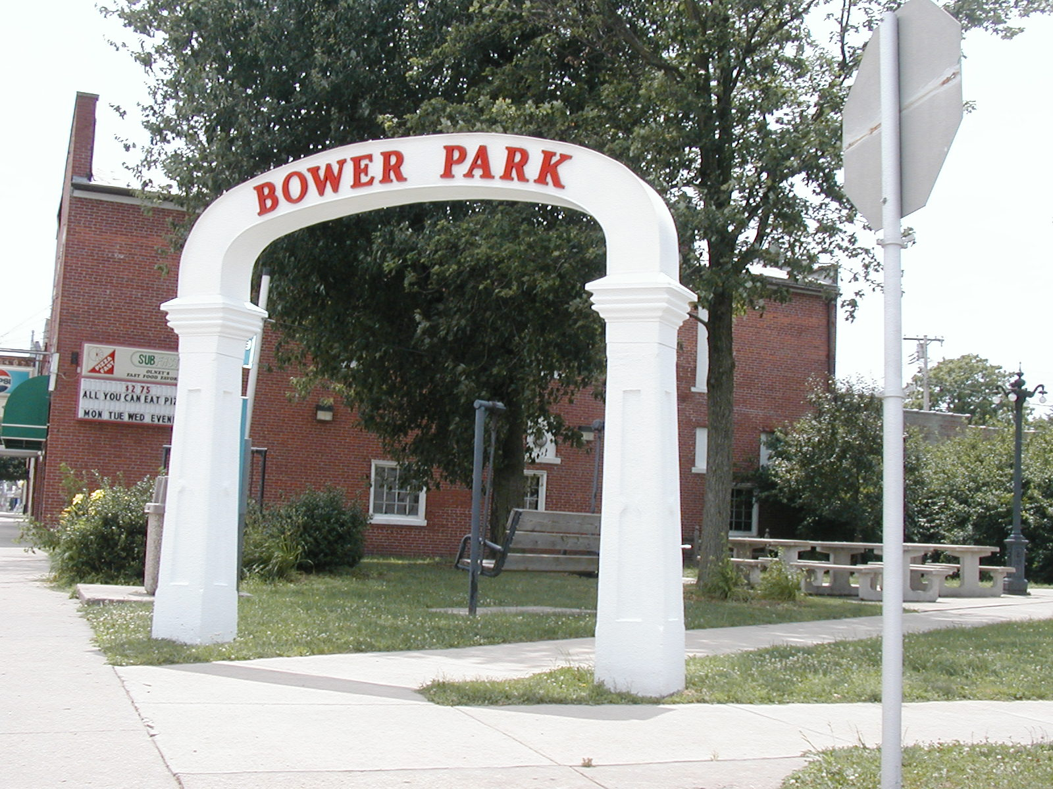
(MARVIN, THE BOWER PARK IS PICTURED HERE AND IS STILL STANDING AND THIS IS WHAT IT LOOKS LIKE TODAY ☺ YES IT IS
ON THE SW CORNER OF WHITTLE AND CHESTNUT. “ ANN)
--------------
I've been trying to remember a park at Whittle and Chestnut, and I've
decided it must have been on the SW corner unless it was gone by 1956 when I began my first paper route out of Beal's News Agency on the NE corner. I vividly remember the police station / fire house on the SE corner and Eggley's Donut Shop (probably established about 1958; I don't remember what was there before) on the NW, but I'm totally blank about the SW corner. Is the park still there?
I was also fascinated by the Main Street pictures. The first must have
been taken in the early 1950's, judging by the cars I can see. There's a
1930-something GM car headed west, and the Mercury near Mike's appears to be a 1949 or early 1950 model. In the second picture I think I see a Corvair two-door, which would place the picture into the 1960's. Corvair was introduced as a 1960 model in1959, but the two-door was a year or two later, as I recall. I love pictures like this.
Finally, I too remember Mrs. Brown fondly, though nothing I made has
survived.
Thanks again, Ann, for what you do. I am always pleased when Olney
Memories shows up in my inbox.
Marvin Doolin
Class of ‘62
----------------------------------------------------------------------------------------------------
Roy Miller
rlm322@frontier.com

Happy Fourth of July . As a pastor just said, it should be a day of THANKSGIVING, like the major holiday.
Is it OK for an old codger to give about 4 spelling corrections in this list ??
”(your help is most welcome Roy). Ann”

1.Borah Holman . I once worked there .
2.Wieland & Goudy Went there a lot
3. Pipers Hardware. Used to go there with older bro & sister when they bought 78 rpm records there.
4 Fulgham Bros App. . Was in same class as Jack Fulgham, so I looked in 1952 yearbook to be sure.

Just want to be helpful, not picky .” (glad for your help) ann”
Roy Miller
Class of ‘52
Beverly Decker Beauchemin
bbev@windstream.net
Hi Ann,
Just a sincere thank you for all you do to keep all of us connected with our past. I was able to get in touch with Ron Scherer regarding memories of Richland County's one room schools. I was a student at the Decker School between Noble and Wynoose for four years until it was consolidated to Wynoose which was a two room school! Precious memories from a very blessed childhood beginning. I will be working with Ron in sharing some of them...stay tuned!! God Bless you and hubby who gives you a helping hand. You are appreciated.
Beverly Decker Beauchemin
Class of ‘56
-------------------------------------------------------------------------------------------------
John Helm
mlehjerhs@gmail.com
I was fiddling around on the ERHS site yesterday and decided to read the very first Olney Memory you posted. It was interesting to see that people remembered the Little Farm Market on Whittle Avenue, and so on. But here's one I'll bet you didn't know about, or p'raps I missed it. I know you remember Charlie Jones and Jones Cycle Shop just north of the Little Farm Market. His original store also had a dirt floor in it. I worked for Charlie one summer, putting trikes together and washing his show windows, etc. He was a nice man. I bought the very first Schwinn Corvette bicycle from him. it was one of the first bikes with middleweight tires, and also had a Sturmey-Archer 3-speed transmission and Weinmann hand brakes.
John Helm
Class of ‘58
------------------------------------------------------------------------------------------------
Pauline Roth Frohning
pfrohning@mmtcnet.com

This is me (at 81 years 2 days old!) riding the Wards Hawthorne bicycle that I bought at Montgomery Wards on Main Street in Olney in 1946. I think it cost about $50.00. It had a carrying basket, a head-light and horn. My daughter, Deborah, had it "refurbished", new tires and paint added. Deborah, had it “resurrected” and gave it to me for my 81st birthday on July 2, 2014. It is a Hawthorne bike. Several years ago, my brother, George, bought it from me. He painted it red, and had a bar added to make it a "boy's bike." I have had other bikes through the years, and still have one that I ride often. Our daughter has had this as her bike, but, just had it stored the last few years. Anyone else have one of these?
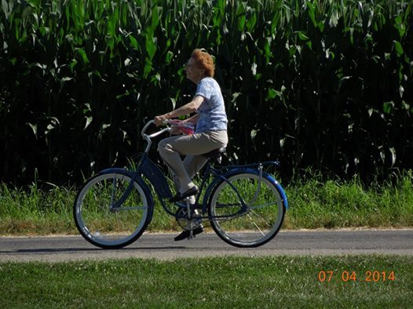

This was the same bike in 1946. I believe that is our '33 Chevy" in the background, and our barn. This is my “new old bike” that I bought from Montgomery Wards in 1946. My daughter, Deborah, had it “resurrected” and gave it to me for my 81st birthday on July 2, 2014. It is a Hawthorne bike.
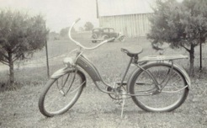

Pauline Roth Frohning
Class of ‘52
---------------------------------------------------------------------------------------------------------------
Richard Wilson
Wilson761@aol.com

Ann - I'm passing along a copy of excerpts about Olney found in Biographical and Reminiscent History of Richland, Clay and Marion Counties circa 1908 along with a couple of old Olney Main Street postcard images. Thought you'd interested. - Rich

OLNEY IN ITS INFANCY [written about 1908]

Richland County was part of Clay and Lawrence counties At the organization of the county there was no town here. What is now Main and Walnut streets and Whittle Avenue was a cross road called Lilley's Crossing. The land was owned by Thomas Lilley and Hiram G Barney who proposed to give ten acres of land each to be laid out in lots and sold at public sale, the money thus raised to be used to build a court house and jail. The lots were laid out and platted by A.T. David, a surveyor, the 20th day of September 1841.
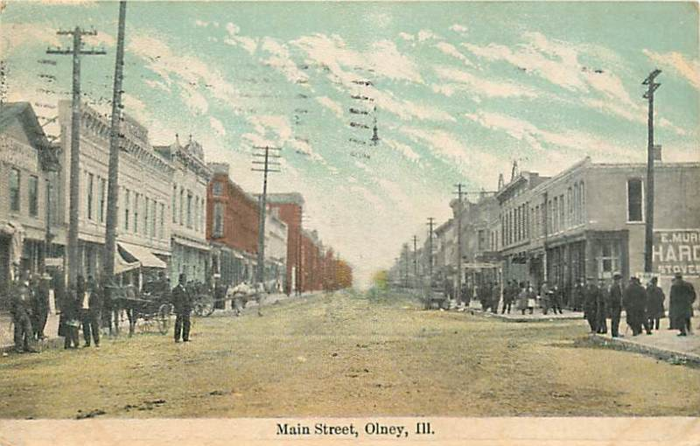

[The building next to The White Front on the far left with the peaked shingled roof is about where John Jacob Astor's "American Fur Company" bought and dressed pelts for shipment to Leipsic, Germany]
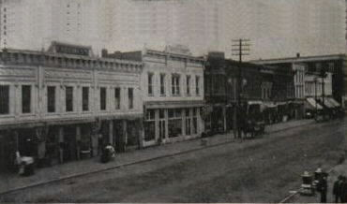

Commencing on the north side of Main Street opposite Coen's Hotel was the first lot west and occupied by a saloon owned and kept by Louis Sawyer, the first Sheriff of the county. The next was the residence of G.F. Powers. The next was a building occupied by the American Fur Company where they dressed the pelts put them into bundles and shipped them direct to Leipsic, Germany. [The American Fur Company was located about where Gaffner Drug Store was located in the 1960s] The next was the residence of Joseph Harmon. The next was John Von Gunten's Bakery, the first regular bakery in Olney. Old man Ross, an old Revolutionary soldier, baked gingerbread before Olney was laid out. Mr. Von Gunten made “spruce” beer out of persimmons and some other truck unknown to the writer. The next was the residence of William Alkire, the next was a little building in which Dr Ridgeway afterward had a “drug store” and his office, next came the hotel kept by Thomas, next was a one story building planked up and down in which K.D. Horrall learned the tinner's trade, next was the drug store and office of Dr. Haynie, next was the store of Henry Spring, Redman's store is now on that site. Where Schultz's store is [the Schultz Building, later J.C. Penney, now a Salvation Army thrift store] lived Jonas Notestine, a tanner by trade, where Elliott's Hall and Hyatt's Opera House now stand lived John H. Gunn, where the Metropole is now [later, the Litz Hotel] lived Dr Craig, where Landenberger's buildings are now Uncle Jimmy Briscoe conducted a small saloon and the post ofiice, in the same building next was the store of Newell and Darling, next was the store of A.L. and R. Byers , next was their warehouse over the front of which was painted “Iron Nails, Stoves Plows, Flour, Salt, Bacon, Castings, and Whisky”
Castings here mentioned were skillets and lids pots and other cast iron utensils for cooking by the old fire place. The next was their pork house about thirty feet wide by one hundred and eighty feet long, the next was the residence of John Garret then a two story building occupied below by P Shaw as a book store and watchmaker's shop, the first in Olney. In the upper story was the Olney Dollar Weekly Gazette office which was owned edited and printed by J.J. Bunting, Milo Powers, and James Nabb . The next was Tom Nettletor's store. Where the Sanitarium now stands [later the Weber Medical Clinic, and now the Olney Trust Bank] lived Frank Heap, and the old Union Hotel was located on a part of the ground. Next was the residence of Thomas Ratcliff and his good wife. Where Dan Geatheart now lives lived William Newell , next was a long about one hundred feet low building in which lived many families. It was called Hugel Row after the owner, next was the residence of William Kidd and that is as far east as the town was platted at that time, and from Walnut street east only one tier of lots deep. On the south side of Main street opposite Mr. Kidd lived Uncle Jimmy Briscoe in a big two story house, going west next was the residence of Michael Stauffer also his tailor shop the first tailor in Olney. Next was Mrs. Heifner the first milliner in Olney.
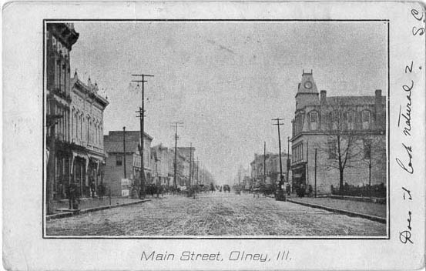
WHEN BLEACHED BONNETS WERE WORN

In those days the ladies wore white Leghorn bonnets which had to be bleached every spring and rebuilt. The bleaching process was performed by burning sulphur and sending the fumes through the straw by a process unknown to the writer, but if you were in the immediate vicinity of the kiln when it was opened you would think there was a fresh crack in the roof of hell. The next was the residence of Mr. Bendel a very highly educated man, next was the building in which the writer and many others went to school to Mr Bendel. The next was a large building where Frank Heap made furniture by hand. Then came Uri's blacksmith shop where Tom Ratcliff learned his trade.
The next was the residence of S.H. Gunn whose widow is living there now, the next was Gunn's store. On Saturday Mr, Gunn took a tub, put in about three gallons of whisky and two gallons of molasses, and stirred it up. He called the mixture black strap. This was free for his customers. The next was a small house in which the telegraph office was kept. The line was from Baltimore to Washington to Pittsburg to Cincinnati to Louisville to Vincennes then along the old state road to St Louis, Missouri. Reuben Gardner, now living in this county, helped to build this line. I think beyond doubt he is the only man now living who helped to put it up He is now over ninety years of age.
The next where Cooksey is now was a harness shop owned by John Allen. Where McShane and Meunch is now was the residence of John M Wilson, the founder of the Olney Republican in 1848. The next was the residence of Ashiel Powers, then Henry Springs's residence. Where Foskett & Gafner are now was the blacksmith shop of J.H. and Henry Johns, then a small room about twelve by sixteen in which K.D. Horrall began business in 1856, then the harness shop of Henry Barney, then a big low one story building in which Louis Hugel kept a clothing store, the first exclusive store of this kind in the county back of which was a building originally built for a stable but was remodeled by Hugel and into which the Olney Dollar Weekly Gazette was moved and there sold to William M. Beck, and by him moved into another building and the name changed to The Olney Times, and in 1859 Mr. Beck put at the head of his columns: “For President in 1860: Abraham Lincoln of Illinois”, the first paper to publicly announce Mr. Lincoln's name for the Presidency. He was elected November 8, 1860. Mr. Beck passed into the other life December 17, 1860. The next was the harness shop of W.P. Laird, then a little short street called Lilley Street running from Main to Market one block. A. Darling lived at the Market street end, then a building sidewise to the street in which G.F. Powers and Nelson Cobley made furiture by hand. Where the head of Whittle Avenue is now stood the saloon of Andrew J. Saulsbury. Where the first National bank is was the store of William Alkire, then the old wooden courthouse, then the office of Horace Hayward, and that was as far west as the town was platted. South of Hayward's office lived Judge Alfred Kitchell, then Levi Notestein. Where the jail and stables belonging thereto are now was the tanyard of Jonas and Levi Notestine across the vats of which the wife of the writer jumped in her girlhood days. Where the four courts are now lived Robert B. Mamey, the first Judge of the Probate Court of this county, and where the writer found his wife now almost forty seven years ago, south of the building and loan office lived M.B. Snyder, the Clerk of the Circuit Court whose son Samuel was the first boy baby born in Olney. North on Walnut from Main at York street, on the west side lived George Lutz, whose daughter Sarah was the first girl baby born in Olney.
Next Jonas Spanglor, next Jacob Hofman, Clerk of the County Court. On the east side was a big two story house in which lived many families. North on Mulberry Street from Main lived Henry Spanglor, north of Butler street was the old log school house in which the writer's wife and many others got their first rudimental knowledge of the English language. This house was used as a court house until the first one was built. It was also used as a Methodist Episcopal church until 1855, when the first Methodist Episcopal Church was built here. Of all the people living in Olney at that time there are only about ten persons living November, 1908.

Then came the building of the old Ohio & Mississippi, now the Baltimore & Ohio Southwestern Railroad, and Olney took on new life, then the old Peoria Decatur & Eastern, now the Illinois Central, then the Cincinnati, Hamilton, & Dayton, old Danville & Olney. Olney has grown from a small village to a city of about six thousand five hundred people.
Rich Wilson
Class of ‘68
==================================================================================================================

