Olney Memories # 108
May 22, 2014 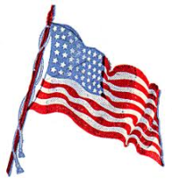
Our Veterans!
Greetings to all of you, the readers of Olney Memories. Hope everyone has a nice Memorial Day weekend as we remember the people who gave their lives for our country.
We keep having good responses of “memories” from our readers and this is what keeps the Olney Memories successful. So keep sending in your memories…..it means a lot! Also thank you for keeping me informed of your e-mail address changes.

Ann Weesner King
Pianoann97@aol.com
Class of 1960

-----------------------------------------------------------------------------------------------
John steury
j.steury@sbcglobal.net
Hey Ann, In memories #107 Peg Wilkins Kuenstler stated she worked at Decker drive in. It was owned by Carl (CD) Decker and his wife Wally Decker. The cooks name was Viola Decker and Rose Canjtrell was my sister . They also owned a drive in Vincennnes (both barrels were painted purple at that time). That was about the time the song Purple Eaters came out . Some people harassed CD about his choice of colors and he painted it red. I don’t remember the exact dates but I worked there as a curb hop. I was about 14 at the time. I also look forward to reading the memories & nbsp.

John Steury
Class of 1960
-----------------------------------------------------------------------------------------------
Ann King
Pianoann97@aol.com
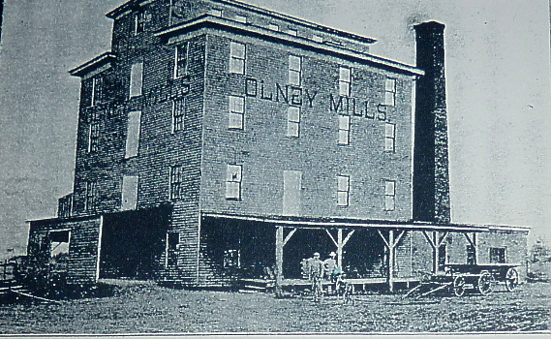
Olney Milling Company
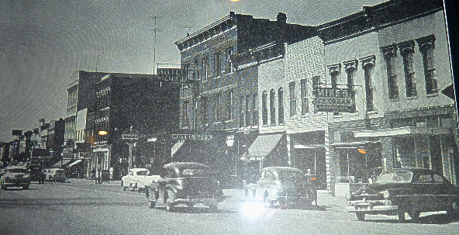
North Side of Main

Ann Weesner King
Class of 1960
------------------------------------------------------------------------------------------------------------

Dorothy Baugh
dl_baugh@comcast.net.

Originally I am from Olney and graduated with the Class of 1942. I just wanted to share with you a little bit about my husband Col. Joseph H. Baugh, a surgeon who treated President Dwight D. Eisenhower and General of the Army Douglas Mac Arthur. He was commander at Fort Benning’s Martin Army Hospital. He was a member of the surgical team that removed General Eisenhower’s gall bladder in 1966 and operated on the former President for an intestinal obstruction in 1969. Colonel Baugh also treated General MacArthur at Walter Reed Army Medical Center in Washington. He attended college and medical school in a city close to Olney which we all know, St.Louis University school of Medicine in 1953. From 1956 to 1971 he was chief of the surgery of the Department of surgery at Walter Reed Hospital. He also built the heart machine at Letterman hospital in San Francisco.
Dorothy Baugh
Class of ‘42

Ann King
Pianoann97@aol.com
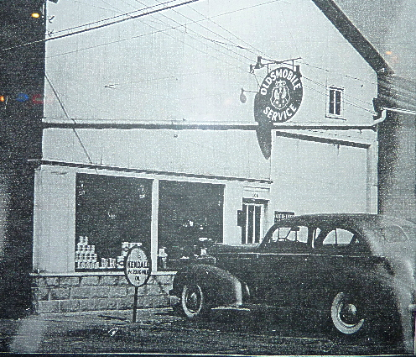
Oldsmobile Service Photo back in the ‘40’s.

Class of 1960

Frances Richey & Eva Fessel

Eva Fessel and I went to the Old Library to see if we could find what businesses were on East & West Main back in the 1940’s. We each took an old Telephone Directory and went through them to get the names and address of the businesses of that particular time.
Frances Richey & Eva Fessell
This is Ann: I will copy the list as it was given to me by Frances Richey’s niece, the late Mary Neunlist McGlothin, classs of 1960. The 1948 list will be in a future Olney Memory.
I was born in 1941, but I can remember some of these business places when I was just a little girl during this time. This list brings back quite a few memories to me. , and I hope it does to many of you too.

1941 Olney City Directory
EAST MAIN STREET
100 Jerry’s Jewel Shop
Downstairs- Dr. V.A. Falkenhain
W.T. Wagner
100 ½ Home Loan & Finance Co.
Dr. Carl Ring
Mrs. Blanche Mosely
102 The Oasis Tavern
103 First National Bank
104 Gebhart Stores Inc.
104 ½ Mrs. Mary E. Moore
108 Robt. Gaffner Co.
108 ½ Smith & Ransom
Dr. C.L. Jordan
Herman Towell
200-202 Sherman Dept. Store
201-203 Ben Murray Hardware Co.
Robert E. Murray
202 ½ Slanker Insurance Agency
Lewis & Lewis
John Dynis
Wm. Houser Sr.
WPA County Road Office
204 City Cigar Store
Wm B. Propes
205 Wachtel Sisters Millinery
Olney Shoe Rebuilding Shop
Max Bloomberg
205 ½ Richland County Agricultural Conserv. Assn.
J.A. Weber Jr. – Dentist
300-2 J.C. Penny Co.
301 Star Grocery
302 ½ Moose Hall
Olney Blue Print Co.
303 American Brokerage
304 Kenny’s Café
304 ½ K.H.Walser (Kenny)
305 John Iaggi Barber Shop
Mays Jewelry Shop
305 ½ W.B.Ruddell
306 Olney Bakery
306 ½ Burl V. Haupt
307 Polly Prim Hat Shop
Anneda shop
307 ½ Dr. G.E. Montgomery
308 Lamkin & Son
Lewis Burgener
308 ½ Dr. G.A. Houchin
James T. DeBord
309 Paramount Market
310 Spitzer & Seiler Tavern
310 ½ Mrs. Ollie A. McMeechen
311-15 Montgomery Ward Co.
312 Geo. L. Richardson
317 King Furniture Store
321 Kroger Grocery & Baking Co.
322 Standard Service Station
400 Litz Hotel
401 Carnegie Library
406 Clellas Beauty Shop
407 Dr. Wm. E. Fritchle. M.D.
408 Olney Cleaners
408 ½ Miss S.M. Schmitt
410 Vacant
412 Van Matre & Pauley (Grocery)
414 Richland Feed & Supply
414 ½ Mrs. H.M. Coventry
415 Bob Forst Conoco Service
416 Shell Main – Morgan Service Station

Even Numbers…North Side of Street
Odd “ …. “ “ “ “

½ Upstairs

George Roth
gsroth2@nwcable.net

The original information and poem is after I decided to add a FEW LINES. Sorry about that. You may want to read the bottom part first.
If you do not remember clothes lines you need to show this to your parents and older people.
Every word of it is exactly what we did when I was growing up.
SOMETHING ELSE THAT HAPPENED ON WASH DAY.
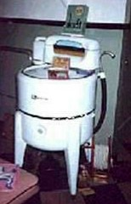

We did not have running water in the house so we carried water from the barn well which had more water than our pump on the back porch.
Then we heated the water in a big kettle on the wooden stove. If it was 100 degrees outside, it was probably 130 inside.
You carried the hot water to the back porch where the washing machine and rinse tubs were at.
SINCE WE ARE TALKING ABOUT THE WOOD STOVE IN THE KITCHEN.
This was also what we did when we were thrashing grain in the middle of summer and all the men were there to eat.
The ladies fixed the BIG MEAL FOR THE MEN to eat outside under the shade tree.
If you didn’t fix more than the next farm they were going to you would feel terrible.
Of course the men talked about it and it would be known all around the neighborhood what a poor meal they had to eat at the Roth’s.
You made a trip to Olney to buy ice so the men could drink LOTS OF ICED TEA, not the warm water that I carried to all the men in the thrashing crew.
The women cooked and made pies for hours, usually starting at daylight because we did not have electricity.
BACK TO WASH DAY
Of course you did not have automatic washers. We had an old washing machine with an older engine under the washing machine.
To start it you had a foot pedal to stomp down on to turn the engine to start it. There was no men around so it was up to the women and young boys to figure out why it would not run. It usually smoked all the time which made the ladies happy.
There was an agitator inside the tub to help get the clothes clean.
Next you would run the clothes through a hand ringer to squeeze the water out of it, then to the next tub to rinse the dirty water out.
Then you did the same thing again and ran the clothes to the next tub of rinse water.
If the clothes looked clean by this time you would run them through the ringer again into a basket to carry to the clothes line to hang up and dry
If you saw a dirty spot on the clothes you always had a scrub board handy to soap and hand scrub it till it was clean.
WHAT IF IT WAS RAINING??
If it was raining you still had wash day unless you were positive it would not rain tomorrow.
Otherwise you had nails at several places in the wall that you had ran a clothes line to each one to hang the clothes on inside.
Sometime the living room was full of clothes lines with wet clothes on them. Heaven forbid if unexpected company pulled up in the driveway.
Everyone would start taking clothes off the line and take the line down before they would see such a horrible site.
If it was close to mealtime the women would start fixing a nice meal for them to eat and then they could visit like they had not done anything all day.
WOW, I DID NOT INTEND TO BORE YOU THIS LONG BUT MEMORIES JUST KEPT COMING.
Hopefully you will appreciate the next time you do laundry.
George Roth
-----------

THIS IS ORIGINAL MESSAGE.

TO THOSE WHO DO NOT REMEMBER ... THESE WERE THE DAYS BEFORE CHOTHES DRYERS WERE AVAILABLE!
THIS IS FUN TO READ AND QUITE TRUE...WE ARE PROBABLY THE LAST GENERATION THAT WILL REMEMBER WHAT A CLOTHESLINE WAS.
And in lots of places they are illegal. It's the poem at the end that's the best!!
Remembering Mom's Clothesline
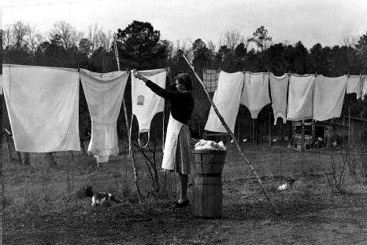

There is one thing that's left out.
We had a long wooden pole (clothes pole) that was used to push the clotheslines up
so that longer items (sheets/pants/etc.) didn't brush the ground and get dirty.
I can hear my mother now...
THE BASIC RULES FOR CLOTHESLINES: (If you don't even know what clotheslines are, better skip this.)
1. You had to hang the socks by the toes... NOT the top.
2. You hung pants by the BOTTOM/cuffs... NOT the waistbands.
3. You had to WASH the clothesline(s) before hanging any clothes -
walk the entire length of each line with a damp cloth around the lines.
4. You had to hang the clothes in a certain order, and always hang "whites" with "whites," and hang them first.
5. You NEVER hung a shirt by the shoulders - always by the tail!
What would the neighbors think?
6. Wash day on a Monday! NEVER hang clothes on the weekend,
or on Sunday, for Heaven's sake!
7. Hang the sheets and towels on the OUTSIDE lines so you could
hide your "unmentionables" in the middle (perverts & busybodies, y'know!)
8. It didn't matter if it was sub-zero weather... clothes would "freeze-dry."
9. ALWAYS gather the clothes pins when taking down dry clothes!
Pins left on the lines were "tacky"!
10. If you were efficient, you would line the clothes up so that each item did not need two clothes pins, but shared one of the clothes pins with the next washed item.
11. Clothes off of the line before dinner time, neatly folded in the clothes basket, and ready to be ironed. IRONED??!! Well, that's a whole OTHER subject!
And now a POEM...
A clothesline was a news forecast, To neighbors passing by,
There were no secrets you could keep, When clothes were hung to dry.
It also was a friendly link, For neighbors always knew
If company had stopped on by, To spend a night or two.
For then you'd see the "fancy sheets", And towels upon the line;
You'd see the "company table cloths", With intricate designs.
The line announced a baby's birth, From folks who lived inside,
As brand new infant clothes were hung, So carefully with pride!
The ages of the children could, So readily be known
By watching how the sizes changed, You'd know how much they'd grown!
It also told when illness struck, As extra sheets were hung;
Then nightclothes, and a bathrobe too, Haphazardly were strung.
It also said, "On vacation now", When lines hung limp and bare.
It told, "We're back!" when full lines sagged, With not an inch to spare!
New folks in town were scorned upon, If wash was dingy and gray,
As neighbors carefully raised their brows, And looked the other way.
But clotheslines now are of the past, For dryers make work much less.
Now what goes on inside a home, Is anybody's guess!
I really miss that way of life, It was a friendly sign
When neighbors knew each other best... By what hung on the line.

George Roth
==================================================================================================================

