Olney Memories # 107

March 14, 2014
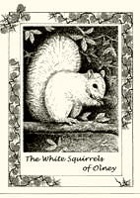

Greetings to all of you! Spring is finally arriving in most of the South and I hope it will reach your area soon if it hasn’t already. Please remember to let me know when you have an e-mail address change so I can make that change on the OM address list. If you know of others who would like to have the OM delivered to them, ask them to write me at pianoann97@aol.com and I will add their name to the mailing list. Also if you wish your name be on the “contact list” of names, just e-mail me and next issue you will see it listed! Remember to send in your own memories…this keeps the Olney Memories alive! Thanks,

Ann Weesner King
Pianoann97@aol.com

Richard Williams
rrw41@earthlink.net
Hello Olneans!
If you have been following all the activity on the Tiger Alumni Center (TAC), you know we are busy! Scholarship Drive, New Tiger Pride Alumni Association (TPAA), New TAC Webmaster, and a New Optional Facebook port. A handful that’s keeping us busy!
• Scholarship Drive: $4K. It being near the middle of March, we’re near the end of our 2014 Scholarship Drive. TAC members over the last two years have donated over $11K. Our goal this year is to award four scholarships of $1K each with a total drive of $4K -- and we’re a bit short at $3K. We hope to get another $1K of donations by the end of the month. Want to join those donating? Send a check, by the end of the month, to ERHS Principal Simpson at 1200 East Laurel Street, Olney, IL. , 62450. On your check make a note of “TAC Scholarship.” Help create one more scholarship of $1K! If you’d like to see the list of scholarship donors, click on http://www.erhsalumni.net/Scholarships-2014.htm
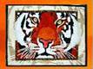
• The new TPAA! With the leadership and legal support of Tom Weber, of the ERHS class of 1964, Tiger Pride Alumni Association (TPAA) obtained legal status in Illinois in January. In the near future, TPAA will hold its first meeting, an organizational one, in which I with Mary Cummings (Class of 1970), Nancy Ramsey (Class of 1966), and Judy Walker (Class of 1964) will establish all seven directors, adding three to our service. TPAA will be all about serving the alumni and other past students, current students, and employees of our school district. We are very happy with our progress, as well as our current TAC, which will be the ‘mouth’ of TPAA. To keep up with TPAA and TAC, join us! All who attended our school district are welcome as members. Go to erhsalumni.net
• Garry Bowman (1964), New Webmaster for TAC. In February, Garry joined TAC as the webmaster and he is in the process of learning how all the doors and windows open at TAC. But he came with past webmaster experience as he was the Webmaster for a Texas state educational website. Come visit us at erhsalumni.net and greet Garry! Each of us when given a new position, hope to dream abit and help make some progress. Garry is very interested in making TAC a website that is easy for senior citizens to use. (And that includes me at 72!)
• Connecting TAC with Facebook. Within a week or so, all TAC members will have the choice of remaining private at TAC or of selecting to have their TAC profile on their Facebook. I have experimented with this new feature and think many will enjoy it.

Happy Days!
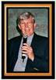
Richard
rrw41@earthlink.net
----------------------------------------------------------------------------------------------------

Richard Blackburn
richardblackburn416@yahoo.com

Ann,
I enjoyed the article by Kay McCarter Harbaugh.
It brought back memories to me. My Brother, George Blackburn worked For the Leingang Bakeryin the forties.
He told a story about Harry Leingang who was quite a teaser.
One day a small boy seven or eight years old bought a dozen doughnuts and Harry told him if he would
bring back the holes , he would give him another dozen doughnuts. The boy took the doughnuts home, ate around the holes,
and brought the dozen holes back to the bakery. Harry, good to his word, gave the boy a fresh new dozen doughnuts.
I don't think Harry made that guarantee again.

Ann, I enjoy reading all of the memories in each issue and appreciate your taking the time to compile all of them.

Richard Blackburn,
Class of 1952

Norm Axelson
normaxelson@frontier.com

This is in answer to one of the readers questions. I graduated in 1965 and spent 20 years in the Naval Air Reserve. I flew over 7,000 hours all over the world in support of all branches of service. We were able to aid in the quick resolution of Desert Shield and Desert Storm. We were able to support our carriers groups and others with mail, parts, replacement men and women all over the world. I became a Crew Chief and flew with many different squadrons all over the USA. C9Bs, DC9-33s and DC-9s which were able to carry 90 passengers or up to 7 pallets of cargo up to 30,000 lbs. It was a great job and wouldn't change it for anything. My father flew as a Crew Chief in WWII on B-17s so I guess I followed after him. I now live in Robbinsville, N.C. in our retirement home in the Smokie Mountains. We fish, and I love playing golf. We have 2 Yorkies and 2 cats. But the most important thing in my life was my 6 children who have been the center of our lives giving us 16 grandchildren. Love all of your memories.

Norm Axelson
Class of ‘65

Mary Lou Brown
marilou_olney@hotmail.com

Hello Ann,
I just read the Olney Memories. You do such an excellent job. Yes I do remember calling the highways the "slab" . I remember my dad, John Marsh helping build 130. He had horses and a slip schoop and was hired during the summer to move the dirt before the concrete could be poured.
Of course I also remember Leingangs, Harry used to give us a donut sometimes when we came in to buy a nickel loaf of bread. Store bought bread was a treat for us as we were used to biscuits and home- made bread. I am a friend of Gertrude Landenburger and enjoyed their article.
We are so blessed to have such wonderful memories.
I also remember Bennie Forsyth. I taught with his cousin Monty for several years. Bennie was in my art class in Jr. High and his mother was a good friend of my husband, Bud Browns mother as they both lived on S. Morgan St.
Thanks again Ann.

Mary Lou Brown
Class of ‘38
----------------------------------------------------------------------------------------------------

Norm Axelson
normaxelson@frontier.com

I graduated in 1965 and spent 20 years in the Naval Air Reserve. I flew over 7,000 hours all over the world in support of all branches of service. We were able to aid in the quick resolution of Desert Shield and Desert Storm. We were able to support our carriers groups and others with mail, parts, replacement men and women all over the world. I became a Crew Chief and flew with many different squadrons all over the USA. C9Bs, DC9-33s and DC-9s which were able to carry 90 passengers or up to 7 pallets of cargo up to 30,000 lbs. It was a great job and wouldn't change it for anything. My father flew as a Crew Chief in WWII on B-17s so I guess I followed after him. I now live in Robbinsville, N.C. in our retirement home in the Smokie Mountains. We fish, and I love playing golf. We have 2 Yorkies and 2 cats. But the most important thing in my life was my 6 children who have been the center of our lives giving us 16 grandchildren. Love all of your Olney memories.

Norm Axelson
Class of ‘65

Dorothy Leet Baugh
dl_baugh@comcast.net

Thank you, thank you! I really appreciate reading all of the Memories and have a special place for them! I am about the oldest (class of 1942) in the group now (88 yrs young)! Sincerely,

Dorothy Leet Baugh
Class of ‘42

Sally Byrne Rynard
sallyry@att.net 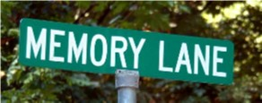

I have so many warm memories of my childhood in Olney. Olney was a booming town at that time with Pure Oil Company being a big influence. Such wonderful caring folks, great friends and schools. Gus and Mary Sliva's love of music and inspiring us and the list just goes on and on. I feel so blessed to be raised in such an inspiring community. Your Olney Memories just brings it all back to me being raised and graduating in 1958.

Again----thanks Ann
Sally Byrne Rynard
Class of ‘58
------------------------------------------------------------------------------

Bette Schmalhausen
bette12041@gmail.com

Ann,
In response to Gib Miller's comments about the Cummins Band, the Schmalhausen from Lawrenceville was Hubert Schmalhausen, he was my uncle and my father Harold's brother. He and his family left Lawrenceville and went to Phoenix, AZ. I don't remember the year.
Bette Schmalhausen
Class of ‘51

-------------------------------------------------------------------------------------------------------------------------------

Peg Wilkins Kuenstler
kcman53@outlook.com
I did not grow up in Olney, but I came here, from Ingraham, in the Summer (between H S classes) to baby-sit for my nephews(Bobby & Gerry Foster). After I was old enough to get a job, I worked at The Steak House(West Main), Bond's Drug Store(corner of Main & Fair), another restaurant on the S. side of Main Street(downtown),I don't recall the name of it, Decker's Drive in, as a curb hop, Ainsbrook Garment Factory. I was married here in Olney at St. Joe in 1956 and have lived here ever since. I sure do enjoy people’s memories as some of them are mine also. Thanks Ann for all you do for us. I also enjoy you on Facebook.

Peg Kuenstler

John Helm
mlehjerhs@yahoo.com

I've been reading your message forum column with great interest; folks who have graduated from ERHS and have fond memories, and folks who went through area schools up to and including some time at ERHS, but for some reason moving away and not graduating from high school in Olney. Also interesting to note is that our website has attracted attention from folks in other schools, who are, in some cases, modeling their own website to be similar to ours. I think that's a terrific tribute to you folks who have put together an on-line place where we can share our memories and pictures. I graduated with the class of 1958, and my late wife, Helen Shultz Helm, graduated in '59. Helen and I "went steady", and were married in 1963. In the days when we were in school, cars played a big part in the social life of ERHS, and practically every guy and many of the girls couldn't wait to get their drivers' license, so they, too, could join the custom of "dragging Main', up and down back and forth, from the Town Talk drive-in on the east side of town, to the Dog and Suds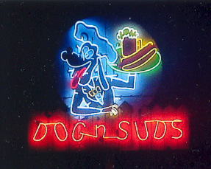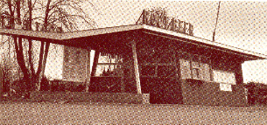, or Decker's Drive-in on the west side of town, not to mention Beal's Skating Rink 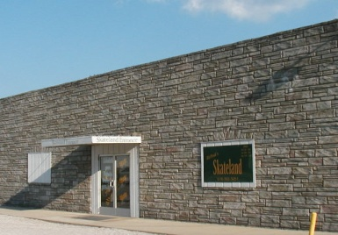and Bowling alley, and the Olney Drive-in Theater 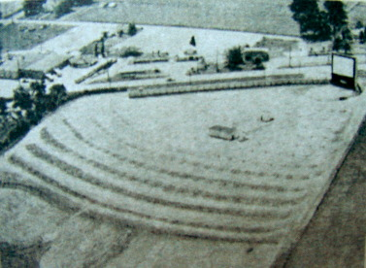. Of course, there was always a crowd at Mike's Ice Cream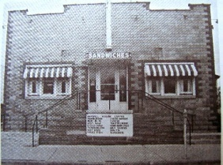 Parlor, and the old Olney Carnegie Library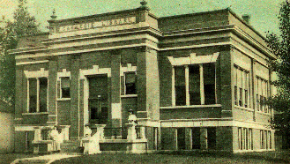 was a quiet place to study, perhaps while holding hands with your steady girl. There's a movie I'm sure a lot of your readers are familiar with, "American Graffiti", starring Ron Howard and Richard Dreyfuss. About once every 6 months I watch it again. It was set in the early '60's and so much reminds me of the great times we all had at ERHS. Our class had its first reunion 10 years after graduation, and had such a wonderful time that we've had a reunion every five years ever since. Our 55th reunion was no exception; a wonderful success. How great to see all the folks again who we'd see every day as we made our way from class to class. My best wishes go out to all the classes who have had the great good fortune to graduate high school in Olney.
John Helm
Class of ’58
----------------------------------------------------------------------------------------------------
(This is Ann, and I’m explaining a little bit what is written below about the books Ron has written and how he would like to donate part of the sales of these two books to the ERHS Scholarship Fund which is a very worthy cause).
Ron Scherer, ERHS Class of ’62, has published two books in his retirement. The first was “The Soldier from Illinois,” written by Ron about Earl Scherer (his third cousin) who landed at Omaha Beach during World War II and shared his food with a starving Dutch boy. Earl lives in Olney and remains very active at the age of 97. The second book, “The Leaf of Golden Memories,” was edited and published by Ron this past fall. The principle author, H.T. Hallwood (pen name), wrote about the true story of his family’s move by covered wagon from the plains of Colorado to the Ozark Hills of Arkansas in 1923. Mr. Hallwood, who is 94, is also an active resident of Olney. Descriptions about both books follow.

Since Ron is a native of Richland County and the books feature two residents of Olney, he has volunteered to donate a percentage of profits from the sale of the books to the ERHS Scholarship Fund. Both books sell for $20.00. There are two preferred ways to maximize the donations to the scholarship fund. By mailing a check for $20 plus $4 shipping to Ron at 320 Bradington Drive, Columbia, IL 62236, Ron will donate 20 percent of the book’s price ($4.00) to the scholarship fund. Or, if you order and pay through PayPal at either book’s Website – www.thesoldierfromillinois.com or www.theleafofgoldenmemories.com – the donation will be 10 percent ($2.00) of the book sale price. (The reason for the lower percentage is due to the increased fee charged by PayPal.) If you contact Ron directly, please specify which book(s) you wish to purchase.
------------------------------------
Ron Scherer
rscherer@htc.net
Descriptions of the books follow:
The Leaf of Golden Memories

In this true story by H.T. Hallwood, you will relive a young boy’s 10-month journey by covered wagon from the plains of Colorado to the Ozark Hills of Arkansas in 1923.
Travel along with “Fatty” and his family as they endure countless sacrifices and hardships. Covering hundreds of miles, the family faced challenges few people could overcome, except those strong at heart, very determined and having strong faith in God.
Edited and published by Richland County native Ron Scherer, you will learn how the discovery of a special golden leaf in the author’s older years led him to recall the vivid memories of that journey and his growing up in the Ozarks. It was as though the leaf opened the door to all those precious moments of his childhood, and how each experience – no matter how pleasant or sad – provided a valuable lesson that helped shape his life.

THE SOLDIER FROM ILLINOIS

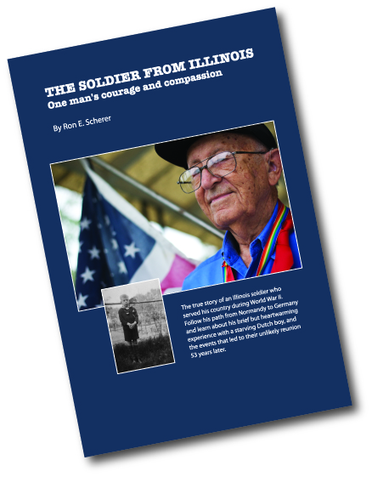
Written by Ron Scherer, this is the true story of a southern Illinois soldier’s experiences in World War II, including his landing on Omaha Beach after D-Day. Drafted as just another GI, he was not a hero in the “Purple-Heart” sense of the word, but a regular soldier “doing his job.”
There was, however, one person who would always think of the American as a hero – a starving young Dutch boy whom the soldier shared his food with while encamped in Maastricht, Holland. On the day they separated, the boy gave the soldier a photograph of himself to show his appreciation. After returning home from the war, with the photograph tucked safely away in his box of memorabilia, the soldier thought of the boy often, but was certain he would never see him again…and was not trying to find him.
Through several unexpected events – some would say guided by divine intervention – a total stranger in the Netherlands, with a copy of the photograph in hand and help from relatives in Canada, mounted a search for the “boy” in 1997 that led the soldier and the Dutch man to reunite in the Netherlands 53 years after their first meeting in 1944. After the man was located, the soldier was notified and his three visits back to the Netherlands to visit the lost boy resulted in a new and lasting friendship, which is detailed in the book.
Ron Scherer
Class of ’62
----------------------------------------------------------------------------------------------------
Peg Wilkins Kuenstler
kcman53@outlook.com
I did not grow up in Olney, but I came here, from Ingraham, in the Summers (between H S classes) to baby-sit for my nephews (Bobby & Gerry Foster). After I was old enough to get a job, I worked at The Steak House (West Main), Bond's Drug Store (corner of Main & Fair), another restaurant on the S. side of Main Street downtown named Robbs (but I don’t remember who the boss was), Decker's Drive in, as a curb hop, Ainsbrook Garment Factory. I was married here in Olney at St. Joe in 1956 & have lived here ever since. I was a young teenager when I worked there & the pay was definitely peanuts, but to a country, farm girl, I thought it was a lot back then & a quarter tip was fantastic. I worked there in the evenings & Saturdays & Sundays when my sister was off from her job when she could take over my nephews that I was baby-sitting with. I loved Sundays, the place was packed after church & that was how I got to know some of Olney's nice people. The help ate when the place closed (?), then we cleaned up the whole place. We waited tables, did dishes, cleaned floors, whatever needed to be done, no job was anymore special than the other, except cooking & cashier.
My job at Decker's Drive Inn was strictly curb-hop, 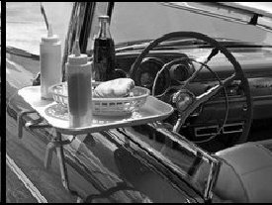 (Not resized yet) sometimes we even did the job on roller skates & got to wear pedal pushers. Most of us roller skated back then, thanks to Rural Youth, 4-H, etc. I remember working with Donna (Woods) Ginder & a girl I believe was named Linda Jones, we were outside help & Rosy Cantrell, & C.D.'s sister worked inside serving the food, Don't remember the cooks name besides CD. C.D. was one big flirt with all girls. We had lots of fun with our work. After the Drive-in theatre movie of the evening was over we were swamped with business. I don't remember ever dropping a tray & only one time of a car driving off with the tray still hooked on his door, he did return, always wondered how many beers he had at the Drive-in. I also worked next door at the Root Beer Barrel (not to be confused for the Dog n Suds), I think maybe Deckers might have owned it (the barrel) also. Today the barrel sets out at the Doll's cabin, for many years, East of Olney. I really liked restaurant work, lots of fun as well as hard work.
The best & most fun job I ever had was at Ben Franklin in the middle to late 70's & in the 80's. I worked in the fabric, craft & framing depts., no favorite dept., loved them all. Worked several other jobs, not mentioned, not favorites though.
I sure do enjoy people’s memories as some of them are mine also.
Thanks Ann for all you do for us
Peg Kuenstler

Ann Weesner King
Pianoann97@aol.com

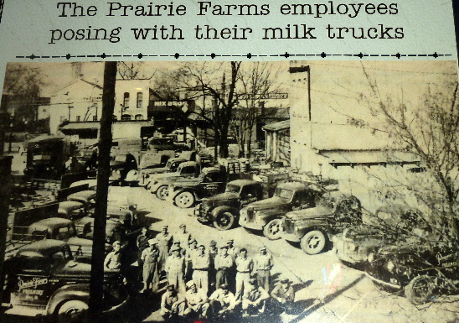

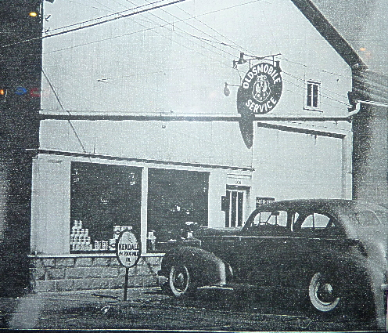
Oldsmobile Dealership & Service
Ann Weesner King
Class of ‘60
Darrell C. Navolt
DarrellNavol3815@aol.com

Ann,
I am not able to find my 1962 Olnean. Do you think any of the readers of the Olney Memories might have one for sale?

Darrell E. Navolt
Class of 1962

Frank Wagner
Flwagner47@gmail.com

I've been working thru the old Memories. My name is in the first or second one! My father George had a barber shop on Whittle Avenue that someone mentioned, but put my name with it. Maybe they intended to mention the classmate associated with the shop.

Looking forward to future Memories, especially from class of '65 folks. 2015 will be our 50th anniversary.

Frank Wagner
Class of ‘65

---------------------------------------------------------------------------------------====================================================================================================

