Olney Memories # 106
February 1, 2014

Happy Valentines Day everyone and welcome to a new year of Olney Memories. Please remember to let me know when your e-mail address changes so you won’t get on my “No-none Delivery” list! It’s hard to find you when I don’t have your current address…

The contact list that is sent out after the Olney Memories is voluntary on your part. If you wish you name to be included on the list, just e-mail me that you wish you name to be on the Contact List….that’s all you have to do and I will put it on there for you!

Enjoy the memories these folks have sent in and hopefully you will think of some yourselves and send them in to be included in Olney Memories # 107!

Looking for current e-mail address for:

Diana Brantigam,
Dannee Newton
Barbara Berger
Goldie Walker
Linda Stanford Peterson
John Sensney
Jerry Pool
Cheryl Wright
Vicki Shumaker Merritt
John & Anna L. (Tweet) Ginder
Ann Lowery Wilson

If any of you can help on this, please let me know.

--------------
Don't forget about Supporting the 2014 Scholarship Fund that is such a beneficial project. Thank you.

All you have to do is mail a check to ERHS. In the note space, write “Scholarship.”

To:
Mr. Simpson, Principal
East Richland High School
c/o: Chris Simpson, Principal
1200 East Laurel Street
Olney, IL 62450

You will get a receipt.

Ann Weesner King
Pianoann97@aol.com
Class of 1960
===========================================================

Norm Axelson
normaxelson@frontier.com

The best time I had where all the Corn Chowder we had in the park. I remember playing on the play ground and listening to the band at other times. I started playing golf my senior year at Olney and have been playing ever since here in the Smokie Mountains.

Norm Axelson
Class of ‘65
--------------------------------------------------------------------------------------------------
Charles Fregeau
n5hsr@sprynet.com
Does anyone else have special Christmas memories? I miss going out to Grandpa’s house at Christmas for dinner. (Ray Leaf, north of town on the ‘slab’, that is, 130.)
Seems like they packed us everywhere to eat, I remember some of us kids sitting on the stairs going upstairs to have a place to sit. That was when I felt like I was part of a REAL family.

Charles Fregeau
Would have been ERHS ‘75

Ann Weesner King
Pianoann97@aol.com

Calling Route 130 “The Slab” brings back good memories…..used to hear that all the time from various people but haven’t heard it for a long time….My dad, Chris Weesner, often called route 130 and route 50 that ran by our house “the slab”. Good to hear it again Charles!! That brought back forgotten memories to me. That might be an expression of the past. Does anyone ever hear it anymore?
Ann Weesner King
Class of 1960

Gilbert (Gibby) Miller
gibmiller@att.net
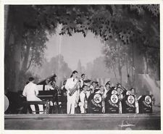(
Just a photo. (not the real Cummins Band)

Re. Cummins Band, my dad( W. D. Miller)played clarinet in that band with L Kent, Maxwells, Pauley, and a SCHMALHAUSEN FROM L’ville: practiced on the 3 floor of 1 st Nat Bank. Hi to Ed Iaun, physiotherapy @ Lawrence County Hospital when I was practicing in L’ville.
Gibby Miller
OTHS 45
------------------------------------------------------------------------------------------------------------
Dick & Anita Landenberger
dicklandenberger@tx.rr.com

Hi
Anita and I thoroughly enjoy these views into the past. The one in Memories # 104 from Linda Schaub-Nace particularly got me thinking.
I remembered my mother, Gertrude Landenberger, class of 1934, telling me about a part of her youth related to the Schaub Funeral Home on Chestnut, and decided to ask her about it. She is 98 now, so it took a while, but we had fun reminiscing.
Mom’s parents (Clarence and Naomi Feutz ) had a small restaurant close to where Hovey’s is now when Mom was in Junior Hi.
They (parents plus sister Helen White -(Bill’s mother and brother) Clarence Jr. “Snitz” all lived up above it. She developed a playmate relationship with Jane Wharf Montgomery who was about the same age and lived in the nearby Chestnut house. This is before it was a funeral home.
Mother remembers the parents as Mr. Jim Wharf and Ms Stone?.
Prior to the organ, the thrill of the house was the “speaking system” that existed between the various floors. Evidently you could open a hatch and blow in it (an air pipe) to get one’s attention on another floor and, when ready to answer, you could talk to each other. Sort of like a laundry chute, but was a little pipe. Quite fun.
Maybe it was still there when Linda and cousins invaded.
She mentioned that, as a young man, Neal Beard lived in the basement in exchange for tending to the coal furnace.
I, too, remember the Town Talk on Whittle. My favorite there was the bar of solid taffy. After freezing it, you could break it into pieces and go about scaring your parents that you were going to pull out all your fillings.
Happy Holidays

Dick/Anita Landenberger
Class of ‘57

----------------------------------------------------------------------------
Ben Forsyth
brforsyth@msn.com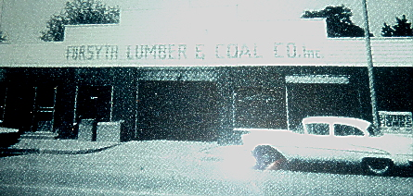
This was Ben Forsyth’s parents Lumber Co. on Whittle Ave that
Operated for many years on Whittle Ave. (picture probably
taken around 1955.

I pulled out a letter you wrote me several years ago concerning my mom’s assistance to a poor young gal in Olney going to a dance. I admit I had tears in my eyes after reading it. My older brother, John, remembers after WWII, my dad often took hot food and blankets down to empty box cars in Olney and gave them away to transient ex-military people who were living in them. WOW, I do not deserve such great parents. I would like to hear from others about their families and good deeds they did. I strongly suspect that our generation in Olney produced a lot of good during the last six decades. No wonder we turned out such great folks such as you and many others. We are all living evidence of the quality of our backgrounds. WE SHOULD BE PROUD.

Ben Forsyth
Class of 1960

-----------------------------------------------------------------------------------------------------------

Walk Down Memory Lane
Not a line of script but sure is a lot of fine memories.
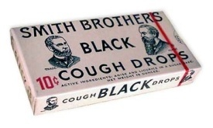 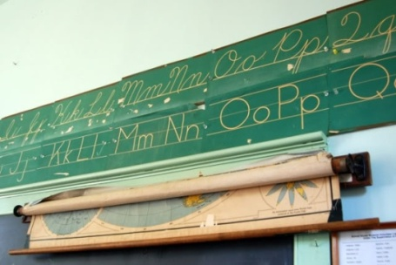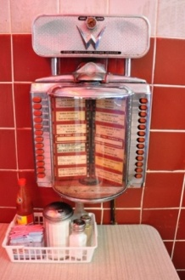
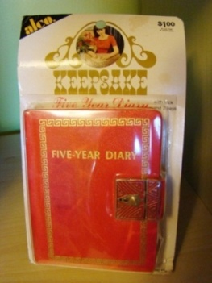
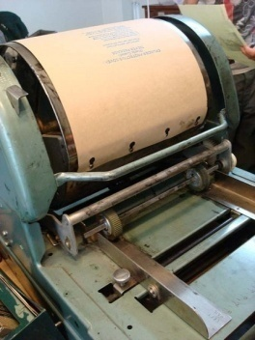 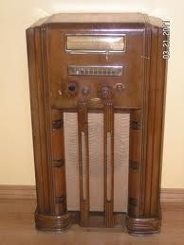
-------------------------------------------------------------------------------------------

Anne Kribbs Meyer
e.anne.meyer@icloud.com
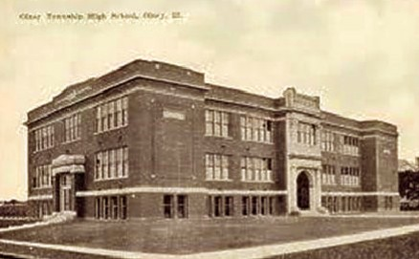
The Jr. High School in the story below: (the old OTHS).

I just saw a post on the Facebook page "You Know You Are From Olney. IL" - a photo of the school building on Main Street (now torn down) with a comment by Paul F. Noerenberg about his dad. I assume he is talking about our wonderful band director in Junior High. He was so very patient and kind. I remember going into the gym through the back door of that building during the summer for lessons as he taught me to play the bassoon. I enjoyed learning the instrument and also remember enjoying the coolness of that spot during those extremely hot days. The gym was built below ground level and about the most comfortable place to be in those days before anyone had air conditioning.
I also recall one day during band practice when Mr. Noerenberg lost his grip on his baton and it flew through the air and went right into the horn of one of the tubas. He just stood there with a dumbfounded look on his face and did not move for several seconds. He, of course, was about the only one who knew what happened and the rest of us did not know what to think of his reaction. We thought something terrible had happened to leave him so stunned. Then he started laughing and went and fished out the baton and gave us all a good laugh.
I sure hope kids today are building some wonderful memories like my generation did while growing up in a great little town like Olney.
Anne Kribbs Meyer
Class of 61

Kay McCarter Harbaugh
philkay1@frontier.com

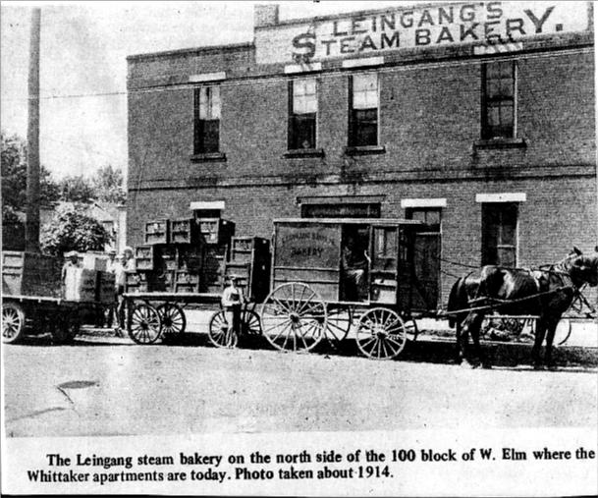
After Leingang’s Steam Bakery, shown above, was closed it was replaced by the Whittaker apartments. Whittaker’s Record and Candy Shop, as most of us knew it, was at the front of the Whittaker apartments. Although neither the apartments nor the candy shop are still in business, the building still stands.

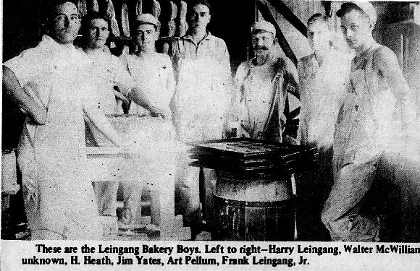
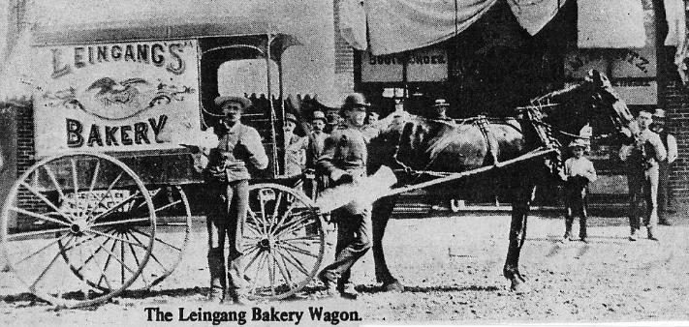

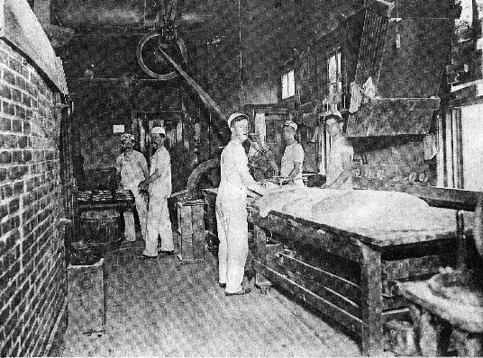
The Leingang Boys, L. to R. Harry Leingang, Walter McWilliams, unknown, H.Heath, Jim Yates, Art Pellum, Frank Leingang, Jr.
Leingang Brothers, Sr. operated this bakery from 1883 until the bakery was taken over by Leingang Brothers, Jr. about 1915. The late Frank H. Leingang, Sr. lived at 122 W. Elm Street in the old brick dwelling. His brother Jacob, lived for many years at the corner of South Washington & East Elm Streets. The old Jacob Leingang residence was one time one of the most fashionable homes in the eastern part of the city. Jacob Leingang passed away about 1930 and Frank Leingang passed away about 1940.

When the Leingang Bros, Sr. retired from the steam bakery business, the business was taken over by Harry Leingang and Frank H. Leingang, Jr., who were brothers. J.W. Pepple, a brother-in-law of Leingang Bros, Jr. operated the business for a time.
The business was operated by the Leingang family until 1918 when Frank and Harry Leingang were drafted into service. During that period, a man named Charles F. Beaird of Bridgeport operated the bakery until about 1919.
Leinglang Bros, Jr. operated the bakery until 1932 when it was closed during the depth of the Depression.
Quite a number of old time bakers were employed by the bakery. They included: George Smith, Leo B. Brown, Jim Yates, Charles Goudy, Charles Nuding, Cecil Reed and others.
In 1916 bread was selling for a nickel per loaf while small loaves not wrapped sold for4 cents.
During the operation of the bakery by Leingang Bros. Jr. many local persons who were unemployed received bakery goods gratis at the bakery.
In 1937, the Leingang Baking Co. was reorganized and operated the business for about five years, when John Merrill operated the business until the beginning of World War II, when it was again closed.
The old bakery building was sold and the owners made the business into apartments.
Kay McCarter Harbaugh
Class of ‘61
====================================================================================================================

