Olney Memories # 105

Merry Christmas from our house to yours!
Richard, Ann & Scooter
+++++++++++++++++++++++++++++++++++
December 9, 2013

Welcome to another issue of Olney Memories. I included a photograph of an Olney landmark in the last issue and asked how many of you could indentify it. Five people responded and four had the correct answer. The picture was the ceiling in the Richland Co. Courthouse. 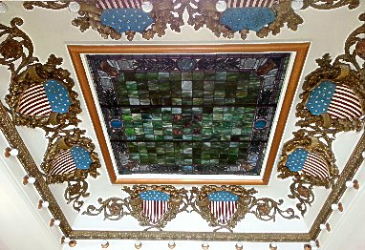

Ann Weesner King
Pianoann97@aol.com
Class of 1960
===================================================================
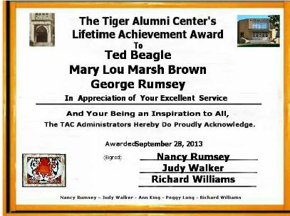

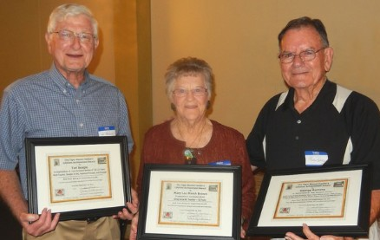
Very rewarding. You all would have been proud if you had been able to witness the reception and its award ceremony. You would have smiled and maybe dropped a tear of joy at the kindness the three had for each other and others whom they included, remembering with respect and joy! It was a very warm, caring session.

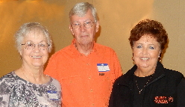
Judy Walker, Richard Williams, Nancy Rumsey

The tribute and pictures above took place at the reunion weekend in Olney, Sept 28, 2013. A big thank you to everyone who had a part in this and to our fine teachers who received the Lifetime Achievement Awards.

Marcella Cummins Zorn
marcellazorn@gmail.com

Thank you! I really enjoyed reading these snippets of Olney history. I did wish that the section on the Band had mentioned that the name change in 1932 to Cummins Municipal Band was in honor of my great- grandfather, James T. Cummins who was the bandleader in its heyday. He was also a town councilor with offices in the Courthouse.

Marcella Cummins Zorn
Class of 1965

Jim Hawkins
Hawkeye183@verizon.net

HI- I KNEW YOUR DAD (BOB SCHAUB) & GRANDFATHER (ORVILLE SCHAUB) QUITE WELL. MY DAD (L.O.-MIKE HAWKINS) HAD A GROCERY STORE & TRUCKING BUSINESS (WHERE CASEY’S IS NOW LOCATED) ON EAST MAIN.
USED TO DELIVER COAL (ORVILLE WOULD ALWAYS WANT STOKER COAL FROM EASTERN KENTUCKY, SO MY DAD WOULD ORDER IT SPECIAL FOR HIM) TO THE FUNERAL HOME. REMEMBER ONCE WHEN THEY WERE MOVING A CASKET AND ORVILLE WAS HIT ON THE HEAD AND IT WAS REPORTED IN THE DAILY MAIL (ORVILLE’S REPLY WAS, “NO I WASN’T HURT, WE SCHAUBS’ ARE TOUGH”.
ALWAYS LIKED VISITING WITH BOB AT THE STORE, FUNERAL HOME OR LATER ON IN SPRINGFIELD. ONE SUMMER, I USED HIS CABIN AT THE OLD VERNOR LAKE (USED TO BELONG TO PENY LENGHANG-PROBABLY NOT SPELLED RIGHT) FOR A WEEK. ASKED BOB WHAT I OWED HIM? HE REPLIED, “NOTHING-JUST LEAVE A COUPLE BUDS IN THE FRIG.” LAST TIME WE VISITED WAS AT THE SECRETARY OF STATE’S OFFICE IN SPRINGFIELD. HE WAS A GREAT FRIEND.
TAKE CARE

JIM HAWKINS
CLASS OF 1951
-------------------------------------------------------------------------------------------------------------Hi Ann,
As usual l enjoyed the most recent issue of OM's I remember Tubby Gassman and family. I didn't go to the Town Talk often because I could get my ice cream free at Schmalhausen's. I remember the taffy apples he made and often my parents and I would stop there after a movie matinee and they would buy me one.
Also the print was too small to read Ed Iaun's history of Olney and I wanted to remind him that he was in the class of '51 not '57. Second time around I could read the print….thanks.
Bette Schmalhausen
Class of ‘51
----------------------------------------------------------------------------------------------------
Marcella Cummins Zorn
marcellazorn@gmail.com

Ann, and since you asked...I do have some more info on the Band and my g-grandfather (and even his father is mentioned in the attached article!)
Here are two photos, one of the Cummins Band in 1915 and a later formal photograph of James T. Cummins:
I am also attaching an article from the Olney Daily Mail of March 2, 1970 that my mother saved for me. "Olney's Famed Cummins Band at Century Mark".
As you might guess, this musical heritage meant a lot to us.

Olney's Famed Cummins Band At Century Mark
By Bert Michels OLNEY DAILY MAIL

The Cummins Municipal Band of Olney is one of the oldest musical organizations in southern Illinois, and on March 1 (Sunday), the band passed the century mark in its existence. As a matter of fact, it is one of the oldest musical organizations in the state and exceeded in age only by the Decatur Municipal Band, formerly the Goodman Band, which is now 113 years old.

The Cummins band traces its history back to March 1, 1870, when the first musical organization in Olney was formed by early settlers of the community, many of whom had been musicians in the Civil War.
The first band was known as the Olney Silver Cornet Band and obtained a charter from the State of Illinois as a non-profit corporation *(This charter is shown with a selection of photos from the band's history on page 6 of today's Daily Mail.)

The first director was Professor Hill, who was an Englishman who came to Olney from
Palestine, 111. The first band was known as the Association of Musicians. One of its members, E. M. Cummins, was the father of the late James T. Cummins, who was for many years director of the Olney band, and for whom the band was later named.

Later, in the Eighteen Eighties, Prof. Sug R. Dalby, one of the leading coronetists in the area, came here from Albion and the name of the band was changed to the Olney Cornet Band. In 1887 and 1888 this band played for the state fair which was held in Olney those two years. The roster of personnel playing in the band for those state fairs included many well-known old-timers: James T. Cummins, director; Charles Britt, Charles Tobias, John Clark, Charles Horrall, Farm Hillis, Lewis Higgins, Cliff Horrall, Charles Griffin, Charles Beaird, George Tippit, Fred Ferriman, Adrian Higgins, Charles Ridgley, James Kaley, WEI Preble, Constantine Clark, John Brockman, William Nuding, James Baldwin, Harvey Barlow and Harry Ridgely.

In 1888 the name of the band was incorporated and known as the Cummins Band. James T. Cummins directed the band from the early 1890's until about 1932, when he retired from the leadership and turned its directing over to R. B. Barrett, the musical instructor at the Olney high school.

Mr. Barrett left Olney about 1940 and was succeeded by Charles Mullinax who was director for six years. After he gave up directing the band, the present director, Leo Sliva, took over the baton. Mr. Sliva, director of the East Richland High School music department since 1939, has had a great influence in continuing the band as the fine musical organization it is today and always had been. His high school bands have taken state honors year after year, and many of his superior musicians contributes their talents to the municipal band during the summer months.

Last summer the band included the following Olney and Southeastern Illinois musicians:
L. Sliva, Director
1969 Instrumentation
Coronets - M. Newcom, J. Gengler, C. Jones, R. Pittman, J. Kessler, K. Shedelbower, M. Buss.
Clarinets - S. Harrison, T. Sullivan, R. Radford, S. Huff, J. Sterchi, D. Horton, M. Noerenberg, N. Scanavino, M. Pampe, S. Berry.
Baritones - W. Pauley, J. Book,
Flutes - B. Sliva, S. Mattoon, L. Berger, D. Pampe.
Horns - C. Roberts, L. Lister, J. Harms, C. Pantle, J. Gallagher, D. Baylor.
Saxaphones - S. Powhatan, M. Weiler, J. Stull, G. Harper.
Trombones - P. Noerenberg, R. Mitchell, D. Jennings, J. Sliva, D. Rogers,
Tuba - C. Baker, S. Jones.
Bass Clarinet - F. Noerenberg
Bassoon - J. Miller
Oboe - N. Wilson
Percussion - L. Buss, T. Bartruff, C. Tatum, L. Kent.

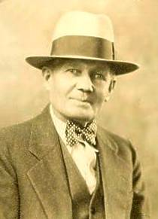
James T. Cummins
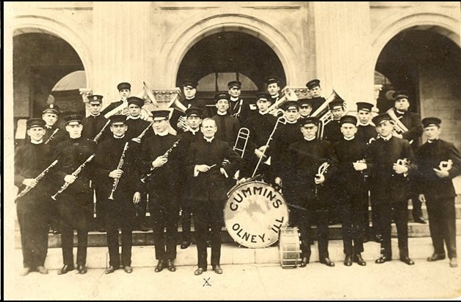

The Cummins Band Thanksgiving 1915
Marcella Cummins Zorn
Class of ‘65
----------------------------------------------------------------------------------------------------

John Helm
mlehjerhs@gmail.com
One of my enjoyable memories in Olney is reinforced by 8 mm movies which my dad took when we were small. There's one scene I treasure specifically; I'm shown sitting on the sidewalk out front of our house, "pecking" a rock on the sidewalk, with 5 white squirrels coming around to see if I was going to feed them a nut. However the only nut in the picture was ME!

I've got all sorts of memories of Olney; you may or may not remember that I had an old Cadillac which I drove to school. It was enormous and heavy and had no power steering. One of the biggest jokes around school was: "Hey, come out to the school parking lot and watch John Helm try to parallel park his Caddy!"

I have memories of when I was around 10 years old in Olney, and on certain days, an ice wagon, drawn by a big white horse would come thru our neighborhood on North East Street. There were still some people who used ice boxes instead of refrigerators, and they'd put cards in their front windows letting the ice wagon driver how much ice they needed. We kids would follow the ice wagon around on a hot summer day and beg slivers of ice to suck on from the driver, who always accommodated us.

John Helm
Class of "58

Ed Iaun
ediaun@gmail.com

On the Tubby Gassmans Town Talk I remember his Candy Apples, the kids liked more than the Corn
Ed Iaun
Class of ‘57
Sue Rice 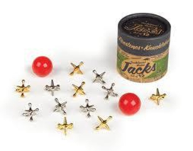
ls_rice@mindspring.com

One of the OM participants indicated that he use to sell the Grit, and that brought back some memories. I did not come up with it on my own, that is for sure. It was a very informative little news paper I remember.

L. Sue Rice
Class of ‘74
-----------------------------------------------------------------------------------------

John Helm
mlehjerhs@gmail.com

I was visiting with Ron and Laura Lee Smith at their home while in Olney; Ron remembered the ice wagon very well. I have all sorts of memories of my early days in Olney; my dad, who died at 93, took his medical training at Washington U med school in STL, and we moved to Olney when I was 9; he took old Doctor Fisher's ophthalmology practice over. We originally lived on Jasper Street and I went to Cherry Street School for about 6 months, then we moved to 321 North East Street and I transferred to Silver Street School. The difference between students from the 2 schools was striking, as the kids at Cherry Street were polite and played sedately, while the guys at Silver Street were rough and tumble, to say the least. I adapted to their ways of play easily; we bestrode our imaginary horses and galloped across the playground, playing cowboys and Indians. I was good at spelling, and lousy at ANY form of math; it took me 2 years to memorize the multiplication tables. My woes at math have followed me all my life, but have not prevented me from writing finance contracts as an automobile salesman, or working as a competent optician for years. English is still my forte, and I'm continuously grieved at the way people mangle the English language. Oh, well, asi es la vida!

JEH
Class of ‘58
++++++++++++++++++++++++++++++++++++++++++++++++++++++++++++++++++++++++++++++++++++++++++++++++++++++++++++++++++++++

