Olney Memories # 102
June 30, 2013
Hope everyone is having a good summer. We continue to have new people added to the Olney Memories mailing list. Also remember you can see the past issues of the Olney Memories on the Tiger Alumni Center Site (link below).
East Richland High School-Olney, IL TIGER ALUMNI CENTER Classes of 1915 - 2013, Olney, IL
Also please remember to let me know of e-mail address changes that you have so the address list can be kept up to date! And keep sending your memories to:
Ann Weesner King
pianoann97@aol.com
Class of 1960
====================================================================

Mary Alice (Reasor) Hart
horst_mary@yahoo.com

For those longing for the good ole days of drive in movies head to Monroe ,WI. There is a one owned by a friend of mine and is just about a mile from my house.I believe it's one of two left in WI. Snow is finally almost all gone and the theater is due to open soon.
Mary Alice (Resor) Hart
Class of '60
----------------------------------------------------------------------------------------
Marvin Doolin
doolin@starband.net

It was a little surprise to see a McDonald's picture in #101. They're
everywhere these days, but they have no place in my memories of Olney between 1953 and 1962. I believe the first one I ever saw was in Normal. I transferred there in 1963 as a sophomore, and there was a McDonald's a short walk from campus. Fifteen cent hamburgers, nineteen cent cheese burgers, as I recall. My wife and I preferred Mr. Quick for some reason I've forgotten. The prices there were identical. I believe it was eventually absorbed by Sandy's and finally by Hardees.
Marvin Doolin
1962

Kenna Sue Hayes (King)
kennawsss@outlook.com
I saw a message from Mary Lou Brown and I just wanted to say "Hi" to her. She was my art teacher in Jr. Hi and she was such a wonderful teacher and so very kind. I even got an "A" in the class... LOL By the way, I still paint!
Mary Lou, I hope you are doing well!
Kenna Sue Hayes (King)
Class of ‘61

Ann Weesner King
Pianoann97@aol.com
Photo of the original Gaffner’s and Jewelry Building where Whittle Ave runs into Main St. This was the way it looked probably in the late 50’s and most of the 60’s. Gaffner’s had a pharmacy, china and crystal department, school supplies, jewelry, and many other things.
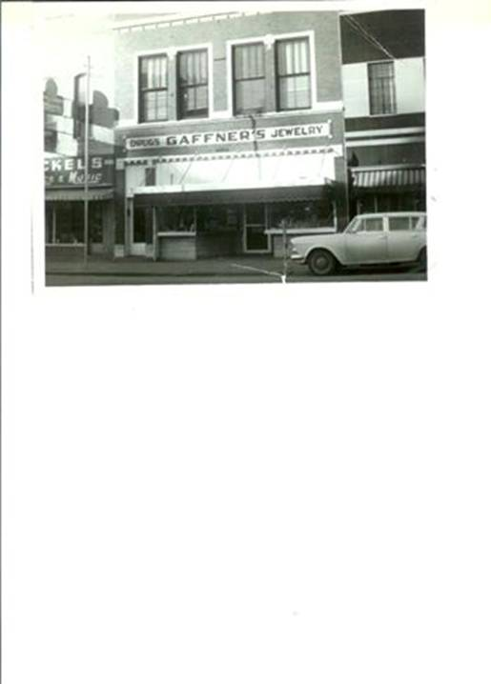

Ann Weesner King
Class of 1960
----------------------------------------------------------------------------------------
Rich Wilson
rdw30296@yahoo.com

As far as I can tell from a Google map of Olney is that "one mile west" of the Richland County Courthouse is in fact just beyond where the Olney Drive-In Theater movie screen was located. Fox Creek is within a few hundred yards and is supposedly where the settlement that later was renamed Olney was first located. I recall some old timers saying that when they were boys they'd seen remnants of buildings in that area but didn't know who'd built them or what had become of the inhabitants. Now we know from reading the "History of Olney" that they relocated to higher and dryer ground.
John Jacob Astor had a fur trading post in "The White Building" with a peaked roof that was located on Main about where Sherman's or Tresslar's were located. The fact that a fur trading post was located in Olney says something about what the local environs must have been like at the time. Astor shipped fur to Europe to be made into men's top hats and bowlers. And that's why "the mad hatter was mad" (Alice in Wonderland); the curing process used mercury that poisoned the hat makers' nervous systems including their brains. Not sure if the mercury impacted the hat wearers too?

Rich Wilson
Class of ‘68
-----------------------------------------------------------------------------------------------------
David Schnautz
david@clarkfreight.com

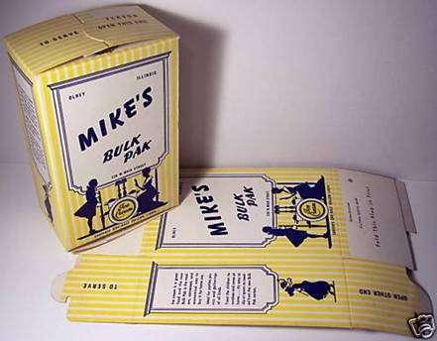
Who of us doesn’t remember this and where it came from?

Sharon Street
Trigger88@aol.com

Hi Ann.........

Thanks for doing such a service to the classmates from ERHS in keeping us all reminded of the days of better times! Seems when I read about memories that others write, it brings other memories to my mind! One that came to me lately was from back in the early 70's...or perhaps in the late 60's.
Does anyone else remember a movie that was made of the City of Olney and Richland County? This was during the time that the Oil Business was really booming and so was Olney. We had a wonderful downtown at that time, too! I remember going to see the movie at the Arcadia on a Saturday afternoon.
Wonder where that film is today and wouldn't it be great to see it again?

Sharon Street Burt
Class of 1960
--------------------------------------------------------------------------------------------
==================================================================
==================================================================

