# IMPORTANT DEFINITIONS

It is good to establish some names and titles, to prevent confusion.

**Negotiation** is the process of narrowing the Buy-Sell Range to zero, to the Deal Point, so the seller can sell and the buyer can buy.

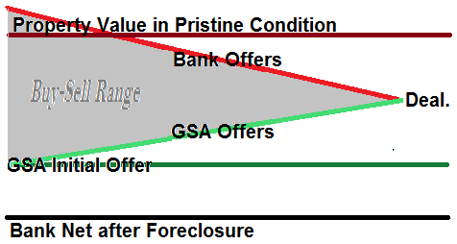

**The Buy-Sell Range** is the spread between the buyer’s most attractive offer to the seller and the seller’s least attractive offer to the buyer. Often, it is a price range. It gets its own topic below. Please see the index.

At our company, negotiation with the bank is done by a **Loss Mitigation Specialist** simply called the **Loss Mitigator (LM)** in-house. The words in this title: “Loss Mitigation Specialist” are designed to give the highly important LM a specific, advanced negotiating advantage, to be discussed later. I got that title from Cory Boatright. Thanks, Cory.

The LM’s counterpart at a bank is usually called the **Negotiator**, or sometimes other names such as **Workout Specialist**.

Our **Property Review Panel (PRP)** decides prices and other negotiation parameters. The members of this panel are not revealed to the bank, supporting an advanced negotiation tactic called, “Appeal to Higher Authority.”

Companies should give their Negotiators the advantage of a higher authority. It’s not ethical to ask Negotiators to lie and invent such a higher authority, so give them a real one, even if they sit on the panel.

Banks usually employ the same tactic. They say that they have to get Investor approval, and often that is true. The Investor is usually someone within the bank, a representative of another company that bought the loan. (There is an ongoing controversy regarding that practice, and the courts are testing it to this date.) Anyhow, a bank Negotiator will often agree in principle, but reserve the investor’s right to veto their position. That puts you at a disadvantage because you agreed and they didn’t. Then, they expect you to raise your price and they still don’t agree, repeating until you stall at your highest price. They never have to concede a thing.

Trying to give the tactic even more power, they won’t reveal who the investor is, lest we appeal directly to that investor. It works with most companies, but not with us.

Our company turns the tables in four ways:

* By asking the seller to get the bank to reveal who the investor is. Legally, the bank must honor the seller’s request for this information, and the Seller tells us.
* By asking the seller to get the bank to reveal who the Mortgage Insurer is. The bank must reveal this to the seller as well,
* By establishing our Property Review Panel, a “higher authority” that must approve all purchases, and
* By not revealing names of the panel’s members. Typically they are the Directors, a Regional Manager and a Loss Mitigator. Notice that the Loss Mitigator may be sitting on the panel and does not have to reveal that fact to the bank.